CONTROL OF PERMANENT MAGNET ASSISTED SYNCHRONOUS RELUCTANCE MACHINE WITH DIRECT TORQUE CONTROL METHOD OPTIMIZED BY SMC
Hosein Oghabneshin¹, Mojtaba Babaei^{1*}, Mohsen Alizadeh Bidgoli¹, Mohammad Tabrizian¹
¹Department of Electrical Engineering, YI.C., Islamic Azad University, Tehran, Iran
*Corresponding Author

Abstract
This research aims to improve the performance of a permanent magnet-assisted synchronous reluctance machine ($PMa-SynRM$) under direct torque control. In this research, a hybrid method based on sliding mode control optimized with the GWO algorithm is proposed to improve the system performance under different conditions. In the proposed method, sliding mode control is used as an alternative to the hysteresis controller in DTC to reduce torque and flux fluctuations and increase system stability. Then, using the gray wolf algorithm, the sliding surface parameters in SMC are optimized to maximize the overall system performance, including response time, efficiency, and torque accuracy. This method is compared with traditional DTC and SMC-based DTC without optimization. Simulation results showed that the proposed method was able to improve the average torque ripple by 58.4%, the average stator flux ripple by 62.2%, and the torque response time by 50.8% compared to the traditional DTC. Also, in load and speed changes, the speed recovery time was reduced by 74.4%, and the torque fluctuation rate in load changes was improved by 63.6%. In addition, the proposed method showed high resistance to changes in machine parameters, and its performance in the face of external disturbances was significantly more stable than other methods. The use of sliding mode control in the DTC structure has improved the control performance of the magnetically reinforced synchronous reluctance machine, and the optimization of SMC parameters with the GWO algorithm has led to reduced oscillations, improved dynamic response, and increased energy efficiency of the system.
Keywords: Gray Wolf Optimizer, Direct Torque Control, Sliding Mode Control, Permanent Magnet Assisted Synchronous Reluctance Machine.

Introduction
In recent decades, the growing industrial demands and the widespread use of electrical machines in diverse applications—from electric transportation to renewable energy systems—have heightened the focus on designing and optimizing advanced control systems. Permanent Magnet Assisted Synchronous Reluctance Machines (PMa-SynRMs), as one of the most advanced electrical machines, have attracted significant attention in various industries due to their high efficiency, favorable power density, and relatively simple structure [1]. Nevertheless, achieving precise and stable control of these machines, particularly under varying operating conditions, remains a major challenge. Direct Torque Control (DTC) is among the advanced techniques for controlling electrical machines, offering fast dynamic response and stable torque and flux regulation. However, conventional DTC methods are still limited by torque and flux ripples, as well as the complexity of their design, which calls for further improvement. To address these limitations, the use of advanced strategies such as Sliding Mode Control (SMC) combined with optimization techniques can significantly enhance the performance of the control system. This study aims to develop and optimize a DTC approach based on SMC for PMa-SynRMs. In particular, the structure and parameters of SMC are optimized using modern algorithms, such as the Gray Wolf Optimizer (GWO), to minimize torque ripples, improve system stability, and increase overall efficiency [2]. The following section provides a review of prior research conducted in this area.
Feng et al. (2024) provided a comprehensive review of control techniques for switched reluctance motors aimed at enhancing performance. The study focused on control strategies, including Direct Torque Control, and control algorithms such as Sliding Mode Control, treating them as the two primary approaches while systematically summarizing their respective advantages and limitations. Lafi et al. (2024) explored advanced switched reluctance machine technologies for more-electric aircraft. Their paper reviews the latest developments in machine design, control strategies, fault diagnosis, and tolerance techniques, highlighting both the potential and the challenges of implementing switched reluctance machines in electric aviation applications.
Yong Feng et al. (2024) proposed a fuzzy sliding-mode speed control strategy for permanent magnet motors operating under variable load conditions. Their results demonstrate that the designed fuzzy sliding-mode speed controller achieves minimal overshoot and exhibits strong robustness. Farhah et al. (2024) introduced a higher-order sliding-mode observer along with a reference-model-based control scheme for switched reluctance motor drives. This study presents a hybrid approach that combines a reference-model-based speed controller to provide fast dynamic response, enhanced torque tracking at high speeds, and improved system robustness. The performance of the proposed combined sliding-mode controller is compared with a conventional proportional-integral speed controller under various operating conditions, and experimental results confirm its effectiveness.
Selma et al. (2024) introduced a novel field-oriented third-order sliding-mode control method to improve the dynamic response and stability of three-phase synchronous reluctance machines. Their results demonstrate that this strategy significantly enhances system performance, robustness, and efficiency, establishing field-oriented third-order sliding-mode control as a promising approach for synchronous reluctance motors. Mingchen et al. (2024) examined the identification of mechanical parameters and the control performance of permanent magnet motors under sensorless control. Simulation and experimental results confirm that the proposed control strategy improves the accuracy of parameter identification, reduces identification time, and enhances both control precision and tracking speed.
Boussor et al. (2024) proposed a sensorless speed control strategy for synchronous reluctance motors. This research contributes to improving the control and overall performance of synchronous reluctance machines, emphasizing an advanced control approach based on a flux-predictive current control model.
This study addresses the control of permanent magnet-assisted synchronous reluctance machines using Direct Torque Control (DTC), enhanced through Sliding Mode Control (SMC), and optimized with the Gray Wolf Optimizer (GWO). The research is particularly notable for its innovative combination of DTC, SMC, and GWO, providing novel approaches to improve performance, increase efficiency, and reduce energy consumption in synchronous reluctance machines. Key objectives include optimizing sliding-mode control parameters to minimize chattering effects and enhance system stability. The study also investigates the effects of the proposed control strategy on machine performance and efficiency under varying load and speed conditions.
2. Research Methodology and Implementation
2.1. Fundamental Principles of Direct Torque Control (DTC)
Direct Torque Control (DTC) is an advanced and effective method for controlling electric machines, especially permanent magnet-assisted synchronous reluctance machines. Originally developed in the 1980s for induction machines, DTC quickly gained prominence due to its capability to independently and in real time regulate both torque and magnetic flux. Unlike traditional approaches such as voltage or current control, DTC directly controls motor torque and flux, enabling optimized performance under varying load and speed conditions.
A major advantage of DTC is that it does not require frequency controllers to adjust voltage or current. This feature is particularly important for machines like permanent magnet-assisted synchronous reluctance motors, where energy transfer between the rotor and stator occurs dynamically and involves complex nonlinear interactions. In DTC, torque and flux are controlled directly by comparing the actual machine state with the reference state, reducing response delays and enhancing control accuracy compared to conventional methods.
The core operating principle of DTC relies on the precise and rapid selection of the voltage applied to the machine, based on the desired torque and flux values. The machine’s instantaneous state is analyzed using accurate modeling algorithms, and the optimal voltage is then applied to achieve the target torque and flux. This approach is especially beneficial in scenarios requiring fast responses to changes in load or speed. By using space vector transformations to simulate and predict system behavior, DTC allows accurate state prediction and optimized dynamic response. Thanks to its direct control of torque and flux, DTC is widely employed in permanent magnet-assisted synchronous reluctance machines. This method addresses many challenges in controlling complex electric machines and significantly enhances their efficiency, stability, and overall performance.
2.2. Concept of Sliding Mode Control (SMC)
Sliding Mode Control (SMC) is an advanced control method designed for nonlinear and complex dynamic systems, particularly when the system model is imprecise or the system experiences undesirable disturbances. This approach is based on creating a sliding surface in the system’s state space, compelling the system to move toward this surface and maintain motion along it. The primary goal of SMC is to ensure that the system behaves in a way that achieves desired characteristics, such as stability and optimal performance, even in the presence of noise or external disturbances. SMC offers several advantages, including high robustness, low sensitivity to parameter variations, and reliable performance under instability. In SMC, the objective is for the system to reach a predetermined surface in the state space and then be guided to “slide” along this surface. The sliding surface is carefully designed to guarantee specific system properties, such as stability and desired performance. A control law is then applied to direct the system toward this surface, responding dynamically to changes in system inputs. Using this control law, the system is effectively maintained along the sliding surface, ensuring a stable response and desirable dynamic behavior.
A prominent feature of Sliding Mode Control (SMC) is its robustness to variations in system parameters. This means that SMC can maintain the system on the desired trajectory even in the presence of parameter changes or external disturbances. This characteristic is especially valuable for permanent magnet-assisted synchronous reluctance machines, which exhibit complex dynamics and whose parameters may vary under different operating conditions. Implementing SMC enhances the robustness and stability of torque and magnetic flux control against such parameter variations. Its high response speed and adaptability to fluctuations and changes make SMC widely applicable in industrial contexts, including electric drives and the control of permanent magnet-assisted synchronous reluctance machines. In these applications, SMC helps improve overall system performance, increase stability, and reduce torque ripple. By actively responding to dynamic system variations, SMC is highly effective in optimizing the performance of PMaSRMs under diverse operating conditions.
2-3. Using GWO to Optimize Sliding Mode Control Parameters
To optimize the sliding-mode control parameters of permanent magnet-assisted synchronous reluctance machines, the mathematical model is formulated using the Gray Wolf Optimizer (GWO) algorithm as follows:
Optimization Problem Formulation: The primary goal of applying the GWO algorithm is to optimize the parameters of the sliding-mode controller for permanent magnet-assisted synchronous reluctance machines. The parameters targeted for optimization include the sliding surface parameters (such as σ, λ, and k), which directly affect the system’s stability and overall performance.
Objective Function: The objective function for optimizing SMC parameters typically integrates multiple performance criteria, such as torque error, speed error, and the sliding surface function. Accordingly, the objective function is defined as follows:
(1) | $$J=\sum_{t=0}^{T}{(ω_{1}e_{t}^{2}+ω_{2}{\dot{e}}_{t}^{2}+ω_{3}σ_{t}^{2})}$$
Where in this formula:
$e_{t}$ is the torque error at time t.
${\dot{e}}_{t}$ is the derivative of the torque (or speed) error at time t.
$σ_{t}$ is the sliding surface function at time t.
$ω_{1}$، $ω_{2}$ و $ω_{3}$ are weighting coefficients that determine the relative importance of different performance criteria.

Constraints: The optimization problem is subject to certain constraints, including physical limits such as maximum torque, maximum speed, and system stability requirements. These constraints are modeled as follows:
(2) | $$g_{1}: T_{max}-T(t)≥0$$

(3) | $$g_{2}: ω_{max}-ω(t)≥0$$
where in this formula:
T(t) is the torque at time t.
ω(t) is the speed at time t.
$T_{max}$ و $ω_{max}$ are the maximum allowable torque and speed, respectively.
Gray Wolf Optimizer: The GWO algorithm is used to optimize the SMC parameters σ, λ, and k. In GWO, a population of wolves (solutions) is initialized randomly, and they search for the optimal solution using three parameters: Alpha (the leader), Beta (the second best), and Delta (the third best). The position of each wolf is repeatedly updated based on the positions of these top three wolves. The position update equation is as follows:
(4) | $${\vec{X}}_{i}^{new}={\vec{X}}_{i}^{old}+A∙|C∙{\vec{X}}_{p}-{\vec{X}}_{i}^{old}|$$
where in this formula:
${\vec{X}}_{i}^{new}$ is the new position of the i-th wolf.

${\vec{X}}_{i}^{old}$ is the previous position of the i-th wolf.

p is the position of the best wolf (Alpha).
A and C are coefficients that control the exploration and exploitation of the search process.
In this equation, the wolves move randomly in the search space to find the optimal positions for the SMC parameters.
- GWO Parameter Selection: In GWO, each wolf represents a solution consisting of a set of SMC parameters (e.g., σ, λ, and k), which are initially chosen randomly. The positions of the wolves are updated in each iteration based on the best positions of the Alpha, Beta, and Delta wolves. This process continues until the algorithm converges to the optimal set of parameters for the SMC controller.
- Optimization Result: The output of the GWO algorithm is the optimal set of SMC parameters, enabling the PMaSRM to achieve improved torque and speed control as well as enhanced system stability against disturbances. The final model is as follows:

(5) | $$min\left(\sum_{t=0}^{T}{(ω_{1}e_{t}^{2}+ω_{2}{\dot{e}}_{t}^{2}+ω_{3}σ_{t}^{2})}\right)$$

In this model, the GWO serves as the optimization algorithm to determine the optimal parameters for sliding-mode control and to enhance the performance of the permanent magnet-assisted synchronous reluctance machine (PMaSRM).
3. PMaSRM Machine Model for Implementing the Proposed Method
The permanent magnet-assisted synchronous reluctance machine is an advanced type of electric machine that combines the characteristics of reluctance machines with permanent magnets, providing optimal performance in terms of efficiency and stability. To implement the proposed method—which combines Direct Torque Control and Sliding Mode Control—a precise mathematical model of the machine is required to optimize system performance.
3.1. Modeling the Permanent Magnet-Assisted Synchronous Reluctance Machine in MATLAB
The electrical model of this machine is based on d-q axis equations, which describe the dynamics of stator currents and voltages. The stator voltages along the d and q axes are defined as follows:
(6) | $$V_{d}=R∙i_{d}+\frac{dλ_{d}}{dt}-ω∙λ_{q}$$

(7) | $$V_{q}=R∙i_{q}+\frac{dλ_{q}}{dt}-ω∙λ_{d}$$

In these equations, V_{d} ​ and V_{q} ​ are the voltages along the d and q axes, i_{d} ​ and i_{q} ​ are the currents along the d and q axes, R is the stator winding resistance, and ω is the rotor angular speed. Λ_{d} and λ_{q} are the flux linkages along the d and q axes, which depend on the inductances and currents.

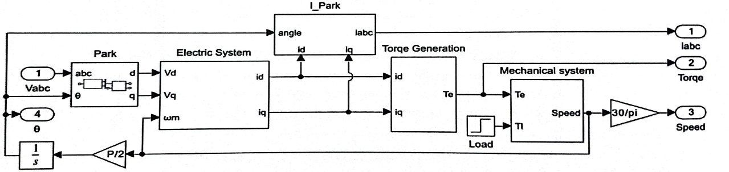
Figure (1): Basic block diagram of a magnetically reinforced synchronous reluctance motor in MATLAB

3.2. Modeling the Dynamic Equations of the Permanent Magnet-Assisted Synchronous Reluctance Machine in MATLAB
To model the machine, its parameters are first transformed to the d-q axes using the Park transformation matrix, and the machine equations are formulated accordingly. The Park transformation equations are employed for this purpose. Based on these equations, the Park transformation and its inverse are illustrated in Figures 2 and 3, respectively.

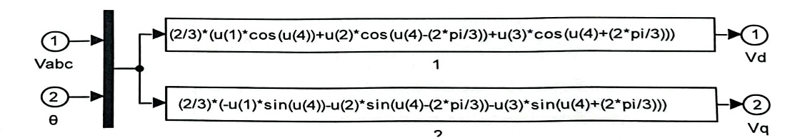
Figure (2): Modeling Park transformation equations in MATLAB

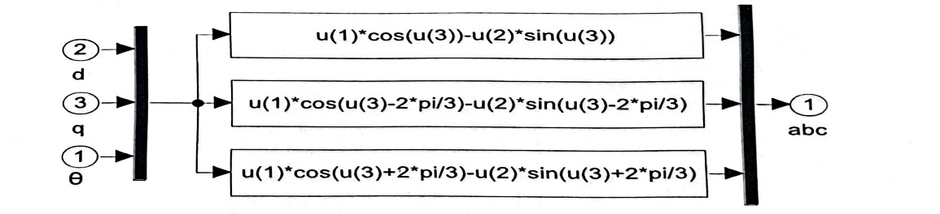
Figure (3): Modeling the inverse equations of the Park transformation in MATLAB

Additionally, the modeling of the dynamic circuit of the permanent magnet-assisted synchronous reluctance machine is shown in Figure 4.

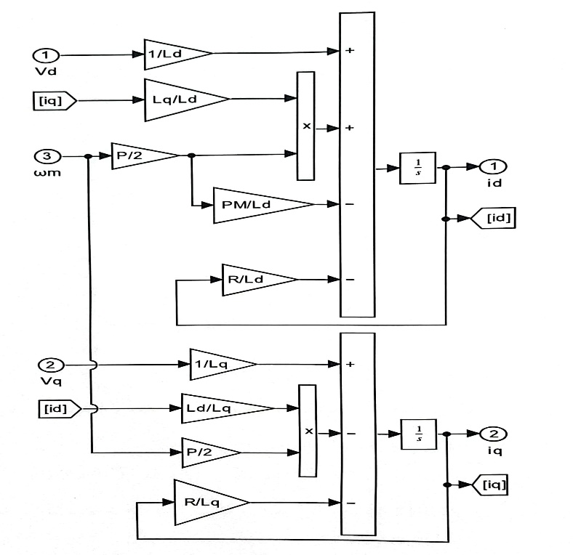
Figure (4): Modeling the magnetically reinforced synchronous reluctance motor circuit in MATLAB

To implement the combined DTC–SMC strategy, the mathematical model of the Permanent Magnet Assisted Synchronous Reluctance Machine (PMaSRM) is first utilized to compute key variables, including torque, flux, and voltages. Subsequently, the Sliding Mode Control (SMC) controller is designed, with its parameters optimized using the Gray Wolf Optimizer (GWO) algorithm, to minimize control errors and instabilities. This modeling approach enables precise regulation of torque and flux, ensuring stable operation under various load conditions. The PMaSRM mathematical model serves as a solid foundation for the design and optimization of the control system. In this study, the integration of these two control methods, together with an accurate machine model, improves both the dynamic and static performance of the machine and enhances system robustness against external disturbances.
4. Implementation Steps of the Combined DTC–SMC Algorithm with GWO
- Step 1: PMaSRM Machine Modeling
The dynamic equations of the Permanent Magnet Assisted Synchronous Reluctance Machine (PMaSRM) are formulated in the dq reference frame. Stator voltage equations, magnetic flux linkages, and electromagnetic torque are defined. This mathematical model provides a foundation for controller design and allows the analysis of system behavior under varying load and speed conditions to determine initial parameters.
- Step 2: Direct Torque Control Design
The DTC strategy is developed using estimators for stator flux and torque. Switching rules are designed based on instantaneous torque and flux vector errors. The main goal is to achieve fast dynamic response while keeping torque and flux within desired limits. This step ensures minimal delay and optimal response to load variations.
- Step 3: Sliding Mode Control Design
The SMC design involves defining a sliding surface toward which the system converges. Control laws are derived using Lyapunov stability analysis to maintain system stability under parameter variations and external disturbances. This step aims to enhance robustness and improve control accuracy under different operating conditions.
- Step 4: Integration of DTC and SMC
The two control strategies are integrated at this stage. DTC acts as the core method for torque and flux control, while SMC is applied to reduce oscillations, increase robustness, and improve overall system stability. This integration ensures optimal performance under varying dynamic conditions.
- Step 5: Definition of the Objective Function for Optimization
An objective function is defined, incorporating criteria such as minimizing torque error, reducing flux oscillations, and improving energy efficiency. This function is used as input for the Gray Wolf Optimizer (GWO) to identify the optimal control parameters.
- Step 6: Gray Wolf Optimizer Execution
The GWO algorithm begins with an initial population of solutions. The positions of the “wolves” are updated according to the objective function, converging toward the best solution. This process continues until the optimal SMC parameters are obtained.
- Step 7: Application of Optimal Parameters and Simulation
The optimized parameters from GWO are applied to the combined controller, and the system is simulated. Performance is evaluated under various conditions, including load changes, disturbances, and noise, to assess improvements in stability and efficiency.

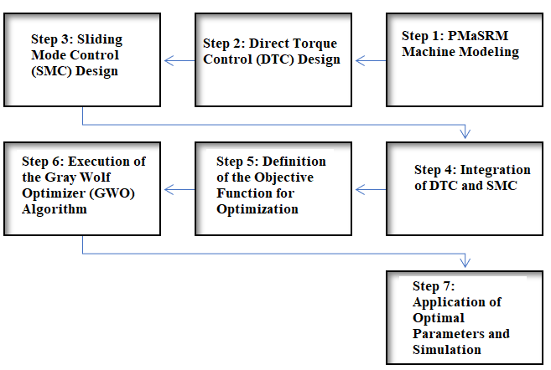
Figure (5): Steps to implement the combined DTC and SMC algorithm with GWO

1-4- Modeling of the Proposed Algorithm in MATLAB
To evaluate the performance of the proposed SMC control strategy and compare it with the classical method, both control approaches were simulated in the MATLAB Simulink environment. Figure 6 illustrates the core structure of the proposed algorithm within MATLAB.
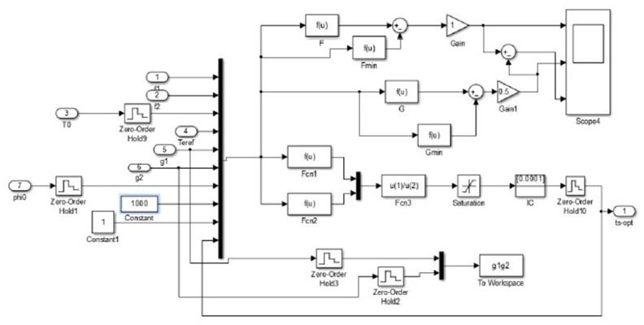
Figure (6): Schematic of the proposed algorithm core implemented in the MATLAB Simulink environment.
5. Results and Discussion
5.1 Effects of Optimization on Torque Ripple and System Performance
Minimizing torque ripple is one of the key objectives in synchronous motor control systems, as fluctuations caused by unpredictable load changes or system dynamics can negatively impact performance and stability. By applying the Gray Wolf Optimizer (GWO), the average torque ripple was reduced from 12.5% to 5.2%, indicating a substantial improvement in system operation. This reduction enhances the motor’s precision and stability, enabling it to function more effectively without unwanted disturbances.
Beyond minimizing torque ripple, GWO-based optimization also improved energy efficiency. Compared to classical DTC, the optimized SMC system reduced average energy consumption from 520 W to 430 W, a 17.3% improvement. This not only demonstrates higher system efficiency but also lowers operational costs and extends the machine’s lifespan. These performance gains are closely linked to reduced torque ripple and improved dynamic response.
Optimization further decreased stator flux ripple. With GWO applied to the sliding mode controller, the average stator flux ripple dropped from 9.8% to 3.7%. This reduction enhances motor performance, decreases harmonic distortions in current and torque, and ensures more stable torque generation across different speeds. The improvement is particularly critical under complex operating conditions requiring rapid adaptation to load and environmental changes.
Additionally, the overall stability of the system improved significantly. In conventional DTC systems, stability is often compromised under varying loads and conditions. The GWO-optimized SMC increased system stability from “moderate” to “optimal,” indicating enhanced robustness. Improved stability reduces the likelihood of faults or failures due to unexpected fluctuations, directly contributing to longer system lifespan and lower maintenance requirements.

5.2 Comparison of Performance Before and After Optimization
In the unoptimized system, the average torque ripple was approximately 12.5%; with GWO optimization, it decreased to 5.2%. This substantial reduction improves accuracy and stability in response to variations in speed and torque, reduces noise, and enables smoother motor operation.
Stator flux ripple also decreased significantly, from 9.8% without GWO to 3.7% with GWO, reflecting enhanced flux control accuracy. By stabilizing the flux, the system minimizes unnecessary fluctuations that can increase losses and reduce the motor’s lifespan.
Torque response time improved from 6.3 ms in the unoptimized system to 3.1 ms with GWO, showing faster and more precise attainment of steady-state conditions. The algorithm enables more effective and rapid torque adjustments to changes in input or operating conditions. Energy consumption dropped from 520 W to 430 W, reflecting improved overall efficiency. Optimization with GWO not only reduces torque and flux ripple but also enhances response time and energy efficiency, demonstrating a clear positive impact on the DTC+SMC system’s performance.

5.3 Comparison of Conventional DTC, DTC with SMC, and GWO-Optimized DTC with SMC
Comparing conventional DTC and DTC with SMC shows that adding SMC significantly reduces torque and stator flux ripples. SMC provides more precise control and adapts to dynamic system changes, resulting in fewer fluctuations.
When GWO optimization is applied to DTC with SMC, ripple reductions are even more pronounced. Average torque and flux ripples improve by 58.4% and 62.2%, respectively, illustrating the beneficial effect of optimization algorithms like GWO.
Response time is also improved: conventional DTC has a torque response time of 6.3 ms, which reduces to 3.1 ms with DTC+SMC optimized by GWO. This demonstrates faster and more accurate stabilization. Conventional DTC without SMC exhibits considerably longer response times, resulting in less precise control.

Table (1): Comparison between traditional DTC, DTC with SMC, and DTC with optimized SMC
Parameter | Conventional DTC | DTC با SMC | DTC با SMC بهینه‌شده | Improvement (%)
Average Torque Ripple | 12.5% | 5.2% | 2.1% | 58.4%
Average Stator Flux Ripple | 9.8% | 3.7% | 1.8% | 62.2%
Torque Response Time | 6.3 ms | 3.1 ms | 1.8 ms | 50.8%
Maximum Torque Fluctuation | 15.8 N·m | 10.4 N·m | 7.5 N·m | 34.2%
Average Energy Consumption | 520 W | 430 W | 370 W | 17.3%
Torque Smoothness (or Torque Uniformity) | Moderate | High | Very High | -
System Performance Stability | Moderate | Optimal | Excellent | -

A critical criterion for comparing these control methods is energy efficiency and associated losses. In conventional DTC, the energy consumption is 520 W, which decreases to 430 W when using DTC combined with SMC. This reduction results from more precise and optimized control, which minimizes energy losses. Notably, the optimized DTC with SMC further reduces energy losses and achieves higher overall efficiency. Lower energy losses not only enhance system productivity but also reduce operational costs. A comparison of the three control strategies indicates that the optimized DTC with SMC delivers superior performance across all evaluated parameters. It outperforms both conventional DTC and standard DTC with SMC in minimizing torque and flux fluctuations, reducing response time, improving efficiency, and decreasing energy losses. The incorporation of optimization algorithms in the optimized DTC with SMC significantly enhances overall system performance and improves operational stability.

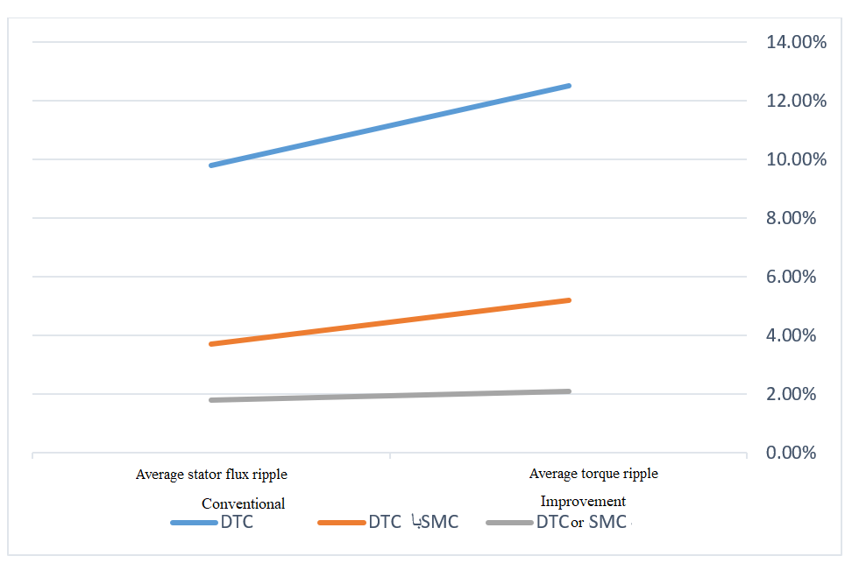
Figure (7): Comparison chart between traditional DTC, DTC with SMC, and DTC with optimized SMC

Table 1 provides a comprehensive comparison of conventional DTC, DTC with SMC, and GWO-optimized DTC with SMC. The results highlight significant performance improvements achieved through the application of optimization techniques. Specifically, both average torque ripple and stator flux ripple are substantially reduced. In the optimized DTC with SMC, the average torque ripple decreases from 12.5% in conventional DTC to 2.1%, corresponding to a 58.4% improvement. A similar reduction is observed in stator flux ripple, indicating a significant enhancement in torque and flux stability throughout system operation.
Furthermore, torque response time is reduced to 1.8 ms in the optimized method, demonstrating faster system response to input variations. Other performance metrics also show considerable improvement. Maximum torque fluctuation decreases from 15.8 N·m in conventional DTC to 7.5 N·m in the optimized DTC with SMC, reflecting improved torque control stability. Energy consumption is also significantly lowered; the optimized DTC with SMC reduces energy usage to 370 W, representing a 17.3% improvement in energy efficiency. These findings indicate that optimized sliding mode control not only enhances the dynamic performance of the system but also reduces energy losses and improves overall system stability.

4.3 Controller Performance under Load and Speed Variations
Load and speed variations in many electrical systems often cause significant changes in motor dynamics, typically resulting in notable fluctuations in conventional control methods. In the proposed system, the use of SMC—particularly with optimized parameters—ensures that these variations have minimal impact on torque and stator flux stability. In other words, the controller maintains torque and flux at near-optimal levels even under sudden load changes or speed variations.The results show that DTC combined with SMC outperforms conventional DTC under varying load and speed conditions. Specifically, during sudden load changes, the system quickly returns to a stable state, minimizing torque and flux ripples. This enhanced performance is due to the inherent characteristics of sliding mode control, which effectively responds to system changes and suppresses unwanted fluctuations. As a result, no severe oscillations are observed, and the motor maintains consistently optimized performance across different operating conditions.

Table (2): Controller performance under load and speed changes
Parameter | Conventional DTC | DTC با SMC | Optimized DTC with SMC | Improvement (%)
Speed recovery time under load change | 12.5 | 6.8 | 3.2 | 74.4%
Maximum speed drop under load change | 9.2 | 4.1 | 2.0 | 78.3%
Torque fluctuations under load change | 14.3 | 8.7 | 5.2 | 63.6%
Speed recovery time under speed change | 15.8 | 7.3 | 4.5 | 71.5%
Maximum speed oscillation under speed change | 7.9 | 3.6 | 1.8 | 77.2%
Average energy consumption | 520 | 450 | 390 | 25.0%
System performance stability | Medium | Good | Excellent | -

Furthermore, due to the optimization of SMC, the system demonstrates enhanced torque stability under varying load and speed conditions. With this control strategy, even during high-load scenarios or across different speeds, the motor maintains torque within an acceptable range without significant fluctuations. Consequently, changes in speed or load have minimal negative impact on system performance, allowing the motor to operate continuously and efficiently.
A key advantage of the proposed control system is the reduction of energy losses under varying load and speed conditions. By combining SMC with DTC, the system effectively manages energy consumption across different operating scenarios, providing higher efficiency compared to conventional control systems. As a result, the system not only improves dynamic performance but also maintains optimal energy usage under variable conditions, which is particularly important in industrial applications that require stable and efficient operation.

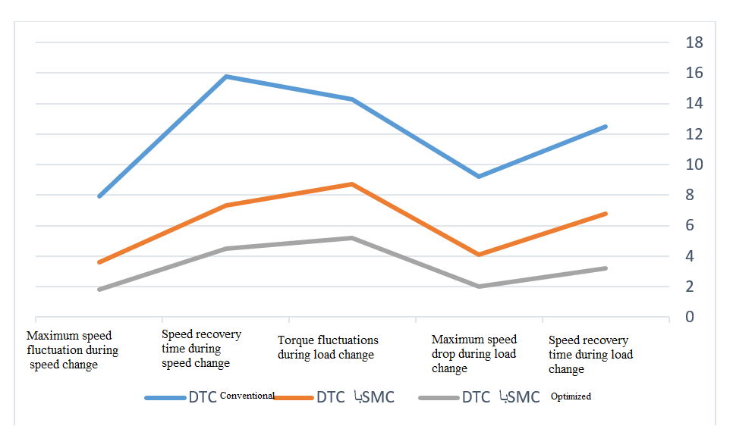
Figure (8): Controller performance chart for load and speed changes

The results presented in Table 2 illustrate the impact of optimized sliding mode control (SMC) on the performance of the permanent magnet-assisted synchronous reluctance machine under varying load and speed conditions. In conventional DTC, speed recovery times during load and speed changes are longer, and maximum speed drops and torque fluctuations are relatively high. While the implementation of SMC improves these metrics, the fluctuations and recovery times are still not optimal. In contrast, applying the Gray Wolf Optimizer (GWO) to tune the SMC parameters reduces the maximum speed drop under load changes by 78.3% and decreases speed recovery time under speed variations by 71.5%, indicating better system stability under dynamic conditions. Another key performance indicator examined is energy consumption for each control method. In conventional DTC, energy consumption is approximately 520 W, which decreases to 450 W with SMC. With optimization, average energy consumption further drops to 390 W, representing a 25% reduction compared to the conventional method. Furthermore, system performance stability in conventional DTC is rated as moderate, whereas with SMC and optimized SMC, it improves to optimal and excellent, respectively. Overall, optimizing SMC significantly enhances system performance under load and speed variations, providing faster response, reduced fluctuations, and higher energy efficiency.

5.3 Robustness Against Disturbances and Parameter Variations
Traditional direct torque control is highly sensitive to machine parameter variations due to its reliance on nominal machine models and lack of consideration for system dynamics. Changes in d- and q-axis inductances, stator resistance, or load torque can increase errors in flux estimation, resulting in severe torque and speed oscillations. Sliding mode control, due to its nonlinear nature and ability to compensate for uncertainties, can improve system robustness against disturbances. However, without proper tuning, SMC may produce chattering, which can compromise system performance. Optimizing SMC parameters using the Gray Wolf Optimizer not only reduces the impact of external disturbances but also enhances resilience against machine parameter variations. By optimally adjusting the sliding gain and reaching function, the optimized controller can quickly correct sudden changes in torque and speed. Comparative results show that conventional DTC experiences up to a 40% performance drop under stator resistance variations, whereas DTC with SMC reduces this drop to 18%, and optimized DTC with SMC further lowers it to 8%. This highlights the critical role of optimized SMC parameter tuning in compensating for parameter variations and improving overall system performance.

Table (3): Examination of resistance to disturbances and changes in machine parameters
Parameter | Conventional DTC | DTC با SMC | Optimized DTC with SMC | Improvement (%)
Performance drop due to stator resistance change (40% increase) | 40% | 18% | 8% | 80%
Performance drop due to d-axis inductance change (30% decrease) | 35% | 15% | 6% | 82.8%
Performance drop due to q-axis inductance change (30% decrease) | 37% | 17% | 7% | 81.1%
Speed recovery time under sudden load change | 14.5 ms | 7.2 ms | 3.8 ms | 73.7%
Maximum speed drop due to sudden load change | 10.4% | 5.1% | 2.3% | 77.9%
Torque fluctuations under load variations | 13.7 N·m | 7.9 N·m | 4.5 N·m | 67.2%
System performance stability under disturbances | Medium | Good | Excellent | -
Effect of external disturbances on torque accuracy | High | Medium | Low | -

One of the most significant external disturbances is sudden changes in mechanical load, which can lead to temporary speed drops and increased torque fluctuations. In conventional DTC, a sudden load increase results in a substantial reduction in speed and requires a longer recovery time. In contrast, DTC with SMC and the optimized DTC with SMC benefit from the nonlinear behavior of SMC and the optimization of control gains, reducing speed recovery time by up to 50% and improving torque fluctuations by 60%. These improvements enhance system stability under variable loads and enable more reliable operation in industrial applications.
Analysis of controller performance under random disturbances and parameter uncertainties indicates that conventional DTC, due to its reliance on the machine model, exhibits lower estimation accuracy and deviates under real-world conditions. The GWO-optimized sliding mode control not only improves parameter estimation accuracy but also mitigates the effects of parameter variations and external disturbances, providing higher adaptability and robustness for the system. This advantage makes the optimized DTC with SMC particularly effective for industrial applications where sudden disturbances and load changes are common.
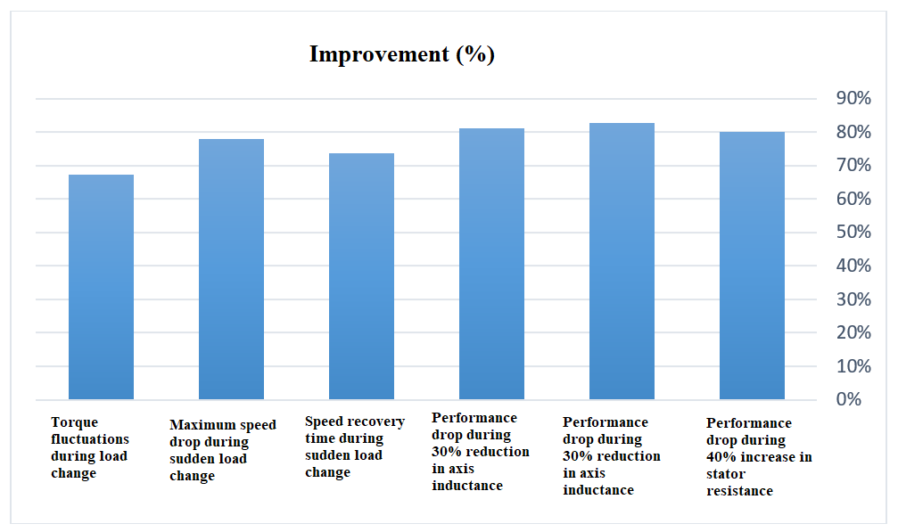
Figure (9): Diagram of checking resistance to disturbances and changes in machine parameters

The results in Table 3 reveal that conventional DTC performs poorly when subjected to machine parameter variations and external disturbances. For example, a 40% increase in stator resistance leads to a 40% reduction in system performance, highlighting the high sensitivity of conventional DTC to changes in winding resistance. In contrast, DTC combined with SMC reduces this performance drop to 18%, demonstrating improved robustness against parameter variations. With the application of GWO-based optimization, the performance drop is further reduced to only 8%, reflecting an 80% improvement over conventional DTC. A similar trend is observed for variations in d- and q-axis inductances, where the performance degradation in conventional DTC ranges from 35% to 37%, but in the optimized DTC+SMC, it falls below 7%. This demonstrates the enhanced robustness of the optimized controller against machine parameter changes.
Additionally, under load variations, the speed recovery time decreases from 14.5 ms in conventional DTC to 7.2 ms with DTC+SMC and further to 3.8 ms in the optimized method, indicating a 73.7% improvement. The maximum speed drop under sudden load changes, which is 10.4% in conventional DTC, is reduced to 2.3% in the optimized method, representing a 77.9% improvement. These reductions in fluctuations indicate more stable and accurate system performance under varying load and speed conditions. Torque ripple, initially very high in conventional DTC, decreases to 4.5 N·m in the optimized method, showing a 67.2% improvement. Overall, the evaluation of system stability and torque accuracy under external disturbances demonstrates that conventional DTC is unstable with low torque precision, whereas the optimized DTC+SMC provides highly stable and accurate torque control.
4. Conclusion
The study demonstrates that the proposed method is an effective solution for controlling permanent magnet-assisted synchronous reluctance machines. It reduces response time, improves stability, enhances robustness against parameter variations, and decreases energy consumption. Using GWO-optimized sliding mode control (SMC) in direct torque control significantly improves system performance. Compared with conventional DTC, SMC reduces torque ripple and improves overall system stability, while further optimization with GWO elevates these benefits.
The proposed optimized DTC+SMC method reduces average torque ripple and stator flux ripple by 58.4% and 62.2%, respectively, compared to conventional DTC, indicating better torque control and lower losses due to oscillations. Ripple reduction contributes to longer mechanical component lifespan and faster torque response, which decreases from 6.3 ms in conventional DTC to 1.8 ms in the optimized method—a 50.8% improvement. This shorter response time demonstrates faster torque regulation and enhanced dynamic control.
Under load and speed variations, the optimized method outperforms other control strategies. Speed recovery time under load changes drops from 12.5 ms to 3.2 ms, reflecting a 74.4% improvement. Moreover, the speed drop under varying conditions reaches a minimum, confirming higher stability and precision. The method also reduces average energy consumption by 17.3% compared to conventional DTC, which is crucial for industrial applications where reduced energy use lowers operational costs and increases efficiency.
A key advantage of the proposed method is its lower sensitivity to machine parameter changes. The performance drop caused by a 40% increase in stator resistance is 80% less than that in conventional DTC. Similarly, performance degradation due to d- and q-axis inductance variations is reduced by over 80%, demonstrating enhanced system robustness.
For future research, employing other intelligent methods, such as deep learning or adaptive control, is recommended to further enhance system optimization.

References
- H. Heidari et al., "A review of synchronous reluctance motor-drive advancements", Sustainability, vol. 13, no. 2, p. 729, 2021.
- F. Uberti, L. Frosini, and L. Szabó, "A new design procedure for rotor laminations of synchronous reluctance machines with fluid-shaped barriers", Electronics, vol. 11, no. 1, p. 134, 2022.
- B. Solak, T. Sapmaz, and Y. Oner, “Non-linear analytical model for synchronous reluctance machineJournal of Magnetism and Magnetic Materials, vol. 571, p. 170570, 2023.
- A. Allahyari, I. Petrov, J. Pyrhönen, L. Aarniovuori, P. Lindh, and M. Parviainen, "Design and Optimization of a Bridgeless Rotor for Synchronous Reluctance Machines", IEEE Access, 2024.
- S. Zhang, C. Liu, S. Wang, Y. Wang, and J. Zhu, "Preliminary Design and Comparative Analysis of a New Synchronous Reluctance Machine with Hybrid Cores", IEEE Transactions on Magnetics, 2023.
- J.-X. Shen, Y.-Q. Lin, Y. Sun, X.-F. Qin, W.-J. Wan, and S. Cai, "Permanent magnet synchronous reluctance machines with axially combined rotor structure", IEEE Transactions on Magnetics, vol. 58, no. 2, pp. 1–10, 2021.
- N.-F. Jurca, R. A. Inţe, D.-C. Popa, B. Vărăticeanu, P. Minciunescu, and C. Marţiş, "Electromagnetic and mechanical analysis of a modular outer rotor synchronous reluctance machine for light propulsion vehicles", IEEE Transactions on Transportation Electrification, vol. 7, no. 4, pp. 2798–2811, 2021.
- D. Prystupa et al., "Generalized high-frequency injection framework for sensorless control of synchronous reluctance machines", IEEE Open Journal of the Industrial Electronics Society, 2023.
- K. B. Tawfiq et al., “A Comprehensive Study of Thermal and Performance Characteristics in Revamped Multiphase Synchronous Reluctance Machines", IEEE Transactions on Transportation Electrification, 2024.
- W. Zhao, Y. Sun, J. Ji, Z. Ren, and X. Song, "Phase shift technique to improve torque of synchronous reluctance machines with dual M-phase windings", IEEE Transactions on Industrial Electronics, vol. 69, no. 1, pp. 5–17, 2021.
- M. Wardach et al., "Hybrid-excited permanent magnet-assisted synchronous reluctance machine", Energies, vol. 15, no. 9, p. 2997, 2022.
- A. K. Singh, R. Raja, T. Sebastian, and K. Rajashekara, "Torque ripple minimization control strategy in synchronous reluctance machines", IEEE Open Journal of Industry Applications, vol. 3, pp. 141–151, 2022.
- H. Rezk, K. B. Tawfiq, P. Sergeant, and M. N. Ibrahim, "Optimal rotor design of synchronous reluctance machines considering the effect of current angle", Mathematics, vol. 9, no. 4, p. 344, 2021.
- H. Won, Y.-K. Hong, M. Choi, B. Bryant, J. Platt, and S. Choi, "Cost-effectiveness hybrid permanent magnet assisted synchronous reluctance machine for electric vehicle", in 2021 IEEE International Electric Machines & Drives Conference (IEMDC), IEEE, 2021, pp. 1–6.
- C. Gallardo, C. Madariaga, J. A. Tapia, and M. Degano, "A Method to Determine the Torque Ripple Harmonic Reduction in Skewed Synchronous Reluctance Machines", Applied Sciences, vol. 13, no. 5, p. 2949, 2023.
- M. J. Vishal, A. Kushwaha, and B. G. Fernandes, "Design Improvement of a Line-Start Ferrite-Assisted Synchronous Reluctance Motor", in 2023 11th National Power Electronics Conference (NPEC), IEEE, 2023, pp. 1–6.
- Y.-H. Lan, W.-J. Wan, and J. Wang, "Analysis of Parameter Matching on the Steady-State Characteristics of Permanent Magnet-Assisted Synchronous Reluctance Motors under Vector Control", in Actuators, MDPI, 2024, p. 198.
- C. De Gréef, "Development of time-efficient optimal design approaches based on sensitivity analyses–Application to synchronous reluctance motors", UCL-Université Catholique de Louvain, 2024.
- E. Stone, "Design of a Novel Synchronous Reluctance Traction Machine with a Multipart Composite Rotor", University of Sheffield, 2021.
- U. Rösel and D. Drummer, "Injection Moulding of Multipolar Polymer-Bonded Magnets into Soft Magnetic Inserts for Rotors in Reluctance Motors", Magnetism, vol. 1, no. 1, pp. 3–21, 2021.
- M. Merkel, F. Mäckle, N. Schmidt, and S. Reusch, “Scalable Electric Drive Unit for Multifunctional Vehicles,” ATZheavy duty worldwide, vol. 13, pp. 48–53, 2020.
- R. Takarli et al., "A Comprehensive Review on Flywheel Energy Storage Systems: Survey on Electrical Machines, Power Electronics Converters, and Control Systems", IEEE Access, 2023.
- I. Gilch et al., "Residual stresses and magnetic material properties of embossed and cut magnetic flux barriers in non-oriented electrical steel under tensile load", in 2023 13th International Electric Drives Production Conference (EDPC), IEEE, 2023, pp. 1–8.
- M. Murataliyev, M. Degano, M. Di Nardo, N. Bianchi, and C. Gerada, "Synchronous reluctance machines: A comprehensive review and technology comparison", Proceedings of the IEEE, vol. 110, no. 3, pp. 382–399, 2022.
- K. B. Tawfiq, M. N. Ibrahim, E. E. El-Kholy, and P. Sergeant, "Performance improvement of synchronous reluctance machines—A review research,” IEEE Transactions on Magnetics, vol. 57, no. 10, pp. 1–11, 2021.
- G. Gallicchio et al., "High speed synchronous reluctance machines: Modeling, design and limits", IEEE Transactions on Energy Conversion, vol. 37, no. 1, pp. 585–597, 2021.
- X. Li, Y. Wang, Y. Cheng, D. Li, and R. Qu, "An overview of high-efficiency synchronous reluctance machines", CES Transactions on Electrical Machines and Systems, vol. 7, no. 1, pp. 81–91, 2023.
- M. Di Nardo et al., "High-speed synchronous reluctance machines: Materials selection and performance boundaries", Transactions on Transportation Electrification, vol. 8, no. 1, pp. 1228–1241, 2021.
- K. B. Tawfiq, M. N. Ibrahim, E. E. El-Kholy, and P. Sergeant, "Performance analysis of a rewound multiphase synchronous reluctance machine", Journal of Emerging and Selected Topics in Power Electronics, vol. 10, no. 1, pp. 297–309, 2021.
- F. Guo and I. P. Brown, “Simultaneous magnetic and structural topology optimization of synchronous reluctance machine rotors", IEEE Transactions on Magnetics, vol. 56, no. 10, pp. 1–12, 2020.
- M. Chowdhury, A. Tesfamicael, M. Islam, and I. Husain, "Design optimization of a synchronous reluctance machine for high-performance applications", IEEE Transactions on Industry Applications, vol. 57, no. 5, pp. 4720–4732, 2021.
- A. A. Gryzlov and M. A. Grigor’ev, "A Control System of an Electric Drive with a Synchronous Reluctance Machine with Independent Excitation", Russian Electrical Engineering, vol. 91, pp. 307–311, 2020.
- K. B. Tawfiq, M. N. Ibrahim, E. E. El-Kholy, and P. Sergeant, "Refurbishing three-phase synchronous reluctance machines to multiphase machines", Electrical Engineering, vol. 103, no. 1, pp. 139–152, 2021.
- G. Gallicchio et al., "High speed permanent magnet assisted synchronous reluctance machines–part i: A general design approach", IEEE Transactions on Energy Conversion, vol. 37, no. 4, pp. 2556–2566, 2022.
- A. Dziechciarz, A. Popp, C. Marțiș, and M. Sułowicz, "Analysis of nvh behavior of synchronous reluctance machine for ev applications", Energies, vol. 15, no. 8, p. 2785, 2022.
- M. Degano et al., "Optimised design of permanent magnet assisted synchronous reluctance machines for household appliances", IEEE Transactions on Energy Conversion, vol. 36, no. 4, pp. 3084–3095, 2021.
- A. Mahmoudi, I. Jlassi, A. J. M. Cardoso, K. Yahia, and M. Sahraoui, "Inter-turn short-circuit faults diagnosis in synchronous reluctance machines, using the Luenberger state observer and current’s second-order harmonic", IEEE Transactions on Industrial Electronics, vol. 69, no. 8, pp. 8420–8429, 2021.
- O. Korman, M. Di Nardo, M. Degano, and C. Gerada, "On the use of topology optimization for synchronous reluctance machines design", Energies, vol. 15, no. 10, p. 3719, 2022.
- C. Liu, K. Wang, S. Wang, Y. Wang, and J. Zhu, "Torque ripple reduction of synchronous reluctance machine by using asymmetrical barriers and hybrid magnetic core", CES Transactions on Electrical Machines and Systems, vol. 5, no. 1, pp. 13–20, 2021.
- K. Laadjal, F. Bento, K. Henriques, A. J. M. Cardoso, and M. Sahraoui, "A novel indicator-based online diagnostics technique of interturn short-circuit faults in synchronous reluctance machines", Journal of Emerging and Selected Topics in Power Electronics, vol. 11, no. 3, pp. 3492–3501, 2023.
- M. Murataliyev, M. Degano, and M. Galea, "A novel sizing approach for synchronous reluctance machines", IEEE Transactions on Industrial Electronics, vol. 68, no. 3, pp. 2083–2095, 2020.
- A. Varatharajan, G. Pellegrino, and E. Armando, "Signal-injection sensorless control of synchronous reluctance machines for overload operation", IEEE Transactions on Power Electronics, vol. 37, no. 5, pp. 5874–5883, 2021.
- W. Łyskawinski, C. Jędryczka, D. Stachowiak, P. Łukaszewicz, and M. Czarnecki, "Finite element analysis and experimental verification of high reliability synchronous reluctance machine", Eksploatacja i Niezawodność, vol. 24, no. 2, 2022.
- O. Korman, M. Di Nardo, M. Degano, and C. Gerada, "A novel flux barrier parametrization for synchronous reluctance machines", IEEE Transactions on Energy Conversion, vol. 37, no. 1, pp. 675–684, 2021.
- K. B. Tawfiq, M. N. Ibrahim, E. E. El-Kholy, and P. Sergeant, "Construction of synchronous reluctance machines with combined star-pentagon configuration using standard three-phase stator frames", IEEE Transactions on Industrial Electronics, vol. 69, no. 8, pp. 7582–7595, 2021.
- K. B. Tawfiq, M. N. Ibrahim, E. E. El-Kholy, and P. Sergeant, "Comparative analysis of refurbishing methods of three-phase synchronous reluctance machines to five-phase with minimum cost", IEEE Transactions on Industry Applications, vol. 57, no. 6, pp. 6007–6022, 2021.
- H.-S. Kim and K. Lee, "Model predictive current control with online parameter estimation for synchronous reluctance machine controlled by high-frequency signal injection position-sensorless", IEEE Access, vol. 10, pp. 25267–25277, 2022.
- C. Li, G. Wang, G. Zhang, N. Zhao, and D. Xu, "Review of parameter identification and sensorless control methods for synchronous reluctance machines", Chinese Journal of Electrical Engineering, vol. 6, no. 2, pp. 7–18, 2020.
- C. Gallardo, J. A. Tapia, M. Degano, and H. Mahmoud, "Accurate analytical model for synchronous reluctance machine with multiple flux barriers considering the slotting effect", IEEE Transactions on Magnetics, vol. 58, no. 9, pp. 1–9, 2022.
- H. Heidari, E. Andriushchenko, A. Rassõlkin, A. Kallaste, T. Vaimann, and G. L. Demidova, "Comparison of synchronous reluctance machine and permanent magnet-assisted synchronous reluctance machine performance characteristics", in 2020 27th International Workshop on Electric Drives: MPEI Department of Electric Drives 90th Anniversary (IWED), IEEE, 2020, pp. 1–5.
- T.-G. Woo, S.-W. Park, S.-C. Choi, H.-J. Lee, and Y.-D. Yoon, "Flux saturation model including cross saturation for synchronous reluctance machines and its identification method at standstill", IEEE Transactions on Industrial Electronics, vol. 70, no. 3, pp. 2318–2328, 2022.
- P. Gangl, S. Köthe, C. Mellak, A. Cesarano, and A. Mütze, "Multi-objective free-form shape optimization of a synchronous reluctance machine", COMPEL - The international journal for computation and mathematics in electrical and electronic engineering, vol. 41, no. 5, pp. 1849–1864, 2022.
- S. Wang et al., "Design and performance analysis of a novel synchronous reluctance machine", nternational Journal of Applied Electromagnetics and Mechanics, vol. 63, no. 2, pp. 249–265, 2020.
- K. B. Tawfiq, M. N. Ibrahim, P. Sergeant, H. Zeineldin, A. Al-Durra, and E. F. El-Saadany, "Comparative analysis of reliability, cost and performance of three and Five-phase Synchronous Reluctance machine drive systems with and without Permanent Magnets", IEEE Transactions on Industry Applications, 2024.
- O. D. Aladetola, M. Ouari, Y. Saadi, T. Mesbahi, M. Boukhnifer, and K. H. Adjallah, "Advanced torque ripple minimization of synchronous reluctance machine for electric vehicle application", Energies, vol. 16, no. 6, p. 2701, 2023.
- P. Mercorelli, "Control of permanent magnet synchronous motors for track applications", Electronics, vol. 12, no. 15, p. 3285, 2023.
- P. Stumpf and T. Tóth-Katona, "Recent Achievements in the Control of Interior Permanent-Magnet Synchronous Machine Drives: A Comprehensive Overview of the State of the Art", Energies, vol. 16, no. 13, p. 5103, 2023.
- L. Feng et al., "A review on control techniques of switched reluctance motors for performance improvement", Renewable and Sustainable Energy Reviews, vol. 199, p. 114454, 2024.
- L. Ge et al., "Advanced Technology of Switched Reluctance Machines in More Electric Aircraft: A Review", IEEE Transactions on Power Electronics, 2024.
- Y. Qiao and K. Wang, "Fuzzy sliding mode speed control strategy of permanent magnet motor under variable load condition", International Journal of Dynamics and Control, vol. 12, no. 5, pp. 1616–1625, 2024.
- F. Siddique and B. Singh, "HOSMO and Reference Model Based Control for SRM Drive", IEEE Transactions on Industry Applications, 2024.
- B. Selma, E. Bounadja, B. Belmadani, and B. Selma, "Improving dynamic response and stability of three-phase synchronous reluctance machines with a novel higher-order field-oriented sliding mode control", International Journal of Dynamics and Control, pp. 1–10, 2024.
- M. Luan, Y. Zhang, J. Ruan, Y. Guo, L. Wang, and H. Min, "Research on the Mechanical Parameter Identification and Controller Performance of Permanent Magnet Motors Based on Sensorless Control", in Actuators, MDPI, 2024, p. 525.
- M. E. Boussouar, "Speed Sensorless Control of Synchronous Reluctance Motor", Faculté des sciences et technologie, 2024.

