Artificial Intelligence (AI): A M-Commerce’s Characteristics
Dr.Jaydipkumar H Trivedi¹, Dr. Darshanaben Dipakkumar Pandya², P. Rajakumar³, Dr.Rajeshwari Trivedi⁴
¹Professor.
Department Of Computer Science and Engineering, Vadodara. Parul University.
²Associate Professor, Department of Computer Science & Application,
Shri C. J Patel College of Computer Studies (BCA), Sankalchand Patel University, Gujarat.
³Assistant Professor,
Department of Computer Science and Engineering, Parul Institute of Technology,
Parul University, Vadodara, Gujarat, India – 391760
⁴Associate Professor,
Department of Computer Science and Engineering, Parul Institute of Technology,
Parul University, Vadodara, Gujarat, India – 391760
Jaydipkumar.trivedi40927@paruluniversity.ac.in
ddpandya.fcs@spu.ac.in
prajakumarkk@gmail.com
rajeshwariptrivedi@gmail.com
Abstract: Broadcasting And Its Receiving Agent Based M-Commerce Model displays the M-Commerce background. The present M-Commerce model shows the transaction, driving factors, characteristics and all kinds of broadcasting and its receiving agents. The study is analyzing the existing M-Commerce’s Characteristics. Changing technology is playing an important role for an M-Commerce. The work is observing m-commerce transactions and its related variables, they are deriving from the Artificial Intelligence based capabilities from the real market place. It is also available from the internet too. The study is using primary and secondary data from the real market places. Stakeholders of the market places need to use Artificial Intelligence for performing m-commerce based transactions.
Keywords: M-Commerce, Artificial Intelligence.
I INTRODUCTION
M-Commerce occurred, and transactions took place on the basis of the present and updated technology. Fundamentally, the work is based on broadcasting and its receiving agent-based M-Commerce model. The study is going through literature reviews, selecting objectives, performing problem formulation, research methods and hypotheses. The research work is indicating existing characteristics of M-Commerce. The work is also proposing Artificial Intelligence as an advanced characteristic of M-Commerce. The study is stating that Artificial Intelligence aspects bring advancement in the computer world. There are some analyses of some existing features of m-commerce. Ubiquity, Convenience, Accessibility, Personalization, localization and Broadcasting capabilities are observed as futures.
II. LITERATURE REVIEWS
(I) Broadcasting And Its Receiving Agent based M-Commerce Business Model by Trivedi J H, Pandya J.G, Trivedi P.H, And Jani A.N. is the base model for the present work. The work was initially presented in the International Conference on Interdisciplinary Subjects from Hemchandracharya North Gujarat University. Patan. India. The work had focused on Broadcasting and Its Receiving Agent Based M-Commerce Model. Suggested Two type of transections. Automatic and Semi-Automatic Transactions. The study had noted Broadcasting Agents and Its Receiving Agents. M-Commerce transactions have been performed on the basis of these two type agents.
(II) Broadcasting And Its Receiving Agent based M-Commerce Model: Recognize M-Commerce Characteristics by Trivedi J.H, Patel P.N, Patel H.N, Soni J.D had indicated the characteristics of M-Commerce. There are a number of existing characteristics analyzed.
(III) Broadcasting Capacity: A M-Commerce Capacity by Prof. (Dr) J.H Trivedi. The study instructed about broadcasting capacity.
(iv) D Xiajun, I Junchi, H Sho, the work shows Ubiquity, Convenience, Accessibility, Personalization and
Localization as a feature of M-Commerce.
III. OBJECTIVES
· Study the feature of the M-Commerce
· Study the transaction of M-Commerce
· Propose Artificial Intelligence as an advanced characteristic.
IV. RESEARCH METHODOLOGY
· Questionnaire and Survey are used as initial research methodology for the present research.
· Analysis used as a key research methodology for evaluating existing systems and interpreting data.
· Scientific and Mathematical are an approach for considering present research methods.
V. BASE MODEL
Let us go through the Broadcasting and Its Receiving Agent Based M-Commerce Model. [1] There are six types of broadcasting agents, 1. Radio Broadcast, 2. Telephone Broadcast, 3. Television Broadcast, 4. Cable Radio Broadcast, 5. Satellite Broadcast, 6. Webcasting Broadcast and there are six types of broadcasting receiving agents. As per the architecture and transaction two type transactions occur, 1. Automatic, 2. Semiautomatic. A business model states that some broadcasting capacity-based m-commerce transactions are recognized. Broadcasting capacity and broadcasting characteristics have also been recognized. The present model has also suggested broadcasting capacity is one of the driving factors which is establishing m-commerce transactions.[4]
Architecture: The architecture of the present model states transactions, broadcasting and its receiving agents.
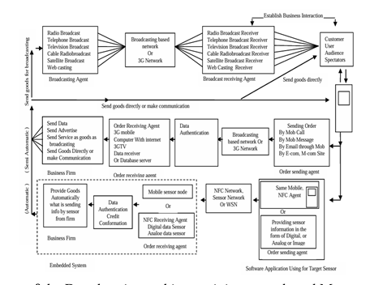
Figure 1: Architecture of the Broadcasting and Its Receiving Agents Based M-commerce Model
VI. AI BASED M-COMMERCE TRANSACTIONS
On the basis of scientific research methodologies primary data have been obtained.
(1) Stakeholder Transactions Credentials:
1. Total Number of Processes Performed: 14 In Numbers.
2. Year: 2025-2026
3. Domains: 1. Business Man 2. Customers 3. Technocrats 4. Education
4. Tools To be Used: Google Chart.
5. Broadcasting Capabilities: 1. Telephone Broadcasting
6. Research Methods: Scientific
7. Collected Data: Primary Data
(2) Transactions Measurements:
1. Using AI based sites for online purchase:
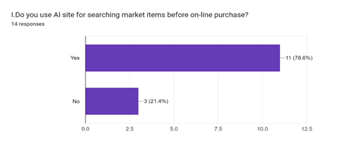
Figure 2: Online Purchase Using AI
2. Using AI based sites for online selling:
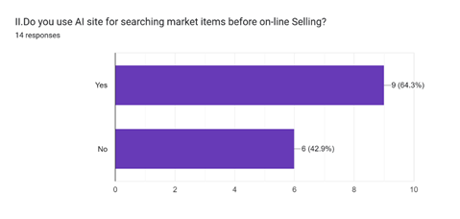
Figure 3: Online Selling Using AI
3. Using AI based sites for Education Purpose:
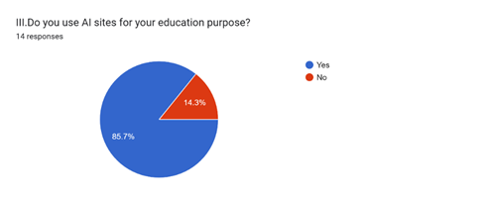
Figure 4: AI Based Site for Education Purpose
4. Using AI for Business Support:
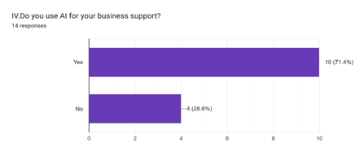
Figure 5: AI For Business Support
5. Do you have your websites:
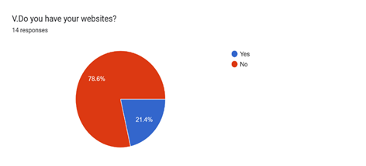
Figure 6: Do You Own Website
6. Have your website an AI Tools:
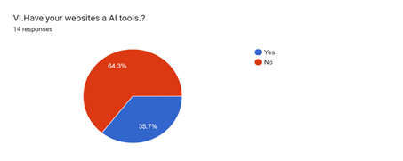
Figure 7: Your Website an AI Tools
7. Businessman using AI for making your documents, banners, hording or any marketing purpose:
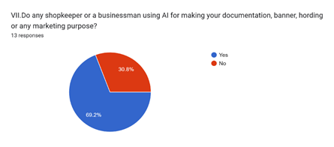
Figure 8: Businessmen Using AI
8. Use of AI in travel booking:
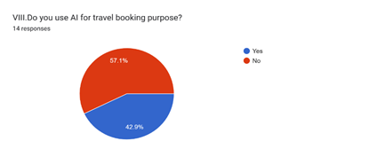
Figure 9: Use AI in Travel Booking
9. Knowing of AI Use:
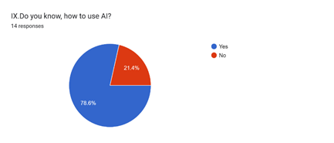
Figure 10: Knowing of AI Use
10. Do the Government or Non-Government Service Employer Using AI
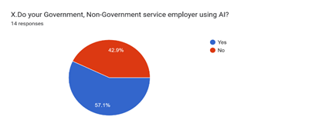
Figure 11: Govt. Non-Govt. Service Employer using AI
11. Do you search on the internet using AI?
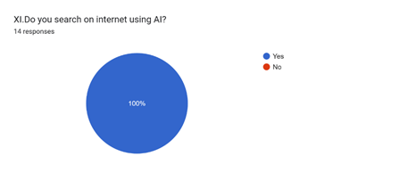
Figure 12: Search on internet using AI
12. Which AI is Favourite? Name it.
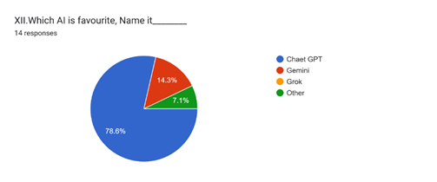
Figure 13: Which AI Is Favourite?
13. Name the profession in which you are using AI
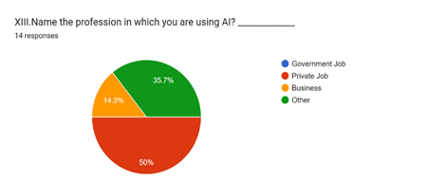
Figure 14: Profession in which AI Using
14. Which Audio Film/Short Video is watching Supported by AI
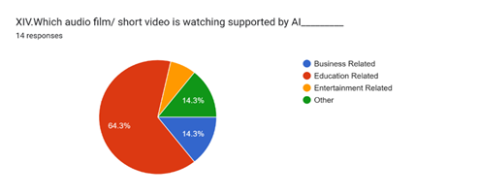
Figure 15: Film Watching Supported by AI
VII. ANALYSIS
Analysis 1: M-Commerce Based Transactions Using Artificial Intelligence (AI):
Transaction Number | Credential: YES | Credential: NO | AI Effect on M-Commerce Domains
Transactions 1 | 11(78.6%) | 3(21.4%) | Purchase
Transactions 2 | 9 (64.3%) | 6(42.9) | Selling
Transactions 3 | 85% | 14.3% | Education
Transactions 4 | 10(71.4%) | 4(28.6%) | Business Support
Transactions 6 | 64.3% | 35.7% | Website using AI
Transactions 7 | 69.2% | 30.8 % | On business object, AI is Using Practically
Transactions 8 | 57.1% | 42.9% | Using AI in Travel Ticket Booking
Transactions 11 | 57.1% | 42.9% | Government/ Non-Government Service Man Using AI
Analysis 2: Artificial Intelligence (AI) is Using for establishing M-Commerce Transections:
Transaction Number | ChatGPT | Gemini | Others
Transactions 12 | 78.6% | 14.3% | 7.1% Others
Analysis 3: Name of the Profession is using Artificial Intelligence (AI) for establishing M-
Commerce Transections:
Transaction Number | Private Jobs | Business Man | Others
Transactions 13 | 50% | 14.3% | 35.7 % Others
Analysis 4: Audio Film / Short Video is watching using Artificial Intelligence (AI) for establishing
of M-Commerce Transections:
Transaction Number | Business Related | Education Related | Entertainment Related | Others
Transactions 14 | 14.3 % | 64.3% | 14.3 % Others | 7.1%
VIII. RESULTS AND OUT COMES
On the basis of architecture of the present model, transection credential and analysis the use of Artificial Intelligence (AI) on M-Commerce background observed. For establishing M-Commerce transactions, Artificial Intelligence (AI) is playing an important role. Initially data is to be taken on the basis of questionnaire using google form.
RESULTS:
Result From Analysis 1:
• 14 Stakeholders have noted it as an active aspect for research consideration.
• 8 Transections have stated that Artificial Intelligence (AI) is an active agent for establishing m-commerce. It signifies the characteristics of m-commerce.
• Translation No.1, 2, 3, 4, 6, 7, 8, 10, 11 and Chart have displayed the occurrences.
• 100% use of Artificial Intelligence (AI) for searching anything from notable search engines. Transection No: 11 and Chart display the occurrences.
Result From Analysis 2:
• Transection No 12 is stating the Users of Artificial Intelligence (AI) for establishing M-Commerce:
78.6 % of ChatGPT, 14.3% of Gemini, 7.1% Other.
Result From Analysis 3:
• Translation No.13 is stating the users of Artificial Intelligence (AI) in M-Commerce from different professions are from Private Job: 50%, Business Man 14.3%, Other 35.7%.
Result From Analysis 4:
• Transaction No.14 is stating the audio film / short video is watched using Artificial Intelligence (AI) for M-Commerce transactions: Business Related 14.3%, Education Related 64.3%, Entertainment Related 14.3%, 7.1 others.
OUT COMES:
Result from Analysis 1,2,3 and 4 is suggesting that transections-oriented M-Commerce characteristics is Artificial
Intelligence (AI).

IX. CONCLUSIONS
The work has the base model of Broadcasting and Its Receiving Agent Based Model. The model has suggested a number of broadcasting and its receiving agent-based m-commerce based transactions. The model had suggested certain characteristics of m-commerce. Present study has also suggested Artificial Intelligence (AI) as characteristics of M-Commerce. The suggestion has been indicated on the basis of primary data and the transactions. The study has focused on transaction measurements obtained from the stakeholders. Analysis, Results and Outcomes have been instructed. Thus, the study suggested Artificial Intelligence (AI) as characteristics of M-Commerce.
X. REFERENCES
[1] Broadcasting and Its Receiving Agent based M-Commerce Business Model by Trivedi J H, Pandya J.G,
Trivedi P.H, And Jani A.N. is base model for the present work.H.N.G.University. Patan. India
[2] Broadcasting and Its Receiving Agent Based M-Commerce Model: Recognize M-commerce's Characteristics,
Trivedi Jaydipkumar H ||, Patel Paresh N ||, Patel Hemant N ||, Soni Jigar D. IOSR Journal of Engineering
(IOSRJEN)ISSN (e): 2250-3021, ISSN (p): 2278-8719 Vol. 04, Issue 01(January.2014), ||V1|| PP 01-11
[3] Jason J Zhang, Yufei Yuan, Norman Archar, Driving Force for M-commerce Success
[4] M-Commerce Driving Factors and Transaction Variables: Aspects that Construct the M-Commerce Model.
Trivedi Jaydipkumar H, Dr. J.G. Pandya, Patel Jagdish M, Mithapara Anita. IOSRJEN, Vol.1, Issue 2.PP.135-141.
[5] Norman Sadeh,M-Commerce Technologies, Services and Business Models.
[6] Ali Khatibi, Abasanul Haque Hishamuddin Ismail and Shameeem Al Mahmud, Factors Driving Electronic
Commerce Initiative in Malaysian’ Organization.
[7] Amdocs Inc,Cable& Wireless, Deutsche Telekom,IBM Corporation,Fujitsu,SAP,Sun Microsystems, The Silicon
Valley World Internet Center (US) and its program supporters.

