Time-Based Motor Rpm Control Path Following UAV
Gedlu Solomon

Research (M.Sc.), Ethiopia Space Science and geospatial Institution, Addis Ababa, Ethiopia.
Email: gedlusolomon076504@gmail.com

Executive summary
This Paper Shows Detail Analysis on Quadcopter Unmanned Arial Vehicle (UAV) That Used To Follow Predefined Boundary By Adjusting Motor Revolution Per Minute (RPM) To 4000/6000 RPM. The Four Motor Orientation As Show In The Below Figure(3) Motor 2 & 3 Country Clockwise Rotation And Motor 1 & 4 Clockwise Rotation. Vertical Force Balances the Vehicle Weight and Horizontal Force Component Variation Will Lead To Move Forward. The Paper Calculates Electrical Component Mass (1.586 Kg) And with Remaining Vehicle Part Payload And Body Frame Mass Assumed 1.586 Kg +0.914 Kg = 2.5 Kg. If The Angle Is Not Match in One Second, The Changed Time Of RPM Duration May Change, After That All Motor Rotate As Planned. Appropriated electronic component selection with flying time capacity of 300 second are calculated. The analysis assumed, no aerodynamic drag and constant gravitational force.
Introduction:
The Current Lineup Of Security Drones Reflects The Variety Of Use Cases Out There, From Fixed-Wing Models That Can Cover Large Areas Quickly To Nimble Quadcopters That Scan Confined Perimeters And Elaborate Structures With A Variety Of Sensing And Monitoring Equipment. They Were Selected To Provide A Practical, Best-In-Class List Based On Feedback From Users In Relevant Industries And To Be A Representative Cross-Section Of Specializations In A Fast-Growing Sector. [1]

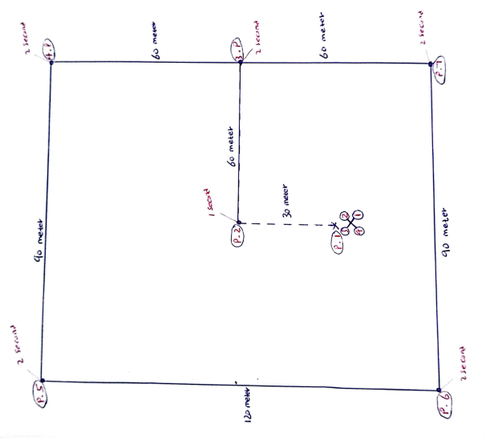
Figure 1: concept of operation

Path Calculation
Boundary Demarcation , Area coverage 1 hectare (10,000 $m^{2})$
Total length cover = 120 meter + 120 meter + 90 meters + 90 meter = 420 meters, Additional length from control station(initial position) to boundary (2*30=60) meter so the total coverage in operation equals to 480 meters.
Estimate The Speed and Flying Time
- Flying time = 10 minutes = 600 second.
- Estimated Speed of vehicle = $\frac{480}{600}=$ 0.8 $\frac{meter}{second}$
Time analysis:
Propeller Selection
- 4 Propellers in Number.
- Total Estimated Vehicle Mass 2.5 Kg and Weight = 2.5 Kg *9.81 m/ Sec = 24.525 Kg m/Sec.
- Total Trust for Propellers, 25 Kg m/Sec( Newton).
- From Single Propeller 6.25 Kg m/Sec( Newton).

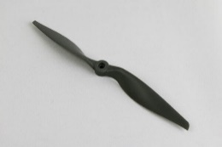
Figure 2: APC Propellers, Product Code: Lp11010e [2]
Table 1: 11x10E, Thin Electric, Use LPAR06E adapter rings, Includes one set of rings from LPAR06E. [2]
Pitch (inches) | 10 in
Propeller Diameter (in.) | 11 in
Hub Diameter | 0.80 in.
Hub Thickness | 0.42 in.
Shaft Diameter | 1/4 in.
Product Weight | 0.81 oz.
Colour | GREY

RPM LIMITS, thin Electric (E) Propellers and Polycarbonate (Durable) FPV Propellers, Maximum RPM = 150,000/prop diameter (inches).
For LP11010E model propeller maximum allowable RPM = 13,636
- Required trust in single propeller = 6.25 newton = 1.41 lbf.
- Estimated Vehicle speed 0.8 m/s = 1.78954903 mph

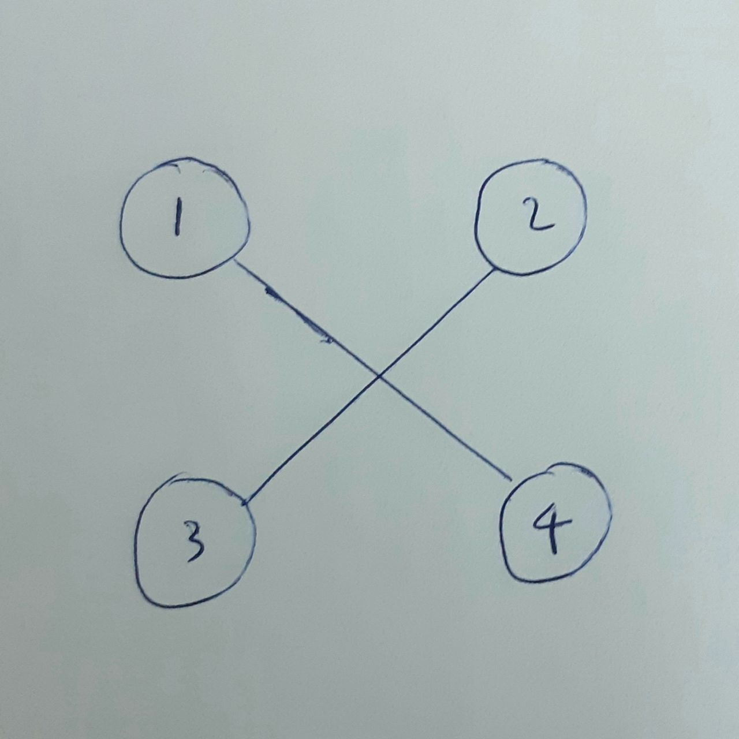
Figure 3: Motor Orientation

climb phase,
[from p1-p2]
for the first 2 seconds all four motors will rotate 4000 rpm
- the vehicle did not generate enough trust to lift.
after 2 second, all four motors will rotate 6000 rpm

Table 2: CLIMB PHASE AT PROP RPM = 6000
V(mph) | J(adv ratio) | Pe | Ct | Cp | PWR(Hp) | Torque (In-lbf) | Thrust (lbf)
0.0 | 0.00 | 0.0000 | 0.1112 | 0.0565 | 0.158 | 1.661 | 1.867
2.5 | 0.04 | 0.0759 | 0.1113 | 0.0581 | 0.163 | 1.709 | 1.868

force variation = thrust – weight = 1.868 – 1.41 = 0.458 ibf = 2.0373 newton
$$v=\frac{F*t}{m}=\frac{8.1492 newton*1 sec}{2.5 kg}=3.26\frac{m}{sec}$$
from control station to fly altitude, height = 30 meter, so the required time(t) = 9.2 sec
total time duration 2 sec + 9.2 sec = 11.2 sec
cruise phase,
[from 2 – 3], at 11.2 sec
motor 1 & 2 rotate 4000 rpm, 1.301 ibf (5.7871363214 newton) each. (one second)
motor 3 & 4 rotate 6000 rpm, 1.868 ibf (8.1492 newton) each. (one second)
resultant force = 2*8.1492 + 2*5.7871363214 = 27.87267264 newton
horizontal force = $\sqrt{{(resulatant force)}^{2}- {(vertical force)}^{2}}$
n:b vertical force = vehicle weight
horizontal force = 13.28195675 newton
$$F_{X}=F*cos(θ)$$
$$θ={61.5 }^{0}$$
resultant force = 4*8.1492 = 32.5968 newton
horizontal force = $\sqrt{{(resulatant force)}^{2}- {(vertical force)}^{2}}$
horizontal force = 21.47267438 newton
total time duration 11.2 sec + sec = 12.2 sec
$$v=\frac{F*t}{m}=\frac{21.47267438 newton*1 sec}{2.5 kg}=8.589069752\frac{m}{sec}$$
the distance from control station to ssgi boundary 60 meters, and the fly time duration = 7 second
at 12.2 + 7 = 19.2 sec
[from p3-4], at second 19.2
motor 1 & 2 rotate 6000 rpm
motor 3 & 4 rotate 4000 rpm
at second 20.2
motor 2 & 4 rotate 6000 rpm
motor 1 & 3 rotate 4000 rpm
at second 21.2
the distance from half boundary to one boundary corner 60 meter, and the fly time duration = 7 second
[from 4-5], at 21.2 + 7 = 28.2 second
motor 1 & 3 rotate 6000 rpm
motor 2 & 4 rotate 4000 rpm
at second 29.2 second
motor 1 & 2 rotate 6000 rpm
motor 3 & 4 rotate 4000 rpm
at second 30.2 second
the distance from half boundary to one boundary corner 90 meter, and the fly time duration = 10.5 second
[from 5-6], at 30.2 + 10.5 = 40.7 second
motor 3 & 4 rotate 6000 rpm
motor 2 & 1 rotate 4000 rpm
at 41.7 second
motor 1 & 3 rotate 6000 rpm
motor 4 & 2 rotate 4000 rpm
at 42.7 second
the distance from half boundary to one boundary corner 120 meter, and the fly time duration = 14 second
[from 6-7], at 42.7 + 14 = 56.7 second
motor 4 & 2 rotate 6000 rpm
motor 3 & 1 rotate 4000 rpm
at 57.7 second
motor 3 & 4 rotate 6000 rpm
motor 2 & 1 rotate 4000 rpm
at 58.7 second
the distance from half boundary to one boundary corner 90 meter, and the fly time duration = 10.5 second
[from 7-3], at 58.7 + 10.5 = 69.2 second
motor 2 & 1 rotate 6000 rpm
motor 4 & 3 rotate 4000 rpm
at 70.2 second
motor 2 & 4 rotate 6000 rpm
motor 1 & 3 rotate 4000 rpm
at 71.2 second
the distance from half boundary to one boundary corner 60 meter, and the fly time duration = 7 second
[from 3-2], at 71.2 + 7 = 78.2 second
motor 4 & 2 rotate 6000 rpm
motor 3 & 1 rotate 4000 rpm
at 79.2 second
motor 3 & 1 rotate 6000 rpm
motor 4 & 2 rotate 4000 rpm
at 80.2 second
the distance from half boundary to one boundary corner 60 meter, and the fly time duration = 7 second
at 80.2 + 7 = 87.2 second
motor 3 & 4 rotate 6000 rpm
motor 2 & 1 rotate 4000 rpm
descent phase
[from 2-1], at 87.2 second

Table 3: DESCENT PHASE AT PROP RPM = 4000
V(mph) | J(adv ratio | Pe | Ct | Cp | PWR(Hp) | Torque (In-lbf) | Thrust (lbf)
0.0 | 0.00 | 0.0000 | 0.1116 | 0.0611 | 0.051 | 0.798 | 0.833
1.7 | 0.04 | 0.0711 | 0.1118 | 0.0625 | 0.052 | 0.816 | 0.834

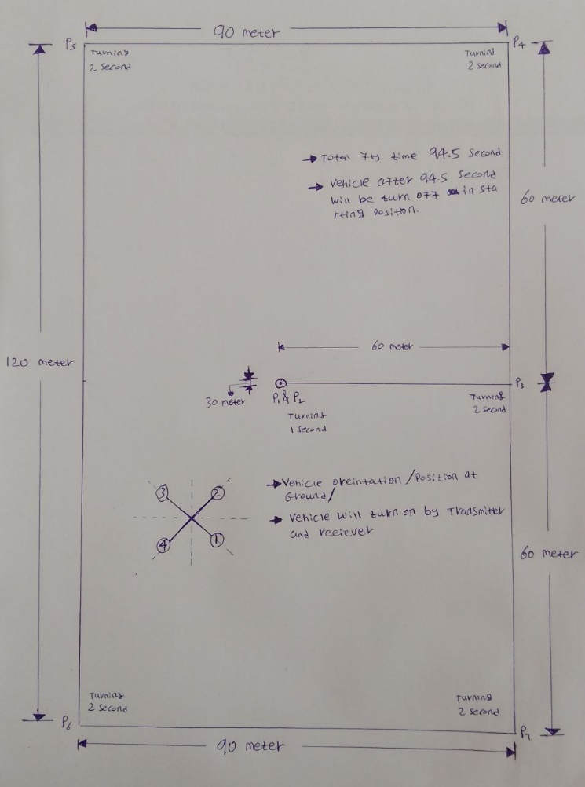
Force variation = weight - thrust = 1.41 – 0.834 = 0.576 Ibf = 2.5622 newton
$$v=\frac{F*t}{m}=\frac{10.25 newton*1 sec}{2.5 kg}= 4.1 \frac{m}{sec}$$
From fly altitude to control station, height = 30 meter, so the required time(t) = 7.3 sec
At 87.2 + 7.3 = 94.5 second
Figure 4: Matured concept of operation
Vehicle Hardwire Selection:

Motor Selection
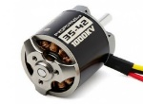
PROPDRIVE V2 3542 1000KV BRUSHLESS OUTRUNNER MOTOR
SPECS:
Model: PROPDRIVE v2 3542 1000KV
KV: 1000 KV
Max current: 47A
ESC: 50~60A
Cell count: 3s~4s Lipoly
Pole Count: 14
Bolt holes: 25mm
Bolt thread: M3
Shaft: 5mm
Connectors: 3.5mm Bullet
Weight: 155g
Electrical Speed Control [ESC]
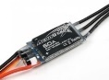
THE AEROSTAR RANGE OF BRUSHLESS SPEED CONTROLLERS
SPECS:
Type: Aerostar 60amp electronic speed controller
Input Voltage: 2~6 lipoly cells/5~18 NiMH cells (6~23V)
Continuous Current: 60amps
Burst Current: 70amps (10secs)
BEC Output: 5.5V/5amps
Programmable: Yes
Dimensions: 56 x 30 x 14mm
Weight: 44g
Battery Connector: XT60
Motor Connectors: 3.5mm gold
Rx Connector: JR type
Lead Length: 270mm
Power Distribution Board [PDB]
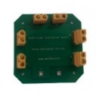
250A POWER DISTRIBUTION BOARD FOR DRONES
SPECS:
250A ESC Power Distribution Board with XT60 Male Connector
3.5mm Banana Bullet Connectors mainly used For Multicopper FPV.
equips Soldered XT60 connector onto the two central terminals
Materials : Aluminum Alloy , Plastic
Battery:
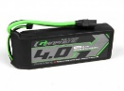
TURNIGY GRAPHENE PANTHER 4000MAH 3S 75C BATTERY PACK W/XT90
SPECS:
Capacity: 4000mAh
Cell Count: 3
Voltage: 11.1V
Constant Discharge: 75C
Peak Discharge (3s): 150C
Battery Size: 145x51x28mm
Weight: 412g
Pack Resistance: 10mΩ
Charge Plug: JST-XH
Discharge Plug: XT90
Flight Controller Board
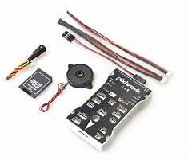
PIXHAWK 2.4.8 DRONE FLIGHT CONTROLLER
SPECS:
32bit STM32F427 Cortex M4 core with FPU.
32-bit STM32F103 failsafe co-processor.
168 MHz.,128 KB RAM.,2 MB Flash.
ST Micro L3GD20H 16-bit gyroscope.
ST Micro X4HBA 303H 14-bit accelerometer/magnetometer.
Invensense MPU 6000 3-axis accelerometer/gyroscope.
MEAS MS5607 barometer.
5x UART (serial ports), one high-power capable, 2x with HW flow control.
2x CAN (one with an internal 3.3V transceiver, one on expansion connector).
Spektrum DSM / DSM2 / DSM-X® Satellite compatible input.
Futaba S.BUS® compatible input and output.
PPM sum signal input.
RSSI (PWM or voltage) input.
Vehicle Communication Link
Receiver
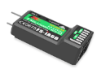
FS-IA6B 2.4GHZ AFHDS 2A 6CH RECEIVER
SPECS:
Product Model: FS-iA6B
PWM channel: 6
Wireless frequency: 2.4GHz
Wireless protocol: AFHDS 2A
Range: 500 ～ 1500m (in the air)
Antenna type: Dual copper tube antenna (150mm * 2)
Power: 4.0-8.4V
RSSI: Supported
Data port: PWM / PPM / i.bus / s.bus
Temperature range: -10 ℃ — + 60 ℃
Humidity range: 20% -95%
Online Update: Yes
Dimensions: 47 * 26.2 * 15 mm
Weight: 10g
Certification: CE, RCM, FCC ID: N4ZFLYSKYIA10
Transmitter
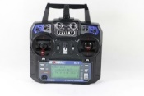
FLY SKY FS-I6X TRANSMITTER
SPECS:
Channels: 6
Model type: Quadcopter
RF range: 2.408 - 2.475GHz
Bandwidth: 500 KHz
Bands:135
RF power: Less than 20 dBm
Protocol: AFHDS 2A
Modulation type: GFSK
Stick resolution:4096
Low voltage alarm: Yes (lower than 4.2V)
PS2/USB Port: Yes (Micro-USB)
Power input:6V DC 1.4AA*4
Weight:392g
Size:174*89*190 mm
Color: Black
Certificate: CE,FCC: N4ZFLYSKYI6
GPS Modules
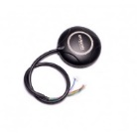
NEO-M8N GPS MODULE
Specs:
Neo-M8N GPS module that includes a HMC5883L digital compass.
A high level of sensitivity and features active circuitry for the ceramic patch antenna.
This modules outputs precise position updates at 10Hz and also has a rechargeable backup battery for warm starts.
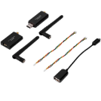
Telemetry
3DR 100mW Radio Telemetry 433Mhz / 915Mhz Air and Ground Data
Transmit Module for APM 2.6 2.8 Pixhawk Flight Control
Specs:
433Mhz frequency band. / 915Mhz frequency band
Range of approx 1 mile with supplied aerial.
MAVLink protocol framing and status reporting.
Frequency hopping spread spectrum (FHSS).
Adaptive time division multiplexing (TDM).
AT commands for radio configuration.
RT commands for remote radio configuration.
Adaptive flow control when used with APM.
Item Name: 3DR Radio Telemetry Module
Band: 433MHz 915MHz
Receiver sensitivity: -117 dBm
Air data rates: up to 250kbps
Transmit power: up to 20dBm (100mW)
Antenna connectors: RP-SMA connector
Output Power: 100mW (20dBm), adjustable between 1-20dBm
Interface: Standard TTL UART
Connection status: LED indicators

Table 4: Total Electrical Components Weight and Size
No | Component | Weight (kg)
1 | Propeller | 4*0.03 = 0.12 kg
2 | motor | 4*0.155 = 0.62 kg
3 | ESC | 4*0.044 = 0.176 Kg
4 | PDB | 1*0.008 = 0.008 Kg
5 | Battery | 1*0.412 = 0.412 kg
6 | FCB | 1*0.03= 0.03 Kg
7 | Receiver | 1*0.01= 0.01 KG
8 | GPS Modules | 1*0.02 Kg = 0.02 KG
9 | Telemetry | 1*0.01 kg = 0.01 KG
Total mass = 1.586 kg
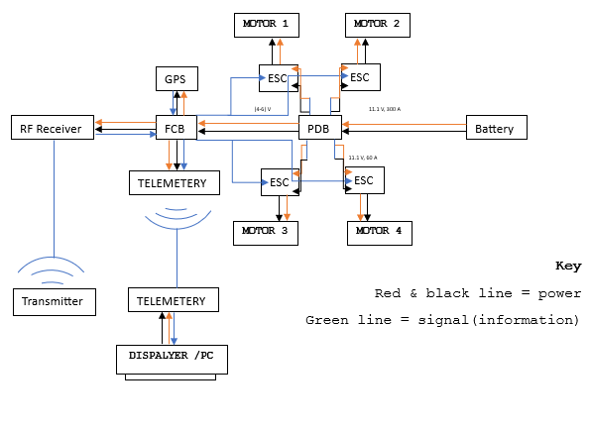
Figure 5: Electronic Component Assembly
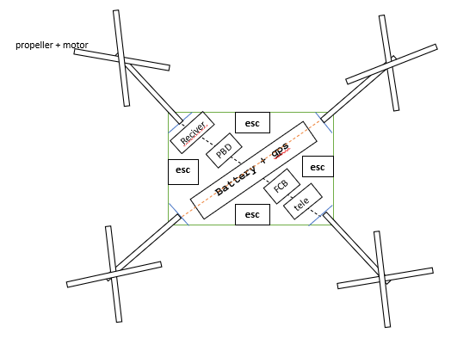
FIGURE 6: Electronic Component Location In Casing Top View
N:B GPS Modules fix in outer casing immediate above receiver and PDB board.

To calculate the flight time of a drone battery, you can use the following formula:
Time = $\frac{Capacity * discharge}{AAD}$
where:
- Time Is the Flight Time of The Drone, Expressed in Hours.
- Capacity Is the Capacity Of Your Battery, Expressed In Milliamp Hours (mAh) Or Amp Hours (Ah).
- Discharge Is the Battery Discharge That You Allow During the Flight. As LIPO Batteries Can Be Damaged If Fully Discharged, It’s Common Practice Never To Discharge Them By More Than 80%.
- AAD Is the Average Amp Draw of Your Drone, Calculated In Amperes.
AAD = AUW * ​$\frac{P}{V}$
where:
- AAD Is the Average Amp Draw, Expressed In Amperes.
- AUW Is the All-Up Weight Of Your Drone – The Total Weight Of The Equipment That Goes Up In The Air, Including The Battery. It Is Usually Measured In Kilograms.
- P Is the Power Required To Lift One Kilogram Of Equipment, Expressed In Watts Per Kilogram. Our Drone Flight Time Calculator Assumes A Conservative Estimate Of 170 W/Kg. Some More Efficient Systems Can Take Less, For Example, 120 W/Kg; If That’s Your Case, Don’t Hesitate To Adjust Its Value.
- V Is the Battery Voltage Expressed In Volts. You Will Find This Value Printed On Your Battery.
AAD = $2.5 Kg*\frac{170 \frac{Watt}{kg}}{11.1 Volt}$ = 38.3 Ampere
Flight time = $\frac{4 Ah *0.8}{38.3 A}$ = 0.0835 hr. = 5 min = 300 Sec

Summary:

Vehicle Initializing Phase, first 2 Second and In Stated Velocity (Climb, Cruise and Descent Phases) Need to Complete Defined Path Within 94.5 Second but The Battery Capacity with Stated Rate and Load Run For 300 Second.

Reference:
- https://es.hi-network.com/the-5-best-surveillance-drones-next-level-inspection-uavs.html
- https://www.apcprop.com/product/11x10e/

