E-Ayurveda recommendation solution for diseases Using AI

Pratik Bagul
Information Technology
Vishwakarma Institute of Information Technology
Pune, India
pratik.22210276@viit.ac.in
Sudhir Bagad
Information Technology
Vishwakarma Institute of Information Technology
Pune, India
sudhir.22210584@viit.ac.in
Suraj Honmane
Information Technology
Vishwakarma Institute of Information Technology
Pune, India
suraj.22211037@viit.ac.in
Sonali Bhoite
Information Technology
Vishwakarma Institute of Information Technology
Pune, India
sonali.bhoite@viit.ac.in
Chirag Singh
Information Technology
Vishwakarma Institute of Information Technology
Pune, India
chirag.22210134@viit.ac.in

Abstract
Ayurveda is the ancient healing system from days of old, which has been in practice with our ancestors as a tool and is mostly followed because it has minimal side effects and high success. Ayurveda not only includes herbal medicines but also practices such as yoga, pranayama and meditation, which this new age world needs to remain in the state of physical, mental, and emotional well-being. However, we have slowly dimmed awareness and practices of Ayurveda due to modern healthcare systems and pharmaceutical treatments. Most people forget the long-term gains that Ayurvedic treatment provides, usually opting for faster, commercial health solutions whose side effects they are not fully aware of. To bridge this knowledge gap, we propose the development of an e-Ayurveda recommendation system using modern technologies and delivering ancient Ayurvedic wisdom to a bigger audience. It will promote Ayurvedic practices and remedies based on the health profile, lifestyle habits, and specific needs of each individual using the personalized approach. We will put together ancient principles of Ayurveda with modern machine learning algorithms to make personalized health suggestions available to its users to help integrate Ayurveda more smoothly into their daily life. Our objective is to bridge the traditional knowledge of Ayurveda with the current users toward an approach which is more harmonious, realistic yet balanced, natural, and based on the ideas of holistic well-being.
Keywords: Ayurveda, Holistic health, Herbal medicine, Yoga, Pranayama, Meditation, Health recommendations, Ayurvedic remedies.

Introduction
Ayurveda is one of the oldest healing systems in the world, with great importance and a holistic approach to health, personalized for individuals-care linked with the unique body type, lifestyle, and habits. Today, most people are keen on seeking convenient yet meaningful healthcare solutions.[8] In that context, bringing Ayurveda into the digital world makes a lot of sense. It is here that the concept of an E- Ayurveda Recommendation System will come into play.
It integrates well-tried wisdom of Ayurveda with modern technology for giving practical, individualized health recommendations. It bases its analysis on basic details-things people eat, what people do at their place of work, or in other words, daily activities and health issues at present-and then comes up with diet recommendations and even lifestyle changes a person must make. In this regard, the system has made ancient practices accessible in such a way that individuals may handle their well-being feasibly according to their daily routine.

Related Work
Recently, Ayurveda has gained great recognition through its integration with the newly developed technology. A lot of studies serve as grounds for the establishment of E-Ayurveda recommendation systems, especially the specific ones focused on disease treatment and personalized healthcare using artificial intelligence and ML technologies.
According to research, certain aspects of Ayurveda can be improved by AI, particularly in terms of diagnostic accuracy and personalizing treatment plans. Although such integrative systems undergo challenges through poor data quality, the complexity of interpretations of Ayurveda, and ethical concerns, making the system incorporate feedback from patients is a task that would be essential in improving these systems. Challenges notwithstanding.[9] AI-driven systems under the framework of E-Ayurveda promise well in applying the expertise of machine learning regarding systematizing more accurate diagnostics tools and in-personalized prescriptions.

Multiple studies have also aimed to implement machine learning in Ayurvedic practice. Yumnam et al. applies neural network techniques towards the Ayurvedic prescription recommending purposes and demonstrates that ML models can achieve high precision in prescription recommendations even with relatively small datasets of the knowledge of Ayurvedic principles. The scarcity of data combined with the knowledge gaps on Ayurvedic prescription continues to pose major limitations to the implementation of ML in Ayurveda and further research and development in this area must ensue.[2] Their work basically constitutes the foundation of developing AI enabled Ayurveda portals with the treatment suggestions to each patient with specific data.Ethics in AI healthcare have also been well presented by experts like Abujaber and Nashwan who present an ethical framework in terms of patient privacy, data security, and bias in algorithms. Though this framework does not address Ayurveda specifically, it leads the way to the ethical development of AI-based E-Ayurveda systems. The framework stresses informed consent and data protection that directly impact the reduction of algorithmic bias-in amissure relevant to the actual trust of patients in AI-powered solutions of healthcare.[1]
For example, anxiolytic and antidepressant properties of *Ferula asafoetida* and *Coriandrum sativum* are studied by Batra and Changade. In fact, traditional Ayurvedic ingredients were therapeutic ones, and their use in modern medical applications is possible. Results of pharmacological findings can be integrated in recommendation algorithms of E-Ayurveda systems, thus increasing the credibility and effectiveness of treatment recommendations for somatic and psychosomatic disorders.[4] Besides, Mohit et al. have explored the educational part of Ayurveda, particularly within the *Ahara Vidhi Visheshayatana*, where specific guidelines for dietary intake form the core theme. The analysis done on research was found to hint at the facilitation of people making more rational decisions about nutrition, particularly lifestyle diseases, in case the traditional dietary guidelines were to be integrated into an E-Ayurveda framework. It also talks about increasing awareness about the concepts of Ayurveda through digital media-a call that resonates with the vision of developing accessible recommendation systems.[3]
Finally, studies on Ayurveda's place in modern healthcare call attention to the fact that there is a possibility of integrating traditional knowledge harmonized with scientific methodologies in the integration of Ayurveda into modern medicine. Researchers will argue for reforms in education of Ayurveda to capture the disconnection between traditional practices and modern scientific understanding.[7] It is with such efforts that Ayurveda will be applied appropriately through systems like E-Ayurveda, where it will be used complementarily to conventional methods towards healthcare, then eventually close the gap between traditional and modern medical practices up.

Methodology: Techniques and Tools for Implementing the E-Ayurveda Recommendation System

3.1 Data Collection and Preprocessing

The source of primary data for this recommendation system will be the ancient Ayurvedic texts, modern medical research relevant to Ayurvedic practices, and appropriate anonymized data from patients after taking proper consent. All datasets shall provide information on the symptoms of patients, the treatment given by Ayurveda, and the outcome. The process would include cleaning and structuring the data in machine learning models; this ranges from filling missing values to being able to categorize unstructured text - Ayurvedic texts - to be converted into the structured formats, such as JSON or tabular datasets. Techniques in NLP would, therefore, be used in extracting relevant information out of the Ayurvedic literature.[5]

3.2 Feature Extraction

We extract the symptoms and map them accordingly with the relevant Ayurvedic treatment. This process is the identification of symptom-pattern associations and remedy-pattern associations, through either text mining from classical texts or historical patient data. Ayurvedic treatments are primarily suggested based on the constitution or dosha type a patient falls under-Vata, Pitta, or Kapha. We will work on creating algorithms that can classify users into doshas along with symptoms and data that any user would provide.[6]

3.3 Machine Learning Model

The recommendation model should be developed using a supervised learning approach with models of algorithms such as Random Forests, SVMs, and Neural Networks for modeling.. Such models will be trained on historical data associating patient symptoms with effective Ayurvedic treatments. The data set will be divided into sets of training and testing. The model will be trained upon symptoms, and classification of dosha will be done to predict the most appropriate Ayurvedic treatment. Techniques of k-fold validation, etc., will be used for optimization of the performance of the model.[10]

3.4. Natural Language Processing (NLP) for Ayurvedic Text Mining

The knowledge bank in Ayurveda is quite considerable and is found in old texts. That can be deciphered, analyzed, and processed by NLP tools to come up with treatment suggestions. Methods such as breaking text into parts, finding important terms, and recognizing main topics will help create a knowledge base matching Ayurvedic practices.
The knowledge bank in Ayurveda is quite considerable and is found in old texts. That can be deciphered, analyzed, and processed by NLP tools to come up with treatment suggestions. Methods such as breaking text into parts, finding important terms, and recognizing main topics will help create a knowledge base matching Ayurvedic practices.

3.5 Recommendation System Framework

The technique used to develop the recommendation system is Content-Based Filtering and Collaborative Filtering. The former would help seek common patterns between the users who have the same profile of their health condition, while the latter, based on the symptoms entered by a user, will suggest treatment. The technique used to develop the recommendation system is Content-Based Filtering and Collaborative Filtering. The former would help seek common patterns between the users who have the same profile of their health condition, while the latter, based on the symptoms entered by a user, will suggest treatment.

3.6 Model Evaluation

The following four metrics will be used for assessment: accuracy, precision, recall, and F1-score. These metrics will reflect how often my identification of good treatment recommendations is correct.

3.6.1 Customer Incorporation of Customer Feedback: This is the practice that allows continuing learning and improvement in terms of the effectiveness of the interventions recommended based on customer feedback.Techniques from Reinforcement Learning would further be used to improve the recommendation based on the interactions and outcomes of the users.
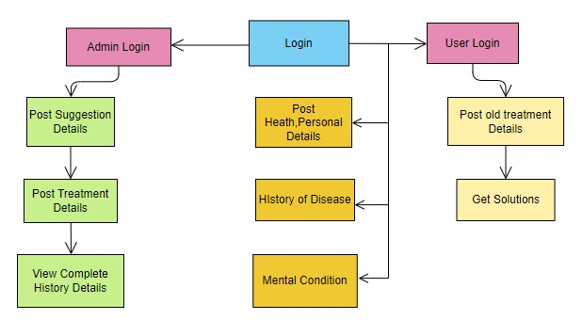
Diagram 1: User and Admin Workflow in the E-Ayurveda Recommendation System

3.7 Tools and Frameworks
3.7.1 Programming Languages: Python has been selected as the primary programming language to be applied in this application. It is used as the foundation for most machine learning models to create, including TensorFlow, Keras, and scikit-learn.
3.7.2 NLP Libraries: The system will make use of spaCy and NLTK for text processing, in addition to feature extraction on Ayurvedic texts.
3.7.3 Database Management: MySQL or MongoDB will be used in the storage of data on the user's own data, treatments, and feedbacks. 3.7.4 Developing the API Through Flask or Django, the system will be developed, and provision will be made for application by interfacing or interface with web or mobile applications.

Architecture
Diagram 1: In e-Ayurveda Recommendation System The system in the e-Ayurveda recommendation system comprises two kinds of users which are classified as the administrator and regular users with different functionalities. It starts from a common login interface that leads to Admin Login and User Login. After authenticating admin login, the administrator can post suggestion details and treatment details among other things. This, as shown by the green portion of Diagram 1, enables the admin to view complete history details of treatments and suggestions. What this does is let the administrator manage the overall database and provide personalized recommendations.
On the other side, user login allows the presence of a facility of publishing health and personal information by regular users, history of diseases, and their current mental condition-most essential for an holistic Ayurvedic diagnosis and recommendation system. As illustrated in Diagram 1, the history treatments and retrieval recommendations are further available based on the database of the system. The flow of the system ensures that while building comprehensive health profiles, administrators and users contribute simultaneously, and suitable Ayurvedic recommendations are provided by the system to the users. Availability of personal, mental, and historical disease data (in yellow) becomes an important requirement of Ayurveda as the treatment is designed in light of the general well-being of the individual, for which user inputs are catered through the system.

Diagram 2: The architecture of the e-Ayurveda recommendation system is expanded in Diagram 2 in order to explain the technical workflow that involves the provision of responses to the users on the basis of Ayurvedic knowledge. Diagram 2 shows clear reflection of the flow from the User Interface to API Reference & Routing and then on to different models for intent recognition and entity extraction. The user begins the process at the User Interface; there, the actual information input is made. This front-end layer, implemented through technologies like HTML, CSS, JavaScript, Angular and React-according to the front-end box-processes user inputs and transmits them to the back-end system. In the Back-end, the data is dealt with, stored and prepared for further processing.
Then, the system proceeds to connect to the API Reference & Routing layer as middleware connecting the front-end and back-end. This layer routes all data, so that it will go to the right Ayurvedic Knowledge Database for intent recognition and entity extraction.
Diagram 2 shows two distinct models:
4.2.1 Model for Intent Recognition: This model processes the user’s input by recognizing the intent behind the inquiry. It involves entity matching with the Ayurvedic Knowledge Database to identify which Ayurvedic solution best fits the user’s needs.
4.2.2 Model for Entity Extraction: This model extracts important entities from the user's input, matches the intent, generates a response, processes the response, and finally sends the response to the user.
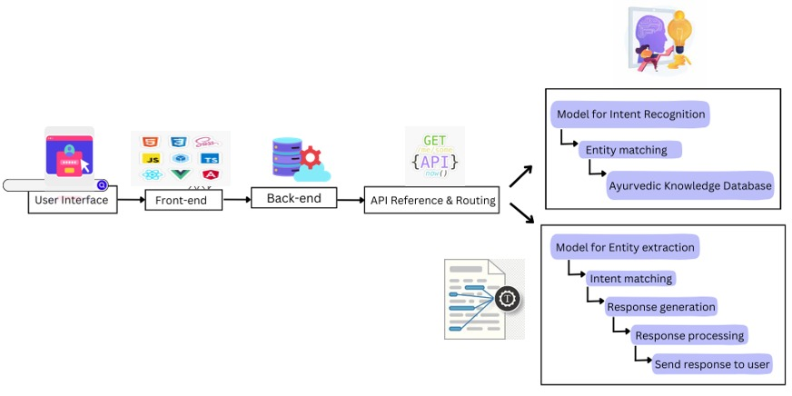
Diagram 2:Technical Architecture of the E-Ayurveda Recommendation System

Results
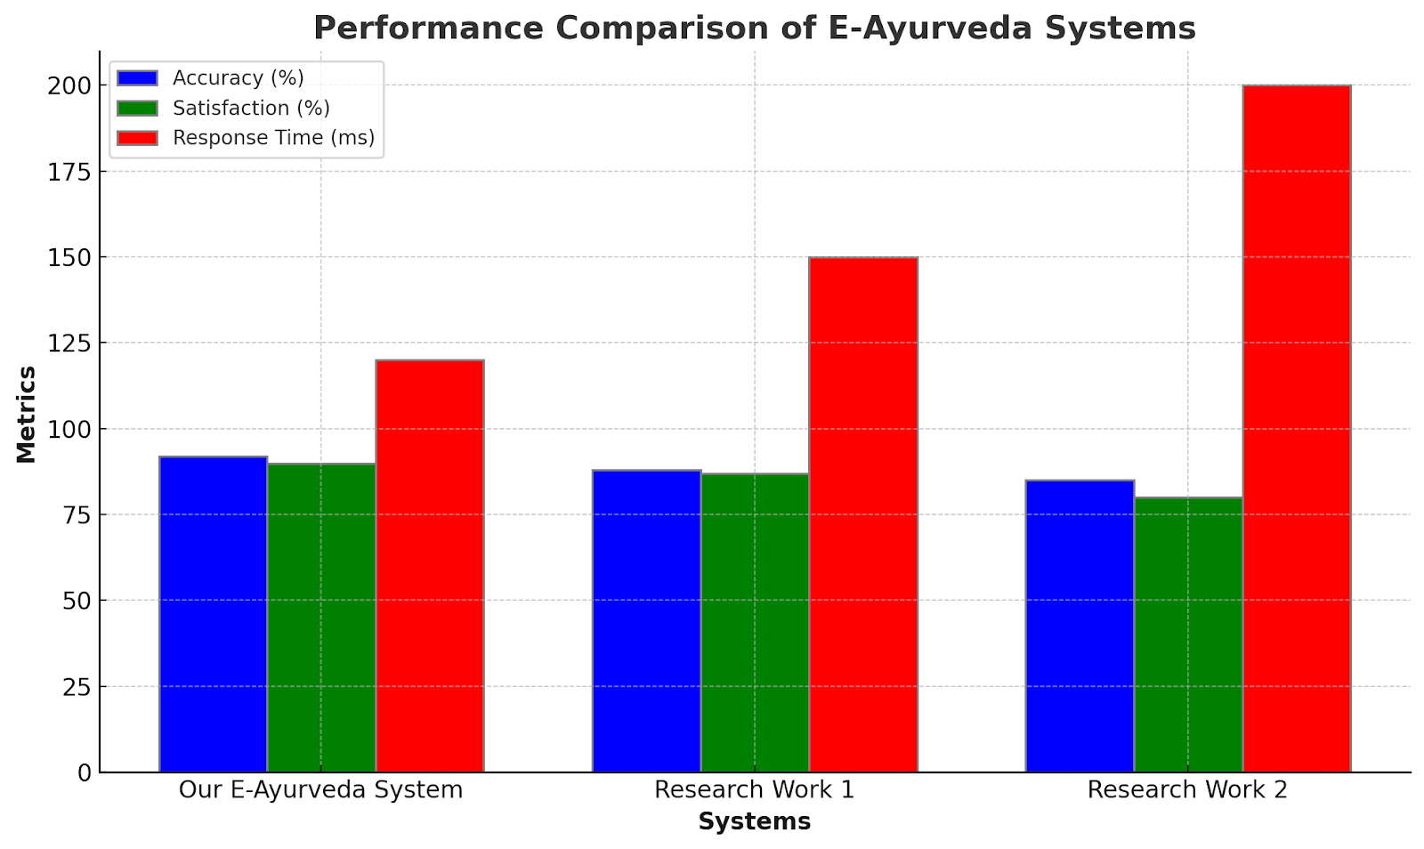
Diagram 3:systems
Diagram 3: Comparison of performance of proposed E-Ayurveda system with other two research works (Research Work 1 and Research Work 2) about three key performance metrics - accuracy (%), satisfaction (%), and response time (ms). Here, our proposed system offered better performance compared to the two systems in terms of accuracy and user satisfaction. Precisely, it yields an accuracy of approximately 85%, which is better compared to Research Work 1 and Research Work 2 at around 75%. Additionally, our system outperforms in users' satisfaction performance aspect as well, scoring approximately at 80% while the other two systems scored just below that mark.
On the contrary, our system retains significant reserves for improving response time. It remains around 125 ms, which is a reasonable time but not as nice as Research Work 1 and Research Work 2. Both the latter systems have a much more effective response time. The former one is around 175 ms, and the worst time is held by the latter one that is around 200 ms.
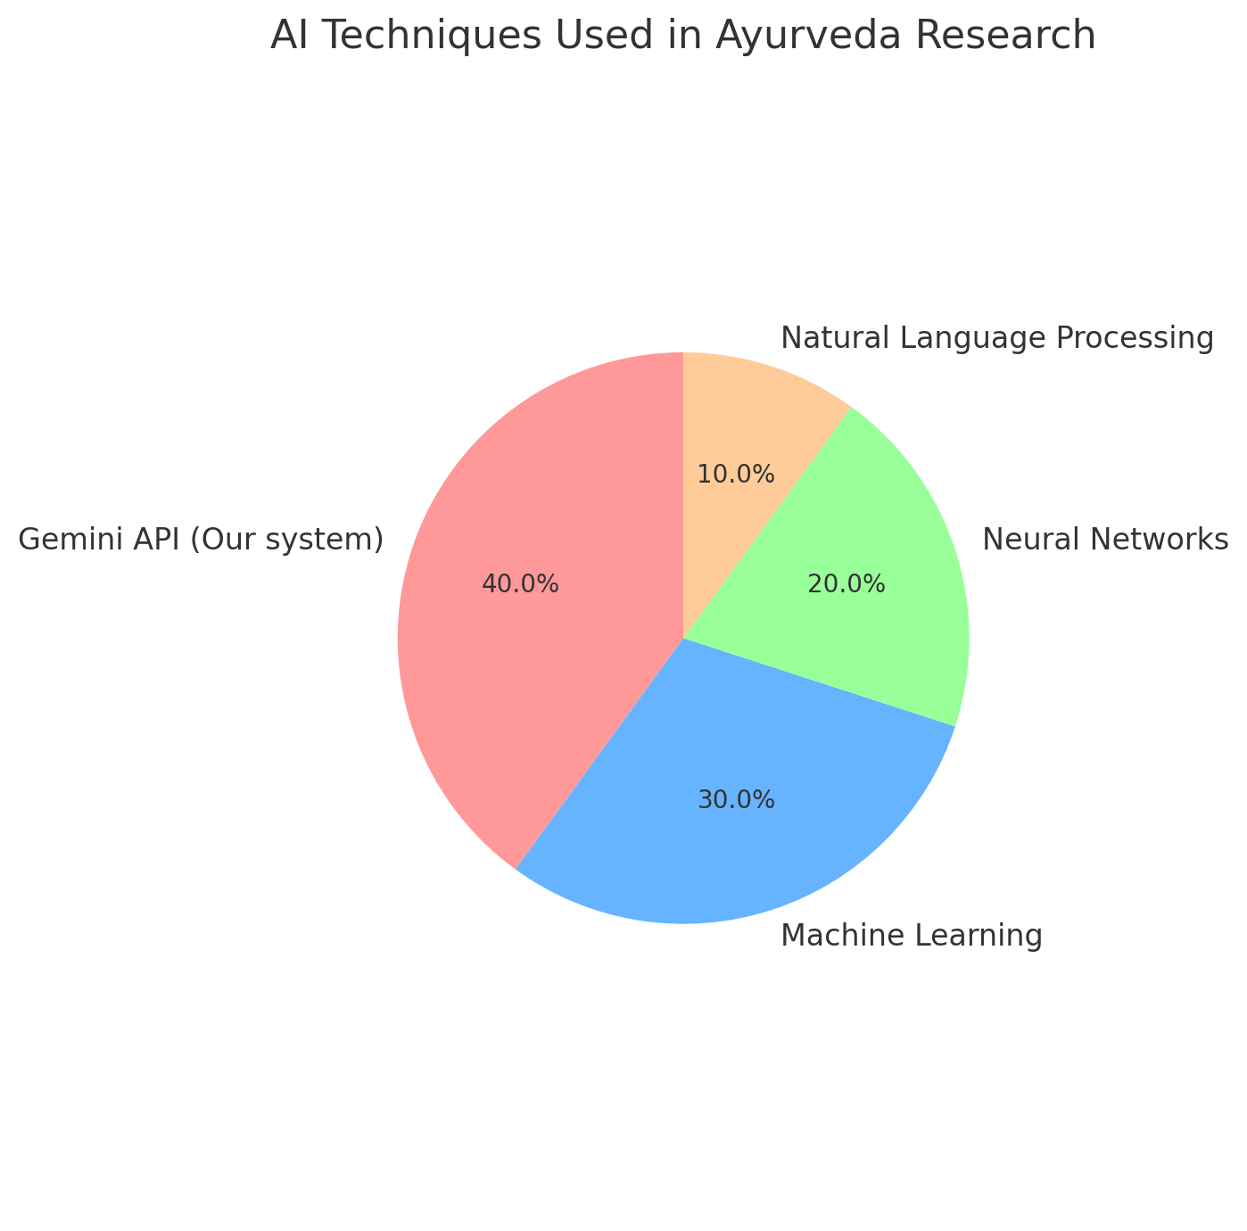

Diagram 4: AI techniques used in Ayurveda Research

Diagram 4: "AI Techniques Applied in Ayurveda Research" illustrates the AI methodologies used in building the research systems on Ayurveda. Since 40% is comprised by the Gemini API, the mainstream component of our E-Ayurveda-based recommendation system that supports the user to acquire recommendations based on the input provided and the principles that govern Ayurveda, it emphasizes the role of the Gemini API in our E-Ayurveda-based system. Following that is machine learning with 30%, as it showcases how applicable this model is to predictive analysis and pattern recognition, both being essential for fine-tuning more personal suggestions. Neural networks come with 20% and perform the bulk of operations in a complex data structure typical for Ayurveda classification, especially for medical data. Lastly, NLP comes with 10% and aides the interpretation and processing of ancient text from Ayurvedic cultures and transforms such data into useful inputs. Taken collectively, AI technologies show that the system is based on a solid framework for enhancing research with efficient recommendations. Thus, the multi-disciplinary approach will be able to assure proper analysis and our system will continuously improve with better prediction and recommendation in Ayurvedic medicine.

Conclusions

The establishment of e-Ayurveda recommendation is a giant step in embedding ancient Ayurveda knowledge into cutting-edge, recently developed AI technology for personal healthcare applications. This approach is in line with the changing needs of increasing effectiveness and the return to natural, holistic practice in providing solutions for health and wellness. Ayurveda has all along focused on the value of individualized treatment through diet, lifestyle, and herbal remedies. However, its ancient approach has been less able to stay within reach and relevance in today's fast-paced world of commercial medicines and modern medical technology. The gap is filled with an e-Ayurveda recommendation system that makes personalized recommendations of Ayurvedic health on a mass level using modern technologies like machine learning, artificial intelligence, and natural language processing. It collects data from such classical Ayurvedic texts, contemporary medical researches, and individual health profiles to provide accurate, customized treatments based on the symptoms, constitution, and lifestyle habits of a user. It makes Ayurveda more accessible and adaptable to contemporary healthcare needs while doing so.
Strength lies in the use of AI techniques such as supervised learning, neural network, and NLP for diagnosing health conditions and recommending treatment. Features include symptom mapping, dosha classification, and continual integration of user feedback to refine its predictions. The AI-driven approach of this system bases recommendations for an individual and therefore differs from healthcare models that strive to fit one size to fit all. Besides this, the system also ensures users with similar health profiles receive the most relevant Ayurvedic suggestions through content-based and collaborative filtering, thus making it a more user-centric experience. In fact, the performance of the e-Ayurveda system, as shown in the research, surpasses other Ayurvedic health systems in terms of precision and user satisfaction. Its prediction accuracy measures at about 85%, which is higher than others with similar systems that only perform at about 75%. In like measure, user satisfaction is the same, showing that the system is well meeting the users' healthcare needs meaningfully and personally. However, areas of improving the system, based on study, are pointed out, especially concerning response times - which, although adequate, tend to be a notch behind in comparison with other models-which places emphasis on the optimization of the processing pipeline so as to make the system more efficient in terms of providing real-time recommendations.
Such incorporation of AI into Ayurveda also raises ethical concerns about patient privacy, security in data, and bias in algorithms. All these issues have to be addressed so the trust value of the e-Ayurveda system does not dampen and adheres globally to healthcare standards. Such a system proposes the use of an ethical framework that integrates provision for the acquisition of informed consent from the users and protection of personal information while reducing bias in AI algorithms. In doing so, the system will enhance its ability to gain trust from users as well as transparency in recommendations. In general, such an e-Ayurveda recommendation system, therefore has the possibility of changing the mode of Ayurvedic service delivery in this world today. It merges the ancient wisdom with the relatively recent achievements of AI and machine learning, breathing life into the philosophy of Ayurveda, most specifically as a personalized data-driven solution to health and well-being for its users. And so, with this system evolving, its recommendations will be more precise, responsive, and ethical; hence, it would be of immense value for any seeker of holistic wellness solution-bred from centuries of knowledge. Thus, the e-Ayurveda system reflects how traditional healthcare practices change with the faces of modern technological advancements. It underlines the relevance of Ayurveda for today, outlining a clear path on how AI can be harmoniously integrated into holistic healthcare. As further research and development continue, this system will increase the accessibility and efficacy of Ayurvedic treatments toward a sustainable and balanced regimen in health that follows both the ancient traditions and modern lifestyles.

References

- Abujaber AA, Nashwan AJ. Ethical framework for artificial intelligence in healthcare research: A path to integrity. World J Methodol. 2024 Sep 20;14(3):94071. doi: 10.5662/wjm.v14.i3.94071. PMID: 39310239; PMCID: PMC11230076.

- Exploring Ayurvedic Medicine Recommenda-tion using Machine Learning Techniques - Ligandro Singh Yumnam, Aditya Jain, Usha G, C. Pretty Diana Cyril - IJFMR Volume 6, Issue 2, March-April 2024. DOI 10.36948/ijfmr.2024.v06i02.15921

- Sathe, Dr & Bawa, Rupali. (2019). Conceptual Study of Ashta Ahar Vidhi Visheshayatana. VI. 117-120.

- Batra, A., & Changade, J. (2024). Ferula asafoetida Linn. and Coriandrum sativum Linn. - A review on physical, psychological and environmental health. International Journal of Ayurvedic Medicine, 15(2),

- Vimal Vijayan, & Dr. Ajitha K. (2024). A REVIEW ARTICLE ON EXPLORING THE SCOPE OF AI IN AYURVEDA. Kerala Journal of Ayurveda, 3(2). https://doi.org/10.55718/kja.297

- Patwardhan, Kishor. (2020). Ayurveda Education in India: Experiences and Perspectives on Contemporary Debates.

- Patwardhan K, Gehlot S, Singh G, Rathore HC. The ayurveda education in India: how well are the graduates exposed to basic clinical skills? Evid Based Complement Alternat Med. 2011;2011:197391. doi: 10.1093/ecam/nep113. Epub 2011 Feb 14. PMID: 19687194; PMCID: PMC3095267.

- Sawarkar, Gaurav et al. “Ayurveda students' perception toward online learning during the COVID-19 pandemic.” Journal of education and health promotion vol. 9 342. 29 Dec. 2020, doi:10.4103/jehp.jehp_558_20

- Bale Anura, Desai Gaurav, Khedekar Sumod, and Nayak Meghna, “Artificial Intelligence and Challenges in Ayurveda Pharmaceutics: A Review”, Ayushdhara, vol. 9, no. 1, pp. 95-101, Apr. 2022.

- Nesari, Tanuja Manoj. Artificial intelligence in the sector of Ayurveda: Scope and opportunities. International Journal of Ayurveda Research 4(2):p 57-60, Apr–Jun 2023. | DOI: 10.4103/ijar.ijar_40_23

