A Multi-Modal Information Fusion Framework for Maritime Anomaly Detection in Heterogeneous Surveillance Systems

Chi-Cheng Tsai¹, Chia-Ling Chen²
Department of Maritime Police, Central Police University, Taoyuan City 333322, Taiwan (R.O.C.)
Corresponding Author: Chia-Ling Chen Email:chiaclloyd@gmail.com

Abstract: Ensuring reliable maritime situational awareness is increasingly challenging due to fragmented surveillance systems and the emergence of sophisticated anomalous vessel behaviours. Conventional approaches relying on single-source data are often affected by environmental interference, communication gaps, and signal manipulation, leading to reduced reliability in safety-critical operations. To address these issues, this study proposes a multi-modal information fusion framework for heterogeneous maritime surveillance environments. The proposed system adopts a multi-layer architecture that integrates satellite sensing for wide-area monitoring, UAV-based platforms for real-time verification, and surface-level sensors such as AIS and maritime IoT devices for continuous tracking. A unified data fusion mechanism is implemented to improve temporal consistency and anomaly detection performance. The framework is evaluated through representative maritime scenarios, including illegal activity detection and AIS spoofing identification. Results show that the proposed approach reduces anomaly verification latency to approximately 80 seconds and achieves a detection reliability of up to 91%, outperforming conventional single-source systems. The proposed framework provides a practical and scalable solution for enhancing maritime monitoring reliability, supporting safer vessel operations, and improving decision-making in complex maritime environments.

Keywords: Multi-Modal Fusion, Maritime Surveillance, Anomaly Detection, Heterogeneous Systems, Data Integration, System Reliability
---------------------------------------------------------------------------------------------------------------------------------------
Date of Submission: 29-Mar-2026 Date of acceptance: XX-XX-2018
---------------------------------------------------------------------------------------------------------------------------------------

- INTRODUCTION
Maritime Domain Awareness (MDA) plays a critical role in ensuring vessel operational safety, protecting the marine environment, and supporting the secure operation of offshore and nearshore infrastructures. Recent studies highlight that modern maritime systems increasingly rely on advanced communication technologies and cybersecurity frameworks to support safe and reliable operations [1, 2]. In addition, the growing integration of intelligent navigation and AIS-based behavioural analysis further emphasizes the importance of data-driven maritime monitoring systems [3, 4].
With the continuous growth of global maritime traffic and the increasing complexity of maritime operational environments, traditional monitoring approaches are no longer sufficient to support timely collision avoidance and safe navigation. Recent research on autonomous navigation and anti-collision decision-making demonstrates the need for more adaptive and intelligent monitoring frameworks [5, 6]. In this context, safety-related decisions rely heavily on the availability, accuracy, and reliability of multi-source maritime data.
In regions characterized by dense vessel traffic and complex navigation conditions, such as narrow waterways and offshore operational zones, the difficulty of detecting abnormal vessel behaviour has significantly increased. Studies on AIS spoofing detection and maritime cybersecurity indicate that identity manipulation and abnormal behavior patterns are becoming critical challenges in modern maritime operations [7, 8]. Furthermore, data-driven maritime traffic analysis approaches reveal that extracting meaningful patterns from AIS data is essential for improving situational awareness and operational safety [9].
Conventional maritime surveillance systems primarily rely on shore-based radar, electro-optical sensors, and AIS-based monitoring for vessel traffic observation and collision avoidance. Although these systems are effective in localized areas, their performance is limited in complex maritime environments. Communication studies show that wireless maritime channels are strongly affected by environmental factors such as sea clutter, multipath propagation, and atmospheric conditions, which significantly degrade system reliability [10]. In addition, bandwidth limitations and data exchange inefficiencies further restrict the performance of conventional maritime communication systems [11].
Satellite-based communication and sensing technologies provide wide-area coverage and are essential for offshore maritime monitoring. Recent research on hybrid satellite–UAV–terrestrial networks demonstrates that integrating multiple communication layers can significantly improve maritime connectivity and coverage [12]. Moreover, optimization of UAV deployment and relay coordination has been shown to reduce communication delay and improve system responsiveness in non-terrestrial networks (NTNs) [13, 14]. These developments indicate that future maritime communication systems should adopt heterogeneous architectures to support reliable offshore operations.
At the surface level, AIS remains the primary data source for vessel tracking and traffic monitoring. However, AIS systems are inherently vulnerable due to the lack of encryption and authentication mechanisms. Studies on AIS spoofing detection and anomaly analysis confirm that such vulnerabilities can lead to incorrect situational awareness and unreliable decision-making [15]. To address these issues, recent research has explored cooperative identification and enhanced communication protocols based on VDES technologies, which improve data exchange efficiency and system coordination [16, 17, 18, 19]. In addition, standardized AIS and VDES communication specifications further support reliable maritime data exchange and interoperability [20, 21, 22].
In parallel, maritime IoT systems and intelligent communication networks have been increasingly investigated to support real-time monitoring and adaptive resource management. Data-driven channel allocation and network optimization methods have demonstrated significant improvements in communication efficiency and system performance in maritime environments. Furthermore, advanced scheduling and resource allocation mechanisms have been explored to optimize communication efficiency in complex maritime networks [23].
To overcome the limitations of single-source monitoring, recent studies have explored multi-source data fusion and intelligent analysis techniques for maritime applications. These approaches integrate heterogeneous sensing data and apply machine learning techniques to improve anomaly detection accuracy and operational reliability. Recent developments in heterogeneous network optimization and data-driven modelling highlight the importance of integrating communication, sensing, and intelligence into unified maritime systems.
Moreover, emerging digital twin technologies have been introduced to enhance system-level monitoring and predictive maintenance in maritime infrastructures. Digital twin-based ship structural monitoring enables real-time condition assessment and improves operational safety [24]. In addition, satellite-based communication systems such as NorSat-2 further support large-scale maritime connectivity and data integration [25].
Despite these advancements, several critical challenges remain. First, existing systems often treat satellite communication, UAV systems, AIS monitoring, and IoT networks as independent components, lacking an integrated architecture for unified maritime monitoring. Second, the impact of data latency, availability, and accuracy on real-time maritime decision-making is not fully addressed. Third, AIS data are frequently used without sufficient cross-validation despite known vulnerabilities. Finally, many studies do not adequately consider practical operational conditions, including environmental variability, communication constraints, and system-level uncertainties.
To address these challenges, this study proposes a multi-modal information fusion framework for maritime anomaly detection in heterogeneous surveillance environments. The proposed framework integrates satellite, aerial, and surface-based sensing data into a unified structure, enabling more reliable and timely detection of abnormal vessel behaviour. By improving data consistency, enhancing cross-source verification, and reducing uncertainty, the framework strengthens maritime situational awareness and supports safer vessel operations in complex maritime environments.

- METHODOLOGY

This study proposes a multi-layer maritime surveillance framework for anomaly detection under complex maritime conditions. The methodology combines a structured sensing architecture with analytical reliability modeling to evaluate whether heterogeneous surveillance resources can support practical maritime safety tasks, including collision avoidance, grounding prevention, vessel identity verification, and anomaly confirmation. Instead of considering communication performance alone, the proposed methodology integrates satellite, aerial, and surface sensing with data fusion and response-delay analysis to improve operational reliability and decision support.
2.1 Multi-Layer Maritime Surveillance Architecture
The proposed system adopts a three-layer architecture composed of high, mid, and low layers. Each layer performs a different operational role and is integrated through a unified data fusion process. The overall architecture is shown in Figure 1.
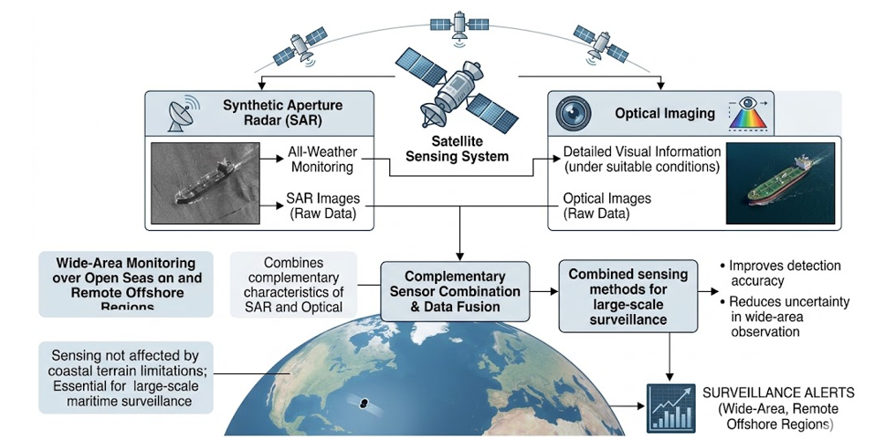
Figure 1: Multi-layer maritime surveillance architecture
The architecture is designed to support key maritime monitoring functions, including wide-area anomaly screening, local verification, and continuous vessel-state tracking. By combining different sensing modalities, the framework reduces the limitations of single-source surveillance and improves anomaly detection reliability.
2.2 High Layer: Satellite-Based Wide-Area Monitoring
The high layer consists of satellite-based sensing systems for large-scale maritime surveillance over open seas and offshore regions. This layer mainly employs Synthetic Aperture Radar (SAR) and optical imaging. SAR supports all-weather wide-area observation, while optical imagery provides detailed visual information when environmental conditions are favorable. Their combined use improves detection accuracy and reduces uncertainty in large-area screening.
To detect suspicious vessel behavior, satellite observations are compared with Automatic Identification System (AIS) data. The spatial discrepancy between observed and reported vessel positions is defined as
$$ΔD=∣P_{sat}-P_{AIS}∣$$
where $P_{sat}$represents the vessel position obtained from satellite sensing and $P_{AIS}$is the AIS-reported position. If AIS data are unavailable, the vessel is classified as non-cooperative. If the discrepancy exceeds a predefined threshold, the vessel may be considered suspicious or potentially spoofed.
2.3 Mid Layer: Aerial Verification Layer
The mid layer functions as a verification layer between satellite monitoring and surface sensing. Its main role is to provide detailed confirmation of suspected anomalies detected by the high or low layer.
Unmanned Aerial Vehicles (UAVs) are used to capture high-resolution optical and infrared data for close-range inspection. This enables verification of vessel identity, onboard activity, and possible illegal operations. Aerostats may also be deployed to provide extended observation duration and communication relay support in offshore environments.
This layer focuses on timely data transmission and rapid confirmation rather than maximizing communication throughput. Its purpose is to support quick and reliable decision-making in safety-critical situations.
2.4 Low Layer: Surface and Maritime IoT Monitoring
The low layer provides continuous vessel monitoring with high temporal resolution. It includes AIS, VHF/DSC communication systems, and maritime IoT sensors deployed on buoys or unmanned surface platforms.
Although this layer offers frequent updates and low latency, it is vulnerable to communication congestion, spoofing, and line-of-sight limitations. These issues may reduce the reliability of vessel tracking and collision prediction. Therefore, additional verification from the high and mid layers is necessary.
The communication and sensing characteristics of the three layers are summarized in Table 1.
Table 1: Multi-Layer Communication and Sensing Characteristics
Steps | Layer | Platform | Communication | Latency | Key Functions | Limitations
1 | High | Satellites (LEO/GEO) | Satellite (X/Ka-band) | High (ms–s) | Wide-area monitoring, anomaly pre-screening | Long revisit time, weather impact
2 | Mid | UAVs, Aerostats | 5G / LTE / Microwave | Medium (10–100 ms) | Real-time verification, anomaly confirmation | Limited endurance, weather sensitivity
3 | Low | AIS, VHF, IoT Sensors | VHF / LoRa | Low (ms) | Vessel tracking, route monitoring | Congestion, spoofing, LOS limits

2.5 Data Fusion and Operational Workflow
The proposed methodology integrates observations from all three layers into a unified operational workflow. Instead of treating each data source independently, the framework combines satellite, aerial, and surface observations to provide a more complete and consistent understanding of maritime conditions.
For example, suspicious activity detected from AIS or maritime IoT data can trigger aerial verification, while satellite sensing provides wide-area contextual support for anomaly screening. This coordinated process improves detection accuracy, reduces uncertainty, and enhances response efficiency. The overall fusion and processing workflow is shown in Figure 2.
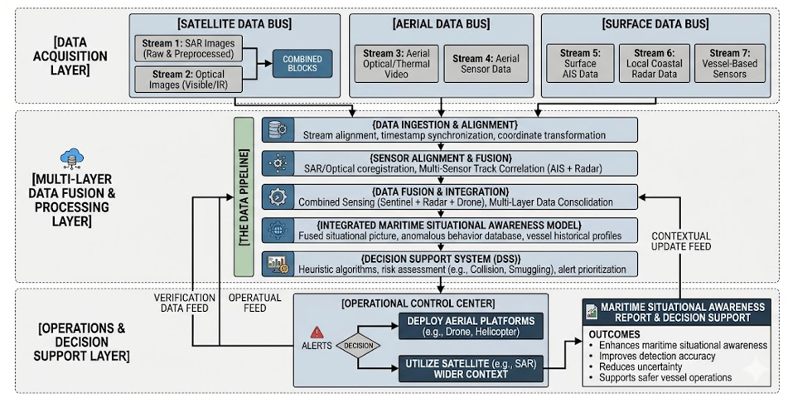
Figure 2: Data fusion and operational workflow
2.6 System Reliability Modeling
From a maritime engineering perspective, the effectiveness of safety-critical operations depends on the availability, reliability, and timeliness of observational data. To evaluate whether the proposed architecture can support practical maritime safety tasks, six key components are considered:
- end-to-end response delay,
- satellite-layer delay,
- aerial relay delay,
- surface-layer delay,
- data availability, and
- AIS identity reliability.
The main variables used in the models are summarized in Table 2.
Table 2: Key Variables and Parameters Used in System Modeling
Steps | Symbol | Description | Unit
1 | $$D_{Total}$$ | Total system response delay | s
2 | $$D_{Sat}$$ | Satellite-layer delay | s
3 | $$D_{UAV}$$ | Aerial relay delay (UAV) | s
4 | $$D_{AIS}$$ | Surface-layer communication delay | s
5 | $$D_{Proc}$$ | Data processing delay | s
6 | $$H$$ | Satellite altitude | m
7 | $$c$$ | Speed of light | m/s
8 | $$θ$$ | Elevation angle | degree
9 | $$d_{uav}$$ | UAV communication distance | m
10 | $$C$$ | Communication capacity | bps
11 | $$B$$ | Channel bandwidth | Hz
12 | SNR | Signal-to-noise ratio | —
13 | $$P_{spoof}$$ | AIS spoofing probability | —
14 | $$ΔP$$ | Position difference | m
15 | $$ΔV$$ | Velocity difference | m/s
16 | $$ΔT$$ | Time difference | s
17 | $$Γ$$ | Consistency threshold | —
2.7 End-to-End Response Delay
The total response delay represents the time required for the system to react to potential maritime risks. It is defined as
$$D_{Total}=D_{Sat}+D_{UAV}+D_{AIS}+D_{Proc}$$
where the terms represent delay contributions from satellite sensing, aerial communication, surface transmission, and data processing, respectively.
2.8 Satellite-Layer Delay
For wide-area monitoring, satellite communication delay is an important factor. The propagation delay is approximate as
$$D_{prop}=\frac{H}{c⋅sin⁡(θ)}$$
where $H$is the satellite altitude, $c$is the speed of light, and $θ$is the elevation angle.
2.9 Aerial Relay Delay
In the aerial layer, the communication delay is expressed as
$$D_{UAV}=\frac{d_{uav}}{c}+D_{MAC}+D_{enc}+D_{codec}$$
where the total aerial delay includes propagation delay, medium access delay, encoding delay, and image/video processing delay.
2.10 Surface-Layer Delay
The delay in the surface layer, mainly associated with AIS communication, is given by
$$D_{AIS}=D_{wait}+D_{prop}$$
where $D_{wait}$is the waiting delay caused by channel access or congestion, and $D_{prop}$is the propagation delay. In dense traffic areas, a larger waiting delay may reduce the effectiveness of collision warning systems.
2.11 Data Availability
To support anomaly verification and safety-related operations, the communication link must provide sufficient data transmission capability. The link capacity is estimated as
$$C=B{log⁡}_{2}(1+SNR)$$
where $B$is the channel bandwidth and SNR is the signal-to-noise ratio. This equation is used to determine whether the system can support essential data transmission, such as real-time imagery for anomaly confirmation.
2.12 AIS Identity Reliability
To assess possible AIS manipulation, a spoofing probability is defined as
$$P_{spoof}=σ\left(w_{1}ΔP + w_{2}ΔV + w_{3}ΔT\right)$$
where $ΔP$, $ΔV$, and $ΔT$denote position, velocity, and time differences, respectively, and $w_{1}$, $w_{2}$, and $w_{3}$are weighting factors. This model provides a simple indicator for identifying suspicious vessel behavior. The AIS spoofing assessment concept is illustrated in Figure 3.
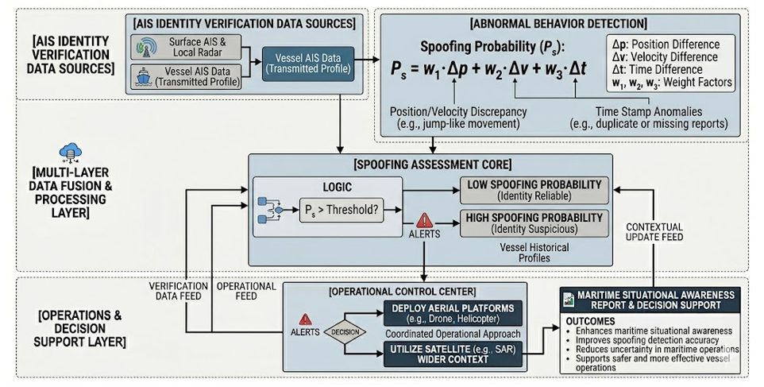
Figure 3: Framework for AIS identity reliability assessment and spoofing probability detection
2.13 Data Fusion and Consistency Check
After information is collected from different layers, a fusion model is used to combine the data:
$$F(S,A,I)=Φ(V_{Sat},V_{UAV},V_{AIS})$$
where $Φ(⋅)$represents the fusion function integrating satellite, aerial, and AIS observations.
A consistency check is then performed as
$$∥V_{Sat}-V_{AIS}∥>Γ$$
If this condition is satisfied, additional verification, such as UAV deployment, is triggered. This mechanism improves detection accuracy and reduces the response time of anomaly confirmation.
2.14 Data Description
This study uses literature-based parameters and synthetic data to evaluate the proposed system. Communication parameters, including satellite delay, UAV relay delay, and AIS transmission characteristics, are selected from reported values in maritime communication studies.
The evaluation scenarios are designed to represent realistic maritime conditions, including illegal activities, AIS spoofing, and abnormal vessel movement. Vessel positions, velocities, and timestamps are generated within reasonable operational ranges. The use of synthetic data allows systematic evaluation of the proposed framework without relying on sensitive operational datasets. The dataset used in this study is publicly available.

- PERFORMANCE EVALUATION AND DISCUSSION
This section evaluates the proposed multi-layer maritime surveillance architecture using four representative maritime scenarios. The case studies demonstrate how integrating satellite, aerial, and surface sensing can improve anomaly detection, data reliability, and operational safety compared to single-source monitoring systems.
Case Study 1: Illegal Oil Discharge Detection
Illegal oil discharge events are time-sensitive, as oil spills may disperse within 1–2 hours.
Operational Process:
Satellite-based SAR is first used for wide-area screening to identify potential oil spills. Once a suspicious region is detected, a UAV is deployed to perform close-range verification.
Engineering Impact:
The UAV layer provides near real-time visual confirmation, with a transmission delay of approximately 80–200 ms. By supporting high-quality video transmission, the system enables reliable evidence collection before the oil spill dissipates.
This approach improves detection reliability compared with single-source systems by reducing uncertainty and enabling cross-layer verification.
Case Study 2: AIS Spoofing Detection
AIS spoofing, such as false identity or position manipulation, is a major threat to maritime safety.
Risk Evaluation:
The spoofing probability is calculated using the model defined in Section II. When a physical vessel is detected by satellite, but no corresponding AIS signal is present, it is classified as a non-cooperative vessel.
Cross Verification:
If the position difference exceeds 500 m, the system identifies the vessel as suspicious and generates an alert. Compared to AIS-only monitoring, this approach improves detection reliability compared with AIS-only monitoring by reducing false alarms and enhancing cross-layer verification consistency.
Case Study 3: Night-Time Illicit Activity Detection
Illegal ship-to-ship transfer activities often occur at night to avoid detection.
Multi-Modal Detection:
SAR is used to detect abnormal vessel proximity regardless of lighting conditions. UAVs equipped with thermal sensors are then deployed to confirm heat signatures and onboard activities.
System Reliability:
Even when AIS communication is affected by congestion, UAV relay communication ensures that anomaly information can still be transmitted in real time. This approach improves system robustness under degraded communication conditions by maintaining reliable cross-layer data transmission.
Case Study 4: Grounding and Route Deviation Monitoring
Detecting abnormal vessel movement is critical for preventing grounding and collision accidents.
Real-Time Monitoring:
The system continuously analyzes vessel behavior using fused data from multiple layers. Sudden speed reduction or abnormal course changes can be detected in real time.
Safety Improvement:
Compared to traditional monitoring methods, the proposed system provides warnings 5–15 minutes earlier, enabling faster response, reducing potential risks, and improving overall response effectiveness.
Discussion
The results from the above case studies indicate that the proposed multi-layer architecture offers clear advantages over conventional single-source monitoring systems.
First, integrating multiple sensing layers improves detection reliability. Satellite systems provide wide-area coverage, UAVs enable high-resolution verification, and surface systems ensure continuous monitoring. The combination of these layers reduces uncertainty and enhances situational awareness.
Second, cross-layer verification significantly improves system performance. By validating anomalies using multiple data sources, the framework reduces false alarms and increases decision accuracy compared to single-source approaches.
Third, communication delays play a critical role in maritime safety. Delays in satellite, UAV, and AIS communication directly affect response time. The proposed analytical model provides a practical way to evaluate whether the system meets operational timing requirements.
Finally, the proposed architecture offers flexibility and scalability for broader maritime applications, including offshore infrastructure monitoring and long-term system management.
Overall, the results demonstrate that the proposed framework improves reliability, reduces response time, and enhances operational effectiveness. These results highlight that system-level reliability depends more on cross-layer consistency than individual sensor accuracy.

CONCLUSION
Summary of Contributions
This study proposed a multi-layer maritime surveillance architecture to address key challenges in existing maritime monitoring systems, including data fragmentation, AIS reliability issues, and limited observation coverage.
The proposed system integrates satellite, aerial, and surface sensing into a unified framework, improving data consistency, anomaly detection capability, and operational reliability in both offshore and nearshore environments.
The main contributions of this study are summarized as follows:
- Multi-layer Architecture:
A three-layer architecture consisting of satellite, aerial (UAV/aerostat), and surface sensing systems was developed. This structure enables coordinated monitoring and supports both wide-area detection and local verification.
- AIS Reliability Assessment:
A simple model was introduced to evaluate AIS reliability using position, velocity, and time differences. This approach helps identify abnormal vessel behavior and potential spoofing events.
- System Performance Modeling:
Basic analytical models were established to evaluate system delay and communication capability. These models help assess whether the system can meet the time requirements of safety-critical operations.
- Case Study Validation:
The effectiveness of the proposed system was demonstrated through several representative scenarios, including illegal activities, spoofing detection, and navigation risk monitoring. The results show that multi-layer integration improves detection accuracy and response speed.
Overall, the proposed approach provides a practical solution for improving maritime monitoring performance and supporting safer vessel operations.
Limitations and Future Work
Although the proposed system improves maritime monitoring capability, several limitations remain.
Satellite systems are affected by revisit intervals and environmental conditions, while UAV platforms have limited endurance and coverage. In addition, surface communication systems may experience congestion in high-density traffic environments.
Future work will focus on improving system performance and expanding practical applications. Possible directions include:
• Enhancing communication reliability for real-time monitoring
• Applying intelligent data processing to reduce system delay
• Extending the framework to support offshore infrastructure monitoring and long-term system management.

REFERENCES
- Alqurashi, F. S., Trichili, A., Saeed, N., Ooi, B. S., & Alouini, M.-S. (2022). Maritime communications: A survey on enabling technologies, opportunities, and challenges. IEEE Internet of Things Journal, 10(4), 3525–3547.
- Harish, A. V., & Tam, K. (2024). Literature review of maritime cyber security: The first decade. Maritime Technology and Research. https://doi.org/10.33175/mtr.2025.273805
- Bai, L., Zhang, X., Yao, R., Lin, Y., & Mei, Q. (2025). Prediction of ship berthing behavior intentions using AIS integration and maritime VHF voice feature selection and recognition. Ships and Offshore Structures, 1–19. https://doi.org/10.1080/17445302.2025.2576919
- Hongjie, S., Zhen, H., & Li’an, Z. (2025). The whole process route planning algorithm based on AIS spatio-temporal big data analysis. Ships and Offshore Structures, 20(7), 912–926.
- Chen, K., Yan, D., & Jing, F. (2025). Autonomous collision avoidance planning for ship speed and course alteration in urgent situations. Ships and Offshore Structures, 1–16.
- He, Y., Liu, Y., Jiang, C., & Zhong, X. (2021). Multiobjective anti-collision for massive access ranging in MF-TDMA satellite communication system. IEEE Internet of Things Journal, 9(16), 14655–14666.
- Duzenli, E., Akyuz, E., Kayisoglu, G., & Bolat, P. (2025). An integrated risk-based modelling approach for prediction of AIS spoofing attacks on-board ship. Ocean Engineering, 342, 122895.
- Azdem, D., Mabrouki, J., & El Hajjaji, S. (2025). Challenges in maritime sector cybersecurity. In Advances in Information Security, Privacy, and Ethics (pp. 125–148).
- Liu, Z., Gao, H., Zhang, M., Yan, R., & Liu, J. (2023). A data mining method to extract traffic network for maritime transport management. Ocean & Coastal Management, 239, 106622.
- Chen, W., Li, C., Yu, J., Zhang, J., & Chang, F. (2021). A survey of maritime communications: From the wireless channel measurements and modeling perspective. Regional Studies in Marine Science, 48, 102031.
- Du, J., Song, J., Ren, Y., & Wang, J. (2021). Convergence of broadband and broadcast/multicast in maritime information networks. Tsinghua Science and Technology, 26(5), 592–607.
- Fang, X., Feng, W., Wang, Y., Chen, Y., Ge, N., Ding, Z., & Zhu, H. (2022). NOMA-based hybrid satellite–UAV–terrestrial networks for 6G maritime coverage. IEEE Transactions on Wireless Communications, 22(1), 138–152.
- Han, Z., Zhou, T., Xu, T., Ouyang, Y., Chen, X., Chen, T., & Hu, H. (2025). Delay minimization in NTNs: Deployment and caching optimization for satellite- and cache-aided UAV. Computer Networks, 264, 111257.
- He, Y., Xie, J., Liu, Y., & Luo, X. (2025). Distributed channel selection, relay assignment, and UAV deployment for delay minimization via game framework. Physical Communication, 72, 102785.
- Louart, M., Szkolnik, J.-J., Boudraa, A.-O., Le Lann, J.-C., & Le Roy, F. (2024). An approach to detect identity spoofing in AIS messages. Expert Systems with Applications, 252, 124257.
- Hu, Q., Song, M., Zhang, D., & Huai, S. (2024). Adaptive cooperative ship identification for coastal zones based on the very high frequency data exchange system. Journal of Marine Science and Engineering, 12(8), 1264.
- Lee, S.-B., Kwon, J.-H., Kim, B.-Y., Shim, W.-S., & Shon, T. (2024). Slot occupancy-based collision avoidance algorithm for very-high-frequency data exchange system network in maritime internet of things. Applied Sciences, 14(24).
- Lee, S.-B., Kwon, J.-H., Kim, B.-Y., & Shim, W.-S. (2024). Block-based self-organizing TDMA for reliable VDES in SANETs. KSII Transactions on Internet and Information Systems, 18(2).
- Li, Z., Xie, Z., He, X., & Liang, X. (2024). Heterogeneous temporal graph powered DRL algorithm for channel allocation in maritime IoT systems. Computer Communications, 213, 260–270.
- Kang, B., Myoung, S., & Choo, H. (2017). Distributed degree-based link scheduling for collision avoidance in wireless sensor networks. IEEE Access, 4, 7452–7468.
- International Telecommunication Union. (2014). Technical characteristics for an automatic identification system using time division multiple access (Recommendation M.1371).
- International Telecommunication Union. (2022). Technical characteristics for a VHF data exchange system (VDES) (Recommendation M.2092).
- Fan, Y. (2023). Research on time slot assignment technology in data link network system (Doctoral dissertation). Xidian University.
- Kim, H. J., & Paik, J. K. (2025). A digital twin model within the framework of a digital healthcare engineering system for aging containership hull structures. Ships and Offshore Structures, 1–18.
- Bradbury, L. M., Diaconu, D., Molgat Laurin, S., Beattie, A. M., Ma, C., Spydevold, I. S., Haugli, H. C., Zee, R. E., Harr, J., & Udnæs, F. (2019). NorSat-2: Enabling advanced maritime communication with VDES. Acta Astronautica, 156, 44–50.

