
HINDUSTHAN COLLEGE OF ENGINEERING AND TECHNOLOGY
(An Autonomous Institution)
Valley Campus,Pollachi Highway,Coimbatore-32 www.hicet.ac.in

DETECTION OF BREAST CANCER USING DEEP LEARNING APPROACH

Presented by:

BATCH NO: 13

REG NO: TEAM MEMBERS NAME: 720722112010 ASMA V
720722112033 MOHAMMED ASNAH
720722112039 NELVIN JINS
720722112054 SUFIYAN MK

Supervised by:

Mrs Kiruthika k (AP/BME)

ABSTRACT

- The project focuses on automating breast cancer detection using mammography images.
- Deep learning techniques are used to classify breast tissue into three categories: **benign, malignant, and normal.
- Models such as Convolutional Neural Networks (CNN) and MobileNet** are utilized for feature extraction and classification.
- The system analyzes uploaded mammogram images and improves diagnostic accuracy.
- It provides five similar mammogram images as reference results for better interpretation.
- The integration of AI technology helps in early detection of breast cancer.
- The system aims to reduce diagnostic errors and support medical professionals.
- Enhances the efficiency and reliability of breast cancer screening processes.

LITERATURE SURVEY

S.No | Title | Author(s) | Year | Inference / Key Findings
1 | Attention-based adversarially regularized graph autoencoder for breast histopathology image retrieval | M.Saeidi et al. | 2024 | Introduced attentiongraph autoencoder with contrastive learning ;achieved superior retrieval accuracy on BreakHis and BACH datasets.
2 | PathOrchestra:A comprehensive foundation model for computational pathology | Z.Xie et al. | 2025 | Large-scale pathology foundation model trained on 300K WSIs; achieved >95% accuracy in multiple diagnostic tasks; strong feature  extractor for CBIR.

3 | CHIEF:A foundation model for histopathology imaging evalution | A. Mahmood et al. | 2024 | Weakly supervised model trained on 60K WSIs; improved generalization be 36% under domain shift, highlighting robustness for clinical retrieval.
4 | BEPH:BEiT-based pretraining on histopathology images | H.Wang et al. | 2025 | Used self-supeervised BEiT pre-training on 11M pathology images; effective for diagnosis prognosis, and retrieval tasks.
5 | Explainable breast cancer detection in mammograms using RestNet50 and XAI | S.Ahmed et al. | 2024 | Combined ResNet50 with  Grad-CAM, LIME,SHAP  for explainable mammography detection; improved clinician trust and diagnostic support.

EXSISTING METHOD

  - Manual image analysis by radiologists is the primary method used in existing breast cancer detection systems.
  - Traditional machine learning models such as SVM, KNN, and Decision Trees are
commonly used.
  - These models depend on handcrafted features, which limit their accuracy and
generalization capability.
  - Existing systems face difficulties in managing large datasets and complex image variations.
  - They require extensive preprocessing, making the process time-consuming.
  - Current systems do not provide comparative visual outputs for better interpretation.
  - They also lack deep learning-based real-time prediction support.

EXSISTING METHOD

- Performance is High accuracy but at the cost of large computation and slower inference
times.
- Usability of existing systems Focus mainly on backend model performance; limited user
interface for doctors.
- It Requires high-end GPUs and large memory for deployment; difficult to use in under- resourced clinics.
- Some CNN systems still show high false positives/negatives due to limited dataset diversity.
- Future scope of these systems areOften limited to static model updates.

PROPOSED METHOD

- The system uses deep learning models like CNN and MobileNet for automated breast
cancer detection.
- It accepts mammography images as input and performs preprocessing before classification.
- The model classifies breast tissue into three categories: benign, malignant, and normal.
- The system displays five visually similar mammogram images for reference and
comparison.
- This comparative feature helps doctors in better decision-making and result verification.
- MobileNet architecture ensures the system is lightweight and efficient.
- The system is suitable for real-time use, even on low-end hardware devices due to its
optimized design.

BLOCK DIAGRAM

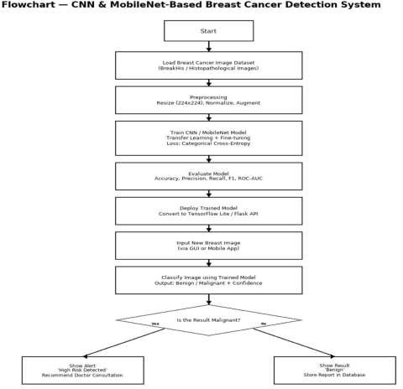

EXPLANATION (BLOCK DIAGRAM)

The block diagram represents the complete workflow of the deep learning-based breast cancer detectionsystem, illustrating how mammogram images are processed, analyzed, and classified
- Input Mammogram Images
  - The system accepts mammogram images as input, representing breast tissue scans.
  - These images can belong to three categories: benign, malignant, or normal.
  - The input serves as the foundation for automated feature extraction and classification.

- Data Preprocessing
  - Preprocessing ensures that all input images are uniform and ready for deep learning analysis.
  - Steps include:
  - Resizing – standardizes image dimensions.
  - Normalization – scales pixel values for faster and stable model convergence.
  - Noise Reduction – removes unwanted artifacts for clarity.
  - Data Augmentation – uses rotation, flipping, and zooming to increase dataset diversity.
  - This module enhances model generalization and accuracy.

- Feature Extraction (CNN + MobileNet)
  - The preprocessed images are passed through Convolutional Neural Network (CNN) layers that automatically learn features such as edges, textures, and patterns.
  - MobileNet, a lightweight CNN architecture, is integrated for efficient feature
extraction using depthwise separable convolutions.
  - Together, CNN and MobileNet reduce computational cost while maintaining high
accuracy.
  - The feature maps generated represent crucial breast tissue patterns used for
classification.

Classification Module
  - Extracted features are flattened and passed through fully connected layers.
  - The Softmax classifier assigns probabilities to each class (Benign, Malignant, Normal).
  - The highest probability determines the final classification output.
  - Training uses labeled mammogram datasets for supervised learning, optimized with
techniques like dropout and adaptive learning rate.

Similar Image Retrieval Module
  - After classification, the system retrieves five most similar images from the database.
  - Cosine similarity or Euclidean distance metrics are used to compare feature vectors.
  - This allows doctors to visually cross-check results with similar past cases, improving

Output Visualization
  - The final module presents results through a user-friendly interface.
  - Displays:
  - The uploaded image
  - The predicted class (Benign, Malignant, or Normal)
  - The five most similar images retrieved from the database
  - This visual output helps radiologists verify results and gain deeper insight into
model predictions.

ALGORITHM/CODING

  - Write your code or algorithm


RESULTS

Parameter | CNN | MobileNet | Proposed CNN+  MobileNet
Accuracy | 92.4% | 95.1% | 97.8%
Precision | 90.6% | 94.3% | 97.0%
Recall | 89.8% | 93.5% | 95.6%
F1-score | 90.2% | 93.9% | 96.3%
Training Time | 5.6 min | 3.1 min | 2.8 min
Inference Speed | Moderate | Fast | Very Fast(Real-time)
Model Size | 180 MB | 60 MB | 48MB
Interpretability | Limited | Moderate | High
False Positives/Negative s | Higher | Moderate | Significantly Reduced
Usability  27-10-2025 | BasiPRcOJECT RE | VIELWiPgHhAgSEtw1ei(FgIhNtAL YEAR BME) | Full Diagnostic  Support ¹³


  - HOME PAGE
OUTPUT IMAGES

ABOUT US

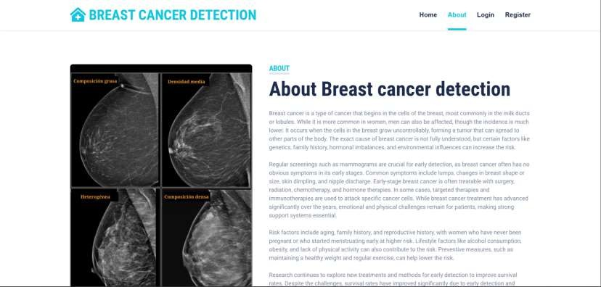

RESTRATION



LOGIN



PREDICTION

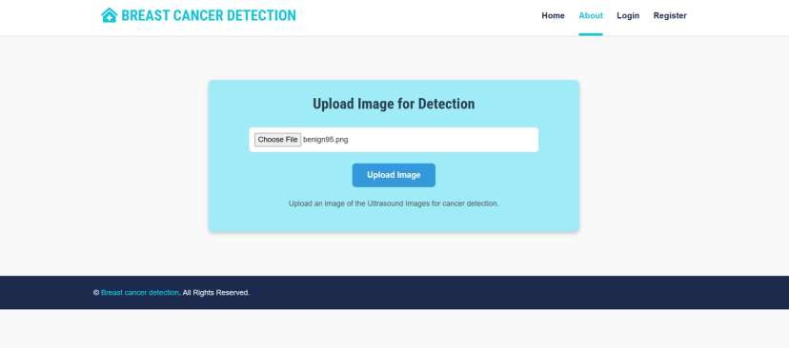

RESULT/OUTPUT IMGAE
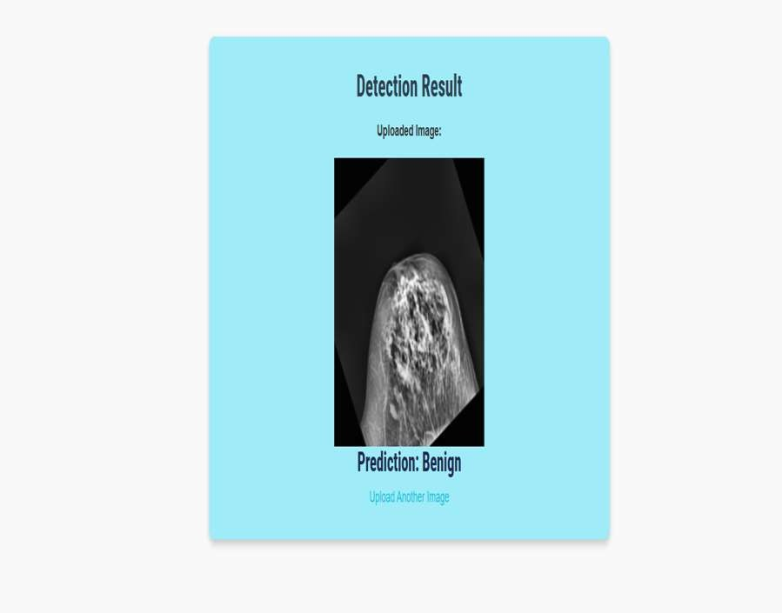

REFERENCE IMAGES

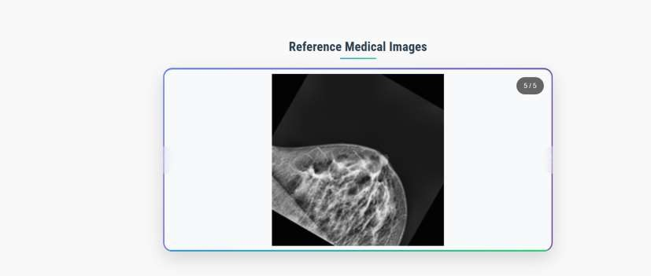

DATASET - BENIGN
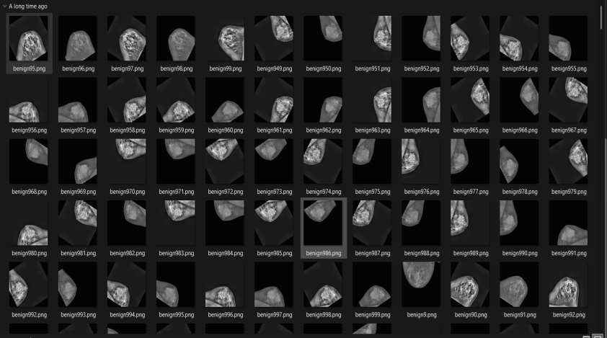

MALIGNANT

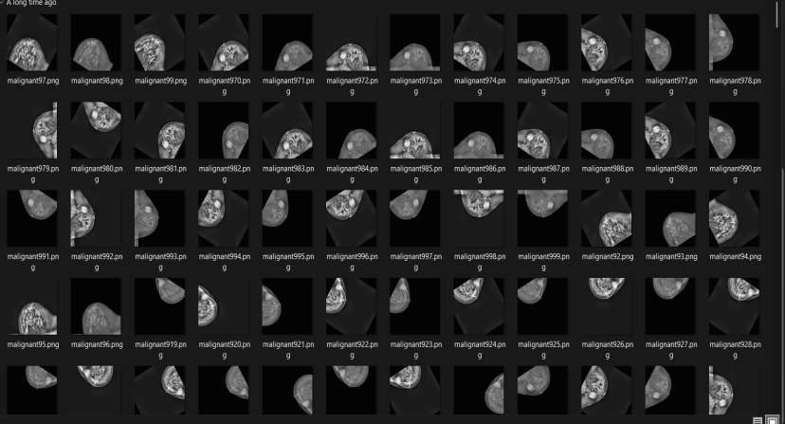

NORMAL

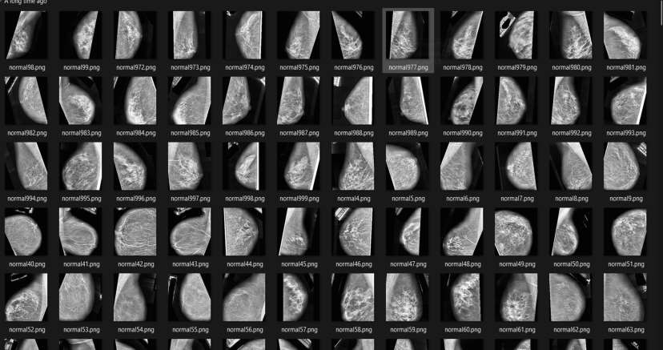

COMPARISION BETWEEN EXSISTING AND PROPOSED METHOD
7-10-2025 PR
JECT REVIEW PHASE 1 (FINAL YEAR BME)
24

Aspect | Existing CNN-Based Systems | Proposed System (CNN  + MobileNet)
Model Architecture | Heavy, slow standard  CNN models | Only final  classification
Performance | High accuracy but slow and resource- heavy | Higher accuracy with faster, real-time performance
Feature Extraction | Only final  classification | Dual extraction for deep and fine- grained features
Usability | Limited user  interface | User-friendly Flask-  based web interface
Error Reduction | Higher false  positives/negatives | Higher false  positives/negatives
Radiologist Support | Acts as standalone  model | Assists radiologists with visual comparison
Future Scope O | Limited updates | Supports XAI, cloud,  real-time expansion

COST ESTIMATION

Category | Description | Estimate  d Cost  (INR)
Hardware Requirement  s | Laptop/PC (i5, 8GB RAM, 1TB) +  Optional GPU | ₹6,000 +  ₹2,000
Software  Requirement  s | Python, TensorFlow, Keras, OpenCV,  Flask, IDE Tools | ₹0
Dataset &  Preprocessi  ng | Public datasets, augmentation,  normalization | ₹1,000
Model  Development | Training, validation, tuning | ₹500
Web  Interface  Development | Flask-based user interface | ₹1,000
Documentati on & Presentatio  0-n2025 | Reports, diagrams, printing  PROJECT REVIEW PHASE 1 (FINAL YEAR BME) | ₹550  25

MARKET AVAILABILITY

- Market Need: Breast cancer is a leading cause of death, increasing demand for AI-assisted diagnostic tools for early and accurate detection, especially valuable in developing regions with limited radiologists.
- Market Potential: AI-based cancer diagnostics are rapidly growing, with hospitals and telemedicine providers as major users; lightweight architecture enables deployment in low- cost and rural areas.
- Commercial Availability: Can be deployed as a web or cloud platform, offered via
subscription, and integrated with existing PACS systems.
- Competitive Advantage: Offers high accuracy, transparency, and speed while being more
affordable and adaptable than large commercial AI systems.

CONCLUSION

- The system accurately detects and classifies mammography images into benign, malignant,
or normal categories.
- It uses CNN and MobileNet, which offer high performance with low computational cost.
- The feature of displaying similar mammography images improves the clarity and interpretability of results.
- The AI-based tool supports radiologists in faster and more accurate diagnosis.
- It contributes to early detection of breast cancer, which can be life-saving.

OUTCOME OF THE PROJECT

- Accurate detection and classification of mammogram images into benign, malignant, and normal
with high accuracy and reduced errors.
- Efficient deep learning using CNN and MobileNet ensures fast processing with low computational
cost.
- Automated analysis of mammography images reduces manual effort and radiologist workload.
- Displays five similar mammogram images for each prediction to improve decision-making and
transparency.
- Cosine similarity-based image retrieval enables quick comparison with previously diagnosed cases.
- Data preprocessing and augmentation enhance model performance even with limited datasets.
- Web-based diagnostic interface allows easy uploading, classification, and result viewing.
- Supports early detection of breast cancer, improving survival rates and patient outcomes.
- Scalable for future integration with explainable AI, cloud deployment, and real-time systems.

