Home Automation System Using Iot

Conference Paper by Tanke Hans
Supervisor : Dr. K. Jayachitra

- Abstract
Home automation using the Internet of Things (IoT) is rapidly emerging as a key component of modern smart homes. This paper presents the design and implementation of an IoT-enabled home automation system, highlighting its architecture, hardware components, communication protocols, and software integration. The system enables remote monitoring and control of household appliances using cloud services, mobile applications, and wireless communication. The results demonstrate the system’s ability to improve comfort, energy efficiency, and security while reducing human effort.
Keywords: IOT, Home Automation, Smart Homes, Wireless Communication, Cloud Computing, Sensors.

Introduction

The concept of smart homes is becoming increasingly relevant with the proliferation of IoT devices. Home automation enables users to control and monitor appliances remotely, enhancing convenience, safety, and energy management. With the advent of low-cost microcontrollers such as Arduino and ESP32, as well as wireless communication protocols like Wi-Fi and MQTT, home automation has become more accessible for research and real-world deployment. This paper aims to explore the development of an IoT-based home automation system suitable for modern households. This system consists of internet of things technology with interconnection of sensors and home appliances communicating independently without human interaction but observation. This automation system uses AVR microcontrollers with the Arduino IDE, an open-source prototyping platform based on easy-to-use hardware and software [3]. It supports external USB hardware (an Android USB accessory) to cooperate with an Android-powered device.

LITERATURE REVIEW

Introduction
Several researchers have explored the use of IoT in smart homes. Studies have demonstrated the use of ZigBee, Bluetooth, and Wi-Fi in enabling communication between devices. Cloud platforms such as ThingSpeak and Blynk provide data analytics and user interfaces for device control. However, challenges such as interoperability, security, and internet dependency remain major concerns. This section reviews related works and highlights the gaps addressed in this project.

System Architecture and Methodology

The proposed system consists of sensors, actuators, a microcontroller, and a cloud platform for remote access. The hardware includes ESP32 for Wi-Fi connectivity, relays for controlling appliances, and sensors such as DHT11 for temperature and PIR for motion detection. The methodology involves real-time monitoring of sensor data, communication via MQTT protocol, and control through a mobile application connected to the cloud.

Hardware Components
The main hardware components used include:
Component | Specification | Description
Arduino UNO | ATmega328P, 14 Digital I/O pins, 5V logic | Microcontroller for processing and control
DHT11 Sensor | Temperature: 0–50°C, Humidity: 20–90%, 3–5V | Measures temperature and humidity
PIR Sensor | 3–7m range, 3–5V | Detects motion for security alerts
Relay Module | 5V coil, 10A @ 250V AC | Controls AC appliances such as fan and light
ESP8266 Wi-Fi Module | 3.3V logic, Wi-Fi connectivity | Provides IoT connectivity to cloud
Power Supply | 5V DC regulated | Supplies stable power to Arduino and sensors

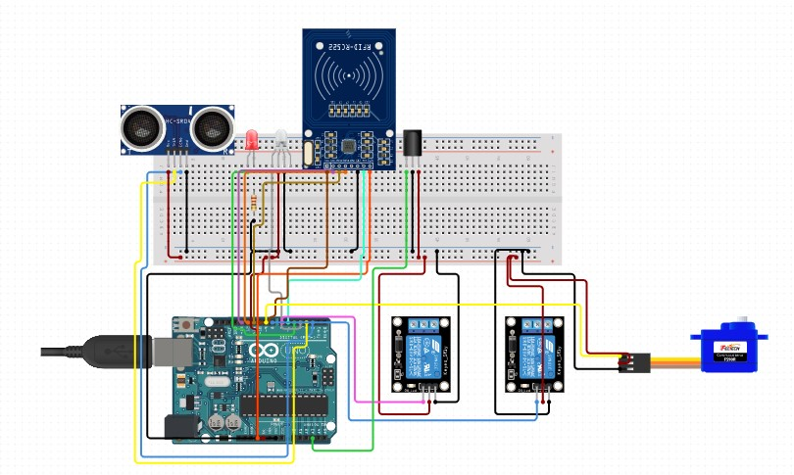

Fig 1. General Architecture

Sensors
(DHT11, PIR)

Fig 2. Block diagram

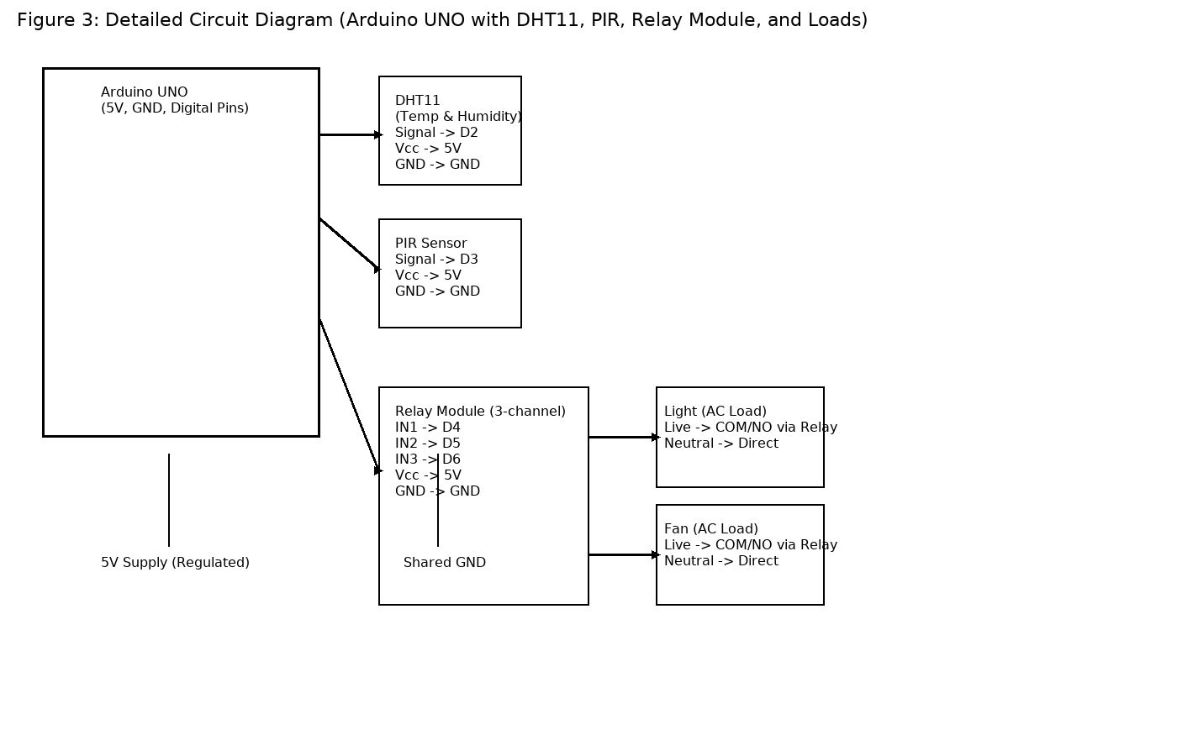

Fig 3. Circuit Diagram (Arduino UNO connected to DHT11, PIR, Relay Module and AC Loads)

Software used

Arduino IDE is used to program the Arduino UNO. The software reads data from the sensors, controls the relay module, and sends sensor data to the cloud via Wi-Fi. A mobile app provides remote control and monitoring.

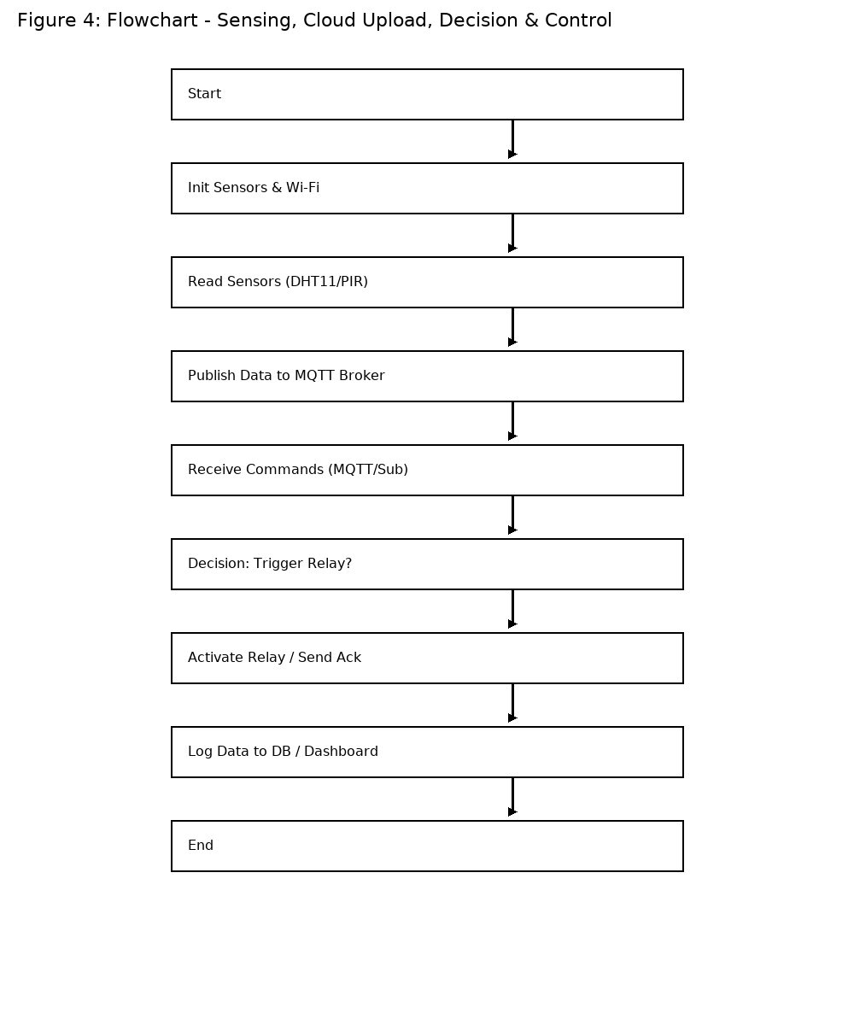

Fig 4. Software Flowchart

Sample Arduino Code

cpp
#include <DHT.h>
#define DHTPIN 2
#define DHTTYPE DHT11DHT dht(DHTPIN, DHTTYPE);
#define PIRPIN 3
#define RELAYPIN 4
void setup() {
Serial.begin(9600);
dht.begin();
pinMode(PIRPIN, INPUT);
pinMode(RELAYPIN, OUTPUT);
}
void loop() {
float temp = dht.readTemperature();
float hum = dht.readHumidity();
int motion = digitalRead(PIRPIN);
if(motion) {
digitalWrite(RELAYPIN, HIGH);
} else {
digitalWrite(RELAYPIN, LOW);
}
// Send data to cloud
delay(2000);
}

Results and Discussion

This designed system is to be tested in a laboratory setup with appliances such as lights, fans, and security alarms. The expected outcome of this system would reliably monitor and control devices in real time. The cloud dashboard will also provide historical data analysis, enabling insights into energy usage. This system will demonstrate high responsiveness and reliability under stable conditions.

Challenges and Limitations

The system faces challenges such as:
1. Dependence on stable internet connectivity.
2. Cybersecurity risks including unauthorized access.
3. Limited interoperability with devices from different manufacturers.
4. Scalability issues for larger deployments.

Future Scope

Future work will focus on integrating artificial intelligence for predictive control, enhancing security through block chain, and enabling interoperability via standardized protocols. Energy optimization through smart scheduling and renewable energy integration will further improve system performance. Voice assistant integration with Alexa or Google Home is also a potential area of expansion.

Conclusion

This paper presented a proposed design of a home automation system using IoT. This system will demonstrate the potential of IoT in transforming conventional homes into smart, connected environments. Despite challenges, the system provides a reliable and user-friendly solution for remote appliance monitoring and control. Future improvements will make such systems more intelligent, secure, and sustainable.

Appendix: Pin Connections

Arduino Pin | Connected Components | Notes
D2 | DHT11 Sensor (Data) | Requires 10kΩ pull-up resistor.
D3 | PIR Sensor (Output) | Detects motion and outputs HIGH signal.
D4 | Relay IN1 | Controls Light load.
D5 | Relay IN2 | Controls Fan load.
D6 | Relay IN3 | Can control additional appliance.
5V | All Sensors + Relay VCC | Power supply line.
GND | All Sensors + Relay GND | Common ground reference.

References

[1] J. Gubbi, R. Buyya, S. Marusic, and M. Palaniswami, "Internet of Things (IoT): A vision, architectural elements, and future directions," Future Generation Computer Systems,vol.29,no.7,pp.1645-1660,2013.
[2] R. Piyare, "Internet of Things: Ubiquitous Home Control and Monitoring System using Android based Smart Phone," International Journal of Internet of Things, vol. 2, no. 1, pp. 5-11,2013.
[3] M. A. A. Al-Qutayri and J. Jeedella, "Smart Home Automation System Based on ZigBee," International Journal ofComputing,2012.
[4] H. S. Kim and S. Y. Park, "Home IoT resistance against cyber-attacks," IEEE Internet of Things Journal, 2018.
[5] Blynk IoT Platform, https://blynk.io
[6] Ngum Breayon Kwe, Serena Williams Nkenglefack Aloga, Pallavi Gupta, Km. Sucheta Singh.
[7] Saleh, Muna & Hamad, Qusay. (2017). Wireless Home Automation System Based On Microcontroller. 10.13140/RG.2.2.26753.51043.
[8] Zhao, Liang and Zhang, Jili and Shen, Yue and Wu, Wenyan (2015) Design and Implementation of Energy Saving Controller for Air-Conditioner in Building. International Journal of Smart Home, 9 (8). pp. 47-54. ISSN 1975-4094
[9] L. Zhang, R. Yan, H. Sun and Y. Qian, "A wireless general air-conditioner remote-controller for smart homes," 2017 Eleventh International Conference on Sensing Technology (ICST), Sydney, NSW, Australia, 2017, pp. 1-6, doi:10.1109/ICSensT.2017.8304498.
[10] Z. Weng, J. Fang, Z. Weng, Y. Cheng and G. Zhang, "Design of node controller for wireless monitoring system of central air conditioner," 2017 IEEE International Conference on Cybernetics and Intelligent Systems (CIS) and IEEE Conference on Robotics, Automation and Mechatronics (RAM),

