Fault Detection classification and Localization of faults occurred in a Photovoltaic System- A Review.

Muhammad Abdullah¹ , Muhammad Qasim Shah^{2 ,} Fajar Kabeer³.
¹Institute of Electrical, Electronics and Computer Engineering, University of the Punjab, Lahore, Pakistan.
²Faculty of Science and Technology, Bournemouth University, England, United Kingdom.
³Department of Physics, Government College University, Pakistan.

Corresponding author: mqasim@bournemouth.ac.uk

Abstract:
In the recent past many people have switched their mode of power generation. Many have now used renewable energy systems and the most efficient and common among them is the photovoltaic system (solar system).
As the demand increases the need for fault tracing is required for the smooth operation of the Photovoltaic system. This review will give a complete insight into faults that can occur in the Photovoltaic system but also their detection, classification, and localization techniques.
Keywords: Photovoltaic system, Existing energy sources (EES), Localization techniques.

- Introduction:
In the recent past, industries across the globe are constantly expanding due to the needs of people around the world. However, with this increase in expansion, the power consumption demand is also increasing exponentially.
In the last decade, the already existing energy sources were used to meet the power demand. There are some issues regarding these existing energy sources (EES) such as the cost of maintenance is quite high and the resources are constantly decreasing with the increase in usage. Some other anomalies are that the generation cost is quite high and the environment becomes toxic with gases like carbon dioxide (CO₂) and greenhouse gasses (GHG).
Due to these harmful impacts of the existing energy sources, the need for renewable energy sources (RES) has increased in recent times. As the (RES) is environmentally friendly the cost of generation will drop exponentially [1-2]. The increasing demand and production of (RES) is also caused by a certain commitment of countries known as the Kyoto Protocol [3]. This very protocol aimed to decrease the impact of existing energy sources on the environment.
The major aim of the latest renewable energy technology (RET) is to integrate power generation through renewable energy sources (RES) into our utility grid. This will help us remove the existing sources that are causing harm to the environment. There are many (RESs) like hydro, thermal, wind, and solar (Photovoltaic). But the most standout is the Photovoltaic (PV). The best way to convert the energy produced by the environment is the PV system and the impact of this on the environment is friendly to nature [4].
With the help of a survey, the generated power by the help of photovoltaic systems (PVS) globally was around 633 GWp.
According to a report by the International Renewable Energy Agency (IRENA), In 2020, the PV installed capacity was around 700,000 MW and this capacity has been increasing since then [5].
There are many advantages of PVS but the fact that these systems are installed outdoors so they are exposed to harsh environmental conditions which decreases their working efficiency by 15-20% [6]. According to the authors in [7] suggested that the PVS suffers from a 0.923 % degradation annually. Another common reason for this is the presence of faults in a PVS.
According to a study of the photovoltaic system (PVS), the total power loss of the PVS due to the faults was about 18.9% [8]. Due to this, the PV system requires constant supervisory control and a monitoring system that can detect, classify, and locate the faults in a PV system to reduce the impact of losses and make sure the PV system works properly.
The block diagram of PV system monitoring is shown in Figure 1,
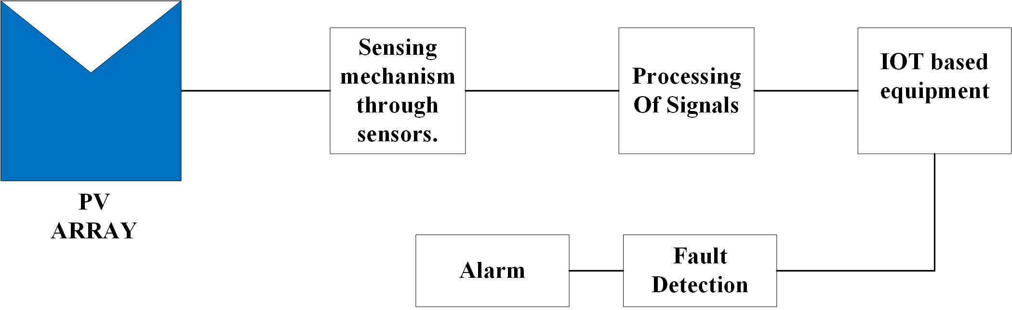
Figure 1. Basic PV monitoring block diagram.
According to the Figure 1. A basic block diagram of a conventional PV monitoring system is depicted. The main purpose of this system is to gather data regarding the performance of the PV system. So, that this data can be used to detect the anomaly the system will face. The data for this purpose is given by the sensors they can be current, voltage, irradiation, and temperature sensors that are constantly recording the data coming from the PV array.
The signal processing unit will process the data and transfer it to IOT-based equipment in which a decision will be made through different types of techniques and algorithms about which type of fault occurred in the PV system. In the past decade, many researchers have focused on creating a system for Photovoltaic fault detection and classification that is cost-effective and highly reliable without hindering the peak performance of the PV system [9].
The need for this system is quite significant as the conventional resources are close to depletion and the shift towards renewable energy is imminent. So, for the smooth operation of the PV system, a fault detection, localization, and classification system is required.
In this paper, different types of PV faults and fault detection techniques will be discussed. Section 2 of this paper will discuss Photovoltaic (PV) modeling, and section 3, will discuss the PV faults. Section 4, will cover fault detection techniques, and section 5, will have a comparative analysis.
- PV cell modeling.
- One diode model.
There are three types of PV cell modeling based on diodes. One diode model, two diode model, and a three diode model. Mostly one diode model is used. One diode model of a PV cell consists of a constant current source denoted by I source with two resistors one in series (Rs) and the other one in shunt (Rshunt) with the diode [10-11]. The total output current of the one-diode model can be elaborated as I load [12-13].
$I_{Load}= I_{Source}-I_{Diode }- I_{Shunt}$ (1)
Overall the one-diode model in terms of performance and simplicity is quite decent [14]. Its characteristics are quite easy to comprehend as the circuit only contains a single diode so the current divisions within the circuit are quite scarce. This model is given in Figure 2.
In equation (1) the $I_{Shunt}$ represents the value of current across the shunt resistor (Rshunt), and the I diode is the current across the diode. The diode current is further calculated and elaborated in [15].
$I_{Diode}= I_{Sat} [exp \frac{\left(V_{Load}+ I_{Load} R_{S}\right)}{\left(α V_{Thermal}\right)}-1$] (2)
In equation (2) the most significant addition is the saturation current also known as the reverse saturation current and is denoted by $I_{Sat}$. $α$ is the diodes ideality factor, and the $V_{Thermal}$ is the thermal voltage of the model. This thermal voltage is calculated by [16].
$V_{Thermal}= \frac{KT}{q}$ (3)
Here some constants are used, K represents the Boltzmann constant K= 1.38 × 10− 23 J/K. T represents the model's operating temperature, and q represents the charge q=1.6 × 10− 19 C.
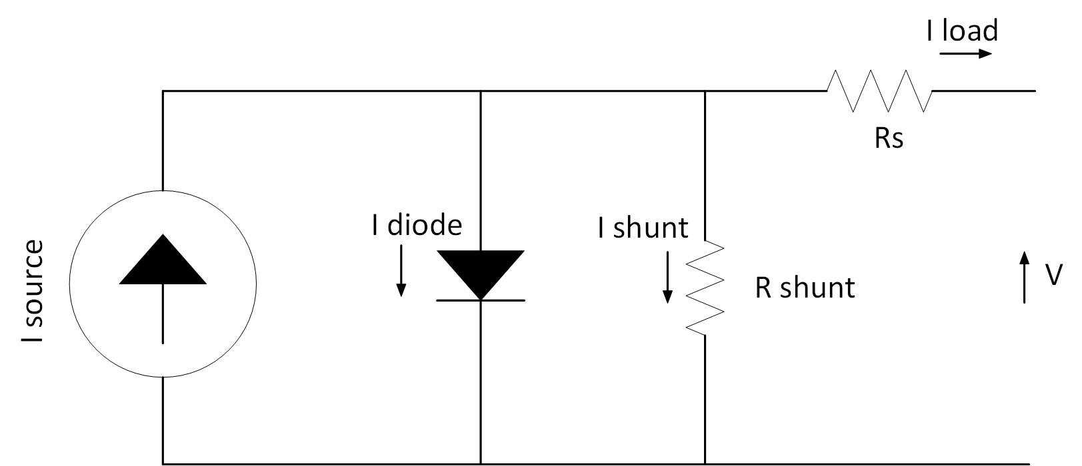
Figure 2. One diode model.

By combining the equations 1 and 2 we will get our final expression for the output current denoted by $I_{Load}$.
$I_{Load}= I_{Source}-I_{Sat} [exp \frac{\left(V_{Load}+ I_{Load} R_{S}\right)}{\left(α V_{Thermal}\right)}-1]- \frac{\left(V_{Load}+ I_{Load} R_{S}\right)}{R_{Shunt}}$ (4)
Equation 4 sums up our one-diode model.
- Two diode models.
The basic circuital diagram of the two-diode model is elaborated in Figure 3.
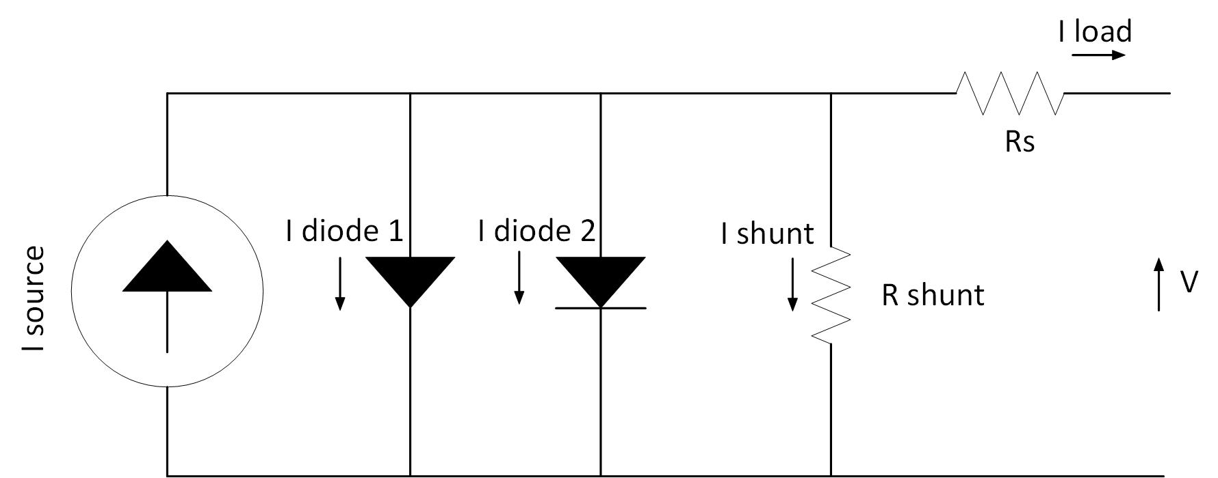
Figure 3. Two diode models.
In the one-diode model due to the presence of a single diode the losses in the depletion region called the recombination losses were not taken into account. But in the two-diode model, there is another diode added [17].
Due to the fact the two-diode model shows higher levels of accuracy as compared to the older one-diode model version, the number of unknown variables has been increased which means a lot more computation will be required [18].
All the mathematical equations for this type of model are described below.
$I_{Load}= I_{Source}-I_{Diode 1}-I_{Diode 2}- I_{Shunt}$ (5)
The load equation of the two diode models shown in Figure 3 is elaborated by equation (5), there is a slight difference between equations (1), and (5). Only the diode current is now taken from two diodes instead of one in the one-diode model.
$I_{Diode 1}= I_{Sat 1} [exp \frac{\left(V_{Load}+ I_{Load} R_{S}\right)}{\left(α_{1} V_{Thermal}\right)}-1$] (6)
$I_{Diode 2}= I_{Sat 2} [exp \frac{\left(V_{Load}+ I_{Load} R_{S}\right)}{\left(α_{2} V_{Thermal}\right)}-1$] (7)
As in the one-diode model, there was only one diode equation due to the presence of a single diode in the two-diode model there will be two diode equations and two ideality factors $α_{1}$ and $α_{2}$.
The $V_{Thermal}$ will remain the same the total output equation of the model will come after the combination of equations (5-7).
$$I_{Load}= I_{Source}-I_{Sat 1} \left[\exp{\frac{q\left(V_{Load}+ I_{Load} R_{S}\right)}{\left( α_{1}V_{Thermal}\right)}}-1\right]-$$
$I_{Sat 2} \left[\exp{\frac{q\left(V_{Load}+ I_{Load} R_{S}\right)}{\left(α_{2} V_{Thermal}\right)}}-1\right]- \frac{\left(V_{Load}+ I_{Load} R_{S}\right)}{R_{Shunt}}$
(8)
the two diodes are better in efficiency but the number of unknown parameters has been increased.

- Three diode model
As the name suggests there will be three diodes present in the system. The equations will be changed slightly due to the increment in number of diodes in the model. The circuit representation of the model is elaborated in Figure 4.
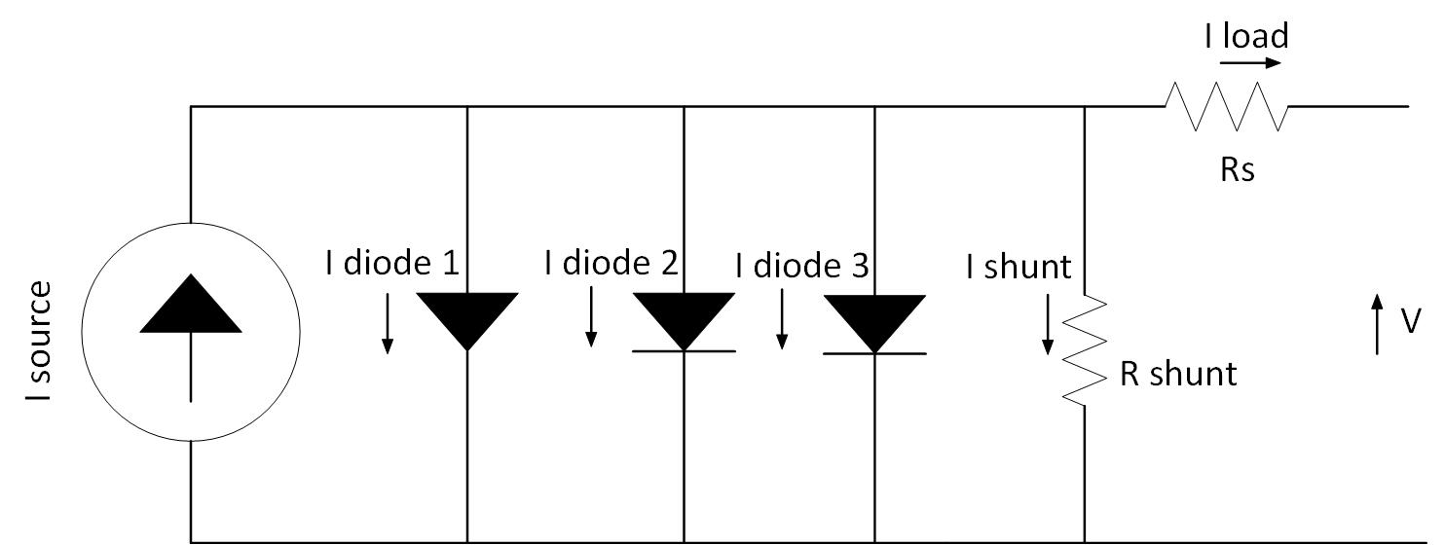
Figure 4. Three-diode model.
The Load equation is given below,
$I_{Load}= I_{Source}-I_{Diode 1}-I_{Diode 2}-I_{Diode 3}- I_{Shunt}$ (9)
The difference from the two-diode model is that a third diode is been introduced in the PV cell modeling now this equation (9) will only be valid in the case of three-diode modeling.
$I_{Diode 1}= I_{Sat 1} [exp \frac{\left(V_{Load}+ I_{Load} R_{S}\right)}{\left(α_{1} V_{Thermal}\right)}-1$] (10)
$I_{Diode 2}= I_{Sat 2} [exp \frac{\left(V_{Load}+ I_{Load} R_{S}\right)}{\left(α_{2} V_{Thermal}\right)}-1$] (11)
$I_{Diode 3}= I_{Sat 3} [exp \frac{\left(V_{Load}+ I_{Load} R_{S}\right)}{\left(α_{3} V_{Thermal}\right)}-1$] (13)
The output equation of the model will become,
$$I_{Load}= I_{Source}-I_{Sat 1} \left[\exp{\frac{q\left(V_{Load}+ I_{Load} R_{S}\right)}{\left( α_{1}V_{Thermal}\right)}}-1\right]-$$
$I_{Sat 2} \left[\exp{\frac{q\left(V_{Load}+ I_{Load} R_{S}\right)}{\left(α_{2} V_{Thermal}\right)}}-1\right]-$
$I_{Sat 3} \left[\exp{\frac{q\left(V_{Load}+ I_{Load} R_{S}\right)}{\left(α_{3} V_{Thermal}\right)}}-1\right]- \frac{\left(V_{Load}+ I_{Load} R_{S}\right)}{R_{Shunt}}$
(14)
- Types of PV systems.
- Standalone / Off-grid system PV system.
Overall, there are three main types of Photovoltaic systems. Off-Grid, On-Grid, and Hybrid, three types have their advantages and disadvantages. The most common and simplest one is the standalone/off-grid system, but the need for this system occurs in remote areas where the means of electricity or a utility grid is hard to find [19]. For a better understanding of the system Figure 5, is given below
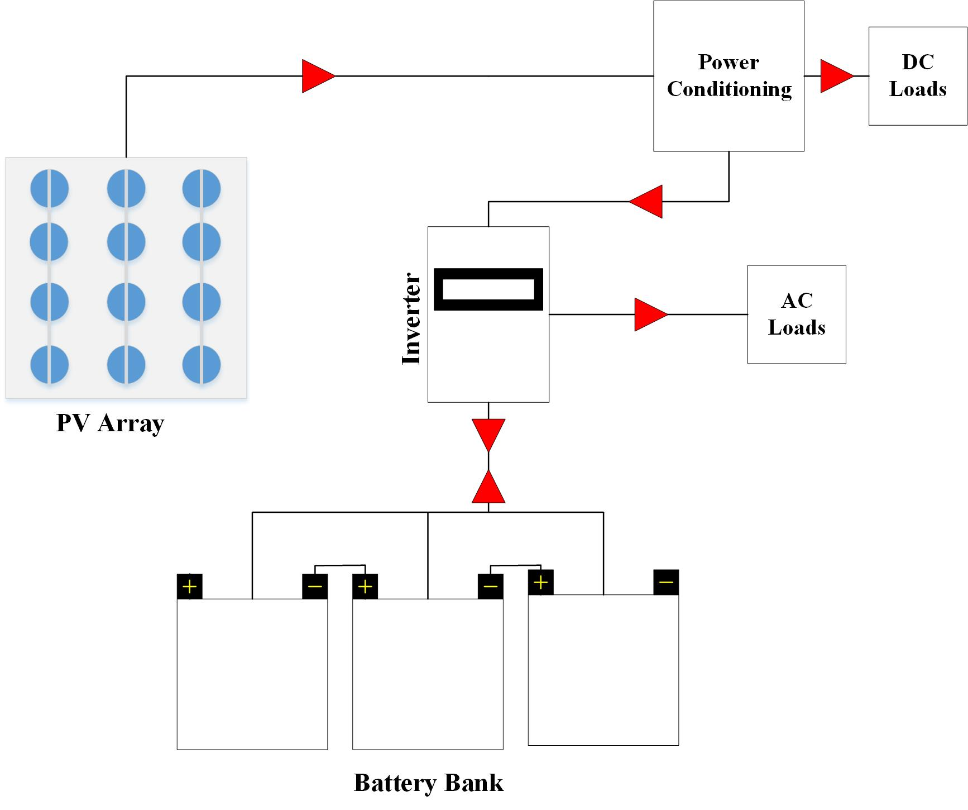Figure 5. Standalone / Off-Grid PV system.

The system given in Figure 5, has a power conditioning unit, with an inverter, a battery bank, and a PV array. The power conditioning unit consists of (converters, regulators, protection diodes, etc). [20] What happens in this type of system is that the power generated by the PV array is DC in nature, so a power conditioning unit refines it to give the DC loads their required type and amount of power.
The surplus power generated in the daytime is stored in the battery bank which will become the source of power at night so, the power can enter and exit from the battery bank that’s why a double arrow is shown in Figure 5. For powering the AC loads an inverter is needed which will convert the DC-AC power and will supply our household’s AC loads. In remote areas, this type of system is ideal where one can live a sustainable life.
The solar irradiation that comes from the sun and produces electric current in PV modules is of non-linear characteristics. Due to the uncertainty of the maximum irradiation at all times a maximum power point tracking (MPPT) is employed in an inverter. This MPPT will make sure that the system works at the maximum power point (MPP) at all times.
- On Grid PV system.
The second type of PV system is the Grid connected or On-Grid system. In this system, there is no need for a battery bank. A detailed description of the On-grid system is mentioned in Figure 6, the on-grid system contains an energy meter, a PV array, diodes (blocking and bypass), an Inverter, and a utility grid [21].
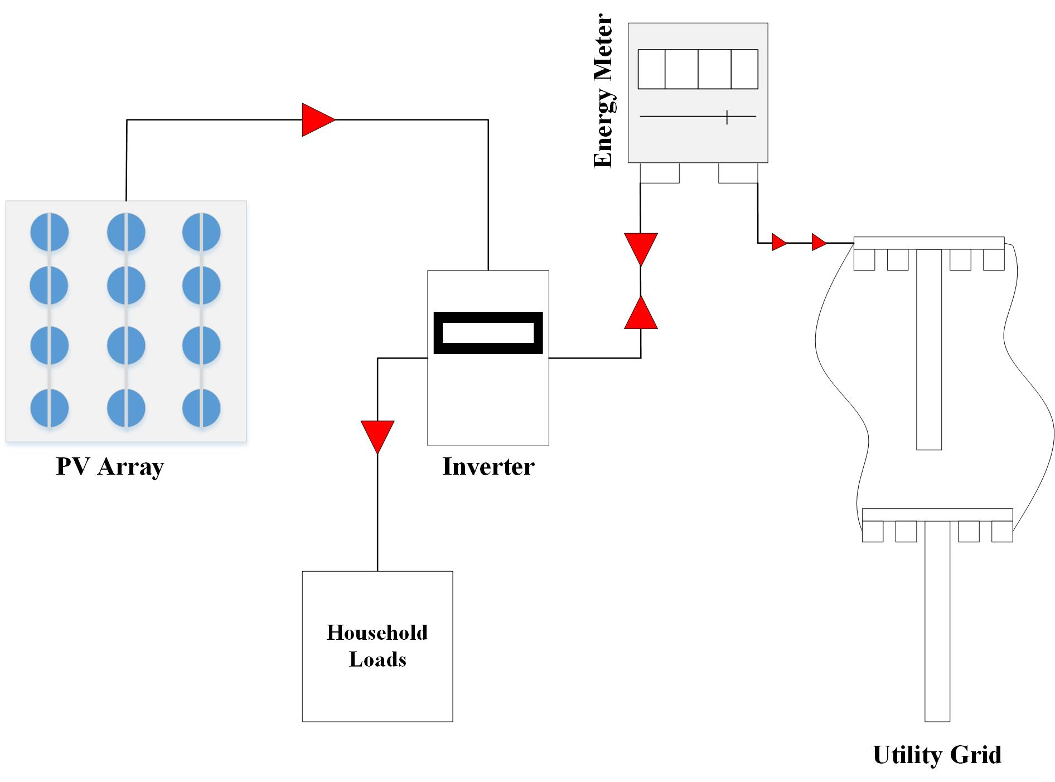
Figure 6. On-grid PV system.
In this PV array generates the power and inside the inverter, there is an MPPT present which is present to deal with the irregularities of irradiations from the sun. During the day hours, the surplus power generated by the array is fed to the local utility grid, and at night-time, the local grid will feed the power required by the household loads.
It is like a bi-directional system. The only disadvantage of this system is during the winters when there is no amount of surplus power so, the cost of electricity usage becomes higher in the winters or in the days when there is no sun.
- Hybrid PV system.
Last but not least the latest advancement in the Photovoltaic system is the hybrid PV system. In short, the hybrid is the combination of both On-grid and Off-grid systems. The block diagram of the system is in Figure 7,
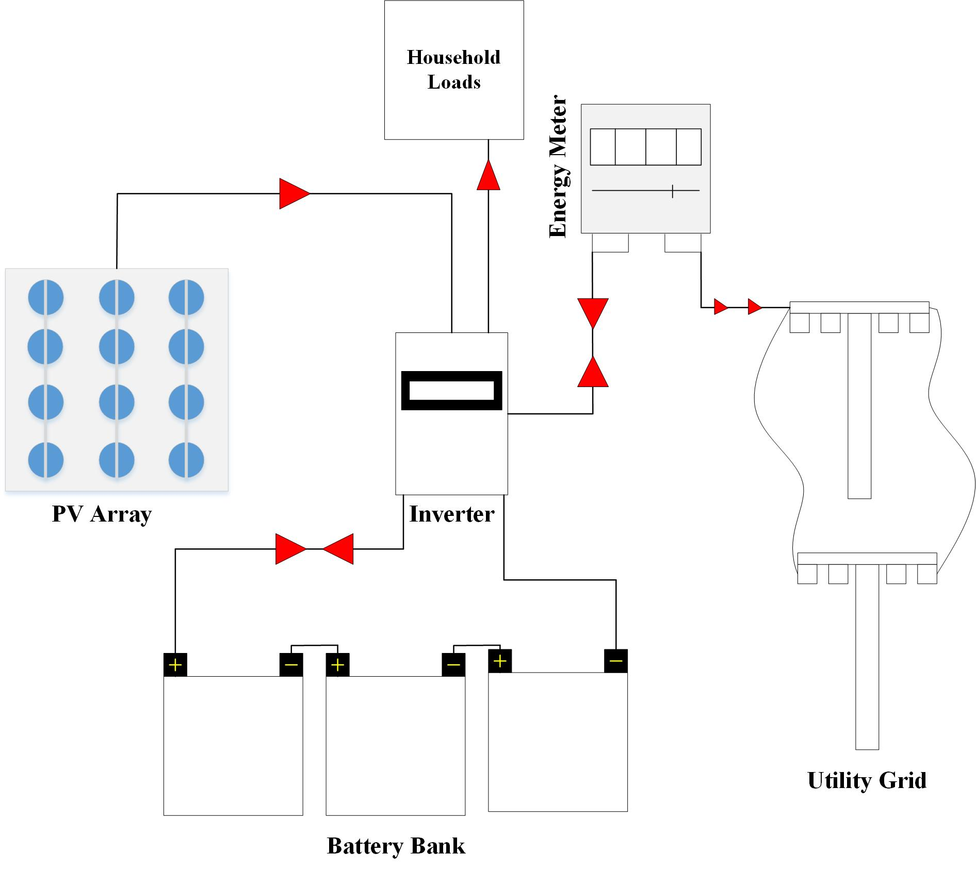
Figure 7. Hybrid PV system.

In this kind of system, when the surplus energy is generated it will be fed into the local utility grid as well, and it will charge the battery bank connected to the PV system.
Now at the time of no sun, there is a choice between whether the required load can be run by just the batteries or whether is it necessary to take the required power through the local utility grid.
As can be seen in Figure 7, there are two arrows placed between the inverter and energy meter and between the inverter and the battery bank. That is the only reason it is called a hybrid PV system.
- Faults in a Photovoltaic system
Just like any other electrical system, Photovoltaic systems (PV systems) do encounter many different types of faults. As the PV systems generate electrical currents only with the sun supplying irradiance, without the sun the system is not efficient and will not work. So, for the availability of the sun, the PV systems are installed outdoors for instance, on the roofs, and in the open fields.
Now this fact raises the question of whether the PV systems are affected by environmental or physical factors, the answer to that is yes. The PV system is susceptible to faults caused by environmental factors as they are such delicate devices in the PV modules.
The faults that can occur in a PV system due to these environmental and physical factors are corrosion, cell damage, glass breakage, delamination, etc).
The other major causes of PV faults are electrical faults, as this is an electrical device so, as discussed earlier it will have electrical system faults like short circuit faults, open faults, etc, the most dominant faults are these two.
If these faults are left unnoticed it will cause a great amount of mismatch in the current-voltage (I-V) characteristics curve, The I-V curve for some major types of faults is given in Figure 8.
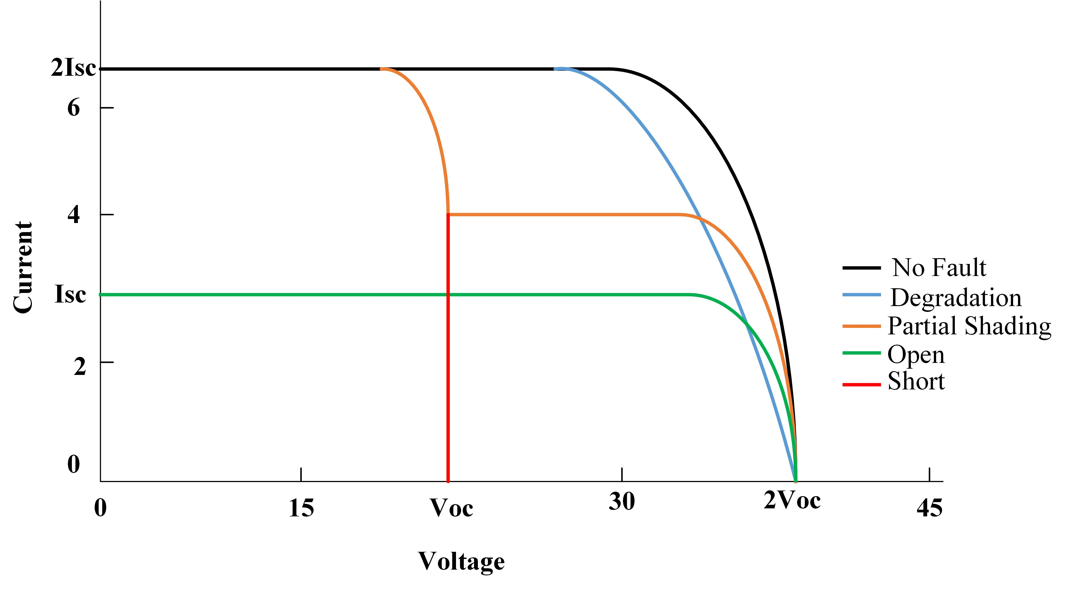
Figure 8. I-V curve.
A lot of power generated by the PV system will be wasted if these types of faults are left unnoticed, as a result, the power demand will not be met by the system. So, for the smooth operation of the PV system, it is necessary to develop strategies to detect and mitigate these faults in the said system.

- Physical faults.
As discussed earlier there are some physical faults and some electrical faults, which can occur in any PV system. Most of the physical faults that occur in a PV system are due to some mechanical stress and the properties of the material used as a raw material for the manufacturing of these PV modules. The major physical faults are degradation, encapsulation corrosion, etc. These faults can be mitigated by using materials that are corrosion-resistant in nature.
- Degradation.
The major reason behind any degradation fault is that the series resistance of the cell is increased or the parallel resistance is somehow decreased. There are some other reasons as well such as, disturbance in the anti-reflection coating of the solar cell which will affect the phenomenon of the photocurrent. What happens is that when the anti-reflection coating is disturbed it will drastically increase the brightness of the specific solar cell that will negatively impact the current generated through the photoelectric effect [22].
As the resistance increases the current of the solar cell will decrease, this will in return drop the total power generated by the PV cell. The impact of the degradation fault on the I-V characteristics curve is shown in Figure 8.
- Encapsulation faults.
This type of fault in any PV system is commonly caused by discoloration and delamination of the PV module. Now both of these are due to the outer environment as the PV modules should be placed out in the open. So, since the PV modules are in the outer environment the accumulation of dust and salts is imminent and sometimes moisture from the environment enters the PV module this will cause the delamination and discoloration of the PV module [23].
- Discoloration
Well, to detect this fault we do not require any state-of-the-art method. We can directly identify this kind of fault with the naked eye. What happens is that the white color material used in the manufacturing of the PV module will change its color from white to brown or yellow. This phenomenon is discussed in [24,25].
Due to the change in the color, the intensity of the light falling onto the PV cells will be reduced drastically which will increase the overall temperature of the PV cell. Due to the increase in temperature, the performance of the PV cells will be decreased that are facing this fault. The discoloration of any PV module can be commonly caused by the accumulation of acids and gases among the layers, stress (thermal stress), or corroded metallic points.
- Delamination
PV module is a stacking of successive layers; delamination is the detachment of these layers or maybe some occurrence of gaps. The delamination can occur due to poor adhesion used. Delamination has many negative impacts on the efficiency of a PV module.
The PV module starts reflecting instead of absorbing which may lead to low power generation. There are some other impacts as well such as, due to the detachment of layers moisture and other gases can easily penetrate the PV module which may lead to some bad effects [24].
- Corrosion
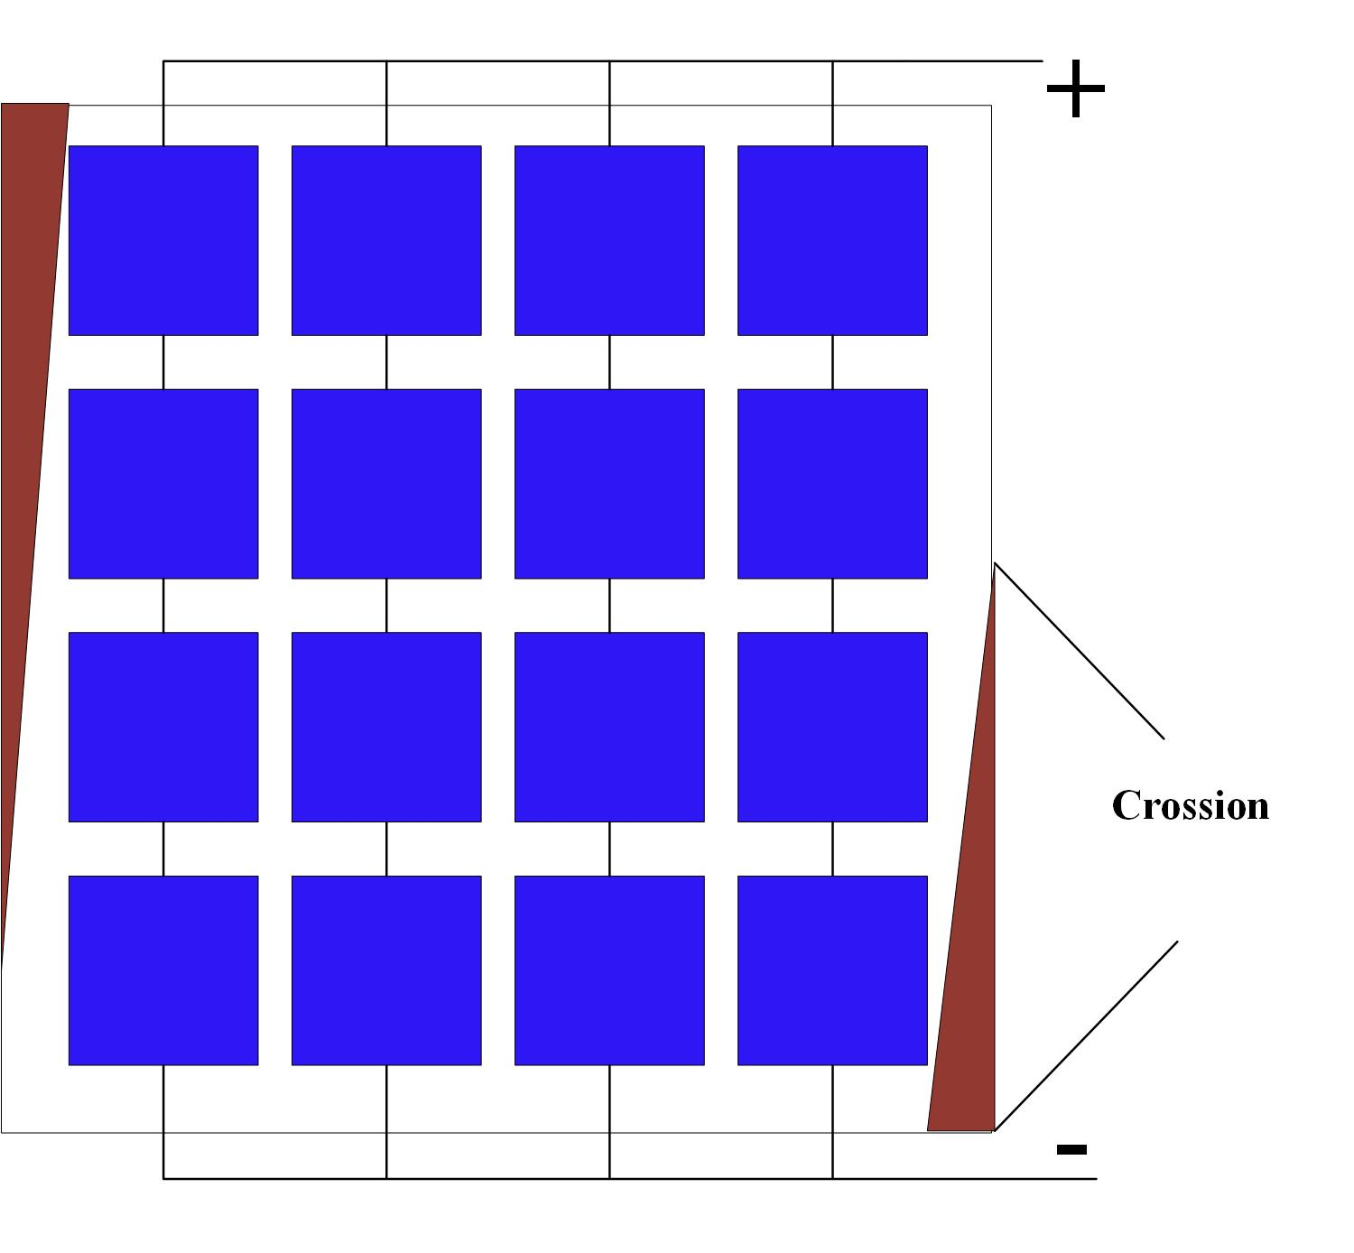
Figure 9. Corrosion fault in PV system.
Another common type of physical fault is corrosion, a detail of this can be seen in Figure 9. There are some gases present in the atmosphere such as carbon dioxide, Sulphur, and other gases that can cause corrosion. When the delamination in the PV module occurs there is a void that can be filled with corrosive gases and moisture which can in return cause corrosion. The corrosion can occur in the contacts metallic of nature connected to the base of the module and the silver fingers present at the upper side of the PV module [26]. The negative impacts of corrosion in a PV system are, due to the moisture entering and corrosion of metallic contacts leakage current can be flown in the system [23]. On the other hand, if corrosion occurs in the conducting wires then it will increase the system's overall resistance which can be harmful to the total yield of the PV system.
- Cell Cracks
There is a silicon substrate used to manufacture a PV cell, now in a PV module a silicon substrate can be cracked which can be classified as cell cracks This can be seen in Figure 10.
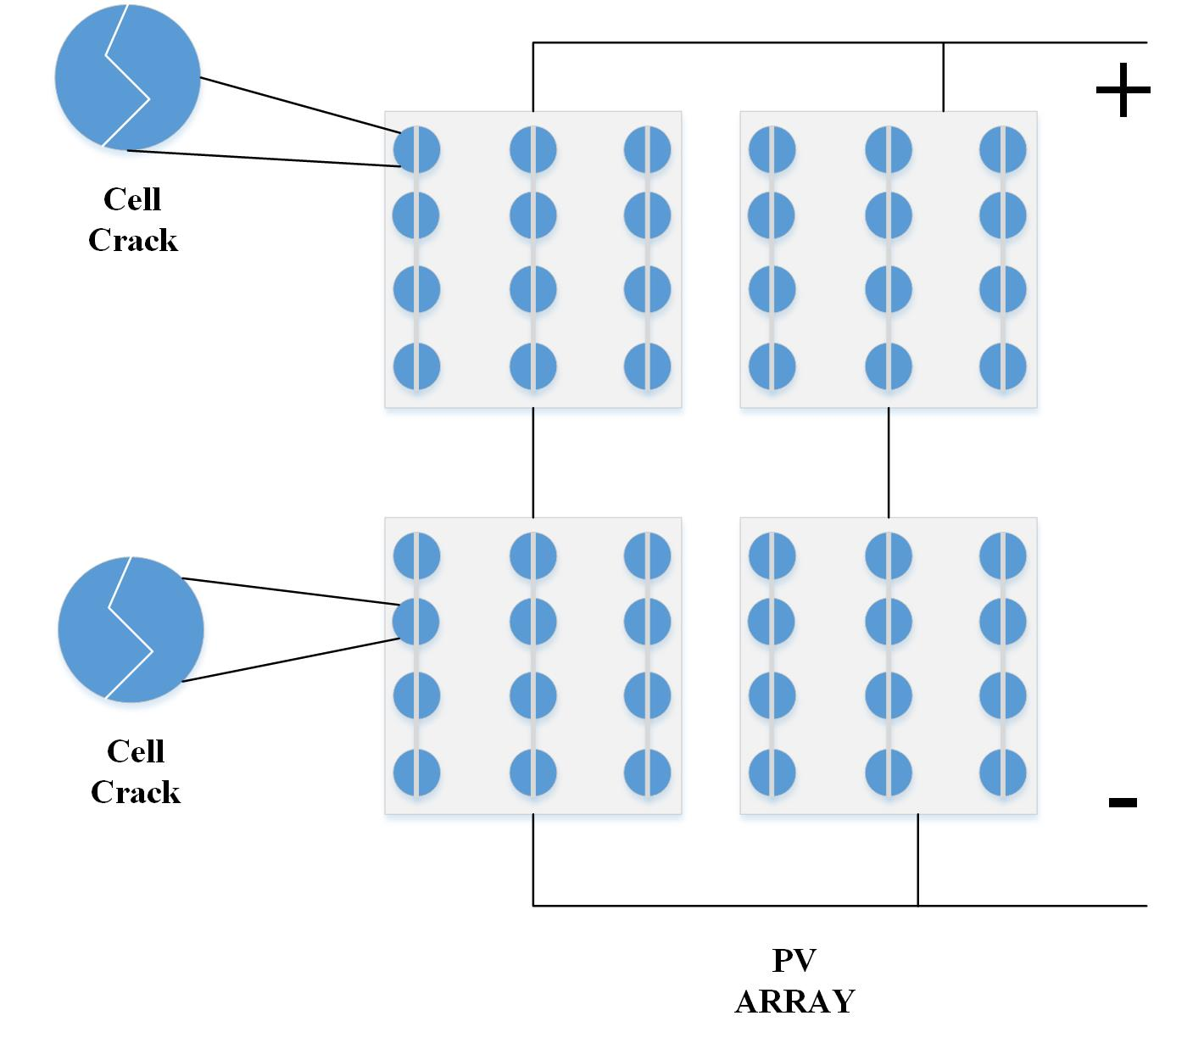
Figure 10. Cell cracks in a PV module.
These cracks can also occur in different layers of lamination of a solar cell. Their size can either be large or so small that they are not visible to the naked eye so, to detect these Electroluminescence imaging is required. The majority of the reasons for these faults are given in [23, 27] as, aging of the cells, the mechanical stress during the manufacturing process, poor handling during the packaging for transportation, shocks during the transportation, hailstorms on PV modules, and sometimes rain and high winds.
- Snail Trails
The silver fingers as the name suggests are made of silver, now when due to delamination and cell cracks the carbon di-oxide from the atmosphere can enter the PV module and start a chemical reaction with the silver and form a certain nanoparticle known as, silver carbonate (Ag₂CO₃). This can cause the discoloration of the silver fingers of a PV module [27, 28]. These snail trails mostly occur near the edges of cells and cell cracks [27].
- Environmental Faults
As the photovoltaic systems are installed outdoors. This will give rise to the fact that the PV system will have to face environmental factors such as solar radiation, storms, clouds caused by shading conditions, and high temperatures causing hot spots and delamination of solar cells.
The most prominent faults caused by environmental factors are mismatch and partial shading and both of these two types of faults can cause significant reduction in total power production and annual yield of the PV system.
- Mismatch Faults
The mismatch faults are the faults that arise when the I-V characteristics of some individual cells differ from the standard testing conditions I-V characteristics. There are two different kinds of mismatch faults one is temporary and the other is permanent.
The temporary is caused by the partial shading conditions and temperature variance which will negatively impact the open circuit voltage (Voc) of the modules facing this fault. while the permanent ones are caused by hotspots, cracks, degradation, etc. The mismatch faults can cause a drastic drop in the total power production of the PV system [29-30].
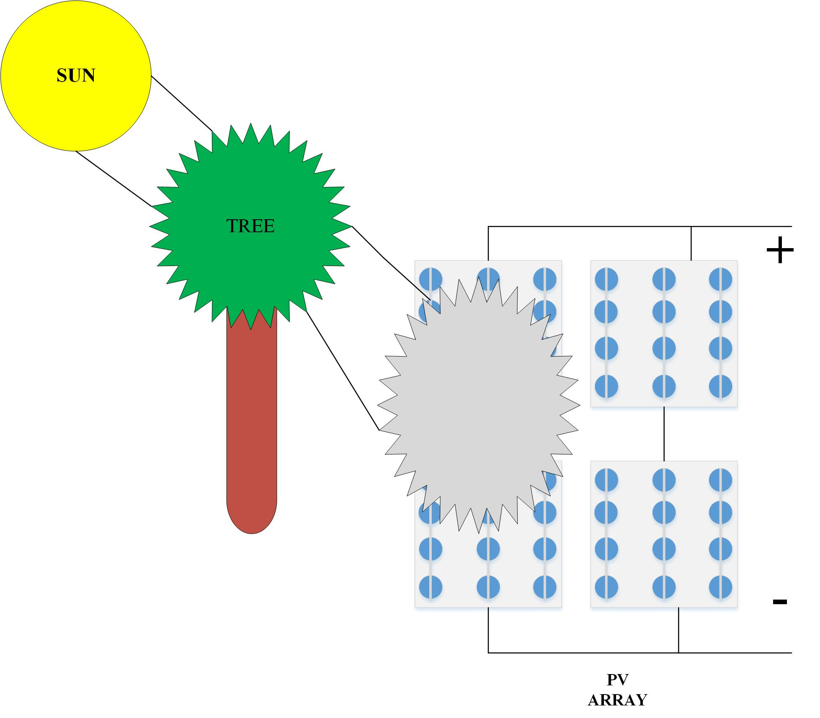
Figure 11. Partial shading due to trees.

- Partial Shading Fault
Partial shading faults occur when a portion of the PV module is under shade or some cells of the PV module are shaded. This phenomenon may lead to increased temperature of the PV module which can cause hotspots that can be harmful to the overall PV system as the total power may be reduced. Because the shaded area of the PV module may act as resistance or power dissipaters. Which will decrease the total current hence power will be reduced by a significant margin.
The main reasons behind partial shading are trees, high-rise buildings, clouds, snow cover, etc. In Figure 11, an example of partial shading is depicted. While the snow-related shading usually occurs in winter what happens is that due to the presence of snow covering the PV modules for long periods can cause a mismatch in the I-V characteristics. That may cause the temperature to rise, which in turn can cause power loss, and in extreme conditions, hotspots can develop due to this.
The partial shading due to snow covering can be seen in Figure 12. Due to this snow covering the PV modules surface characteristics may be negatively affected [31-32].
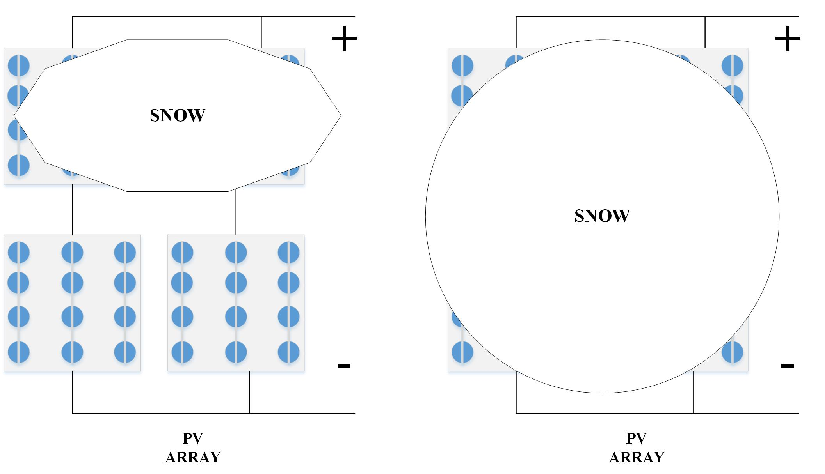
Figure 12. Partial shading due to snow.
- Hot Spots.
Hotspots mainly occur due to the high surface temperatures of the PV modules. Some of the regions have high heat concentrations due to some physical defects. Such as cell cracks and delamination etc, while other reasons may include partially shaded PV cells.
What happens is the regions with higher heat concentrations will cause differences in the I-V characteristics as compared to the overall I-V characteristics of the PV module. This may cause a mismatch and will cause a localized on the PV module's surface. This phenomenon is shown in Figure 13.
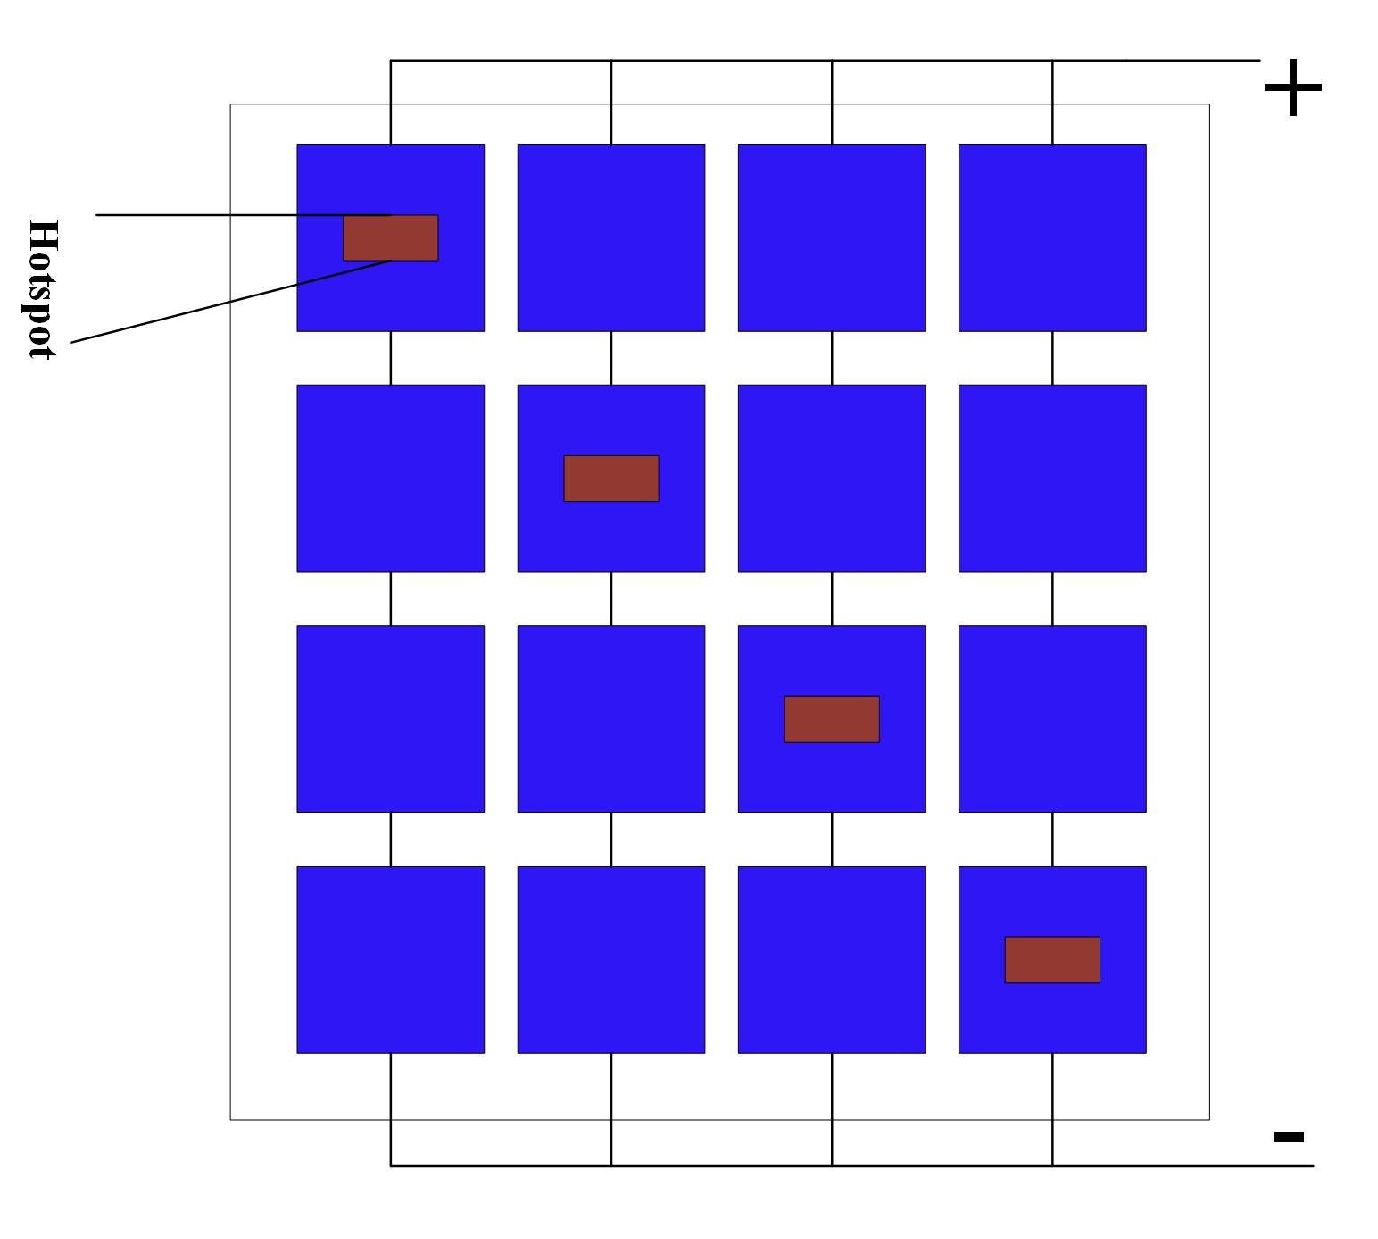
Figure 13. Hotspots fault in a PV module.
Heating due to hotspots occurs when the working value of the current becomes greater than the standard testing condition's short circuit current rating. The damage due to this fault can be normal to severe depending upon the magnitude of the fault and the duration of the given fault.
The causes behind this given fault are aging of the PV cells, cracks, mishandling, accumulation of dust, and partial shading [33-36], etc.
- Electrical Faults
The PV systems are classified as electrical systems. These are susceptible to conventional electrical systems faults such as short circuit faults, open circuit faults, earth faults, etc. The faults that occur between the conductors, frames, and a conducting device connected to the earth are classified as electrical faults.
Some other faults that are considered to be electrical faults occur in electrical devices and some measuring instruments. There are two major classifications in electrical faults, AC faults and DC faults.
- AC Faults.
There are two sides to the Photovoltaic power system. One is the DC side where the PV array is connected, PV array produces DC power. While there is a side where the inverter and utility grid is present known as the AC side. So, the faults that can occur in the inverter and Grid are classified as AC faults.

- Inverter Faults.
As the current at the output of the PV array is of a DC nature. PV arrays are DC devices, Now the inverter is connected in parallel with the PV array to convert the DC to AC at the required frequency level. Now the faults can occur in the inverter due to three main contributing factors.
Installation/configuration errors, overburden on the inverter, and uncontrolled voltages and currents [37]. The configuration is essential for any inverter according to the system installed and if the load exceeds the inverter rating this can be catastrophic. In the grid-tied inverters if the grid experiences any faults it will disconnect the PV system from the grid but if not done then it will be classified as an inverter fault.
- Grid Fault.
In a grid-connected PV system, an inverter is connected in parallel between the PV array and the grid. Now essentially during any fault occurrence in the grid, the inverter should disconnect the grid from the PV arrays so that further injection of power in the grid can be prevented. Now faults at the power distribution unit, breakage in transmission lines, blackouts, and overloading are classified as Grid faults [29].
- DC Faults.
At the DC side of the Photovoltaic system, the PV arrays are present with blocking diodes and bypass diodes. So, the faults occurring among the mentioned parts of the PV system’s DC side are classified as DC Faults. There are many further classifications of the DC faults but some of the most common and severe will be discussed below.
- MPPT Faults
In any PV system charge controllers/ regulators are present to extract the maximum power that is available during sun hours. The MPPT is run on an algorithm that can feed the maximum available power to the inverter for better working efficiency.
Now if any fault occurs in the charge controller may affect the ability of MPPT to maximize the power available. This type of fault is known as MPPT fault [29]. Due to this PV system suffers from power loss.

- Battery Bank related Fault
In a PV system, the need for a battery bank is imminent. When there are sun hours available the PV system will store the surplus power in the battery bank available. So that when there are no sun hours the battery can successfully supply the load the required power. Now when a fault occurs in the battery bank region it may be classified as the battery bank fault and it will be DC in nature.
The major reason behind this fault is the problems with the charging of batteries if the batteries are continuously charging even if their capacity is full it will cause harm to the battery as it will be overcharged.

- PV Array Faults
The most important part of any PV system is the PV array. Now most of the severe faults occur in this region of the system. Some of these faults are discussed below.
- Single Line-Ground Fault (S-L-G),
The single line-ground fault (SLG) is one of the most common and severe depending upon its position and nature. Figure 14 will elaborate it further. This type of fault occurs when a current-carrying conductor makes a connection with the ground due to some reason it will cause an increase in the short circuit current Isc value as compared to the standard testing conditions Isc. The affected module's open circuit voltages Voc will become 0V.
Overall the voltage of the PV array will be decreased due to this kind of fault and a noticeable difference among values will be seen. The direction of the current will be changed as can be seen in Figure 14, in string one the fault appeared in the last module so, the current will travel through the ground instead of going up in the string [29].

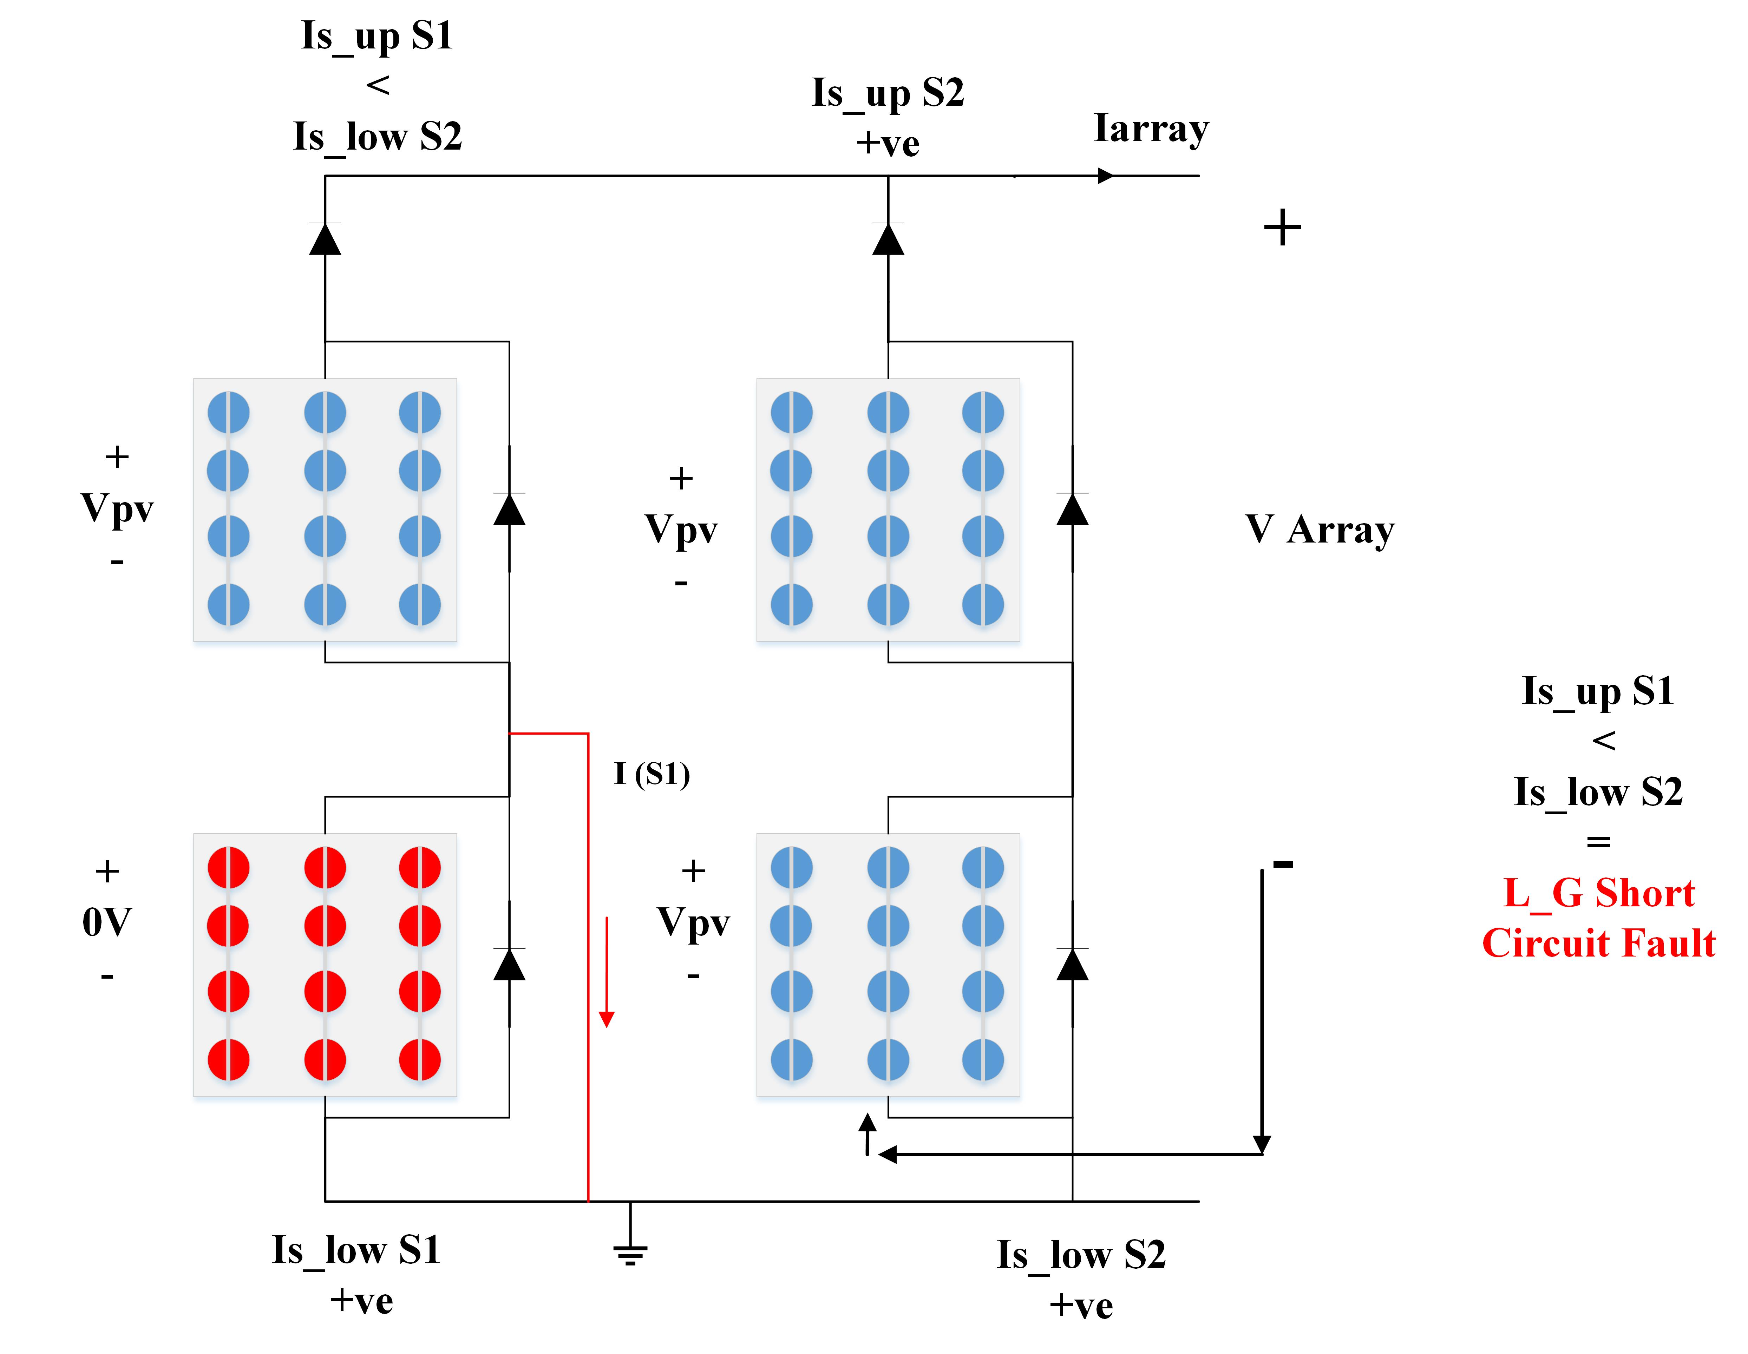
Figure 14. Single Line-Ground Fault (S-L-G).

- Multiple Line-Ground Fault (M-L-G)
According to Figure 14, if the 2nd string of a PV module faces an L-G fault condition then the (S-L-G) will become a Multiple Line-Ground Fault. Because there are two modules in 2 strings are faulty. In this condition, the overall PV array voltage will decrease further than the (S-L-G) fault conditions.
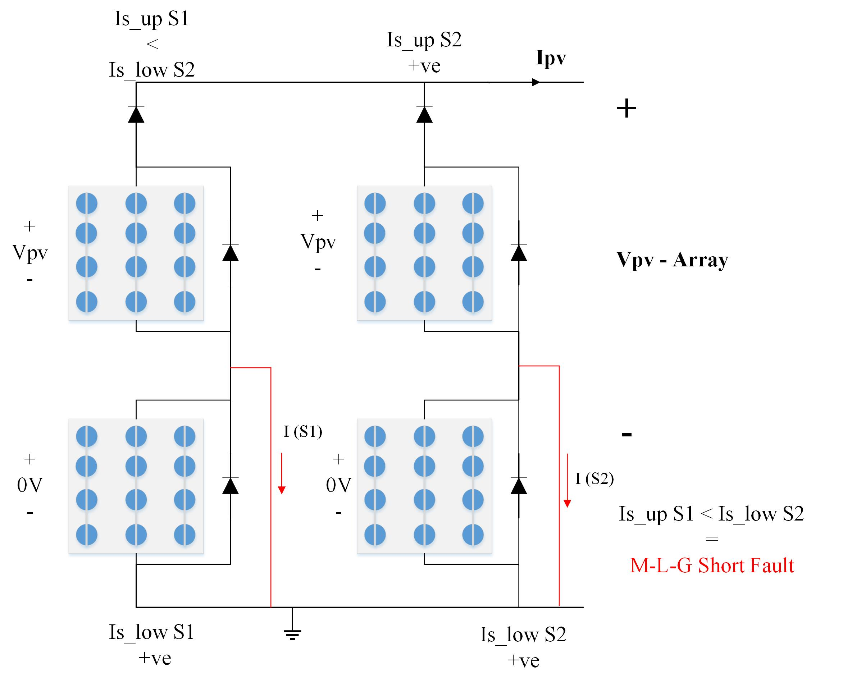Figure 15. Multiple Line- Ground Fault (M-L-G)

- Line-Line Fault in a similar string.
In Figure 16, a Line-Line Fault in a similar string is elaborated, There are two major classifications of Line-Line Fault in a PV system one is a Line-Line in a similar string and one is a Line-Line in multiple strings [33]. In the similar string L-L an accidental connection is made between modules in a similar string this causes the overall Voltage to PV array to be lower than the Standard PV array voltages and the current of the string will become 0A.
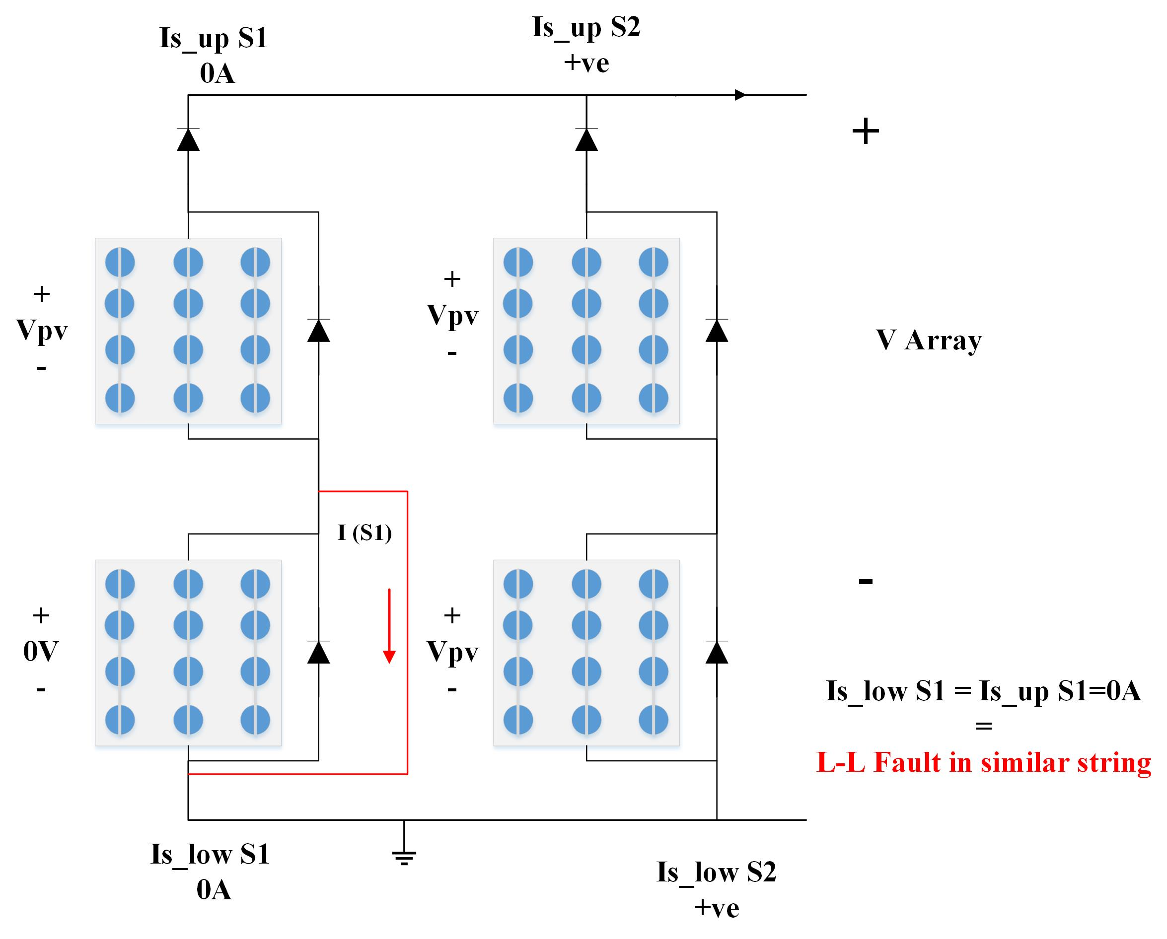
Figure 17. Line-Line Fault in a similar string.

- Line Line in multiple strings.
As discussed before a line-to-line fault is a connection of strings it can be in a similar string or with a neighboring string. Figure 18, will elaborate on the line-line fault among multiple strings.
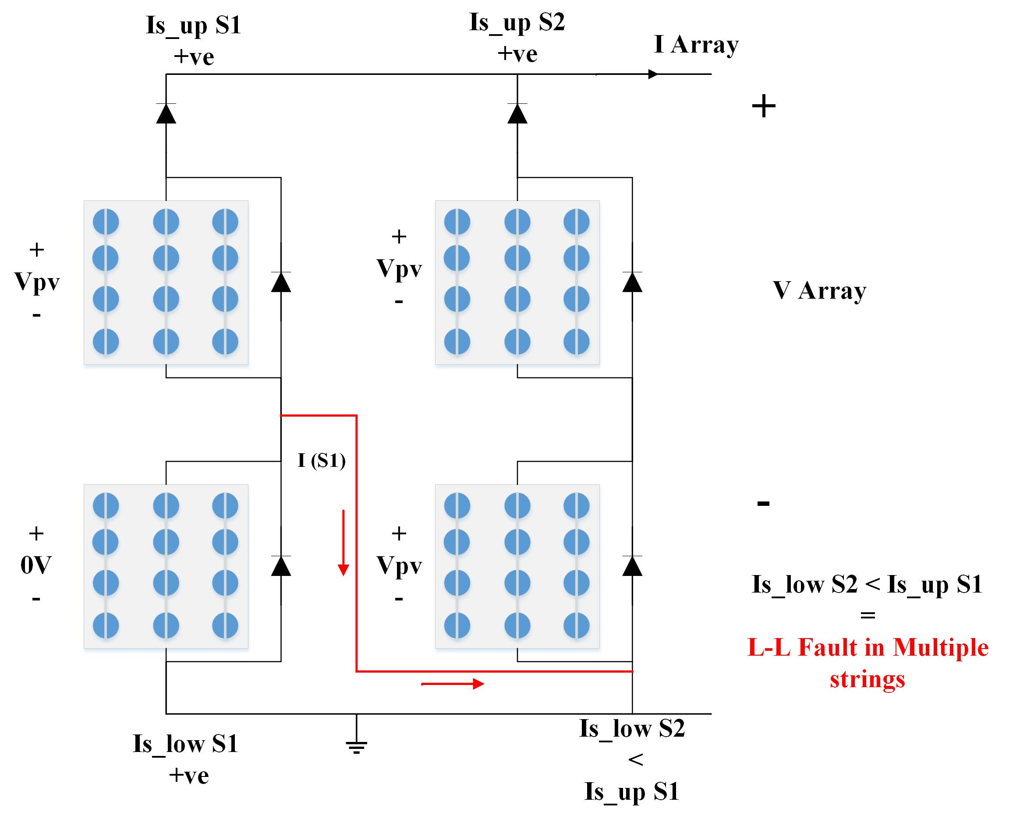
Figure 18. Line-Line in multiple strings.
In this type of fault the path of current is changed instead of following the conventional path the current will now enter in neighboring string.

- Open Circuit Fault
In an open circuit fault any module can be disconnected from the string or any string can be disconnected from the whole system. This type of fault usually occurs due to human error like improper connections, loose connections, etc.
Due to the open circuit fault, the short circuit current of the system decreases which will in return decrease the total array current and due to a decrease in array current the total power yield will decrease [24]. In Figure 19 a description of this fault can be seen.
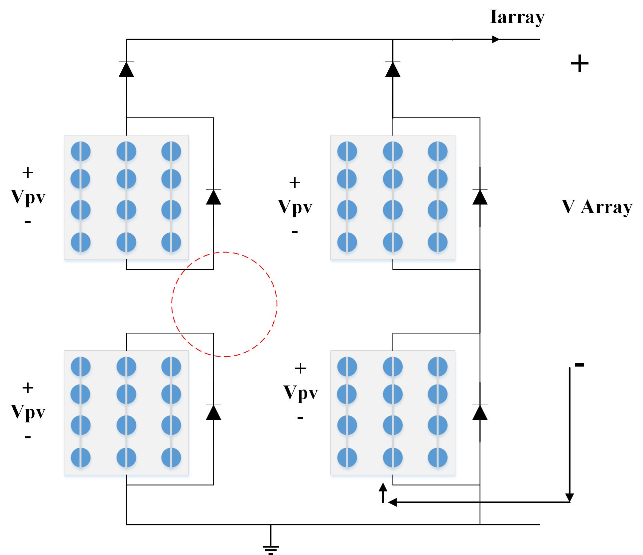
Figure 19. Open circuit fault.
It can be seen from the red encircled region in Figure 19. That the second module in string one is open circuited.
- Bypass Diode Faults
There are some protection devices present in a PV system one of them are blocking diodes those who prevent any reverse current in strings. While other are known as the bypass diodes. These diodes are connected in parallel with the PV module. Usually they remain inactive but whenever a shading fault occurs they gets active to prevent the PV module from getting burnt due to excessive heat produced by any PV module that experiences partial shading [38].
There can be two kinds of faults associated with the bypass diodes either they can be open circuited or short circuited. A figure 20 will discuss both these faults.
When the bypass diodes are faulty due to excessive heat hotspots will be created on the PV module that is experiencing the partial shading fault [24].
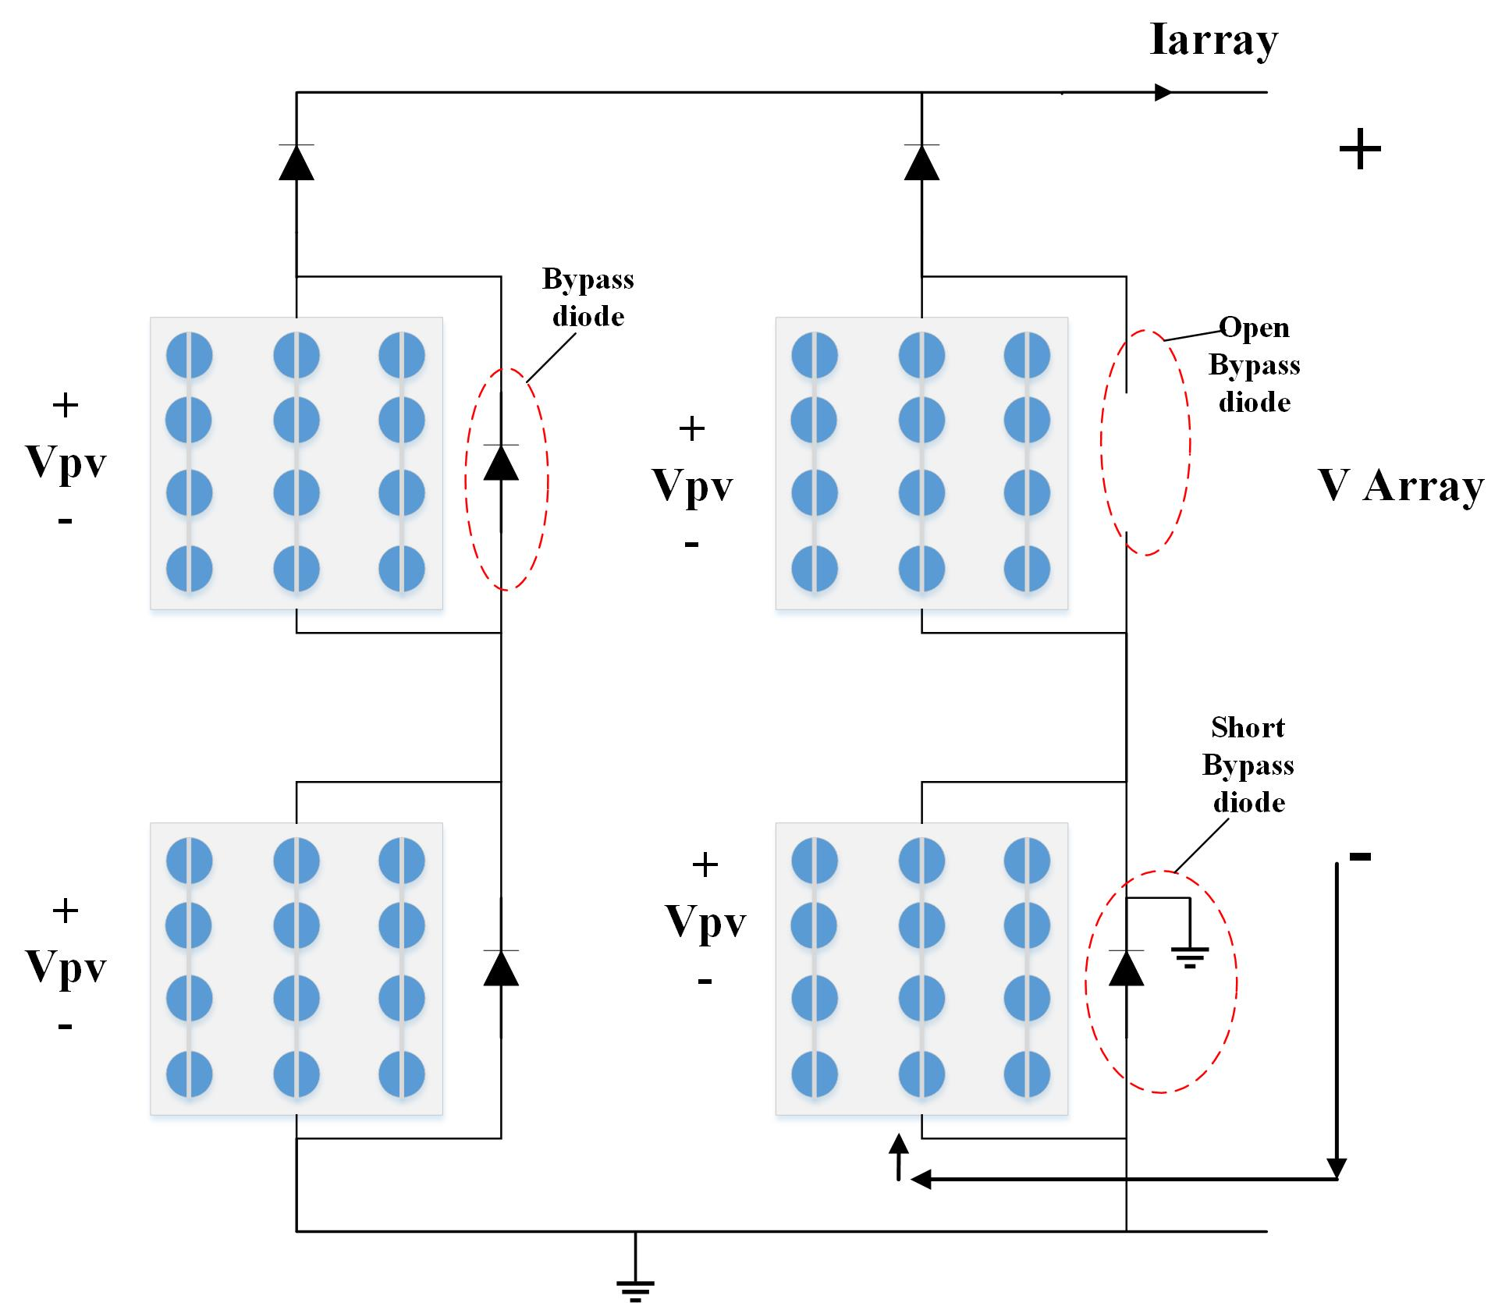
Figure 20. Bypass diode Faults.
A summary of all the faults discussed in the literature can be seen in Figure 21.
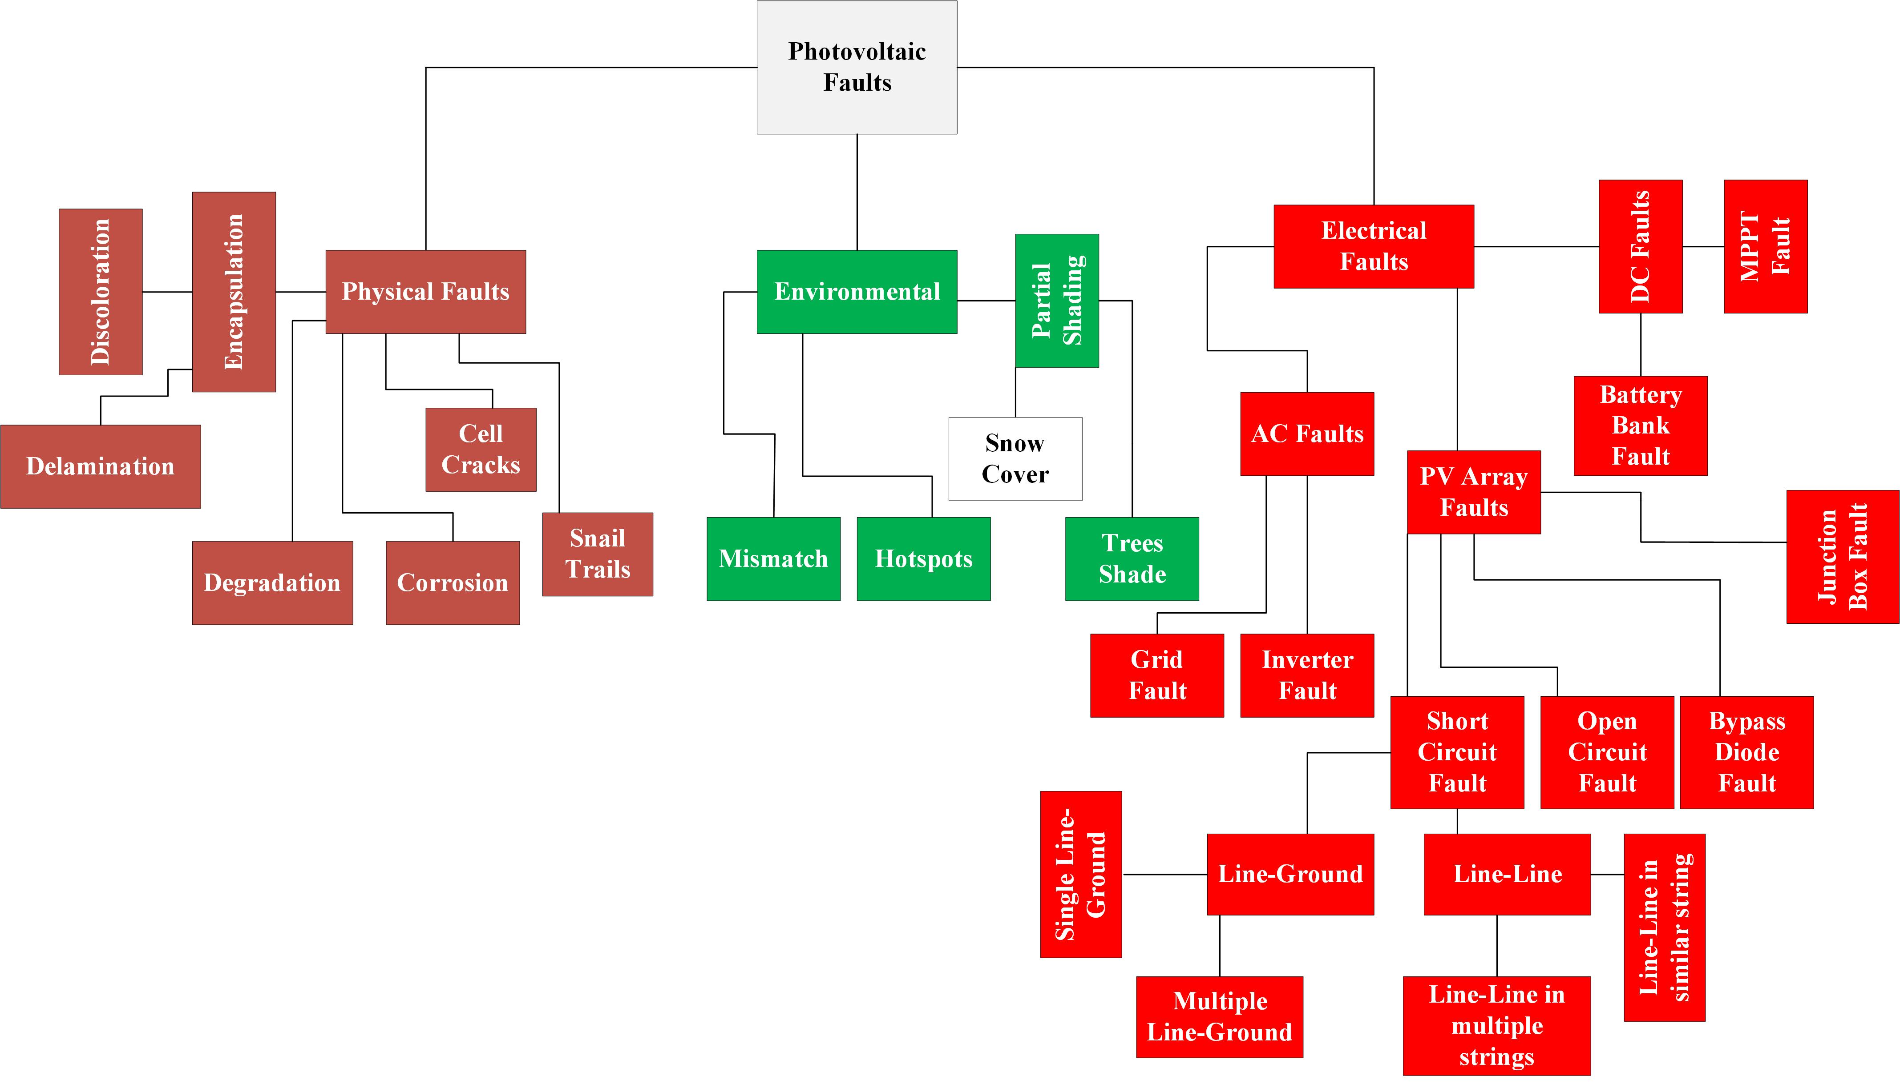
Figure 21. PV Faults Summary.

- Photovoltaics Fault Detection, Classification and Localization Techniques.
To this date, many researchers have developed techniques that will assist in PV fault detection and classification. Recently many have focused on not just detection and classification but also the successful localization of the faults that can occur in any kind of PV system.
There are four major categories of these techniques Statistical techniques, Visual and Thermal techniques, Machine Learning techniques, and Electrical-based techniques.
In this portion of the review, these techniques will be discussed in the given order.
- Statistical Techniques.
In this section, some of the most commonly used statistical techniques to detect the faults will be discussed and the PV faults that they can detect will be mentioned.
- K-nearest neighbor technique (KKN).
The (KKN) technique is commonly used for string-related faults in any PV system. These faults include open circuit faults and partial shading faults [39]. The technique employs an algorithm that will detect and classify the PV faults successfully.

- Exponentially weighted moving average method (EWMA).
The working principle of this technique is quite simple first for reference some parameters of normally working PV cells are gathered such as current and voltages under various temperatures and irradiation levels then they will be compared with the PV cell that is facing some sort of fault.
After this comparison, the (EWMA) chart will then be employed to detect and classify the PV fault [39].

- Univariate and multivariate EWMA.
Just like the (EWMA) this technique also uses the same working principle. This technique also employs a chart to identify the type of PV fault that is present. Just there is one shortcoming is that for detection through multivariate EWMA can be done one should first employ the univariate EWMA [39].
- Statistical t- Test.
Just like any other statistical technique, this one also uses the comparison of the data between the healthy PV module parameters and faulty PV module parameters. The main advantage of this technique over the others is that it can not only detect and classify the PV faults but can also find the location of the PV fault.
Another advantage of this technique is that it can be used as an automatic fault diagnostic by considering some environmental and electrical parametric data. For any kind of fault, PV module, PV strings, and MPPT regulator this technique can detect and classify them.
The localization in this technique is done by comparing the ideal and measured values gathered from the ratio between power and voltages of the faulty PV module [39].
- Earth Capacitance Measurement Technique.
This method is quite exclusive as it is used to detect anomalies in the PV system during some natural disasters. This method also relies on the comparison of data of a healthy PV string with a string containing faults.
This very technique does not depend upon any climatic data. It is quite suitable for the inspection of a PV system; it is suitable for diagnosing faulty connections in any string [23].
- Time Domain Reflectometry Technique.
The working principle of this technique is the comparison of the input signal from the PV system with the reflected signal. This technique is suitable for the detection, classification, and localization of the degradation faults by simply analyzing the disturbance or changes in the waveforms.
In this, the faulty connections and the changes they do to the impedance both are analyzed by the reflected signals [23].

- Visual and Thermal Techniques.
These techniques usually depend upon the visual and thermal analysis of faults in a PV system. These require infrared cameras and many other equipment required for the complete operation of these techniques. The already existing visual and thermal techniques are mentioned in the paragraphs below.
- Visual Inspection
One of the most commonly used and easy to understand among all the visual and thermal techniques is the visual inspection. The working principle of this method is the shade analysis.
With the help of an additional apparatus SolmetricSuneye the shading analysis is done, now this analysis is important to detect the potential anomalies related to the partial shading. This technique can monitor the system alongside all its components.
With the help of this technique, many potential faults like discarded ruins, leaf litter, and bird turds can be successfully diagnosed. The only drawback is the safety [40].
- Electroluminescence Imaging Technique.
Well, this technique is used for the characterization of the PV modules and is highly accurate. This technique provides us with a quick-resolution image that can detect PV faults like micro-cracks and delamination etc PV cells with increased series resistance in other words the degradation fault can also be detected by usage of this technique. The quality of electrical connections is also analyzed using this technique [41].
This technique is usually practiced in the low light like when there is no sunlight available. In this the faults are detected by the glow as the light is radiated through the excitation of the electrons and holes there occurs a glow, which grows as the rate of excitation increases this in return detects the potential anomalies [42].
- Infrared Thermography Technique.
Infrared thermal imaging for PV fault detection is contactless and safe. As the PV modules release electromagnetic waves the radiation process occurs. Now because of those electromagnetic waves infrared rays radiate as well.

Infrared radiation occurs due to the movement of atoms of an object whose temperature is above 0K or it contains external energy [43]. Infrared thermography (IRTG) is the most used technique for the detection, classification, and localization of the faults that can occur in the PV array side or some other components such as connector cables and junction boxes, etc.
This technique is economical and reliable it gives the complete 2D distribution of all the characteristics and parameters of the PV modules and it gives the results quite quickly. There are two further classifications of the IRTG and they are classified as active and passive infrared thermography.
- Active Infrared Thermography (IRTG).
The working principle of this technique is simple in that internal heat is flown into the object by simply increasing the temperature with the use of an external heat source [43].
The most commonly used and simple to comprehend is the pulsed active (IRTG). In this as the name suggests heat pulses are used. An external heat source such as a heat gun lamp, etc [44] releases heat pulses on the object that needs to be heated.
Another type of pulsed IRTG is the long pulsed active infrared thermography in this a continuous pulse from a low-power heat source but the main focus in the long pulse is the cooling [45].
The lock-in thermography is related to the oscillating temperature domain, In this internal faults in a PV system can be detected by the change in waves [46].
Vibro-active infrared thermography is related to mechanical vibrations what happens is that vibrations are applied and are converted into thermal energy that in return will detect faults like delamination etc by forming a hot spot at the place of damage [47].
- Passive Infrared Thermography
The passive thermography is known as the steady state conditions thermography this technique is cheaper and does not require any kind of external heating. Instead, it just works by collecting the infrared radiations from the PV modules. It only requires an Infrared camera [43].

The fault detection, classification, and localization can be done by simply observing the real-time imaging of the PV modules no hardware and humans are required for this technique.

- Machine learning Techniques.
In recent decades the artificial intelligence (AI) tool is quite famous as it can be used in various fields such as medicine, robotics engineering, language processing, and in some behavioral science, etc. It is a quite powerful tool as it can also be used for forecasting and predictions [48-49].
Machine learning (ML) is a subset of the AI techniques as it is actively used to date in many different projects and deep learning is further a subset of machine learning.
In the PV system, the (ML) that can be used are neural networks [50-51], fuzzy logics [52], decision trees [53], support vector machines [54], etc.
- Decision Tree (DT) Technique.
One of the widely used and easy to comprehend is the decision tree algorithm. This is one of the machine learning types. Recently it was discovered that this can straightaway detect the faults in a PV system with a impeccable accuracy of 99%.
The training of the model is quite on the expensive side the (DT) model will work with 99% accuracy only with the trained data set. This model may not work at its full potential if some unknown data that is different from the trained data is fed to the model [55-56].
- Probabilistic Neural Network (PNN) Technique.
This is a further classification of the neural network which is used to detect the problems related to patterns. In a PV array, this is used for the detection of pattern recognition faults. This technique does this for self-learning and parallel processing.
The PV parameters in their nominal operating conditions are fed to the PNN model to train the provided data set. Once the data set is trained the PNN can detect and classify faults.

The PNN technique is faster than the multilayer perceptron but its speed can be decreased when new data is fed. This technique is mostly used for modeling structural failures and character recognition [55, 57, 58].
- Artificial Neural Network (ANN) Technique.
Artificial neural networks (ANN) are the stacking of three layers in a feed-forward way. There are three layers of neural networks. This technique is 99% efficient which is better than the other neural network's accuracy for the detection and classification of faults in a PV system.
Only one layer is not responsible for the successful operation of this technique therefore multiple layers of ANN are intertwined together for the detection of faults in a PV system.
The detection process is self-learning and is automated no need for human is required to perform this technique. They need to be trained first for the maximum accuracy output [55, 59, 60].
- Multilayer perceptron ANN.
The faults in PV system that occurs due to environmental factors such as faults like partial shading can be detected and classified by the multilayer perceptron model with good working accuracy.
The data set is required for the training of the multilayer perceptron model the data set will include PV module parameters all the data is used by recorded observations over the time.
The training of the model is done by the Resilient back propagation algorithm after the training the fault is traced by the usage of computational analysis which was in return used for the approximation of the vital [55, 59].
- Deep Learning.
Machine learning (ML) is a subset of AI just like Deep Learning (DL) is a further subset of machine learning shown in Figure 22.

There are many algorithms available but the best deep learning algorithms for the fault tracing of PV systems are the convolutional neural network (CNN), recurrent neural network (RNN), long short-term memory (LSTM), and autoencoder/decoder [61-62].
- Convolutional neural network (CNN)
The CNN is different from the standard artificial neural networks (ANN) this type of data processing technique [63] uses convolution instead of the conventional matrix multiplication which possesses a grid-like structure [64].
The CNN is used for fault classification and detection by simply using three input parameters for the training of the data set and those three are PV normal current, PV normal voltage, and the fill factor. This technique is justified by the experimental test it successfully detects line-line and open circuit faults [65].
The more improved and data-efficient CNN is used by the combination of the convolution neural network (CNN) with a gated recurrent unit (GRU) which not only takes the I-V characteristics as input but also includes irradiation levels and the ambient temperature [66]. The actual working layers of this is elaborated in Figure 23.
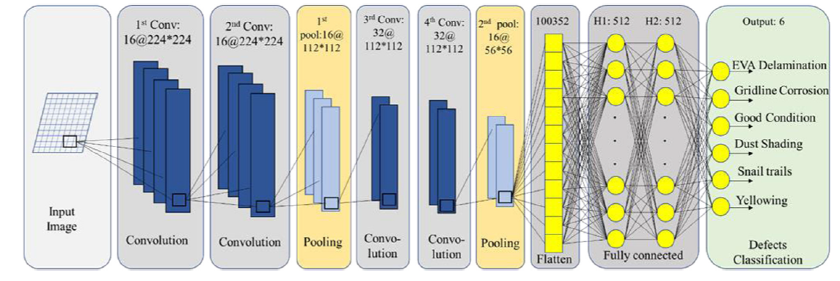
Figure 23. The architecture of the CNN for fault detection and classification in PV systems with depth DL [66].

- Long short-term memory networks (LSTM).
LSTM is on the types of the (RNN) the LSTM shines when there is an increased gap among the input and output sequences this is done by a gate known as the forget gate which is the part of a typical LSTM structure. The forget gate is a deficiency in the RNNs [67].
According to an experiment, an accuracy of 91.21% in PV fault detection was achieved by a system connected to the IEEE bus system with the help of the LSTM RNN [68].

- Generative adversarial neural networks (GAN) Technique.
The GAN consists of two different networks one is used for new data production known as the generative layer of the GAN architecture and the other layer is used for the evaluation of data for authentication this one is known as the discriminative network [69].
A static adversary is used for the training of the networks and for the reconstruction of the input layer GAN uses a special type of supervisory called supervised learning [70].
In [71] the GAN technique is used for the detection and classification of DC series arc faults of the PV system.

- Electrical based techniques.
One of the most commonly used techniques that are used for fault tracing in PV systems is the Electrical-based technique.
Conventionally these technique uses the I-V characteristics of the PV system for the tracing of the faults that can occur in a PV system or sometimes times usage of sensors is required.
- I-V characteristics curve analysis (IVCA).
Among all the Electrical-based techniques (EBT) the most common and easy to understand is the (IVCA) technique. In this technique, the I-V characteristic curve provides us with parameters like short circuit current (Isc) and open circuit voltage (Voc) of the PV module used and some other factors as well [72-73].
These parameters are then analyzed to detect and classify the type of fault the system is dealing with. The I-V curve is different for each fault case multiple faults can be traced using this technique the I-V curve for every kind of fault is given in Figure 8.
- Power Loss Analysis (PLA).
For the usage of this (PLA) technique the system under study needs to be monitored for extracting the parameters like current and voltages to find out the power losses of the system under study.
This is a comparative technique in which the power value simulated is compared with the measured or calculated power of the PV system.
Several simulations need to be done and then compared with the actual measured values. The detection and classification is done concerning the difference between simulated and measured values in other words by comparing the error in power of the system [24, 74].

- Sensors Based Techniques (SBT).
According to this recent years many researchers have set their sights on the fault detection, classification and localization of faults in a PV system.

The constant need for a low-cost fault tracing technique is required by optimizing the number of sensors used for the fault tracing process. After employing the sensors a microcontroller is required for the successful detection, classification, and localization of the PV faults. There are many techniques available and some of the most efficient ones are cited in this review.
- Diodes-based Technique.
The authors in [75] developed a new approach called diodes-based fault detection, classification, and localization of PV systems. In this technique, the diodes a connected to each string in two positions one is placed at the top of each string and one is placed above the last PV module in a PV string. The upper ones are connected to two voltage sensors and diodes above the last PV module are connected to one voltage sensor.
The placement of the sensors is of quite significance in the sensor-based techniques for fault diagnosis. In this technique from the upper two voltage sensors, one is for the fault detection and one for the location of the fault and the lower voltage sensor is for the fault classification.
Three parameters are evaluated for the successful working of this technique. One is the critical voltage (V_{C}), array voltage (V_{A}), and the (Voc). By the evaluation of these parameters, line-line and line-ground faults are diagnosed. A circuit diagram for this approach can be seen in [75].
- Two Current Sensors per string Technique.
The authors in [76] have developed a technique in which two current sensors were placed in every string, one is placed on top of the string and the other at the bottom of the same string. The technique incorporated a microcontroller, which will simply compare the information coming from the current sensors and will diagnose faults in a PV system.
Three important parameters were used for the fault diagnostic. Critical voltage, maximum voltages of the PV module, and the path of the current. The path of the current was identified with the help of the current sensors and the critical voltage was calculated with the help of a number of series PV modules (Ns) connected in a string multiplied by the open circuit voltages (Voc).

By carefully evaluation of the parameters detection and classification of line-line and line-ground faults of the PV system is done.
- Opto-coupler Based Technique.
The authors in [77] created a new approach for the detection, classification, and localization of partial shading faults in a PV system.
An optocoupler is an optical device that is electrically isolated. As we know there is a bypass diode present in parallel with the PV module. Now when there are normal conditions the current follows the conventional path since when there is partial shading the current will now flow through the bypass diode and the optocoupler will be in a high state while in normal conditions the optocoupler will be in a low state.

References.

[1] Tsai W-T, KuoK-C. An analysis of power generation from munici-pal solid waste (MSW) incineration plants in Taiwan. Energy 2010;35:4824–30.
[2]Mercure J-F, Salas P. An assessment of global energy resource economic potentials. Energy 2012;46:322–36.
[3] de Boer, Y., 2008. Kyoto protocol reference manual on accounting of emissions and assigned amounts [www document]. unfccc.int. URL https://unfccc.int/ documents/34558 (accessed 4.26.22).
[4] Madeti SR, Singh SN. A comprehensive study on different types of faults and detection techniques for solar photovoltaic system. Sol Energy 2017;158:161–85.
[5] Mantel, C., Villebro, F., Alves dos Reis Benatto, G., Rajesh Parikh, H., Wendlandt, S., Hossain, K., Poulsen, P.B., Spataru, S., Séra, D., Forchhammer, S., 2019. Machine learning prediction of defect types for electroluminescence images of photovoltaic panels. Applications of Machine Learning http://dx. doi.org/10.1117/12.2528440.
[6]
Espinosa AR, Bressan M, Giraldo LF. Failure signature classification in solar photovoltaic plants using RGB images and convolutional neural networks. Renew Energy 2020;162:249–56.
[7]SarikhS, Raoufi M, Bennouna A et al. Characteristic curve diagnosis based on fuzzy classification for a reliable photovoltaic fault monitoring. Sustain Energy Technol Assess 2021;43:1.
[8] Firth SK, Lomas KJ, Rees SJ. A simple model of PV system performance and its use in fault detection. Sol Energy 2010;84:624–35.
[9] Madeti SR, Singh SN. Monitoring system for photovoltaic plants: a review. Renew Sust Energ Rev 2017;67:1180–207.
[10] Ye, M. Y., Wang, X. D., and Xu, Y. S. (2009). Parameter Extraction of Solar Cells Using Particle Swarm Optimization. J. Appl. Phys. 105 (9), 094502. doi:10.1063/1.3122082.
[11] Murty, V. V. S. N., and Kumar, A. (2020). Multi-objective Energy Management in Microgrids with Hybrid Energy Sources and Battery Energy Storage Systems. Prot. Control. Mod. Power Syst. 5 (1), 1–20. doi:10.1186/s41601-019-0147-z.
[12] Nayak, B., Mohapatra, A., and Mohanty, K. B. (2019). Parameter Estimation of Single Diode PV Module Based on GWO Algorithm. Renew. Energ. Focus 30,1–12. doi:10.1016/j.ref.2019.04.003.
[13] Guchhait, P. K., and Banerjee, A. (2020). Stability Enhancement of Wind Energy Integrated Hybrid System with the Help of Static Synchronous Compensator and Symbiosis Organisms Search Algorithm. Prot. Control. Mod. Power Syst. 5 (2), 138–150. doi:10.1186/s41601-020-00158-8.
[14] Humada, A. M., Hojabri, M., Mekhilef, S., and Hamada, H. M. (2016). Solar Cell Parameters Extraction Based on Single and Double-Diode Models: A Review. Renew. Sustainable Energ. Rev. 56, 494–509. doi:10.1016/j.rser.2015.11.051.
[15] Jordehi, A. R. (2016). Parameter Estimation of Solar Photovoltaic (PV) Cells: a Review. Renew. Sustainable Energ. Rev. 61, 354–371. doi:10.1016/j.rser.2016.03.049.
[16] Ishaque, K., and Salam, Z. (2011). An Improved Modeling Method to Determine the Model Parameters of Photovoltaic (PV) Modules Using Differential Evolution (DE). Solar Energy 85 (9), 2349–2359. doi:10.1016/j.solener.2011.06.025.
[17] Zhang, X. S., Li, S. N., He, T. Y., Yang, B., Yu, T., Li, H. F., et al. (2019). Memetic Reinforcement Learning Based Maximum Power point Tracking Design for PV Systems under Partial Shading Condition. Energy. 174, 1079–1090. doi:10.1016/ j.energy.2019.03.053.

[18]
Ishaque, K., Salam, Z., Taheri, H., and Shamsudin, A. (2011). A Critical Evaluation of EA Computational Methods for Photovoltaic Cell Parameter Extraction Based on Two Diode Model. Solar Energy. 85 (9), 1768–1779. doi:10.1016/j. solener.2011.04.015.

[19] Florida Solar Energy Center. (2014). Types of PV Systems. Retrieved from: http://www.fsec.ucf.edu/en/consumer/solar_electricity/basics/types_of_pv

[20] Kim, S.-K., Jeon, J.-H., Cho, C.-H., Kim, E.-S., Ahn, J.-B., 2009. Modeling and simulation of a grid-connected PV generation system for electromagnetic transient analysis. Sol. Energy 83 (5), 664–678.
[21] Anon, 2021b. Https://backend.orbit.dtu.dk/ws/portalfiles/portal/192237454/ machine_learning_pr, pastebin. [Online]. Available: https://pastebin.com/ LFp119uK. (Accessed: 04 November 2021).
[22] Nilsson D. Fault Detection in Photovoltaic Systems. Digitala Vetenskapliga Arkivet, 2014. URN: urn:nbn:se:kth:diva – 153945.
[23] Triki-Lahiani A, Abdelghani AB-B, Slama Belkhodja I. Fault detection and monitoring systems for photovoltaic installations: a review. Renew Sust Energ Rev 2018; 82:2680–92.
[24] Abdul Mawjood K, Refaat SS, Morsi WG. 2018. Detectionandpre-diction of faults in photovoltaic arrays: A review. In 2018 IEEE 12th International Conference on Compatibility, Power Electronics and PowerEngineering (CPE-POWERENG2018).IEEE,1-8. https://doi.org/10.1109/CPE.2018.8372609.

[25] Sarikh S, Raoufi M, Bennouna A etal. 2018. Photovoltaic discoloration and cracks : experimental impact on the IV curve degradation. In International Conference on Electronic Engineering and Renewable Energy. Proceedings of the 9th International Renewable Energy Congress (IREC),Hammamet, Tunisia, 26–28 March 2018, 609–16.
[26] Abd, AllahS, Gharabawy E. Review on corrosion in solar panels. Int J Smart Grid 2018; 2: 218.
[27] Singh D, Kathuria RS . Fault prediction and analysis techniques of solar cells and PV modules. Int J Eng Sci Res Technol 2018;7:384–99.
[28]
Yang H, Chang J, Wang H etal. Power degradation caused by snail trails in urban photovoltaic energy systems. Energy Procedia 2016;88:422–8
[29] Mahalakshmi R, Karuppasamypandiyan M, Bhuvanesh A etal.Classifica-tion and detection of faults in grid connected photovoltaic system. Int J Sci Eng Res 2016;7:149–54.
[30] Niazi KAK, Yang Y, Sera D. Review of mismatch mitigation techniques for PVmodules. IET Renew Power Gener 2019;13:2035–50.
[31] Andrews RW, Pollard A, Pearce JM. The effects of snow fall on solar photovoltaic performance. Sol Energy 2013;92:84–97.
[32] Heidari N, Gwamuri J, Townsend T etal. Impact of snow and ground inter-ference on photovoltaic electric system performance. IEEE J Photovoltaics 2015;5:1680–5.
[33] Appiah AY, Zhang X, Ayawli BBK etal. Review and performance evalua-tion of photovoltaic array fault detection and diagnosis techniques. pg1110 2019;2019:1–19.
[34] Bharadwaj P, Karnataki K, John V. 2018. Formation of hotspots on healthy PV modules and their effect on output performance. In 2018 IEEE 7th World Conference on Photovoltaic Energy Conversion (WCPEC) (A joint conference of 45th IEEE PVSC, 28th PVSEC & 34th EU PVSEC). IEEE, 676–80.
[35] Wang Y, Itako K, Kudoh T etal. Voltage-based hot-spot detection method for PV string using projector. IEEE International Conference on Power and Renewable Energy (ICPRE) 2016; 2016: 570–4.
[36] Wendlandt S, Drobisch A, Buseth T etal. 2010. Hotspot risk analysis on silicon cell modules. In 25th European Photovoltaic Solar Energy Conference and Exhibition. EU PVSEC, 4002–6.
[37] Batzelis E, Samaras K, Vokas G etal. Off-grid inverter faults: diagnosis, symptoms and cause of failure. Mater Sci Forum 2016; 856: 315–21.
[38] Vieira RG, de Araújo FMU, Dhimish M etal. A comprehensive review on bypass diode application on photovoltaic modules. Energies 2020;13:2472.
[39] Zinger DS. Review on methods of fault diagnosis in photovoltaic system applications. J Eng Sci Technol Rev 2019;12:53–66.
[40] Bosman LB , Leon-Salas WD, Hutzel W etal. PV system predictive maintenance: challenges, current approaches, and opportunities. Energies 2020;13:1398.
[41] Drabczyk K, Kulesza-Matlak G, Drygała A etal. Electroluminescence imaging for determining the influence of metallization parameters for solar cell metal contacts. Sol Energy 2016;126:14–21.
[42] dos Reis Benatto GA etal. Drone-based day light electroluminescence imaging of PV modules. IEEE J. Photovoltaics 2020;10:872–7.
[43] Kandeal AW, Elkadeem MR, Thakur AK, Abdelaziz GB, Sathyamurthy R, Kabeel AE, Yang N, Sharshir SW (2021) Infrared thermography-based condition monitoring of solar photovoltaic systems: a mini review of recent advances. Sol Energy 223:33–43. https://doi.org/10.1016/j.solener.2021.05.032.
[44] Maldague X, Galmiche F, Ziadi A (2002) Advances in pulsed phase thermography. Infrared Phys Technol 43(3–5):175–181.
[45] 48. Sinha A, Sastry OS, Gupta R (2016) Detection and characterization of delamination in PV modules by active infrared thermography. Nondestruct Test Eval 31(1):1–16
[46] Datong W, Gerd B (1998) Lock-in thermography for nondestructive evaluation of materials. Rev Therm 37(8):693–703
[47] Rantala J, Wu D, Busse G (1996) Amplitude-modulated lock-in vibrothermography for NDE of polymers and composites. Res Nondestr Eval 7(4):215–228.
[48] Hong Y-Y, Pula RA (2022) Methods of photovoltaic fault detection and classification: a review. Energy Rep 8:5898–5929. https://doi.org/10.1016/j.egyr.2022.04.043
[49] Li B, Delpha C, Diallo D, Migan-Dubois A (2021) Application of artificial neural networks to photovoltaic fault detection and diagnosis: a review. Renew Sustain Energy Rev 138:110512. https://doi.org/10.1016/j.rser.2020.110512.
[50] El-Rashidy MA (2022) An efficient and portable solar cell defect detection system. Neural Comput Appl 34:18497–18509. https:// doi.org/10.1007/s00521-022-07464-2.
[51] Herraiz AH, Marugan AP, Marquez FPG (2020) Photovoltaic plant condition monitoring using thermal images analysis by convolutional neural network-based structure. Renew Energy 153:334–348. https://doi.org/10.1016/j.renene.2020.01.148
[52] Balasubramani G, Thangavelu V, Chinnusamy M, Subramaniam U, Padmanaban S, Mihet-Popa L (2020) Infrared thermography based defects testing of solar photovoltaic panel with fuzzy rulebased evaluation. Energies 13:1343. https://doi.org/10.3390/ en13061343
[53] Madeti SR, Singh SN (2018) Modeling of PV system based on experimental data for fault detection using kNN method. Sol Energy 173:139–151
[54] Ali MU, Khan HF, Masud M, Kallu KD, Zafar A (2020) A machine learning framework to identify the hotspot in photovoltaic module using infrared thermography. Sol Energy 208:643–651. https://doi.org/10.1016/j.solener.2020.08.027.
[55] Pillai DS, Rajasekar N. A comprehensive review on protection challenges and fault diagnosis in PVsystems. Renew Sust Energ Rev 2018;91:18–40.
[56] ZhaoY, Yang L , Lehman B etal. 2012. Decisiontree-based fault detection and classification in solar photovoltaic arrays. In 2012 Twenty-Seventh Annual IEEE Applied Power Electronics Conference and Exposition (APEC). IEEE,93–9.
[57] Kebir ST, Cheggaga N, Ilinca A etal. An efficient neural network-based method for diagnosing faults of PV Array. Sustainability 2021;13:6194.
[58] RakeshN, Banerjee S, Subramaniam S etal . A simplified method for fault detection and identification of mismatch modules and strings in a grid-tied solar photovoltaic system. Hunted Heretic; the Life and Death of Michael Servetus, 1511–15532020;21:2.
[59] Basnet B, Chun H, Bang J. An intelligent fault detection model for fault detection in photovoltaic systems. J Sens 2020;2020:1–11.
[60] Aslam M, Lee J-M, Hong S. A multi-layer perceptron based deep learning model to quantify the energy potentials of a thin film a-Si PV system. Energy Rep 2020;6:1331–6
[61] Hong Y-Y, Pula RA (2022) Methods of photovoltaic fault detection and classification: a review. Energy Rep 8:5898–5929. https://doi.org/10.1016/j.egyr.2022.04.043.
[62] Alpaydin E (2016) Machine Learning: The New AI. MIT Press, Cambridge
[63]
LeCun Y, Bengio Y, Hinton G (2015) Deep learning. Nature 521:436–444
[64] Goodfellow I, Bengio Y, Courville A, Bengio Y (2016) Deep learning, vol 1. MIT Press, Cambridge.
[65] Zaki, S., Zhu, H., Fakih, M., Sayed, A., Yao, J., 2021. Deep-learning–based methodfor faults classification of PV system. IET Renew. Power Gener. 15 (1), 193–205.
[66] Li, X., Yang, Q., Lou, Z., Yan, W., 2019. Deep learning based module defect analysis for large-scale photovoltaic farms. IEEE Trans. Energy Convers. 34 (1), 520–529.
[67] Hochreiter S, Schmidhuber J (1997) Long short-term memory.
Neural Comput 9:1735–1780
[68] Veerasamy V et al (2021) LSTM recurrent neural network classifier for high impedance fault detection in solar PV integrated power system. IEEE Access 9:32672–32687
[69] Goodfellow I, Pouget-Abadie J, Mirza M, Xu B, Warde-Farley D, Ozair S, Bengio Y (2014) Generative adversarial nets. In: Advances in neural information processing systems, pp 2672–280
[70] Mellit A, Kalogirou S (2021) Artificial intelligence and internet of things to improve efficacy of diagnosis and remote sensing of solar photovoltaic systems: challenges, recommendations and future directions. Renew Sustain Energy Rev 143:110889. https:// doi.org/10.1016/j.rser.2021.110889.
[71] Lu S, Sirojan T, Phung BT, Zhang D, Ambikairajah E (2019) DA-DCGAN: An effective methodology for DC series arc fault diagnosis in photovoltaic systems. EEE Access 7:45831–45840.
[72]. Fadhel S, Delpha C, Diallo D, Bahri I, Migan A, Trabelsi M, Mimouni MF (2019) PV shading fault detection and classification based on I–V curve using principal component analysis: application to isolated PV system. Sol Energy 179:1–10.
[73] Ko¨ntges M, Kurtz S, Packard C, Jahn U, Berger K, Kato K, Friesen T, Liu H, Iseghem MV, Wohlgemuth J, Miller D, Kempe M, Hacke P, Reil F, Bogdansk N, Herrmann W, Buerhop-Lutz C, Razongles G, Friesen G (2014) Review of failures of photovoltaic modules—iea-pvps [www document]. https://iea-pvps.org.
[74] Chouder A, Silvestre S. Automatic supervision and fault detection of PV systems based on power losses analysis. Energy Convers Manag 2010;51:1929–37
[75] Ahsan Mehmood , Hadeed Ahmed Sher, Ali Faisal Murtaza , and Kamal Al-Haddad , A Diode-Based Fault Detection, Classification, and Localization Method for Photovoltaic Array, IEEE Transactions on Instrumentation and Measurement, vol. 70, 2021.
[76] Ali F Murtaza, Mohsin Bilal, Riaz Ahmad, Hadeed Ahmed Sher A Circuit Analysis based Fault Finding Algorithm for Photovoltaic Array under L-L/L-G Faults, IEEE Journal of Emerging and Selected Topics in Power Electronics 2019.
[77] Ali F Murtaza, Hadeed Ahmed Sher, Kamal Al-Haddad, Filippo Spertino; Module Level Electronic Circuit Based PV Array for Identiﬁcation and Reconﬁguration of Bypass Modules, ieee transactions on energy conversion, VOL. 36, NO. 1, MARCH 2021.

