A Deep Learning-Based Framework for Precision Agriculture to Monitor Crop Health, Detect Diseases, and Predict Yield Using Drone and Satellite Image Analysis

Chinnem Rama Mohan¹, Palaganti Venkata Nagendra Sai Sandeep², A. Ashok Kumar³, S. Kiran^{4*}
¹Department of CAI & CSD/CAD, Narayana Engineering College Nellore, Andhra Pradesh, 524004, India
²Department of CSE, Narayana Engineering College Nellore, Andhra Pradesh, 524004, India
³Department of Physics, YSR Engineering College of YVU, Proddatur, Andhra Pradesh, 516360, India
*⁴Department of CSE, YSR Engineering College of YVU, Proddatur, Andhra Pradesh, 516360, India
* Corresponding Author: S. Kiran, Email ID: rkirans125@gmail.com
Abstract:
Artificial intelligence, specifically deep learning, is gradually changing the agricultural industry as it is introduced to new forms of data analysis and image recognition. It is different from conventional machine learning because this technology generates useful findings from a vast amount of farming data without human intervention. The deep learning models are also very effective in processing data from sensors, drones, and satellites to provide farmers with a detailed view of their crops and fields. This assists to enhance the efficiency in precision farming, and here, water, fertilizer, and pesticide among other necessities are applied only where and when they are needed. It also supports the accomplishment of the maximal producing activity without increasing the risks of detrimental environmental impacts. One of the most vital use cases of deep learning is the observation of the condition of crops. These deep learning models diagnose diseases, determine nutrient deficiencies and pests that may be infecting crops at an early stage, through captured images from drones or ground cameras. This enables farmers to undertake particular actions to avert crops being destroyed, and thereby enhance the production and availability of food. Deep learning in particular also holds a few promises in the estimation of crop yields. These models engage in field image analysis and can thus estimate crop yields. Such data provides farmers with better understanding on how to make right choices in terms of resource management, timing of harvesting, and promotion of farming produce in the market. In addition to the massive opportunities, there are unique difficulties involved in applying deep learning in agriculture. These models can only be successful if they are fed with large and high-quality data for training purposes. Additionally, for it to be implemented on large scale it has to be accessible and affordable for all the small-scale farmers. Last but not the least, the invention of deep learning has led to a revolutionary strategy in the field of agriculture. Being equipped with intelligent devices for data analysis and image recognition, a farmer is given a gadget that can help to improve resource usage, monitor crop condition, and guarantee further food supply.
Keywords: Deep learning; Precision Agriculture; Remote sensing; Crop Monitoring; Weed Detection and Management; soil analysis; Satellite Image Analysis; Food Quality Inspection; Harvesting systematization; Irrigation Management; Yield Prediction; Crop Classification and analysis; Sustainable Farming Practice.

- Introduction
The agriculture sector, the backbone of the world feeding the population, has much to combat. Feeding the world of increasing demands requires more efficiency and effective use of resources while paying attention to resilience in the face of climate change and unpredictable weather. This is when deep learning, a leading-edge direction of AI, takes the lead here as a game-changer.
Deep neural networks reproduce the structure and capability of the human mind by using it to learn complex patterns from mass data repositories. Unlike machine learning methods of the past, which might use pre-specified features, deep learning does very well in automatically extracting useful information from agricultural data. The data may be collected from different sources, like soil moisture monitoring sensors, high-resolution crop image capture by drones, and weather pattern tracking satellites.
Through deep learning, farmers consider numerous factors and make decisions that improve agricultural practices overall. This result gives birth to a new form of precision agriculture, where water, fertilizer, and pesticides are consumed with targeted precision, causing less waste and environmental impacts.
Deep learning technology has unlimited uses in agriculture and continues to advance. From early detection of diseases in crops to estimating yields and having intelligent irrigation systems, deep learning provides a beneficial collection of tools that may be used to increase agricultural productivity and sustainability. The following sections will be dedicated to the deep-learning applications revolutionizing agricultural landscapes.
Objectives:
- Tailoring Farming Practices to Individual Needs: Focus on personalized agriculture approaches tailored to individual farms or fields, leveraging deep learning to analyze specific data points and provide customized recommendations for optimal crop management, resource allocation, and decision-making.
- Improved Crop Monitoring and Management: Develop deep learning techniques to analyze agricultural data, including satellite imagery, soil samples, and weather patterns, with high precision to enable early detection of crop diseases, pest infestations, and nutrient deficiencies. This facilitates timely interventions and adjustments in cultivation practices to maximize yield and quality.
- Enhanced Predictive Analytics: Utilize deep learning predictive modeling to assess risk factors and potential challenges in agricultural production, allowing farmers to proactively address issues such as adverse weather conditions, market fluctuations, and resource shortages. This empowers farmers to adopt preventive strategies and optimize resource utilization for sustainable agriculture.

This article explores the possibilities of using deep learning to revolutionize agriculture, outlining its central concepts, diverse applications, and challenges.
- Core Principles and Applications: Detailed underlying principles of deep learning algorithms in agriculture and explore their applications in various domains, including crop monitoring, pest management, and yield prediction. They highlighted the potential of deep learning to revolutionize agricultural practices and improve productivity.
- Challenges and Considerations: Addressed vital challenges such as data quality, scalability, and interpretability of deep learning models in agriculture. He emphasized the importance of transparent and ethical development practices to ensure the trustworthiness and reliability of AI-driven solutions in agriculture.
- Algorithms and Future Directions: We outline the practical strategies for responsible implementation and advancement of deep learning in agriculture, including ongoing sensor technologies and data analytics developments. We discuss future directions, such as integrating robotics and precision farming techniques to enhance agricultural productivity and sustainability further.
- Conclusion: This section highlights the transformative potential of deep learning in agriculture, from personalized crop management to proactive risk mitigation. It stresses the importance of embracing safe and ethical practices in the development and deployment of AI technologies to foster sustainable agricultural innovation.

Vision:
Enhanced Precision and Resource Management:
- Deep learning models can evaluate datasets from diverse sources through careful analysis, developing the most accurate field maps that guide precision watering, fertilization, and pest control.
- This exacting methodology ensures meticulous use of resources, consequently helping to avoid unnecessary pollution and waste.
- Farmers may make real-time decisions based on data that consider crop needs, weather patterns, and other local conditions to allocate farm resources where they are relevant.
Improved Crop Health and Disease Management:
- Deep learning models do wonders in discovering patterns in images very well. This empowers the build-up of the surveillance of diseases and pests using armed images from drones or ground-based cameras.
- The earlier and more accurate the detection, the timelier intervention is provided, which prevents crop loss and, hence, maintains food security.
- With the help of deep learning approaches, data from the past can be analyzed to implement disease forecasting based on weather conditions and crop health indicators.
Increased Yield and Productivity:
- Through the analysis of field images, deep learning models can predict the crop yield with extreme accuracy.
- This gives farmers the power to more efficiently plan multiple resources, schedule harvesting, and develop market strategies.
- Hence, Deep learning enables the automation of picking devices that can identify and bring in fully matured crops with higher precision and reduced workforce costs.
Sustainable Farming Practices:
- Deep learning models can learn soil quality status and suggest adequate fertilizer rates, thus contributing to environmental pollution prevention.
- Deep learning can design irrigation systems that minimize water wastage and promote sustainable water management by anticipating requirements in a highly precise manner.
- Deep learning-based precision agriculture equipment could help us curtail the greenhouse gases produced by traditional farming systems.
Democratization of Knowledge and Decision-Making:
- Deep learning models can process vast amounts of data and turn it into practical recommendations that farmers can adopt, even with limited agronomical expertise.
- The creation of simple interfaces and mobile applications for small farmers is a must for promoting deep learning tools and thus making the agricultural sector flexible and accessible.

Mission:
Building a Robust Data Infrastructure:
- Create standardized collection workflows for sensors, quadcopters, and satellites to maintain their data quality and interoperability.
- Create representations of the data in a secure and accessible repository to share and understand agricultural data among farmers, which will, in turn, bring collaboration and innovation.
- Promoting and cognizing farmers through equipping them with skills for inputting data, maintaining it, saving it, and using it correctly.
Democratizing Access to Deep Learning Technologies:
- Design cost-effective and farmer-friendly deep learning platforms, creating customized technologies to meet farmers' limited resource requirements.
- Design educational programming and training materials that guide farmers through deep learning technologies and help them utilize their skills adequately.
- Support collaborations between deep learning specialists, agricultural extension offices, and technology businesses to give rise to the effective deployment of the technology.
Advancing Research and Development:
- Enhance deep learning algorithms constantly for smart farming purposes, making areas such as early disease detection and weather prediction the top priorities.
- Explore the synergy of deep learning with other forthcoming technologies, such as robotics and the Internet of Things (IoT), and utilize such systems to make intelligent agriculture feasible.
- Fund into the ethical questions of deep learning in farming; resolving the data privacy and algorithmic bias dilemmas would be an essential part of the task.
Promoting Environmental Sustainability:
- Build artificial intelligence to enhance the efficiency and effectiveness of irrigation, phasing restrictions on chemical solutions, and soil quality care.
- Utilize the powerful capabilities of deep learning to trace and measure pollutants such as greenhouse gas emissions and influence the adoption of responsible resource utilization methods.
- Collaborate with politicians to design and pass laws and incentives that encourage the adoption of deep learning technologies to create environmentally sustainable agriculture.
Fostering Global Collaboration:
- Create international research collaborations to disseminate knowledge and compendium efficient examples in deep learning for agriculture.
- One of the themes in the structure is identifying the data privacy and security issues related to global data transfer for agricultural applications.
Roles:
Disease and Pest Detection: Deep learning can perceive the disease and pest levels in the crops by analyzing drone and ground-based camera imagery in the early stages of these diseases. As a result, measures can be initiated at the right stage, and a minimal number of crops could be lost.
Yield Prediction: From the critical point of analyzing field images, deep learning technologies can forecast the crop yield with surprisingly high accuracy. It allows farmers to put their resources to better use for planning wise usages of farming inputs, harvesting, and the right marketing strategies for their produce.
Weed Detection and Control: An area where deep learning algorithms can excel is the capability to zoom in on crops and differentiate them from weeds in the imagery. Thus, there is a scope for target-specific weed control that reduces herbicide application.
Soil Management: Using deep learning models allows us to read from soil data regarding the fertility level, moisture content, and any potential deficiencies. Knowing the fertilization requirement of the envisaged crop will allow the farmer to optimally apply fertilizer and sustain soil health.
Precision Irrigation: Through running models of weather data, soil moisture, and crop requirements, deep learning can direct irrigation system's water use to a minimum without reducing crop water use efficiency.
Livestock Management: Deep learning can be a useful tool for monitoring animal health, predicting disease incidences, and optimizing livestock feeding.

Figure –1 depicts the roles of deep learning in Agriculture:

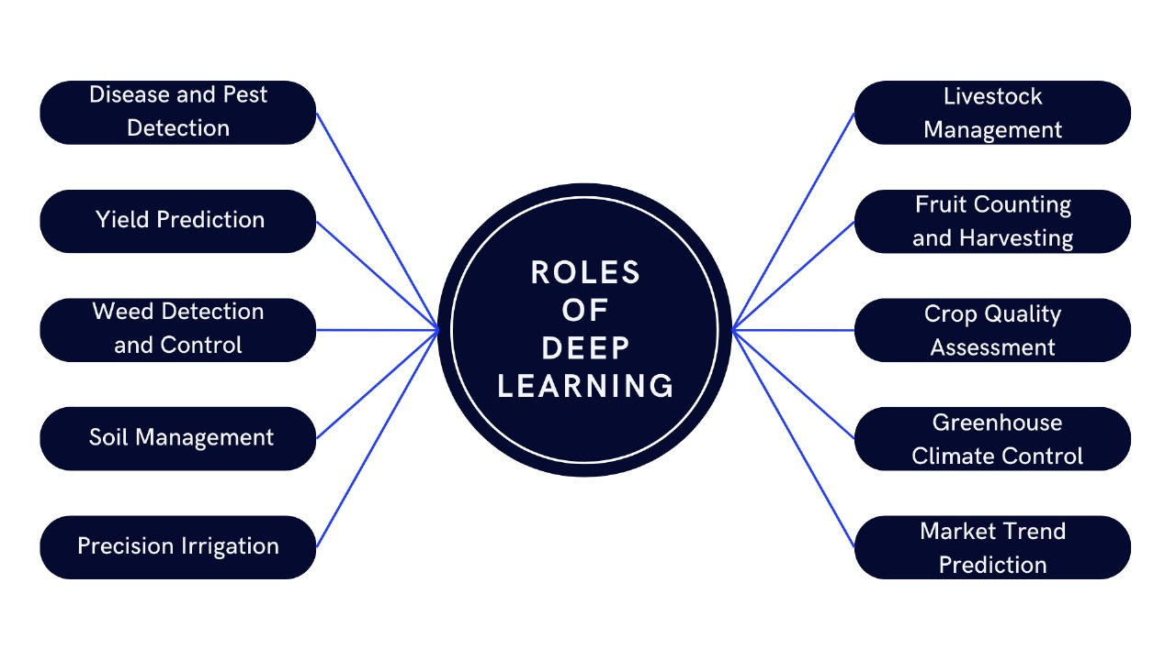
Fig 1: Roles of Deep Learning in Agriculture

Fruit Counting and Harvesting: Using deep learning, fruit counter models can give more precise yield estimates, which can facilitate the advancement of automatic foraging technologies.
Crop Quality Assessment: Deep learning may be used to judge images of crops and provide information on their development. This will allow, for instance, only mature commodities to be harvested and inappropriate ones to be automatically rejected during sorting.
Greenhouse Climate Control: Through deep learning, an automated system can be created that optimizes temperature, humidity, and ventilation in greenhouses. As a result, overall crop growth can be enhanced while energy consumption is minimized.
Market Trend Prediction: Deep learning models can research historical and market trends to help farmers make data-driven decisions in geography, sales, or commodities [1].

Opportunities:

Personalized Farm Management: Deep learning once goes into specific data of soil conditions, weather patterns, and local plant history orientation into an intelligent model that will learn how to create customized recommendations for resource allocation, planting strategies, and pest control.
Predictive Maintenance: Deep learning, using data analysis from farming machinery, can predict where failure can occur and help schedule maintenance, minimizing downtime and keeping the operation on the right track without any discomfort.
Robotic Weed Removal: Deep learning-armed robots can easily be taught to detect and rid crops of weeds accurately. This means the reliance on harsher herbicides will be reduced, significantly decreasing human resource costs.
Weather Resilience: Deep learning algorithms can access historical weather patterns and climate trends to give farmers the information they need to adapt and choose plants that carry changing weather conditions.
Crop Breeding and Improvement: Deep learning can help discover robust, predictable genotypes by matching the blueprints of desirable traits in crops. This allows crops to breed quickly and thus build disease-resistant and high-yielding varieties.
Food Security Monitoring: With deep learning, the worldwide agricultural data can be examined, the food crisis identified to terminate in its tracks, and early defense responded to in food-insecure areas.

In Figure 2, we have discussed opportunities of deep learning in agriculture:

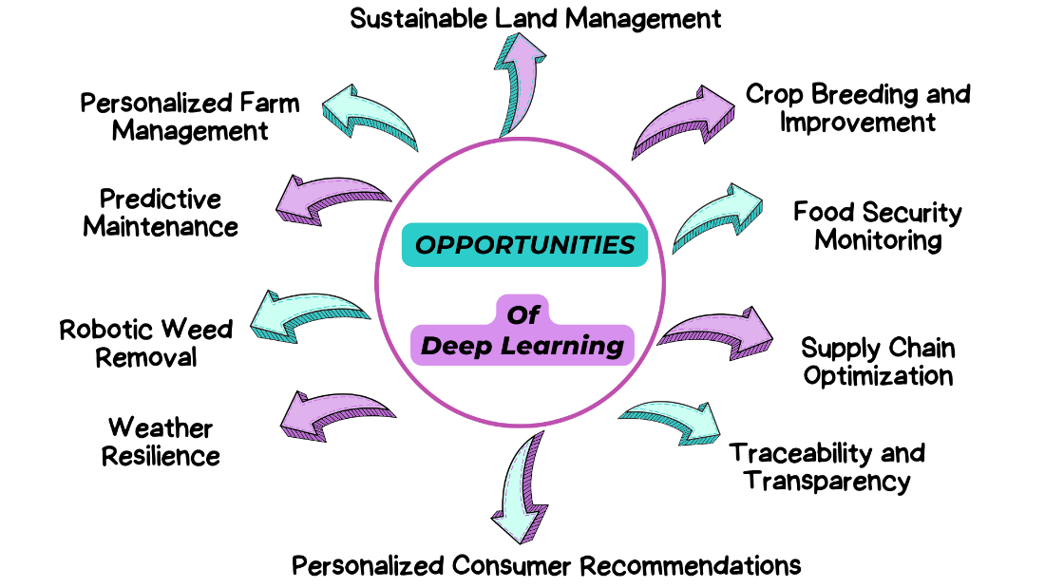

Fig 2: Opportunities of Deep Learning in Agriculture

Supply Chain Optimization: Deep learning has the potential to sharpen the agricultural supply chain by improving forecasting, controlling logistics, and reducing food waste.
Traceability and Transparency: Deep learning can be used to discover the passage of food from the farm to the table, ensuring its authenticity and winning over enterprising customers' trust.
Personalized Consumer Recommendations: Deep learning allows us to examine consumer data and recommend locally grown vegetables according to a person's taste and diet.
Sustainable Land Management: Deep learning algorithms can analyze satellite images and sensor data to identify areas under threat of land degradation and deforestation, which helps in sustainable land management to be passed on to future generations [2].
- Challenges
Data scarcity and quality: Deep learning algorithms' success is primarily associated with large loads of well-marked data. Collecting data in agriculture is complicated and one of the most expensive processes. Different weather conditions and strange farming approaches in various localities confound the data collection.
Technical expertise: Technical proficiency is necessary not only for the implementation but also for the management of deep learning systems. Smallholder farmers, particularly in deprived areas, may need more resources or training in this intricate subject.
Environmental factors: Farming conditions are often unpredictable and prone to abrupt weather cycles, sunlight fluctuations, and destructive pests. Even though the deep learning models must be strong enough to adjust to the varying circumstances and provide correct recommendations, this capability is a significant requirement.
Regulations: The sphere of agricultural activity is precisely regulated, and the entry of AI can be obstructed by adherence to rules. Achieving the desired balance in innovation, safety, and labor laws is necessary.
Explainability and trust: Deep learning models are like "black boxes," at times, the way they reach the decision process becomes unclear, which becomes a point of concern. This absent or inaccessible transparency can make it difficult or even impossible to trust the recommendations provided by the models.

In Figure 3, we have outlined the challenges of deep learning in agriculture:

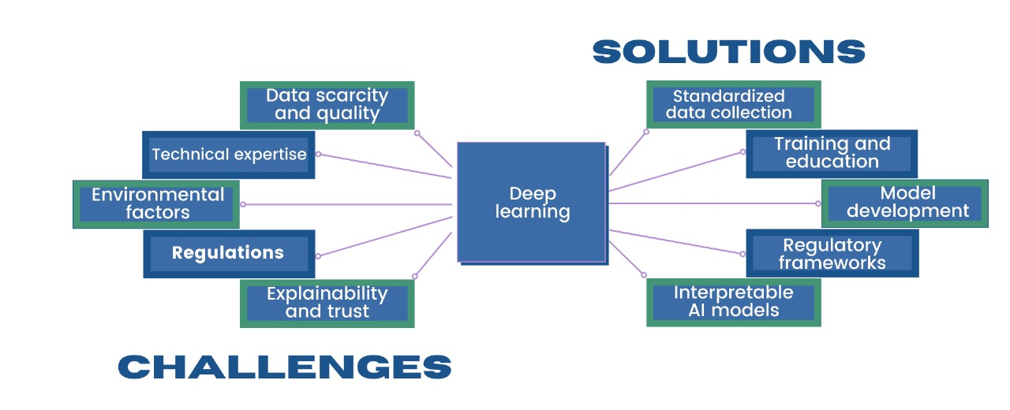
Fig 3: Challenges of Deep Learning in Agriculture

Overcoming these limitations is critical to effectively adopting deep learning in agriculture. Here are some potential solutions:

Standardized data collection: Using uniform data gathering approaches and getting all scientists and farmers to cooperate in the whole process will help solve the problem of data shortage.
Training and education: By implementing training programs and educational materials, farmers gain competency in using deep learning technologies.
Model development for dynamic environments: If programmed, algorithms can be made to fit changing environmental conditions and handle multiple influencing factors, which is crucial.
Regulatory frameworks: Promoting laws that motivate invention and ensure the security and humane treatment of people is essential.
Interpretable AI models: Research on how to develop more interpretable deep-learning models is essential, as it helps farmers understand the workings of the model and why it suggests specific strategies, thereby building trust in the technology [2].

- TRANSPARENCY ISSUES
Black Box Model:
Issue: stakeholders face difficulty in the decision-making process due to a lack of interpretability and their opaque nature, which leads to a lack of trust
Remedy: Applying more interpretability techniques to develop model predictions and enhance the trust towards stakeholders
Techniques:
- Surrogate models offer more straightforward interpretation while maintaining accurate prediction by constructing simplified models.
- Layer-wise Relevance Propagation (LRP): This technique helps the model to explain the predictions of neural networks by propagating layers of neural networks, identifies the features of input about model predictions, and helps users interpret [3].

Biased Data and Quality:
Issue: Models with biased or low-quality data lead to irregular outcomes, especially in an agricultural context, where data is unique and is collected under various conditions.
Remedy: Implementing data preprocessing techniques to enhance the data quality.
Techniques:
- Data augmentation: This technique helps to reduce data overfitting by generating synthetic data and applying various transformations, such as scaling, flipping, rotation, and translation.
- Balancing methods: imbalanced issues can be addressed by under-sampling for majority classes and oversampling for minority classes [4].

Limited Access to Algorithm Models:
Issue: limited access to algorithms and models leads to difficulty in external validation, reproducibility, and collaboration in agricultural applications
Remedy: promoting open science practices by pre-trained weights releasing model architecture and source code.
Technique:
- Open sourcing: releasing all the resources of the algorithms and models under open-source license on platforms like GitHub, which allows the researchers to access and use them for specific agricultural applications
- Model-sharing platforms: These are dedicated platforms for sharing models or algorithms in agriculture, such as the TensorFlow hub or model hub, which provides hosting and sharing models within agriculture [5].

Data Privacy and Security Concerns:
Issue: data related to yields and farm management are used for training a model, and sharing of data can expose data leaks due to inadequate safeguards and security measures
Remedy: By implementing privacy-preserving techniques to protect the data from leaks.
Techniques:
- Federated Learning: Models are trained locally on individual servers or devices, which ensures that the data's sensitivity remains on local devices and reduces risk exposure [6].
- Differential Privacy: This method protects individual data by adding noise or model parameters. It preserves the privacy of agricultural data.

Knowledge Sharing and Interdisciplinary Collaboration:
Issue: lack of collaboration between the researchers can restrict the sharing of knowledge, methodologies, and data across disciplines, leading to missed opportunities and the development of innovative solutions
Remedy: Foster collaboration between researchers, data scientists, and organizations.
Techniques:
- Training programs: Conduct training programs on agriculture and deep learning concepts to accelerate the students' gain of interdisciplinary skills and knowledge. This technique fosters individuals' work across disciplinary boundaries.
- Research partnerships and networks: establishing the networks between institutions, researchers, and organizations about agriculture and deep learning to facilitate collaborations, sharing of resources and expertise, and knowledge exchange.

- SECURITY ISSUES

Model Poisoning Attacks:
Issue: Malicious individuals can manipulate data into false information, which can lead to compromised deep learning models.
Remedy: Regularly verify the data sets for anomalies and establish data validation techniques to mitigate false information.
Techniques:
- Examination of the data involves statistical analysis, visual inspection, and automated tools to interrogate the suspicious data. It also ensures the accuracy and fairness of the model [7].
- Data validation ensures the integrity and quality of the data and includes cross-validation, data augmentation, and other detection methods, such as outlier and drift detection.

Model Theft & Intellectual Property:
Issue: Models are highly exposed to risk, and theft or unauthorized access can lead to the sacrifice of intellectual property.
Remedy: Watermark methods are used to identify unique individuals and enable tracking and verification of ownership.
Techniques:
- Watermark model: This technique modifies the model architecture and its properties to encode the watermark to track and verify the ownership of the models. In a trace of theft, the model can be extracted to prove ownership.
- Federated Learning: This technique enables the models to train on local devices, such as edge devices, without sharing data with a central server. This technique mitigates the risk of data exposure and model theft [8].

Model Drift and Degradation:
Issue: When deployed in dynamic agricultural environments, the models may experience drift or degradation due to changes in data distribution or environmental factors.
Remedy: to retain models with updated data, we implement the mechanisms for adaptive learning and also monitor the model continuously
Techniques:
- Continuous monitoring: It involves tracking performance measures such as precision, accuracy, and recall. Any uncertainties from expected performance led to model drift.
- Adaptive learning: Models dynamically update themselves when changes in data distribution occur, periodically retraining them with augmented or updated data. This ensures that models remain effective regarding environmental impacts.

Sensor spoofing manipulation:
Issue: Manipulating sensor data or signals to mimic legitimate sensor readings or false information leads to irregular decision-making processes.
Remedy: Implement security measures such as protocols to protect the IOT devices from tampering.
Technique:
- Anomaly detection: detects the early manipulation attempts of data or false information and allows the models to perform corrective actions.
- Authentication protocols: Protocols such as cryptographic keys or secure boot mechanisms are utilized to check that only authorized devices can access the transmitted and network data.
Insider Threats:
Issue: Individuals with authorized access to the agricultural environment may misuse their permission to access sensitive data or sabotage the model operations.
Remedy: Implement privilege separation and access control systems to restrict the actions of insiders based on their roles and responsibilities.
Technique:
- Role-Based Access Control (RBAC): Implementation of this technique restricts the access policies based on the user’s policies, roles, and responsibilities within the organization [9].
- Separation of Duties (SoD): reduces the risk of insider misuse or fraud by preventing unchecked control over sensitive operations.

- SCALABILITY ISSUES
Data Quality and Volume:
Issue: Low-quality and insufficient data create difficulties in model generalization and training.
Remedy: Implement data augmentation techniques and collaborate with researchers and farmers to collect diverse, high-quality datasets.
Techniques:
- Augmentation of Data: generating the process of artificially increasing data size by modifications based on the insertion, deletion, etc., and reducing the overfitting to improve model performance [10].
- Collaborative Data Gathering: This involves engaging with individuals, industries, and organizations to gather information on agriculture and become experts in agriculture and deep learning.

Computing Resources:
Issue: The efficiency of the models can be reduced due to the increased computation power, which leads to scalability issues.
Remedy: using parallel processing and cloud computing methods to distribute workloads efficiently.
Techniques:
- Cloud computing: utilizes flexible cloud platforms to access resources. It provides a wide range of services and pre-configured machine-learning environments.
- Distributed Training divides training tasks among multiple devices for parallel processing and reduces the time required to train models. Frameworks such as Horovod, Pytorch, and Tensorflow allow distributed training [11].

Model complexity
Issue: Complex models take longer to train due to resource-intensive operations.
Remedy: Utilization of methods to optimize the models
Techniques:
- Model pruning is a method of reducing redundant parameters and connections to reduce model size and computational complexity while preserving predictive performance. It leads to faster inference times and reduced memory.
- Quantization: This method represents the model's weights with a few bits to reduce memory requirements. It includes various methods, such as dynamic range quantization and uniform quantization.

Cost implementation:
Issue: Costs associated with developing deep learning in agriculture cannot be afforded by small-scale farmers.
Remedy: consider cost-reducing methods to decrease the financial burden for farmers.
Techniques:
- Government inducements: The government encourages small-scale farmers especially and provides financial support to farmers, which can accelerate the development and deployment of models.
- Open-source inducements: They provide more transparency and customization, as the farmers can access this data from open-source platforms and collaborate with experts to reuse the existing models, which can reduce expenses.
Dynamic conditions in the Environment:
Issue: Agricultural environments are associated with constant changes, such as soil conditions and weather patterns, making adapting deep learning models challenging.
Remedy: Establish robustness techniques, such as adaptive algorithms and continual learning, to enable models to adapt quickly to dynamic environmental conditions.
Techniques:
- Continual learning: Empower models to adapt to new data without obliviating previous knowledge.IT adapts to the new data and learns incrementally without forgetting past experiences.
- Adaptive algorithms adjust the behavior of parameters that are dynamically concerned with the Environment. They help monitor variations in soil conditions, pest infestations, weather patterns, and other environmental factors.

- ADVANTAGES
In Figure 4, we have discussed the advantages of deep learning in agriculture:

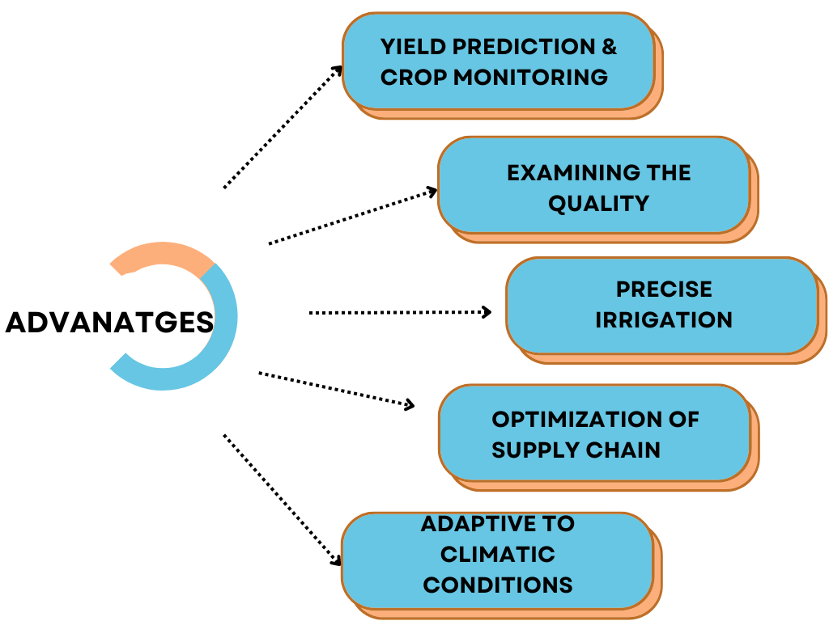

Fig 4: Advantages of Deep Learning in Agriculture

- Yield Prediction & Crop Monitoring:
- Models can identify areas of crop disease by utilizing satellite imagery or aerial photography to examine various indicators of crop health, such as vegetation indices that use the Normalized Difference Vegetation Index (NDVI) and soil moisture levels, encouraging farmers to take preventive measures.
- Algorithms such as CNNs, RNNs, LSTM networks, etc., can integrate multiple data sources, such as past yield data and weather forecasting, to predict yields.

- Examining the quality:
- Training the models on large datasets of labeled data to distinguish between the different characteristics of the goods based on visual appearances such as size, shape, texture, and color to examine the quality of agricultural products such as veggies, grains, and fruits results in reducing manual inspection, labor costs, and time-saving.
- Algorithms such as Siamese neural networks help sort and grade products, which results in customer satisfaction, quality items, and increased competition in the market.

- Precise Irrigation:
- Plant water requirements can be determined precisely based on various algorithms that analyze the moisture level of soil and crop stress indicators resulting from sensor networking. These algorithms predict the moisture level in soil and water requirements by learning the relationships and complex patterns in the data.
- These models can adapt to environmental changes such as rainfall or temperature fluctuation to adjust the water requirements for crops and reduce water wastage.

- Optimization of Supply Chain:
- These algorithms learn the relationships and patterns within the large-scale datasets related to logistics in the supply chain and optimize the supply chain's operations, including reducing transportation costs, minimizing product spoilage, and improving on-time delivery.
- These models enable the agile-decision decision-making process for dynamic factors such as weather conditions and seasonal variants [12].

- Adaptive to climatic conditions:
- These models' environmental inputs predict future weather patterns with high accuracy by analyzing the interactions in the data, which results in anticipating shifts in precipitation, temperature, and weather events. Farmers use this information to make decisions on selecting crops, irrigation management, planting schedules, and pest control.
- These models warn about weather-related risks so farmers can take preventive measures to protect their crops.

- DISADVANTAGES
1. Acquiring Large Volumes of Datasets:
- Models are trained effectively by depending on large labeled datasets, whereas in agriculture, data collection involves manual processes, which are time-consuming and expensive.
- Even identifying infectious pests in images and crop diseases may also require a domain expert, which is a manual process, whereas the models rely on data sets to pose significant barriers to widespread scalability and adoption.

2. Transferability Limitation:
- Once the models are trained on a particular dataset from a specific geographical region or crop type, they may need more generalization when applied to different geographical areas or regions. Variations in agricultural practices, crop phenotypes, and environmental changes may cause this.
- Similarly, once trained on one dataset, models cannot generalize the characteristics of different regions, leading to reduced accuracy and performance.

3. Complexity During Computation:
- It is challenging for small-scale farmers to have limited access to high-performance computing infrastructure due to their large-scale computations and complex architectures.
- Also, the operational cost associated with running and maintaining the models may become a burden on budgets and require investing in hardware such as cloud computing services and graphics processing units (GPUs).

4. Lack of Interpretability:
- ‘Black box’ models are complex and opaque, which makes it difficult to interpret the decision-making process. This is not like traditional ML algorithms, which provide transparent model reasoning.
- Lack of interpretability is quite a problem in agriculture, where stakeholders require explanations for model predictions, which leads to distrust.

5. Lack Of Data Security and Privacy:
- Datasets related to yield projections and farm management practices are utilized to train a model. However, storing, collecting, and sharing such data can expose individuals and organizations to unauthorized access or data leaks.
- Inadequate safeguards and security measures compromise the integrity, confidentiality, and availability of agriculture data in the data handling process.

- APPLICATIONS
Detection Of Crop Diseases:
- Convolutional neural networks (CNNs), which have powerful tools for detecting disease in crops, involve the following steps:

In Figure 5, we have outlined the processing steps for detecting the crop disease:
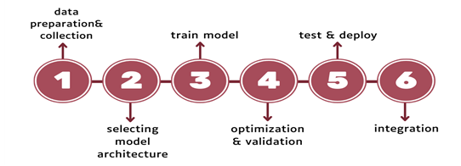

Fig 5: Process of detecting the crop diseases

- By processing these steps, the models can detect the disease and helps to improve farmers' ability to monitor crop health.
Classification of crops:
- Models using convolutional neural networks (CNNs) are able to excel at identifying features on drone images or satellite images that help classify crops.
- These image datasets are pre-processed to remove noise and filter to enhance the features. The models using CNN are trained on supervised learning to identify each pixel or patch of the image as the corresponding crop type.

Analyzing and managing the soil:
- Advanced models can interpret soil properties, soil composition, and quality by leveraging data sources such as remote sensing images and sensing data.
- The models use convolutional neural networks (CNNs) and recurrent neural networks (RNNs) to train and provide valuable data on soil fertility, nutrient levels, and erosion patterns.

Precise Agriculture:
- Farmers can be enabled by models to optimize resource usage, such as pesticides, water, and fertilizers, and improve productivity while minimizing environmental impact.
- Models facilitate accurate predictions and recommendations for various farming practices by analyzing extensive data, including images and historical data.

Robotics in agriculture:
- Power vision systems, which are deep learning techniques, can enable tasks such as fruit detection, autonomous field navigation, and harvesting.
- Robots using deep learning algorithms can accurately identify ripe fruits or foliage. Precise harvesting is performed, and the robot can be navigated autonomously based on environmental impacts, which reduces labor costs and promotes sustainable farming practices [13].

- FUTURE DIRECTIONS
In Figure 6, we have mentioned the future directions of deep learning in Agriculture:

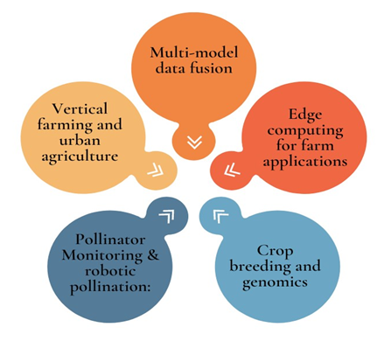
Fig 6: Future Directions of Deep Learning in Agriculture

- Multi-model data fusion:
- Provides integration for various sources of data. By combining these different types of data through various algorithms, agricultural stakeholders can understand the factors that are influencing crop growth and yield, which results in optimal planting and precise irrigation.
- Models trained from multi-model data are more resilient to environmental impacts as they extract data from multiple sources.

- Edge computing for farm applications:
- Helps in deploying the models directly on the farm equipment such as tractors and motors to enable immediate real-time decision-making regarding pest control, precise irrigation, and crop health.
- Processing the data on edge devices reduces the data transfer cost and minimizes the latency, giving faster response during critical operations in agriculture.

- Crop breeding and genomics:
- Models analyze vast genomic datasets to enhance productivity and predict traits in crops, such as disease resistance, yield, and nutritional content.
- Editing the genome enables precision breeding with greater accuracy and speed, minimizing the traditional trial-and-error process.

- Pollinator Monitoring & robotic pollination:
- We optimize the robotic pollination processes by analyzing the plant morphology and flower characteristics using algorithms to execute precise pollination.
- Models help monitor pollinator populations using image recognition, and data analysis helps trace real-time pollinator activity.

- Vertical farming and urban agriculture:
- Algorithms analyze vast amounts of datasets collected from vertical farming and urban agriculture to identify patterns that optimize crop growth conditions, such as humidity, temperature, and light intensity.
- Models can automate urban agriculture by predicting optimal planting time and real-time environmental uncertainties such as light and nutrient levels. They can also manage the robotic systems for maintenance, harvesting, and planting [14].

- ALGORITHMS
In Figure 7, we have mentioned the algorithms related to deep learning in agriculture:
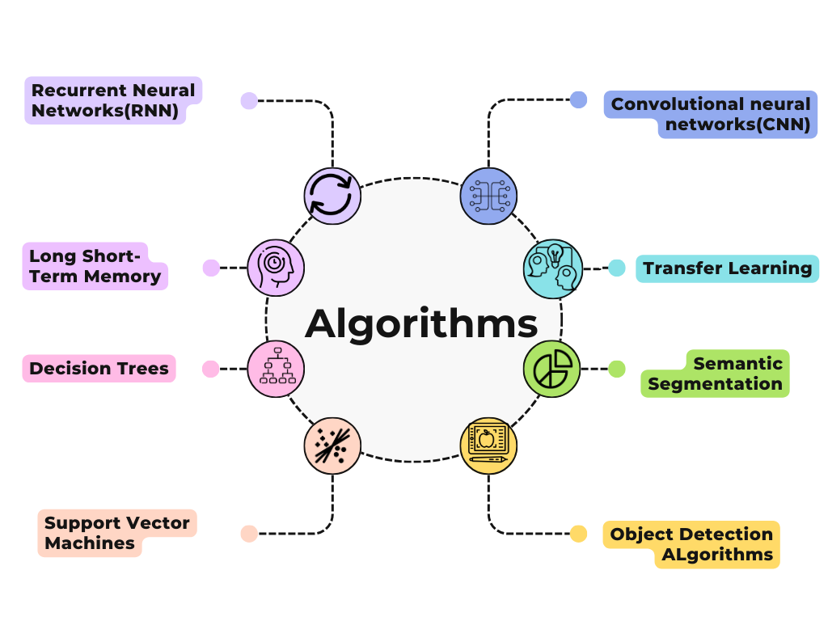
Fig 7: Different types of Algorithms used for Deep Learning in Agriculture

Classification & Identification of the crops:

- Convolutional Neural Networks (CNNs): This algorithm automatically learns related features from raw image data. This algorithm trains the models on supervised learning containing different images of various crops. Once the machine is wholly trained, it can recognize the unique features of various crops, such as leaf color, texture, shape, and arrangement [15].
- Transfer Learning: It uses the Pre-trained CNN models, which have already been trained on large data sets such as ImageNet. This algorithm is one of the advantages because pre-trained models are already trained on various generic features for image recognition. By tuning the models based on crop-specific data, we can achieve good performance with less data from scratch.
- Pre-trained CNN models: These models are adaptive to crop identification by tuning their existing parameters on specific data sets. Commonly used architectures are Inception, ResNet, VGG, etc.

Estimation of Yield:

- Recurrent Neural Networks (RNNs): This algorithm handles sequential data by managing internal memory. It maps time-series data, such as historical yields, with the corresponding environmental factors (weather conditions, irrigation levels, soil quality, etc.). This algorithm processes the data step-by-step, where each sequence corresponds to a unique time point in a series.IT can learn the temporary dependencies between time steps and use the information to predict yield estimation.
- Long-Short-Term Memory (LSTM): This algorithm is a type of RNN algorithm and helps to vanish the gradient problems that are common in RNNs. This algorithm is used to capture long-range dependencies by using specific memory calls and controlling the flow of data through the network. Hence, it is suited for tasks where long-term patterns in data are crucial, such as prediction on yield estimation.

Precise Agriculture:

- Decision Trees: This algorithm is a popular machine learning method that uses supervised learning and utilizes the classification and regression categories. This algorithm involves in various ways:
- Irrigation scheduling: By analyzing the weather forecasts, water requirements for crops, soil moisture levels, and irrigation system efficiency, it can develop an optimal irrigation schedule that ensures proper hydration for crops while saving water
- Optimal Planting Locations: It analyzes topography, soil type, past yield data, and environmental conditions to recommend where to plant crops.
- Support Vector Machines (SVM): Scenarios with complex decision boundaries; this algorithm is a powerful tool for classification tasks. This algorithm is utilized in various ways:

  - Predicting crop health: This model can detect crop health using data collected from sensors and satellite images. It considers various factors, such as leaf color, vegetation indices, and disease symptoms, to classify the crop as healthy or unhealthy.

- Conclusion
Deep learning is poised to witness the culmination of a revolution in agriculture. By equipping farmers with the necessary tools for data analysis and image recognition, the system promises to solve the most urgent problems the agro-industry faces. By minimizing the use of resources and increasing plant strength, deep learning will promote sustainable practices and ensure food quantity and quality.
The ability of deep learning models to mine hidden valuable signals from significant datasets is pivotal for the creation of precision agriculture methods. This information-based approach ensures that resources like water, fertilizer, and pesticides are applied only where and when needed. Additionally, this practice minimizes waste and environmental impact, improves yield, and maximizes profitability for farmers.
One of the other important aspects of deep learning is the early detection of crop diseases and pests, which is where it performs very well. Using drone or ground-based cameras, these deep learning models can detect threats quickly, taking preventive steps to minimize crop losses. Not only does it ensure food security, but it also builds more standalone agriculture by limiting the use of chemical pesticides, promoting a friendly ecosystem.
Looking towards the future, deep learning technology in agriculture is known to reach not only present problems. Together with other emerging technologies like Robotics and the Internet of Things (IoT), the Vision of deep learning is boundless. Picture-up robots are empowered with deep learning algorithms that can recognize and clear weeds independently, and intelligent irrigation systems modify water flow according to sensor data and forecast weather in real-time. These situations reflect a vision of a future where mindless activity is eliminated, and agriculture will be more economical and environmentally friendly.
However, with the successful introduction of deep learning into agriculture, some things could be improved, too. The task here is to provide proper access to the expert's high-quality labeled data for training deep learning models. Similarly, the challenge of bridging the digital gap and making these technologies affordable and accessible to small-scale farmers is also crucial so that there can be large-scale adoption. Both the bottom-up and top-down approaches are needed together to solve these challenges.
In sum, deep learning is the gate of opportunities allowing agriculture to transform. If we use deep learning to our advantage, we can start the future when agriculture is not merely a matter of productivity but also ecologically sound and robust. These are the critical goals in the future: collaboration, ethical innovation, and fair access. These technologies should be used for better health and a more secure food supply, which will not only benefit the present generation but will also be enjoyed by later ones.

References
- Attri, I., Awasthi, L. K., Sharma, T. P., & Rathee, P. (2023). A review of deep learning techniques used in agriculture. Ecological Informatics, 102217. https://doi.org/10.1016/j.ecoinf.2023.102217
- Albahar, M. (2023). A survey on deep learning and its impact on agriculture: Challenges and opportunities. Agriculture, 13(3), 540. https://doi.org/10.3390/agriculture13030540
- Hu, T., Zhang, X., Bohrer, G., Liu, Y., Zhou, Y., Martin, J., ... & Zhao, K. (2023). Crop yield prediction via explainable AI and interpretable machine learning: Dangers of black box models for evaluating climate change impacts on crop yield. Agricultural and Forest Meteorology, 336, 109458. https://doi.org/10.1016/j.agrformet.2023.109458
- Zhang, X., Yang, J., Lin, T., & Ying, Y. (2021). Food and agro-product quality evaluation based on spectroscopy and deep learning: A review. Trends in Food Science & Technology, 112, 431-441. https://doi.org/10.1016/j.tifs.2021.04.008
- Alibabaei, K., Gaspar, P. D., Lima, T. M., Campos, R. M., Girão, I., Monteiro, J., & Lopes, C. M. (2022). A review of the challenges of using deep learning algorithms to support decision-making in agricultural activities. Remote Sensing, 14(3), 638. https://doi.org/10.3390/rs14030638
- Liu, X., Xie, L., Wang, Y., Zou, J., Xiong, J., Ying, Z., & Vasilakos, A. V. (2020). Privacy and security issues in deep learning: A survey. IEEE Access, 9, 4566-4593. DOI: 10.1109/ACCESS.2020.3045078
- Sun, G., Cong, Y., Dong, J., Wang, Q., Lyu, L., & Liu, J. (2021). Data poisoning attacks on federated machine learning. IEEE Internet of Things Journal, 9(13), 11365-11375. DOI: 10.1109/JIOT.2021.3128646
- Ferrag, M. A., Shu, L., Djallel, H., & Choo, K. K. R. (2021). Deep learning-based intrusion detection for distributed denial of service attack in agriculture 4.0. Electronics, 10(11), 1257. https://doi.org/10.3390/electronics10111257
- Alahmadi, A. N., Rehman, S. U., Alhazmi, H. S., Glynn, D. G., Shoaib, H., & Solé, P. (2022). Cyber-security threats and side-channel attacks for digital agriculture. Sensors, 22(9), 3520. https://doi.org/10.3390/s22093520
- Kamilaris, A., & Prenafeta-Boldú, F. X. (2018). Deep learning in agriculture: A survey. Computers and electronics in agriculture, 147, 70-90. https://doi.org/10.1016/j.compag.2018.02.016
- Karar, M. E., Alsunaydi, F., Albusaymi, S., & Alotaibi, S. (2021). A new mobile application of agricultural pests recognition using deep learning in cloud computing system. Alexandria Engineering Journal, 60(5), 4423-4432. https://doi.org/10.1016/j.aej.2021.03.009
- Ünal, Z. (2020). Smart farming becomes even smarter with deep learning—a bibliographical analysis. IEEE access, 8, 105587-105609. DOI: 10.1109/ACCESS.2020.3000175
- Zhou, Z., Majeed, Y., Naranjo, G. D., & Gambacorta, E. M. (2021). Assessment for crop water stress with infrared thermal imagery in precision agriculture: A review and future prospects for deep learning applications. Computers and Electronics in Agriculture, 182, 106019. https://doi.org/10.1016/j.compag.2021.106019
- Mohamed, M. (2023). Agricultural Sustainability in the Age of Deep Learning: Current Trends, Challenges, and Future Trajectories. Sustainable Machine Intelligence Journal, 4, 2-1. https://orcid.org/0000-0002-8212-1572
- Guo, Y., Zhang, J., Yin, C., Hu, X., Zou, Y., Xue, Z., & Wang, W. (2020). Plant disease identification based on deep learning algorithm in smart farming. Discrete Dynamics in Nature and Society, 2020(1), 2479172. https://doi.org/10.1155/2020/2479172.

