AGRICULTURAL COOPERATIVE MODEL: A PANACEA FOR ECONOMIC DEVELOPMENT OF SMALL SCALE BUSINESS FAMERS IN ILESHA, OSUN STATE. NIGERIA.
Abstract
Owolowo ile – ege garri processing industry which is a small scale cassava processing industry, located in Ilesha, Osun State was purposively selected as a case study because it is a cooperative business. This industry was established in 1991 by eight men (8) who were mostly retirees. A researcher made questionnaire was used to collect information from thirty (30) respondents: the manager, four official staffs and 25 randomly selected processors in the industry. The study found that within twelve years of the utilization of their self raised initial capital of N240, 000 naira (Two hundred and forty thousand naira) this cassava – based industry had impacted on and attracted the involvement of many more people because within the period of the study (i.e. 2007-2011) the processors had quadrupled in number (e.g. 8 to 30), the facilities (equipments) in use had increased from one machine and a frying pot to many, this translated into being able to produce large quantities of fried garri, fufu and also starch for marketing to the people in Ilesha and neighbouring cities like Ibadan , Lagos, etc. This is indicative of economic growth. The industry also became a source of employment for community members in the sense that, as at the time of study four staffs were employed to work and coordinate the industry.
It was observed that despite all odds of small scale industry and the problem of people migrating from rural to urban area, this agro-based industry still existed successfully in the community, and many of such industry can be replicated by such agricultural cooperative groups nationwide so as to further boost the productivity as well as the economy of the area and nation at large. However, government and individual still have major roles to play in ensuring the growth and development of the nation in this respect .The local agricultural cooperative groups should form regional cooperative consortium with more networking for the farmers, in order to create more jobs for the young ones, and to increase agricultural productivity in the country thus resulting in a better and more sustainable economy.
Key Words: agricultural cooperative, cassava processing industry, model, small scale enterprise.

Introduction.
Agriculture involves the production, processing and utilization of agricultural products like crop, livestock, forestry, fishery and wildlife products. The consciousness of agriculture started when man discovered that while hunting, the discarded seeds of the eaten fruits germinated and grew into similar fruit bearing trees, hence he started planting. Subsequently agriculture moved from this stage to a subsistence level stage in which he was producing to feed himself and his family. No provision was made for the marketing of the products because there were no organized market, and the prevailing exchange system then was trade by batter. With time it became imperative that agriculture should produce extra for the market. At this point in time, organized market was formed and people therefore adopted improved method to expand their output or productivity. This marked the beginning of commercialization and modernization of agriculture into which cooperative model is able to find its bearing or ensconce itself.
The term cooperative can be used in its generic term to cover a wide area of activities in which two or more people join together either formally or informally; ad hoc or permanent basis; for legal and socially accepted acts which may be in the interest of those performing the acts without its being detrimental to anyone else. There existed three different schools of thought on cooperative business enterprise, namely:
- Cooperative enterprise school (capitalism)
- Cooperative common wealth (which is capitalistic and partly socialistic)
- Socialistic cooperative (socialism)
The first school of thought says that cooperative is an independent economic unit or business formed and operated by households aimed at improving members’ economic status. The second school of thought says that in addition to cooperative being an enterprise it eliminates the cooperative capitalistic system and replaces it with an economic system based on mutual cooperation. The third school of thought says that cooperative enterprise is an important starting point which ultimately leads to socialism. However, by the 19TH century, the underlying rationale for the emergence of cooperative efforts by farm operators or farmers surfaced based on the need for a higher incidence of specialized farming assets because of the inelastic supply of farm products and the changing market structure of agriculture.
One of the major problems faced by underdeveloped countries of the world which are mostly in Africa of which Nigeria is one (though a bigger country) is the lack of capital base or formation with which to execute and promote all the economic activities of the nation thus resulting in national poverty and a state of depressed economy being experienced over many years. This was why in the past years, the main thrust of the government policy focused for sometime on Structural Adjustment Programmes (SAP); Farm Settlement schemes (FSS) etc in order to revamp the economy. One of the many ways by which this problem could be solved is through the formation of cooperative societies. The application and use of agricultural cooperative and cooperative societies could become relevant ,vital and effective means of transforming the economy of the nation.
In a much more positive sense, cooperative means activities undertaken by cooperative organizations in the field of agriculture to enhance economic development among small scale farmers. They are particularly helpful in improving the economy of the beneficiaries (who could be either urban / rural inhabitants) who tend to easily understand its principles and characteristics. The peculiar characteristics of cooperatives are:
- The collective marketing of products,
- Group farming
- Mobilization of capital resources at grass roots level for capital formation, and
- Creation of agricultural employment opportunities resulting in improvement of the standard of living of its members (in both rural and urban areas).
Nigeria as a nation needs this sort of cooperation and common aim of the expansion, modernization of the rural economy which is integrated into a good social setting. Perhaps one of the most effective ways to increase food, economic activities (such as the marketing of agricultural products) in Nigeria is to organize small scale producers into voluntary, democratically managed, viable cooperative instruments of social and economic transformation. This suggestion is premised on the believe that cooperative and rural development work hand in hand. Nigeria needs to move from preponderance of the present individual, small scale farmers to cooperative and possibly at large scale levels of productivity. The inherent advantages accruing from this will include the usage of a large supply of land , water resources, improved human skills and managerial abilities, diffusion/ adoption of new knowledge about agricultural technology, encouragement of base formation and investment in agriculture and assurance of economic benefits in terms of increased farm production to the farmers with the believe that farm or agricultural produce/ products from a nation satisfy and sustain its domestic demand for human consumption and local industries. The coming together of related farmers as agricultural cooperative will expand productivity hence the export of the country’s product thus giving room for the development of the nation.
The central focus of this study is to measure and evaluate the impact of a small scale agricultural cooperative business named Owolowo Ile-ege processing industry on the livelihood of its members. It is an attempt to measure the impact an agricultural cooperative group could exert on the development of the economics of the rural areas. In a nut shell the objective of this paper is to show case the operation of small scale group of business farmers, (ile – ege processing industry), their source of fund, the importance of such agric cooperative business to the economy of the people and the limitation of such small scale businesses
An ile – ege processing industry which has adopted a cooperative system is chosen and used as a case study. In Yoruba, which is a dialect in the south western part of Nigeria, ‘’ile-ege’’ means ‘’cassava house’’ where the processing of cassava tubers is done. It is called Owolowo ile-ege processing industry. It is a small scale cassava processing industry located in Ilesha, Osun State, Nigeria. This study covers five year period from 2007-2011. The industry was purposely selected for this presentation because it is master minded by a retiree after leaving government job which he had successfully done for over 35years. This is because the major problem often faced by such retiree is the issue of how to be gainfully employed, remain active and alive for longer years. At post retirement, such categories of people often try many avenues for survival and sustenance for themselves. A questionnaire was developed and used to elicit information on the socio-economic characteristics of the manager of the industry, the four regular staffs and twenty- five randomly selected cassava processors in the industry. This means that 30 respondents constitute the sample size for the study.

The specific objectives of the study are to..
- Elucidate on the farm operation speciality of the centre as perceived by the founder
- Find out the management strategy adopted by the centre for the smooth running of the business
- Determine the conditions necessary or utilized for bringing about the success of this processing (agricultural) industry.
- Determine the growth of the industry over a five year period of operation (2007-2011)
using two null hypotheses that:
Ho1: the agricultural development of an area (rural or urban) cannot be improved through the help of cooperative societies
Ho2: a cooperative organization does not have any important impact on the development of agriculture in the rural or urban areas
Result and Discussion
The ile-ege processing centre solely specializes in the processing of cassava tubers into many products for ultimate human consumption, as shown in the pictures below indicating all that goes on in the various departments of the industry. The infux of the harvested cassava tubers,


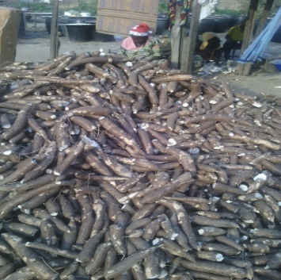
Fig 1:Overview of the ile ege processing industry 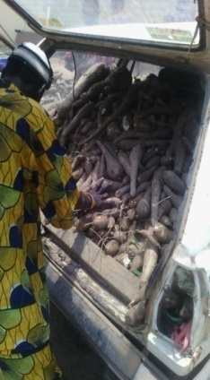 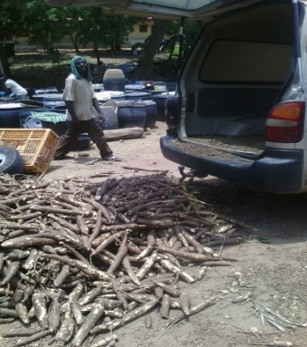
Fig 2: Cassava tuber arrival to the centre in vehicles.
supplied daily to the centre are from the industry’s farm itself, and other nearby individual farmers who are mostly members of the cooperative too. The Ile-ege itself has two acres of land on which cassava is planted. The daily supplies of harvested cassava are brought into the centre with pick – up van vehicles (Fig 2), for retailing.

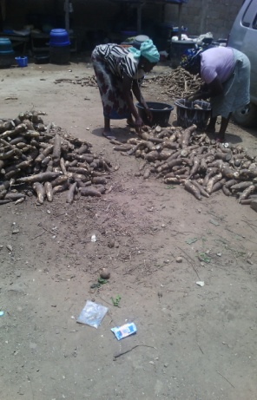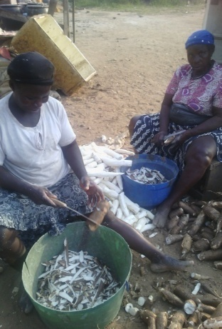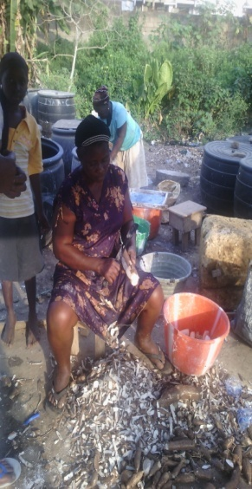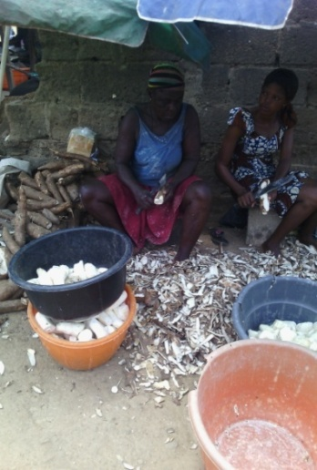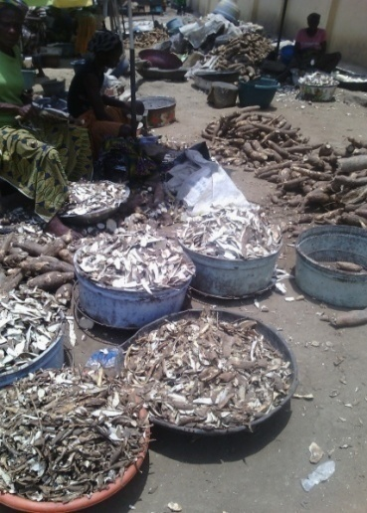
3(a) 3(b) 3(c) (3d) 3(e) 3(f)
Fig 3a-f: Cassava peeling phases by women, teenager and youths.
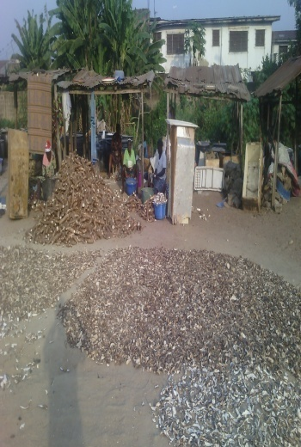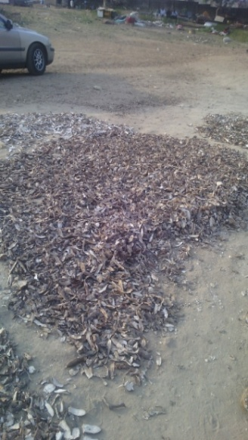
Fig 4: Drying the peeled cassavas
When off-loaded, retail buyers (Fig 3a-f) purchase them for processing into food items (such as garri, fufu, lafun). The water that comes out from fufu processing becomes starch.
Targeting such small scale agricultural enterprises through the cooperative effort organised and established by this industry is a critical, thriving innovation which supports the needs of small scale agricultural cooperative farmers and entrepreneurs to capture and add values to on-farm, post harvest and off-farm enterprises. Small scale farmers who are environmentally sustainable can be assisted to overcome high marketing costs thus enabling them to harness their market potential without sacrificing yield.

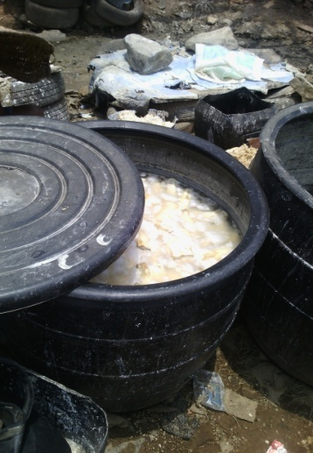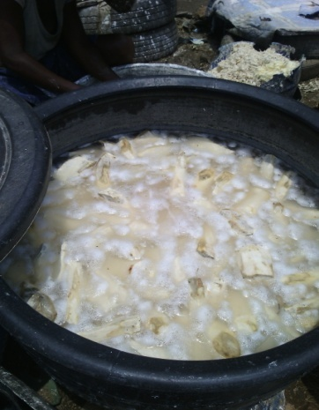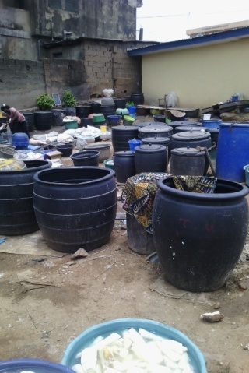
(5a) (5b) (5c)
Fig 5a-c: Soaking of cassava to ferment
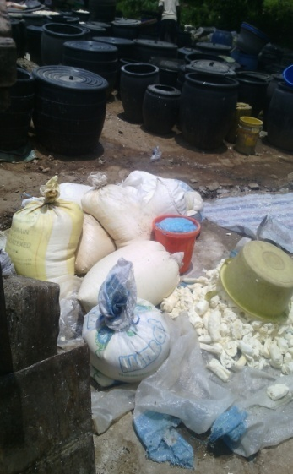

(6a)Sifting the (6b)Bagging the (6c)Pressing the (6d) Water extracted from
fermented cassava cassava cassava into paste cassava for making starch


(6e) Cooking the paste into local fufu (6f)Packaging/wrapping the fufu
Fig 6a,b,c,d,e,f: Production department showing the processing of fermented cassava into fufu and starch.
The processing into garri is depicted in the next seven pictures (Fig 7a-g)
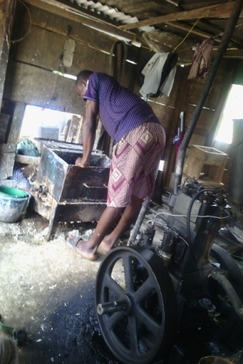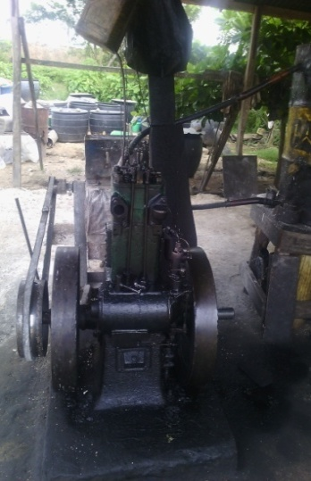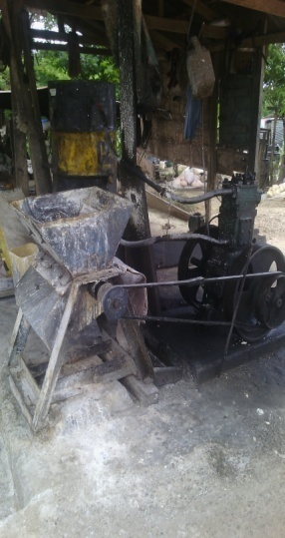
(7a)Different side views of the locally fabricated grating machine
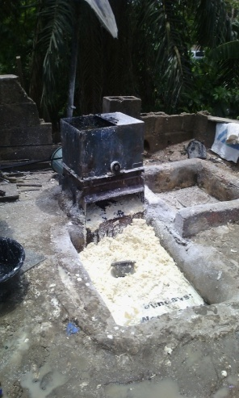   (7d) Frying of cassava
(7b)Grated cassava inside pit (7c)Pressing or dewatering of grated cassava
 (7e) Final product (GARRI)

Fig 7(a-e): (Production department showing garri processing

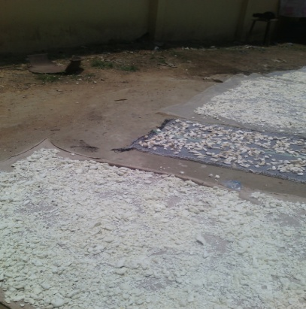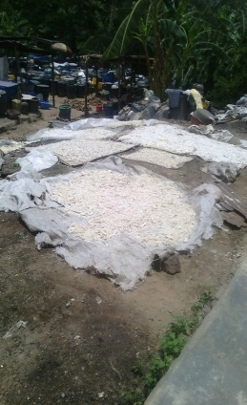
(8a)Removing chaff (8b) Chaff sample (8c&d) Sun-drying the cassava chaff into
from fermented cassava Lafun
Fig8a-d: Production department showing Lafun making from the fermented cassava
Pictures 1-8: Pictorial illustrations of the production departments of the centre
For the smooth running of any business set up, its operation rely mainly on effective management. This industry has four regular staffs, account clerk, sales manager, and other 2 staffs at the production department. However, management could be defined as an act of creating a favourable environment whereby working groups of human beings are led to accomplish enterprise objectives. Data gathered (through the questionnaire) from the management of the organization studied shows that the industry comprises of four main departments under the leadership of the managing director who is the president of the society. The departments are; production department, personnel department, finance department and marketing department, with their subsectors shown in the diagram below. The management strategy adopted at the industry is that all the cooperative members jointly take decision on what to do at any given time.

Managing Director (President)

Production dept. Personnel dept. Marketing dept. Finance dept
Finance Manager

Peel Wash Fermentation Grating Frying Sales Manager Account clerk
Section Section Section Section Section

Locally dried, Sales Men Sales Women
used as goat
and sheep
food.
Pressing/hydraulic
machine
Shocked in water(H2O) Garri Processing
and Sieving for fufu starch
processing
( wet cassava Dough)

Waste product (locally dried, blended
and converted to flour like Lafun)

Fig 9: Organisation structure at Owolowo ile-ege processing industry
Production processes carried out by the production department is shown in the subsectors under it. This department is the largest section of the centre and harbours all the full time and part- time co-operators. The full time members are those who are there all the time while the part time members are the occasional ones who only come when they have products to dispose off, to buy, and at scheduled meeting periods etc, but they must be financial members of the cooperative group. On regular basis, the industry recruits, trains, redeploys and utilize employees or human resources within the cooperative system. The observed increment in the membership of this ile-ege cooperative business and the regular availability of raw materials (cassava tubers) all year round in the centre is one major evidence that the production management unit has been concerned with managing the physical resources for creating products in sufficient quantities to meet the market demands. It was also found that this industry produce fufu, starch and garri in large quantity for sales at the neighbouring towns and markets like Ibadan, Lagos etc. Their production depends on the availability of raw materials (cassava) from the factory’s farm Aladiye village, in Ilesa under Atakumosa Local Government Area. In addition it was found that, yearly dividend payments are declared and distributed to members at the annual general meetings tagged AGM. There has indeed been a rational, planned approach in the area of sufficient recruitment of suitable staff, their retention, optimum utilization and staff improvement in terms of performance over the years in this ile-ege processing industry. They have sufficient labour to meet their demands.
Some of the conditions that have been found to be responsible for the successes recorded in this Ile-ege agricultural cooperative are that;
- it is a member – driven cooperative in which the responsibility and control of the organization is the sole duty of the members
- the cooperative ensured that the members’ household needs are not isolated or neglected. Rather, the needs are integrated into their operations. For examples, members are always obliged whenever they need and make request for loans for other household needs. This for example, constitute the major reason given for the observed fluctuation in the yearly investment into the enterprise as recorded in Table 1.
- Experienced, trained and professionally competent people are invited or elected as board of directors to manage the cooperatives and this gives room for efficiency
- The members adhere to the joint use of concept (such as joint use of capital, joint use of facilities, joint purchasing, joint marketing etc).
- Members struggle to be self reliant, accumulate/save capital and develop other resource (i.e. livelihood diversification) so as not to kill the cooperative.
- They also made the cooperative an open, socially aware, socially sensitive institutions taking care of the social concern for one another’s’ business, problems and in their relationship with customer, members, employees and the larger community, with all these in place, the group keeps having more members.
The growth of the centre over a five years period (2007-2011) is shown or depicted by the discussion below:
The study found that an initial self raised capital of #240,000.00 formed the investment and individual share capital when the business commenced in 1991. The method of raising capital after then was through members monthly contributions to form their investment and shares. Other sources of funds include savings, fines, interest on loans collected by members, partner contributions etc. The land used was a donation by the initiator of the programme.
The five year financial records of the cassava marketing transaction in the centre was taken and the statistical analysis of the profit values were determined so as to be able to know and express the growth, weakness and strength of the profit values (i.e. capitalization and financial record of the industry ). The findings are expressed on table I where for example in 2007 when the cost of production was #200,000.00 and sales obtained was #350,000.00. this yielding a 20% profit margin. The profit values are statistically illustrated with the bar chart
Table I: Five years illustration of the financial sales records of cassava
year | Cost of cassava tubers purchased | Sales of cassava | Profit made | Profit margin(PM) | Percentage (%)
2007 | 200,000.00 | 350,000.00 | 150,000.00 | 750,000.00 | 20%
2008 | 250,000.00 | 380,000.00 | 130,000.00 | 750,000.00 | 17.33%
2009 | 250,000.00 | 400,000.00 | 150,000.00 | 750,000.00 | 20%
2010 | 180,000.00 | 300,000.00 | 120,000.00 | 750,000.00 | 16%
2011 | 200,000.00 | 400,000.00 | 200,000.00 | 750,000.00 | 26.67%
Total | 1,080,000.00 | 1,830,000.00 | 750,000.00 | 750,000.00 | 100%

2007 | 20%
2008 | 17.33%
2009 | 20%
2010 | 16%
2011 | 26.67%

Fig 10: Bar chart of profit value made in the industry (2007 to 2011)
indicating that a profit of #150,000.00 was made at the end of the year. In 2008, an addition (33.3% = #50,000.00) of the profit was re-invested along with the original capital but a profit of #130,000.00 was made, indication a decrease / decline in profit. (i.e. a profit lower than the previous year). As the yearly investment in production fluctuates, the profit margin also fluctuates (in 2010 and 2011). The fluctuations was due to loans taken by members for meeting their other household needs (i.e. outside cassava farming business). Nevertheless, for the entire period (5 years) the co-operators were able to embark in a one million plus (#1,080,000.00), cassava trading/ business which yielded close to two (2) million (#1,830,000.00) resulting in a total profit of #750,000.00 for the five years; (i.e. a mean profit X = #50,000.00 per year)
A profit value of 26.67% accrued to the centre in the 5th year of the study (i.e. year 2011).
With this observed growth in production, it means the two null hypothesis raised that;
Ho1: the agricultural development of an area (rural and urban) cannot be improved through the help of cooperative societies.
Ho2: a cooperative organization does not have any important impact on the development of agriculture in the rural/urban areas are both rejected,
This is because, the findings in the study has shown that if an agricultural cooperative group or organisation is adequately funded it will ably fulfil its major role of help and service rendering to its members (whether in rural or urban areas), thus developing them. One of the roles cooperative system is noted for is being able to assets many Small scale business or individuals to partially or fully overcome the problems of limited access to finance and high cost of business of establishment which often plague most Small Scale industries in the country. However, this study was limited/hindered by lack of proper record keeping by the society to know the actual kilogram of the cassava produced per year and unwillingness to divulge information to outsiders and even researchers who are desoves of tapping from their wealth of experience. The information so presented were got from the president who is the managing director of the industry that was magnanimous enough to release the records used. He is acknowledged in this paper.
In view of the fact that, small and medium enterprises (SMEs) are strategically important and critical to the creation of employment, competition, innovation, productivity and growth had contributed over or greater that 10% of the nations’ gross domestic product (GDP), it is vital to note that there is the need for a well organised & managed cooperative society (especially for agriculture), that will give and bring adequate loan facilities to the members through the resources they have pooled together (i.e. self-effort) with minimal interest compared to bank loans. Such cooperative societies can be initiated, built and sustained by experienced retires (as in this case). The cooperative members can further be trained or taught the habit of buying and selling their products to the neighbouring society/community (i.e. trading).
Conclusion
Agricultural cooperatives are joint efforts / groups / associations which are very relevant to the development of the rural areas (which is often regarded as the base of agriculture). Their formation (agric cooperatives) must be encouraged as a means of accelerating the pace of the nation’s economic advancement and as a medium of building a viable society.
Reference
Adegbite, S. A. and Aberoijo, I. O. (2006). Personal Entrepreneurial Attributes of Small and Medium Scale Industries in Osun State, Nigeria. Journal of the Faculty of Social Sciences, Obafemi Awolowo University, Vol. 20(1)
Annual Report of the Owolowo Ile-ege processing industry for 2007-2011.
Rasheed , H. (2002). Developing Entrepreneurial characteristics in Youths; The effect of education and enterprise experience. International J. of Entrepreneurship Education, 2C5), 120-132
Norbert, M. I (2000) edition Small Business Management.
Okafor, F. I. (2000) edition Entrepreneurship Development.
Emma, E. U. and Mgbada, J. U. (1997). Management of Small scale business: Agribusiness and Cooperative Enterprises.

