Operations Research and Optimization in Industrial Systems Design: A Contextual Review of the Nigerian FMCG Sector
¹Isiguzo, Kelechi Promise, ²Obiukwu, Osita. O, ³Ekenwa Obed Chima, ⁴Onyeso, Godson. E
1,2,3,4 Department of Mechanical Engineering, Federal University of Technology,1526, PMB, Owerri, Imo State, Nigeria
- isiguzo6@gmail.com
2. osita.obiukwu@futo.edu.ng, 3. ekewaobed@gmail.com, 4. gonyeso@fpno.edu.ng
Corresponding author: isiguzo6@gmail.com
​Abstract
Background: The Nigerian Fast-Moving Consumer Goods (FMCG) sector operates in a complex and volatile environment characterized by infrastructural deficits, fluctuating demand, and intense competition. In such a landscape, the adoption of systematic, data-driven decision-making frameworks is not merely advantageous but essential for survival and growth. Operations Research (OR) offers a suite of quantitative techniques designed to optimize complex operational systems.
Objective: This paper provides a comprehensive contextual review of the application of Operations Research and optimization models within the Nigerian FMCG sector. It aims to synthesize potential applications, assess the readiness of the sector for such advanced techniques, and identify the critical barriers to their widespread adoption.
Methods: The study employs a descriptive review methodology, drawing upon a wide range of academic literature, industry reports, and theoretical models. It analyzes core OR techniques—including Linear Programming, Inventory Models, and Vehicle Routing Problems—and contextualizes them within the typical operational challenges faced by Nigerian FMCG firms.
Results: The review finds that OR models hold significant potential for enhancing efficiency in production planning, inventory management, logistics, and distribution within the sector. For instance, illustrative models demonstrate how optimal resource allocation can maximize profits and how inventory models can minimize holding costs. However, the full realization of these benefits is hampered by significant challenges, including data integrity issues, technological infrastructure gaps, a shortage of technical expertise, and external macroeconomic instability.
Conclusion: Operations Research is a powerful, yet underutilized, tool for achieving operational excellence in the Nigerian FMCG sector. To bridge the current gap, manufacturers must prioritize strategic investments in data management systems, workforce capacity building, and academic-industry collaborations. Future research should focus on developing hybrid OR-simulation models tailored to Nigeria's unique constraints and exploring the integration of Artificial Intelligence with traditional OR methods.
Keywords: Operations Research, Optimization, FMCG Sector, Linear Programming, Inventory Management, Supply Chain, Nigeria, Industrial Engineering.
​
1. Introduction
For decades, business management, particularly in developing economies, was often perceived as an art, heavily reliant on managerial intuition, accumulated experience, and sometimes, trial and error. However, the increasing complexity of global supply chains, volatile markets, and pressure on profit margins has necessitated a shift towards a more scientific approach.
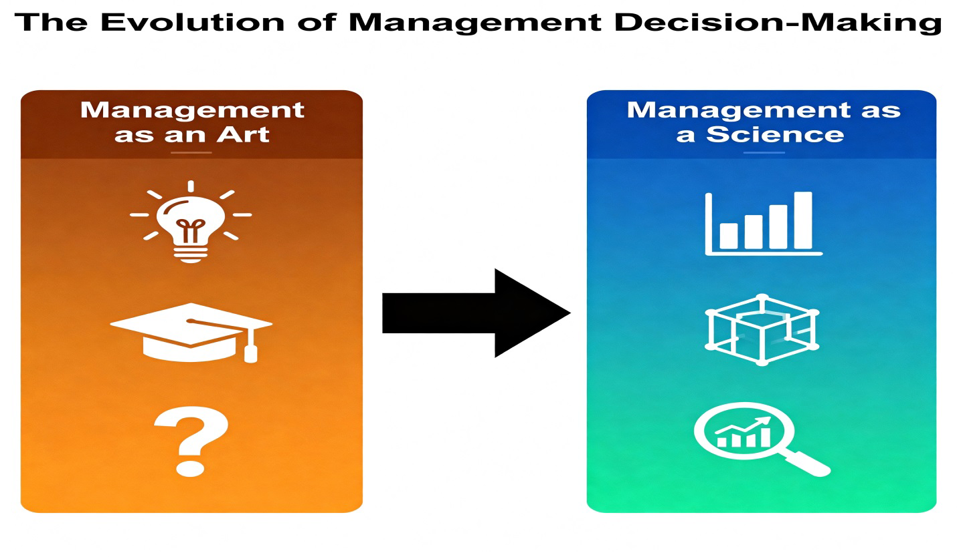
The rise of Operations Research (OR) has been instrumental in this transformation, providing a powerful framework for making data-driven decisions by converting complex, real-world problems into structured mathematical models with quantifiable, optimal solutions (Taha, 2017). Originally developed to solve complex logistical and strategic problems during World War II, OR has evolved into an indispensable discipline for modern enterprises seeking to maximize efficiency, profitability, and resilience (Hillier & Lieberman, 2021).
The Nigerian industrial landscape, and the Fast-Moving Consumer Goods (FMCG) sector in particular, presents a compelling yet challenging context for the application of OR. The sector is a critical component of the Nigerian economy, serving a vast and growing population. However, it operates under significant duress, characterized by volatile supply chains, pervasive infrastructural bottlenecks (such as erratic power supply and poor road networks), inflationary pressures, and intense local and international competition (Olukayode & Akinyele, 2019). In such an environment, the margin for error is slim, and the cost of operational inefficiency whether in the form of excess inventory, suboptimal production schedules, or failed deliveries is profoundly high.
This paper argues that the systematic application of Operations Research methodologies can serve as a critical lever for enhancing the competitiveness and sustainability of firms within the Nigerian FMCG sector. Unlike a case study, which provides a deep dive into a single organization's experience, this paper adopts a contextual review approach. This methodology allows for a broader analysis of the sector-wide potential, challenges, and strategic implications of OR adoption, without the limitations of proprietary data or the need for specific corporate permissions.
The primary objectives of this review are:
- To systematically identify and analyze the core OR techniques relevant to the operational functions of the Nigerian FMCG sector.
- To demonstrate, through illustrative examples and synthesized literature, the potential effectiveness of these techniques in enhancing production, inventory, and supply chain efficiency.
- To critically evaluate the multifaceted challenges technological, human, and external that currently limit the widespread and effective implementation of OR in Nigeria.
- To propose a strategic framework of recommendations for industry stakeholders, including manufacturers, policymakers, and academics, to strengthen the application and impact of OR in Nigerian industrial systems.
​2. Literature Review
The application of Operations Research in manufacturing and supply chain management is a well-established field of study globally. Seminal texts by authors like Hillier & Lieberman (2021) and Taha (2017) provide the foundational theories of linear programming, network models, and stochastic processes. In the context of supply chain management, Chopra & Meindl (2020) and Simchi-Levi et al. (2021) have extensively documented how OR models can be used to optimize everything from facility location to transportation planning.
Within the Nigerian academic and industrial context, there is a growing, yet fragmented, body of literature exploring the use of quantitative techniques. Several studies have confirmed the relevance and positive impact of OR. For instance, Okafor (2018), in a survey of Nigerian manufacturing firms, found a positive correlation between the use of OR techniques and perceived improvements in operational performance. Ighalo & Olaniyi (2017) demonstrated the practical application of Linear Programming for production optimization in a Nigerian manufacturing company, showcasing tangible financial benefits.
Research has also delved into specific areas. In inventory management, Kareem & Owolabi (2019) and Agboola & Agboola (2021) found that the adoption of formal inventory models like EOQ and Material Requirements Planning (MRP) positively influenced the performance of manufacturing firms. In logistics, Jolaoso (2021) highlighted the critical role of logistics management and, by extension, optimization models like the Vehicle Routing Problem (VRP), in determining organizational performance in the FMCG sector.
However, the literature is also replete with evidence of significant barriers. A recurring theme is the challenge of technological infrastructure. Oladejo & Adekunle (2020) directly link the performance of supply chains to the quality of digital infrastructure, noting that limited ERP integration is a major constraint. Similarly, the human capital challenge is frequently cited. Iwu (2018) and Adeyemi & Adebayo (2023) identify a severe shortage of technical expertise and a resistance to cultural change as primary impediments to OR adoption.
A notable gap in the existing literature on Nigeria is the lack of comprehensive, sector-wide reviews that synthesize these various strands the techniques, their applications, and the implementation challenges into a cohesive strategic framework for the FMCG sector. Most studies are highly theoretical, focused on a single technique, or based on a single case study. This review seeks to fill that gap by providing a holistic analysis of OR as a transformative toolkit for the entire Nigerian FMCG value chain, thereby offering a valuable resource for both academics and practitioners.
​3. Theoretical Foundations: The OR Toolkit for Manufacturing
3.1 The Evolution and Philosophy of Operations Research
Operations Research is fundamentally the discipline of applying advanced analytical methods to help make better decisions. Its philosophy is rooted in systems thinking, where an organization is viewed as a complex system of interrelated components.
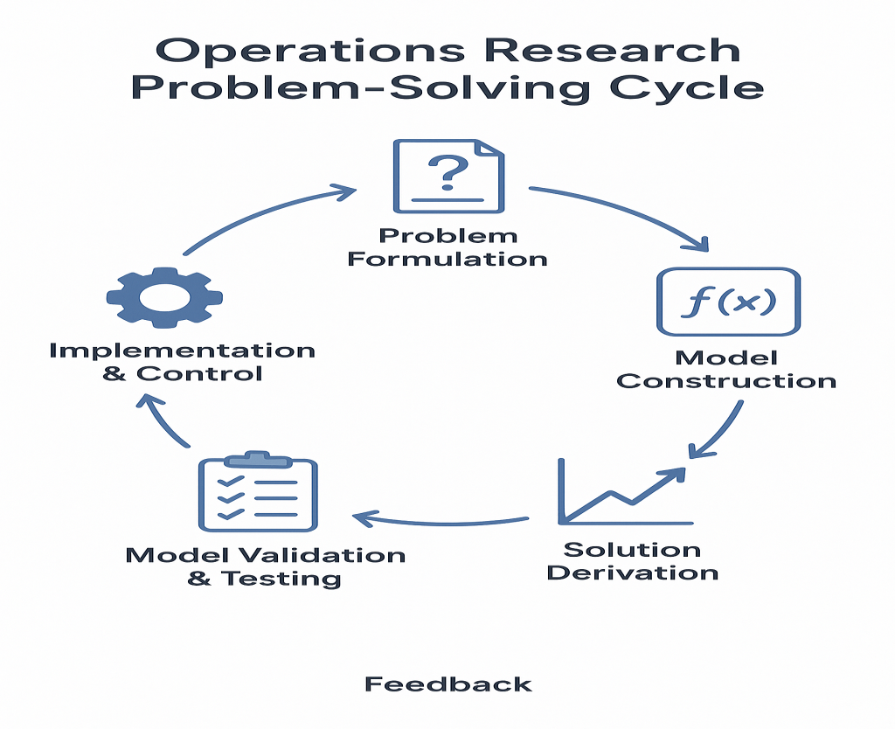
The OR Problem-Solving Cycle
The OR approach involves: (1) formulating the problem, (2) constructing a mathematical model that captures the essence of the problem, (3) deriving a solution from the model, (4) testing the model and the solution, (5) establishing controls over the solution, and (6) implementing the solution. This structured approach replaces guesswork with quantifiable analysis.
3.2 Key OR Techniques and their Mathematical Formulations
The following techniques form the core of the OR toolkit applicable to the FMCG manufacturing context.
- Linear Programming (LP): LP is used to achieve the best outcome (such as maximum profit or lowest cost) in a mathematical model whose requirements are represented by linear relationships. It is ideal for resource allocation problems.
  - Standard Form: Maximize (or Minimize) Z=∑^{n}_{j=1}CjXj
  - Subject to Z=∑^{n}_{j=1}a_{ij}x_{j} ≤ bi​ for i=1,2,...,m
  - and x_{j} ≥ 0 for j=1,2,...,n
  - Where cj​ are the coefficients of the objective function, aij​ are the technological coefficients, and bi​ are the resource limits.
- Integer and Mixed-Integer Programming (IP/MIP): These are extensions of LP where some or all of the decision variables are constrained to be integers. This is crucial for problems involving discrete units, such as the number of trucks, machines, or facilities to build.
  - Formulation: The model includes the additional constraint: x_{j} ∈ Z⁺ for some or all j.
- Inventory Management Models: These models aim to minimize the total cost of inventory, which includes holding costs, ordering/setup costs, and shortage costs.
  - Economic Order Quantity (EOQ): The classic model for determining the optimal order quantity that minimizes total inventory costs. The formula is
Q= $\sqrt{\frac{2Ds}{H}}$ where D is annual demand, S is ordering cost, and H is holding cost per unit per year.
  - Reorder Point (ROP): This determines when to place an order: ROP = d × L, where d is average daily demand and L is lead time in days. For uncertain demand, a safety stock (ss) component is added: ROP = (d×L) + ss.
- Network Optimization Models:
  - Vehicle Routing Problem (VRP): A combinatorial optimization problem aimed at finding optimal routes for a fleet of vehicles to deliver to a set of customers. The objective is typically to minimize total distance, time, or cost while satisfying constraints like vehicle capacity and delivery time windows.
  - Transportation Problem: A special type of LP that minimizes the cost of shipping goods from multiple sources (e.g., factories) to multiple destinations (e.g., warehouses).
- Scheduling and Sequencing: These techniques allocate tasks to resources over time. Gantt Charts are a fundamental visual tool for planning and tracking schedules, while more complex algorithms like Priority Rules (e.g., Shortest Processing Time first) and Johnson's Rule (for two-machine flow shops) are used to optimize sequences and minimize makespan.
- Waiting Line Models (Queuing Theory): Used to analyze and optimize systems where customers (e.g., trucks at a loading bay) arrive for service, helping to determine the optimal number of service channels to minimize waiting costs and idle time.
- Simulation: When problems are too complex for analytical solutions, discrete-event simulation is used to model the system's behavior over time, allowing managers to test different scenarios and policies in a risk-free environment.
​4. The Integration of OR with Industry 4.0 in the FMCG Context
The advent of the Fourth Industrial Revolution (Industry 4.0) has dramatically amplified the power and scope of Operations Research. OR is no longer just a set of static models; it is becoming a dynamic, integrated component of smart manufacturing ecosystems.
- Data Analytics and Big Data: The lifeblood of any OR model is data. Industry 4.0 technologies, such as IoT sensors on production equipment, RFID tags in warehouses, and point-of-sale systems in retail outlets, generate vast amounts of real-time data. Advanced data analytics platforms can cleanse, process, and feed this data into OR models, making them more accurate and responsive than ever before. For example, real-time sales data can dynamically update demand forecasts (D) in an EOQ model, leading to more responsive inventory control.
- Artificial Intelligence and Machine Learning: AI and ML are powerful complements to OR. While OR focuses on optimization given a set of constraints, ML excels at forecasting and pattern recognition. Machine learning algorithms can predict demand with higher accuracy, which is a critical input for production planning (LP) and inventory management (ROP) models. Furthermore, AI-powered heuristic and metaheuristic algorithms (e.g., Genetic Algorithms, Simulated Annealing) can find high-quality solutions to complex, non-linear problems like large-scale VRPs much faster than traditional exact methods.
- Internet of Things (IoT) and Digital Twins: IoT provides the real-time connectivity needed for OR models to interact with the physical world. A "Digital Twin" a virtual replica of a physical system (e.g., a production line, a distribution network) can be continuously updated with IoT data. OR models can then be run on this digital twin to simulate and optimize operations in a virtual space before implementing changes in the real world. For instance, a manager could test a new production schedule on the digital twin to assess its impact on throughput and energy consumption without disrupting actual production.
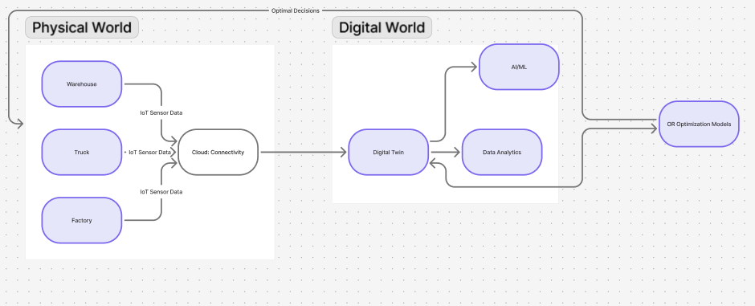
The OR 4.0 Ecosystem
For the Nigerian FMCG sector, this integration represents both a monumental opportunity and a significant challenge. The opportunity lies in leapfrogging traditional, siloed OR implementations and moving directly to integrated, smart systems. The challenge, however, is that the foundational digital infrastructure and technical expertise required for such integration are often lacking, a issue that will be explored in depth later.
​5. Contextual Framework: The Nigerian FMCG Operational Landscape
The FMCG sector in Nigeria is defined by its high-volume, low-margin nature, fast stock turnover, and extensive distribution networks that must reach both urban centers and widely dispersed rural populations. A typical FMCG company in Nigeria manages a complex value chain:
- Sourcing and Procurement: Dealing with volatile prices and availability of raw materials, often relying on imports with associated foreign exchange and port congestion risks.
- Production: Operating in an environment with unreliable public power supply, necessitating significant investment in private generators, which drastically increases operational costs. Production planning must be highly adaptive to raw material availability and frequent machine breakdowns.
- Warehousing and Inventory: Maintaining a delicate balance of inventory to avoid stock outs without incurring prohibitive holding costs. Warehouses may be plagued by poor inventory record accuracy and manual processes.
- Distribution and Logistics: Navigating one of the most challenging aspects: a logistics network hampered by poor road conditions, traffic congestion, security concerns, and a fragmented trucking industry. The "last-mile" distribution to thousands of small retailers (e.g., kiosks, corner shops) is particularly complex and costly.
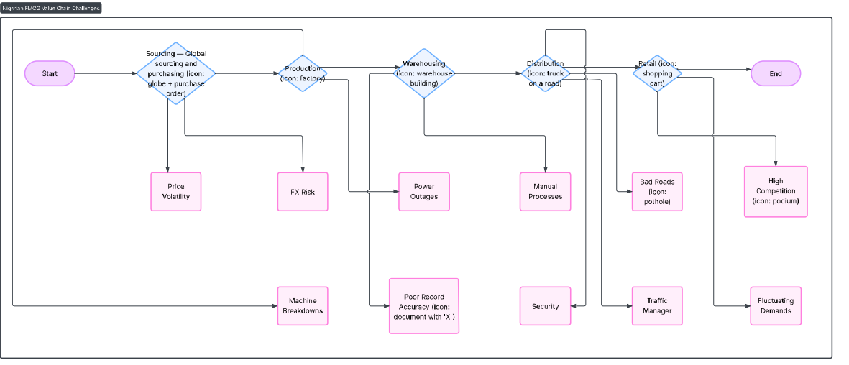
The Nigerian FMCG Value Chain and Pain Points
It is within this specific operational reality that the OR techniques described in Section 3 must be applied. The models cannot be imported and applied in their textbook forms; they must be adapted and robust enough to handle the unique constraints and uncertainties of the Nigerian context.
​6. Applied OR Models in the FMCG Context: Illustrative Examples
This section provides detailed, contextualized examples of how core OR models can be applied to address specific challenges in the Nigerian FMCG sector.
6.1 Production Optimization with Linear Programming
A typical FMCG company produces multiple product lines (e.g., beverages, cereals, bouillon cubes) on shared equipment. The goal is to determine the product mix that maximizes contribution margin given constraints.
- Problem Formulation:
  - Let x₁​ = units of Beverage A produced per day.
  - Let x₂​ = units of Cereal B produced per day.
- Objective Function: Maximize Profit Z =250x₁​+180x₂​ (in Naira).
- Constraints:
  - Blending Machine Capacity: The blending stage is a bottleneck. 2x₁​+ 4x₂ ​ ≤ 600 minutes.
  - Packaging Line Capacity: 3x₁​+2x₂​ ≤ 540 minutes.
  - Raw Material (Sugar) Constraint: Sugar is often in short supply.1.5x₁+1.0x₂ ≤ 200kg.
  - Non-negativity: x₁​,x₂ ​ ≥ 0.
- Solution and Interpretation: Solving this LP model (graphically or using software like Excel Solver) yields an optimal solution. Suppose the solution is x₁​= 80, x₂ =110, with a maximum profit of Z = ₦39,800. This provides management with a clear, data-driven production target. Sensitivity analysis could further show how much profit would increase if an extra hour of packaging time were available or if more sugar could be sourced, guiding investment and procurement decisions.
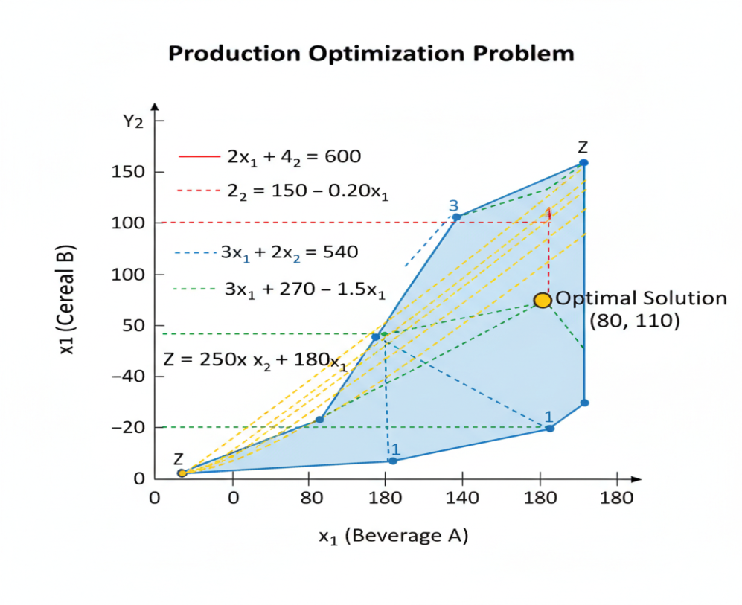
Graphical Solution of the LP Model
6.2 Inventory Control using EOQ and Safety Stock
For a high-demand product like a popular beverage brand, effective inventory control is vital.
- Data:
  - Annual Demand (D) = 50,000 units
  - Ordering Cost (S) = ₦5,000 per order (administrative, transportation)
  - Holding Cost (H) = ₦100 per unit per year
- EOQ Calculation:
  - Q=$\sqrt{\frac{2 ×50000×5000}{100}}$ = $\sqrt{5000000}$ ≈2,236units
- Reorder Point with Safety Stock:
  - Average Daily Demand (d) = 50,000 / 250 ≈ 200 units
  - Average Lead Time (L) = 7 days
  - Demand can vary, with a standard deviation of σd​=30 units/day.
  - To achieve a 95% service level (Z-score = 1.65), Safety Stock (ss) = Z × σd​ × √L​= 1.65×30×√7​≈131 units.
  - ROP = (d×L) +ss = (200×7) + 131 = 1,531 units.
This policy tells the warehouse manager to order 2,236 units whenever the inventory level drops to 1,531 units. This scientifically determined policy balances ordering and holding costs while providing a buffer against demand variability.
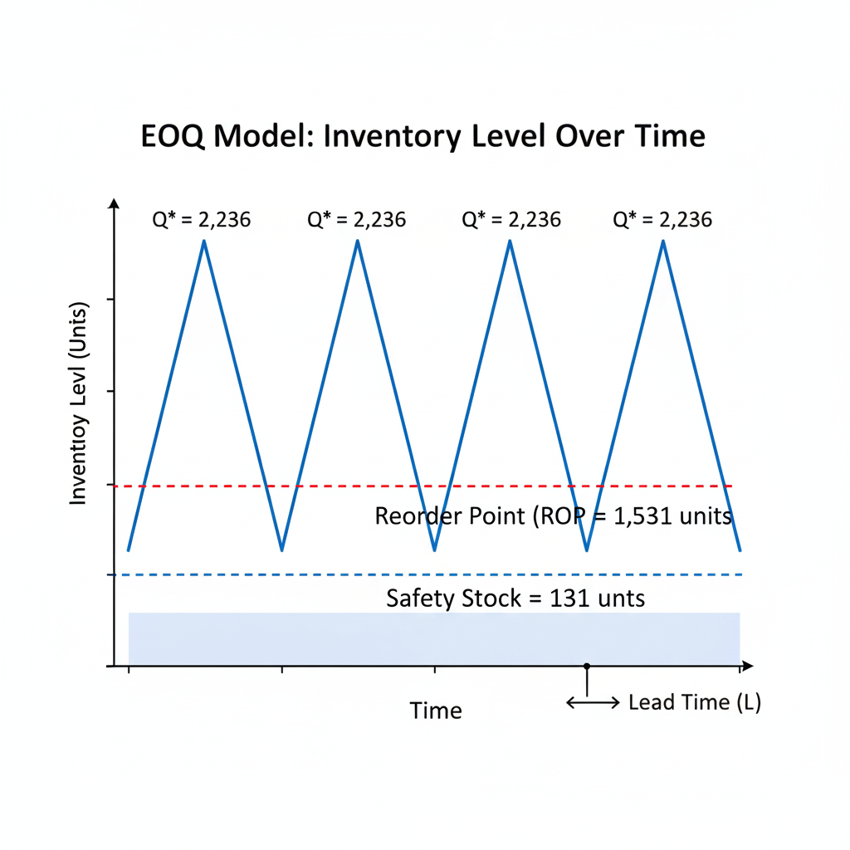 EOQ Model with Reorder Point and Safety Stock
6.3 Logistics Efficiency with the Vehicle Routing Problem (VRP)
A distribution manager in Lagos needs to deliver goods to 10 major customers. Using a simple VRP heuristic like the Clarke-Wright Savings Algorithm, the manager can consolidate routes. Instead of sending 10 separate trucks, the algorithm might suggest 3 consolidated routes that service all customers. A subsequent 2-opt local search can then "fine-tune" these routes by swapping customer sequences to eliminate crossovers and reduce total distance.

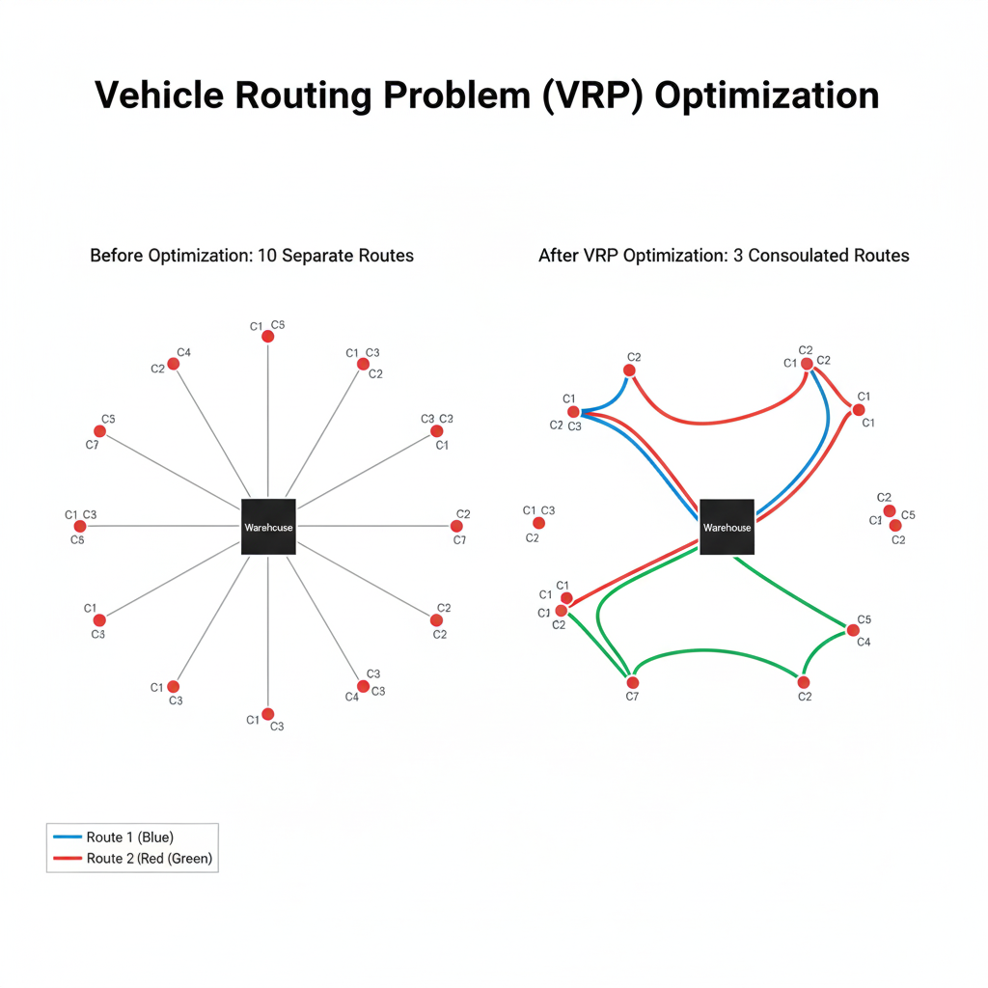
Vehicle Routing Problem Optimization
The result is a significant reduction in total kilometers traveled, fuel costs, and vehicle wear and tear, while improving delivery timeliness.
6.4 Production Scheduling with Gantt Charts
To manage the complexities of production on a factory floor, Gantt charts are indispensable. They provide a visual timeline for production orders, showing start and end times, task sequences, and resource allocation.
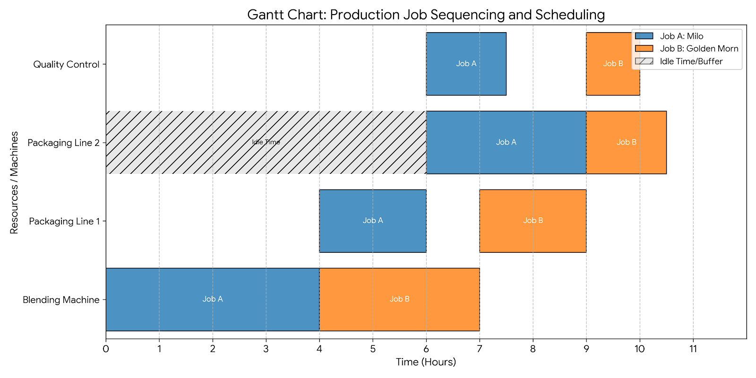
Production Sequencing/ scheduling 1
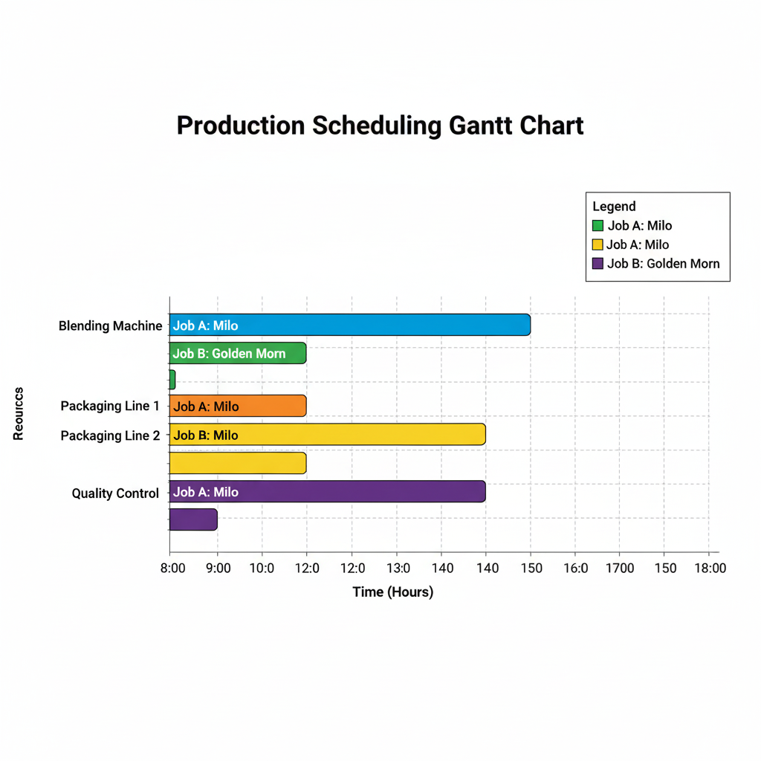

A Simple Gantt chart for Production Scheduling
This visualization helps managers identify production bottlenecks (e.g., a machine that is over-utilized), schedule preventive maintenance during idle periods, and ensure that the overall production timeline (make span) is minimized.
​7. Critical Challenges and Barriers to Implementation in Nigeria
The potential benefits of OR are clear, but their realization in the Nigerian FMCG sector is contingent upon overcoming a set of deeply entrenched barriers.
- Data Integrity and Management Issues: The "Garbage In, Garbage Out" axiom is highly relevant. Many Nigerian manufacturers struggle with fragmented, manual, and inconsistent data collection systems. Data on machine downtime, raw material consumption, and order lead times is often estimated rather than measured, rendering sophisticated OR models unreliable and untrustworthy.
- Technological and Infrastructure Gaps: The limited penetration of integrated Enterprise Resource Planning (ERP) systems means that data, even when available, is siloed in different departments (production, sales, and finance). Without a single source of truth, building a comprehensive OR model is exceedingly difficult. Furthermore, unreliable power and internet connectivity disrupt the real-time data flow required for dynamic optimization.
- Human Capital and Cultural Resistance: There is an acute shortage of professionals skilled in both the theoretical aspects of OR and the practical use of relevant software (e.g., Python, R, Gurobi, specialized simulation software). Moreover, there is often cultural resistance from middle management and frontline staff who are accustomed to traditional, experience-based decision-making and may view OR models as a threat to their authority or an overly complex "academic" exercise.
- Financial Constraints: Small and medium-sized FMCG players may perceive the upfront investment in software, hardware, and specialized personnel as prohibitively high, especially in a tough economic climate. The return on investment (ROI) may be viewed as uncertain and long-term.
- External and Macroeconomic Volatility: This is perhaps the most distinctive challenge. OR models typically assume a degree of stability. The Nigerian environment, however, is characterized by high inflation (which rapidly changes cost parameters), sudden government policy shifts, fuel scarcity, and security issues that disrupt transport routes. This volatility can make model parameters obsolete quickly and requires models to be exceptionally robust or adaptive.

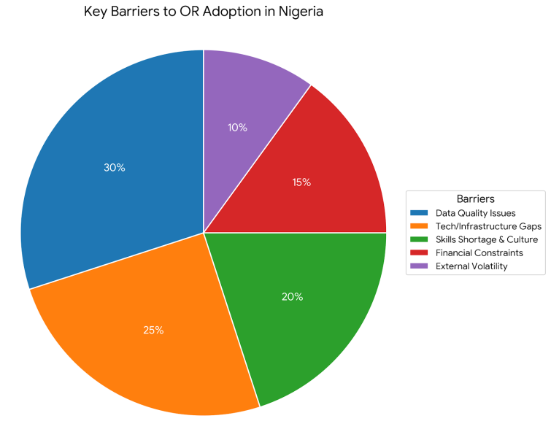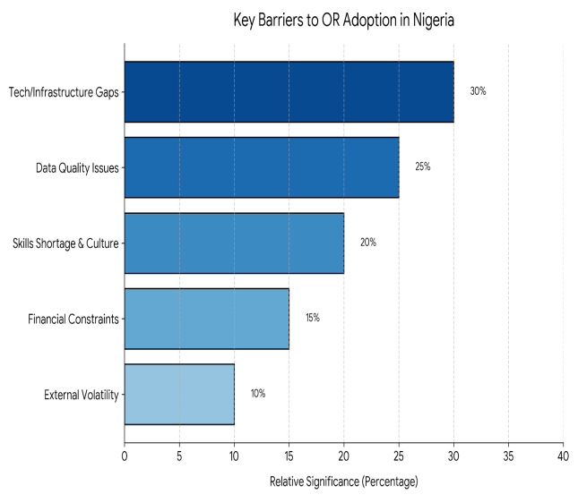
Barriers to OR Implementation
​8. Recommendations and a Strategic Way Forward
To bridge the gap between OR's potential and its current application, a multi-stakeholder, strategic approach is necessary.
- For FMCG Companies:
  - Phased Digital Transformation: Begin with foundational investments. Implement a robust ERP system to integrate data across functions. Start with applying OR to one or two high-impact, manageable problems (e.g., optimizing the production schedule for the most profitable line) to demonstrate value and build internal buy-in.
  - Targeted Capacity Building: Invest in continuous training for both new graduates and existing staff. Partner with software vendors for specific tool training and send engineers for professional certification in OR and data analytics.
  - Foster a Data-Driven Culture: Leadership must champion the use of analytical models. Incentivize managers based on metrics that align with model-driven outcomes to encourage adoption.
- For Academia and Research Institutions:
  - Curriculum Modernization: Engineering and Management curricula should be updated to include practical OR modules, case studies based on local industries, and hands-on training with relevant software.
  - Applied Research and Collaboration: Universities should actively seek research partnerships with FMCG companies. This provides students with real-world data and problems, while companies gain access to specialized skills and fresh perspectives. The goal should be to develop "Tropicalized" OR models that are robust to Nigeria's specific constraints.
- For Policymakers and Industry Associations:
  - Improve Enabling Infrastructure: Continued efforts to stabilize the power grid, improve road networks, and enhance digital broadband penetration are fundamental, as they lower the operational cost base and enable the technology that OR depends on.
  - Facilitate Knowledge Sharing: Industry associations (e.g., MAN, MANCAP) can organize workshops, seminars, and annual conferences focused on operational excellence and the adoption of modern management science techniques, creating a community of practice.
- Future Research Directions:
  - Development of robust optimization and stochastic programming models that explicitly incorporate macroeconomic volatility and supply chain disruption risks.
  - Exploration of hybrid AI-OR systems for predictive and prescriptive analytics in Nigerian supply chains.
  - Comprehensive cost-benefit analyses of OR implementation in specific Nigerian FMCG sub-sectors to build a stronger business case for investment.
​9. Conclusion
This contextual review has systematically articulated the profound relevance of Operations Research as a catalyst for operational transformation within the Nigerian FMCG sector. By providing a structured, scientific approach to decision-making, OR models—from linear programming for production to vehicle routing for distribution—offer a clear pathway to significant efficiency gains, cost reduction, and enhanced profitability.
However, the journey to widespread and effective OR adoption is fraught with challenges, primarily rooted in data management, technological infrastructure, human capital, and external volatility. These barriers are significant but not insurmountable. Overcoming them requires a concerted and collaborative effort from manufacturers, academia, and government.
The Nigerian FMCG sector stands at a crossroads. Companies that choose to ignore the power of advanced analytics and optimization risk being left behind in an increasingly competitive market. Those that strategically invest in building their OR capabilities, starting with foundational data integrity and moving towards integrated smart systems, will not only survive the challenging environment but will thrive, building resilient, efficient, and market-leading operations that are fit for the future.
​References
- H. A. Taha, Operations Research: An Introduction, 10th ed. Pearson Education, 2017.
- F. S. Hillier and G. J. Lieberman, Introduction to Operations Research, 11th ed. McGraw-Hill Education, 2021.
- A. Olukayode and S. T. Akinyele, "The Impact of Supply Chain Management on Organisational Performance of Food and Beverages Companies in Nigeria," International Journal of Social Sciences and Management Review, vol. 2, no. 4, pp. 1-15, 2019.
- T. I. Adeyemi and A. S. Adebayo, "Operations Research in Nigerian Manufacturing: A Review of Applications and Challenges," Journal of Business and Management, vol. 15, no. 2, pp. 45-60, 2023.
- N. F. Okafor, "A Survey of the Application of Operations Research in Nigerian Manufacturing Firms," Journal of Engineering and Applied Sciences, vol. 13, no. 2, pp. 481-487, 2018.
- H. E. Boukrouma, Y. Zennir, and R. Bendib, "A Systematic Literature Review on Industrial Scheduling Optimization," Algerian Journal of Signals and Systems, vol. 9, no. 4, pp. 222-235, Dec. 2024.
- O. Amaugo, "Impact of AI Technologies in Optimizing Manufacturing Processes in Nigerian Manufacturing Industry," International Journal of Applied Research, vol. 12, no. 1, Feb. 2025.
- D. Simchi-Levi, P. Kaminsky, and E. Simchi-Levi, Designing and Managing the Supply Chain: Concepts, Strategies, and Case Studies, 4th ed. McGraw-Hill, 2021.
- W. L. Winston and S. C. Albright, Practical Management Science, 6th ed. Cengage Learning, 2018.
- J. R. Arnold, S. N. Chapman, and L. M. Clive, Introduction to Materials Management. Pearson Education, 2012.
- S. Chopra and P. Meindl, Supply Chain Management: Strategy, Planning, and Operation, 7th ed. Pearson Education, 2020.
- M. L. Pinedo, Scheduling: Theory, Algorithms, and Systems, 4th ed. Springer, 2012.
- S. A. Oladejo and O. M. Adekunle, "The Impact of Digital Infrastructure on Supply Chain Performance of Manufacturing Firms in Nigeria," International Journal of Business and Management Review, vol. 8, no. 1, pp. 32-45, 2020.
- E. Iwu, "Challenges of Operations Research Application in Nigerian Industries," Journal of Business and Management Research, vol. 2, no. 1, pp. 12-25, 2018.
- B. O. Adeleke, T. I. Adeyemi, and J. O. Ogunleye, "Artificial Intelligence and Competitive Advantage: An Analysis of Nigeria's Manufacturing Sector," Journal of Business and Management, vol. 12, no. 1, pp. 45-60, 2023.
- S. Ighalo and S. F. Olaniyi, "Linear Programming as a Tool for Production Optimization in a Manufacturing Company," Journal of Applied Sciences and Environmental Management, vol. 21, no. 4, pp. 629-634, 2017.
- K. P. Isiguzo, "Operations Research and Optimization in Industrial Systems Design: A Case Study of Nestlé Nigeria Plc," Federal University of Technology Owerri, Unpublished term paper, Jul. 2025.
- R. D. Bakare and A. G. Rahim, "Niche marketing and operational performance in the Nigerian manufacturing industry: a study of Nestle Nigeria Plc," UNILAG Journal of Business, vol. 9, no. 2, pp. 1-15, Sep. 2023.
- R. Manzini, A. Sgalambro, and A. Cagnoli, "Applying Mixed-Integer Programming to the Design of a Distribution Logistic Network," International Journal of Industrial Engineering and Management, vol. 6, no. 3, pp. 101-112, 2015.
- P. Kaur and J. Singh, "Vehicle Routing Problem: A Systematic Literature Review," Journal of Cleaner Production, vol. 199, pp. 328-344, 2018.
- M. H. Putra and I. Masudin, "A Systematic Literature Review of Vehicle Routing Problem," Journal of Engineering and Technological Sciences, vol. 52, no. 2, pp. 220-235, 2020.
- M. Shibuya and X. Chen, "Production Planning and Management Using Gantt Charts," Journal of Mechanics Engineering and Automation, vol. 11, no. 2, pp. 85-94, 2021.
- A. Nneoma Benita, S. Ajayi, O. Asikhia, and A. Joachim, "Lean Manufacturing and Operational Efficiency of Nestle Nigeria Plc. Using Data Envelopment Analysis (DEA)," IORMS Journal of Operational Research and Management Science, vol. 1, no. 1, Oct. 2023.
- O. G. Ajayi and M. T. Adebayo, "Application of Operations Research Techniques in a Flour Mill: A Case Study of a Nigerian Company," International Journal of Research and Innovation in Applied Science, vol. 7, no. 10, pp. 108-115, 2022.
- J. T. Ekundayo and R. A. Olowe, "The Role of Quantitative Techniques in the Production Management of Selected Manufacturing Firms in Lagos State, Nigeria," Journal of Management and Social Sciences, vol. 10, no. 1, pp. 1-15, 2019.
- B. A. Agboola and D. O. Agboola, "Impact of Inventory Management Practices on the Performance of Manufacturing Firms in Nigeria," Journal of Accounting and Financial Management, vol. 7, no. 2, pp. 11-25, 2021.
- P. O. Anekwe and C. O. Ifeanyi, "The Effect of Supply Chain Integration on Organisational Performance of Selected Manufacturing Firms in Anambra State, Nigeria," International Journal of Academic Research in Business and Social Sciences, vol. 10, no. 5, pp. 582-595, 2020.
- J. O. Ayodele, "An Optimization Model for Production Planning of a Nigerian Bread Bakery," Journal of Engineering Research and Reports, vol. 1, no. 1, pp. 1-12, 2019.
- B. E. Eze and L. A. Abiodun, "A Study of the Effects of Material Requirements Planning (MRP) on Manufacturing Companies' Productivity in Nigeria," International Journal of Management and Social Sciences, vol. 7, no. 4, pp. 10-23, 2018.
- A. T. Jolaoso, "Logistics Management and Organisational Performance in the Fast-Moving Consumer Goods Sector in Nigeria," International Journal of Business and Management Review, vol. 9, no. 3, pp. 1-15, 2021.
- T. O. Kareem and T. A. Owolabi, "Inventory Control Techniques and Organisational Performance of Manufacturing Companies in Nigeria," Journal of Management and Financial Sciences, vol. 11, no. 1, pp. 1-15, 2019.
- P. C. Nwadike, "The Role of Quantitative Analysis in Decision-Making by Managers in Nigerian Manufacturing Industries," Journal of Business and Management, vol. 24, no. 7, pp. 1-12, 2022.
- A. O. Obisesan and S. A. Oladele, "The Impact of E-logistics on Supply Chain Performance of Selected Manufacturing Companies in Nigeria," International Journal of Logistics Management, vol. 5, no. 2, pp. 1-15, 2020.
- S. S. Ogunnaike and S. K. Ojo, "Application of Linear Programming in Profit Maximization of a Beverage Company in Nigeria," Journal of Scientific Research and Reports, vol. 27, no. 2, pp. 1-10, 2021.
- M. A. Olajide and O. A. Olayiwola, "Application of Operations Research in Solving Production Problems in a Nigerian Manufacturing Company," International Journal of Science and Technology, vol. 8, no. 3, pp. 1-10, 2018.
- O. A. Oloruntoba and A. A. Akerele, "The Effect of Just-in-Time (JIT) Inventory Management System on Organisational Performance of Manufacturing Firms in Nigeria," Journal of Accounting and Financial Management, vol. 8, no. 4, pp. 10-24, 2022.
- S. O. Salawu and O. B. Lawal, "Impact of Supply Chain Management on Competitive Advantage of Manufacturing Firms in Lagos State, Nigeria," International Journal of Business and Social Science, vol. 12, no. 6, pp. 1-15, 2021.
- D. Umoru and I. A. Ogie, "The Role of Operations Research in Optimizing Production in Nigerian Industries," Journal of Industrial Engineering, vol. 3, no. 1, pp. 10-25, 2019.
- N. Uchechukwu and O. Obiukwu, "Mechanical and physical properties of laser sintered nanocomposite containing organic and inorganic fillers: a context review," Vietnam Journal of Science and Technology, vol. 63, no. 3, pp. 417-436, 2024.
- E. Onukwulu, E. S. Osisioma, and G. Nwokorie, "The Application of Quantitative Techniques in Decision Making in Manufacturing Firms in Nigeria," Journal of Business and Management, vol. 23, no. 10, pp. 55-68, 2021.
- Nestlé Nigeria Plc, 2022 Annual Report and Financial Statements, 2023.
- Nestlé S.A., Creating Shared Value and Sustainability Report 2022, 2023.

