Design and Development of a Remote-Controlled Amusement Park Train: A Low-Cost Electromechanical Prototype
*S.O. Onifade¹
¹Department of Mechanical Engineering, Faculty of Technology, University of Ibadan, Nigeria
*S.O. Onifade¹: sammyemmy_2020@yahoo.com | https://orcid.org/0009-0009-4484-0371
ABSTRACT
The growing demand for safe, interactive, and energy-efficient transportation within recreational environments has necessitated the development of local, compact systems that blend engineering with user experience. This project focuses on the design and construction of a remotely controlled amusement park train intended for leisure transport in amusement parks, resorts, children’s playgrounds, and recreational centers. The train system is designed to simulate a miniature park train capable of carrying light loads or passengers (children or display models), with emphasis on safety, reliability, ease of operation, and cost-effectiveness. This project focuses on the design and construction of an amusement park train system with remote control functionality, developed primarily for recreational transportation in parks and leisure centers. The park train is designed to carry people safely around a circular track with a diameter of 6 meters at a controlled, convenient speed. Its primary aim is to provide a fun, low-speed mobility experience while demonstrating the integration of mechanical and electronic systems for recreational purposes. The amusement park train is powered by a 5-horsepower variable-speed electric motor, which supplies torque through a transmitting shaft connected via bearings and couplings to the rotating arm mechanism. This mechanical setup enables the coach to revolve around the circular path, supporting a maximum load of six passengers totaling approximately 404 kg. The system operates on a 220–240V AC power supply at 50Hz frequency, commonly available in most local environments. An essential feature of this project is the incorporation of a wireless remote- control system, which utilizes radio frequency (RF) signals to perform basic functions such as starting and stopping the train. This not only enhances safety and convenience but also introduces an element of automation into the system. The major goals of the project include providing affordable, efficient, and user-friendly transportation for amusement parks, while showcasing the application of mechanical design principles and remote-control integration.
Keywords: Amusement park train, remote control, rotating coach system, electric motor drive, mechanical design, RF control, affordable transport system, human-load mobility, automation.
INTRODUCTION
Background of the Study
Amusement parks are recreational environments designed to provide fun and relaxation for people of all ages. Among the various attractions available, amusement park trains serve as both functional and entertaining transport systems, offering riders a guided tour or circular ride around the park. Traditionally, these trains are manually operated or rely on fixed track systems with limited control features. However, with the advancement of modern engineering and the increasing integration of automation into mechanical systems, there is a growing interest in developing miniature amusement trains with remote control capabilities.
Remote-controlled systems in such recreational devices offer enhanced safety, better control, and increased user convenience. With wireless control, operators can start, stop, and manage the speed of the train from a safe distance, eliminating the need for onboard operation. This is particularly useful in environments involving children, where safety and monitoring are paramount.
The design and construction of an amusement park train with remote control incorporate knowledge from various branches of engineering, including mechanical design, electric motor control, structural analysis, and electronic communication. The train system typically consists of a chassis, an electric propulsion unit, a shaft or gear transmission, a seating coach, and a remote-control unit using radio frequency (RF) or Bluetooth technology. Materials such as mild steel, rubber, and plastic are commonly used due to their availability, cost-effectiveness, and strength-to-weight advantages.
This project aims to develop a functional, affordable, and locally fabricated amusement park train capable of carrying passengers around a circular path while being operated remotely. It also offers a platform for practical learning, innovation, and the demonstration of applied engineering principles.
Statement of the Problem
In many local amusement parks, recreational transport systems such as miniature trains are either manually operated or imported at a high cost. These systems often lack essential control features, are difficult to maintain, or do not meet safety standards suitable for children and family use. The absence of remote operation limits the flexibility and safety of the ride, especially in crowded or dynamic environments. Furthermore, the reliance on foreign products creates a dependency that undermines local fabrication capabilities and increases maintenance costs due to the unavailability of compatible spare parts. Most existing park trains are not designed with affordability, energy efficiency, or ease of operation in mind. This creates a gap in the availability of locally produced, safe, and cost-effective alternatives. There is, therefore, a pressing need to design and construct a low-cost, user-friendly amusement park train that integrates basic automation through remote control. Such a system should be constructed using locally available materials and must be capable of carrying a reasonable number of passengers around a guided path in a safe and reliable manner. The challenge lies in achieving this within a limited budget while maintaining safety, performance, and functionality.
LITERATURE REVIEW
Amusement rides, particularly miniature trains, have evolved from basic manually driven systems to complex, motorized, and even remotely operated systems. The development of an amusement park train involves the integration of mechanical systems, electrical drives, wireless communication, and user safety features. This section presents an extensive review of existing research and literature relevant to this project, covering six core areas: mechanical structure and locomotion principles; electric drive systems; remote control technologies; materials selection and fabrication processes; safety and maintenance; and educational and practical significance of engineering design projects in the context of amusement systems.
The mechanical structure of an amusement park train is essential to its performance, safety, and durability. The chassis or frame, which serves as the foundation, must be capable of withstanding dynamic and static loads, particularly when carrying human passengers. As per Sharma and Singh (2017), chassis design in low-speed vehicles must balance weight distribution, structural rigidity, and shock absorption. The coach frame must also accommodate the propulsion system (e.g., electric motor and shaft), seating arrangements, and turning mechanisms.
Locomotion in a circular path requires the conversion of rotary motion from the motor to linear or curvilinear movement along a track. This involves gear systems, drive shafts, and wheels. In some park train systems, the train is attached to a fixed rotating arm connected to a central shaft, allowing it to revolve on a circular track. The train's maneuverability depends on proper alignment of axles, turning radius considerations, and load balancing.
Studies such as those by Rehman et al. (2018) emphasize the importance of transmission components like bearings, couplings, and pulleys, which ensure that mechanical energy is efficiently transferred with minimal friction losses. These components are selected based on the torque output of the motor, load conditions, and expected duty cycles.
Electric motors are widely preferred in amusement applications due to their ease of control, low noise, and reduced maintenance compared to combustion engines. The use of a 5-horsepower variable-speed motor in small train systems allows precise regulation of speed, which is essential in environments where children or families are passengers. According to Khurmi and Gupta (2011), the motor’s horsepower must match the weight of the train, frictional resistance of the wheels, and desired operating speed.
Direct coupling of the motor to the drive shaft is often adopted in compact systems. However, gear reduction mechanisms are used in some designs to ensure adequate torque at low speeds. Brushless DC motors are increasingly used in modern designs for their improved efficiency and longer service life, although AC motors remain common due to their lower cost and simplicity in systems connected directly to the grid (Bolton, 2015).
Battery-powered trains are becoming more popular as they provide portability, eliminate the need for overhead wiring, and offer eco-friendliness. However, this requires energy management systems and motor controllers to regulate power delivery, especially under varying loads.
According to Shinde & Gaikwad, 2020, the integration of remote control into amusement park train systems introduces a level of automation and safety, allowing the operator to control the system without direct interaction. Remote-controlled operation typically uses Radio Frequency (RF) or Bluetooth technology. RF-based systems are more suitable for longer ranges and open outdoor environments, while Bluetooth is often used in enclosed or personal applications.
The basic remote- control setup includes a transmitter (remote) and a receiver embedded in the train system. The receiver is connected to relays or a motor driver circuit that translates signals into motor operations. This allows for functions such as Start/Stop, speed variation, and directional control. Incorporating remote control enhances safety by enabling emergency shutdowns and avoiding the need for onboard drivers.
More advanced systems integrate microcontrollers such as Arduino or PIC, which allow further expansion to include sensors, speed regulation, feedback systems, and obstacle detection. Such systems reflect the trends in mechatronics and smart mobility, where transportation units operate under partially or fully autonomous conditions.
In their study, Afolabi et al., 2020., Material selection significantly impacts the cost, performance, weight, and durability of the amusement train. In recreational designs, mild steel is commonly used for the chassis and body frame due to its good weldability, mechanical strength, and affordability. It is also readily available, making it an ideal choice in developing countries.
For non-load-bearing components, plastics and rubber are used to minimize weight and improve user comfort. Rubber tires or rubber-coated wheels offer shock absorption, vibration damping, and enhanced grip. Plastics such as acrylic or polypropylene may be used for body covers, panels, or seating areas due to their resistance to corrosion and ease of fabrication.
Material selection is also influenced by the expected operating environment. Outdoor trains may require materials with anti-corrosion properties or protective coatings to withstand exposure to rain and sunlight. Additionally, considerations such as ease of repair, availability of spare parts, and recyclability further influence selection decisions.
Maintenance is a critical aspect of any mechanical system, especially those carrying human passengers. Regular maintenance routines such as lubrication of shafts and bearings, tire inflation, and inspection of electrical wiring are necessary to ensure continued reliability. Olawale and Ibitoye (2012) note that preventive maintenance reduces downtime and prevents mechanical failures that could lead to accidents.
Safety considerations in amusement rides are regulated in many countries through standards and inspection guidelines. Even for small park trains, ensuring passenger stability, providing guard rails, limiting speed, and integrating emergency stop functions are essential. Speed regulation via resistors or motor controllers helps avoid jerks or sudden acceleration.
Additionally, the use of seat belts, speed limiters, and soft starting techniques in motor control can enhance passenger safety, especially when children are involved. The use of visual and audible indicators (e.g., horns, lights) also adds a layer of communication between operator and passengers.
Engineering design projects such as amusement park trains provide excellent platforms for project-based learning. Kolmos et al. (2009) argue that hands-on projects engage students in applying theoretical knowledge from mechanics, electronics, and materials science to solve real-world problems. This kind of interdisciplinary project promotes creativity, teamwork, and innovation.
In polytechnic and technical institutions, projects like these are increasingly used for HND and B.Tech thesis work. They offer the opportunity to explore fabrication techniques, CAD modeling, electromechanical system integration, and system testing, which are critical skills for engineers. Students are also exposed to cost estimation, project planning, and report writing, which are essential for real-world engineering practice.
Park & Lee, 2021 note that in recent years, the use of automation, Internet of Things (IoT), and renewable energy in amusement rides has gained attention. Developers are integrating solar-powered systems, smart monitoring, and cloud-based control for security, energy efficiency, and improved user experience. While these technologies may not yet be fully implemented in small park trains due to cost constraints, they represent future directions for innovation.
Additionally, modular design and 3D printing are being explored to reduce costs and simplify part replacement in amusement systems. This further promotes sustainability and faster prototyping in recreational engineering.
While considerable literature exists on mechanical systems and electric drive technologies, there is relatively limited work on the design of affordable, locally fabricated, and remote-controlled park trains that meet safety standards in low-income regions. Most existing systems are either too expensive, imported, or not designed with tropical conditions in mind.
This project aims to fill this gap by developing a low-cost, locally fabricated, and functional amusement park train prototype using accessible materials and simple electronic control systems. It combines proven mechanical principles with basic automation to create a solution that is both practical and educational.
The literature reviewed shows that the design and development of amusement park trains involve multidisciplinary knowledge, including mechanical design, motor technology, control systems, material science, and maintenance strategies. While advanced models incorporate high-level automation, cost-effective systems that meet local needs can still be developed with basic tools and principles. The present project leverages this knowledge to produce a functional prototype suited for recreational use and educational demonstration, emphasizing affordability, safety, and engineering value. In light of the preceding information, the objectives of this project are outlined as follows:
- To design and construct a stable and safe rotating amusement park train with remote control for basic operation at a reasonable economic value;
- To select cost-effective and locally available materials;
- To prepare working drawing and assembly drawing for its construction process;
- To ensure the system can carry a modest human load under safe conditions;
- To assess performance, durability, and maintenance requirements.
METHODOLOGY
The development of the remote-controlled amusement park train was executed through a structured engineering design and fabrication approach. This process encompassed the conceptualization, design, material selection, fabrication, assembly, and performance evaluation of a rotating amusement train system. The methodology integrates mechanical and electrical subsystems to ensure efficient functionality, system coherence, and user safety.
The project followed the standard engineering design cycle, which began with identifying functional and performance requirements. The amusement train was intended to transport six passengers along a circular track with a minimum turning radius of 3 meters (track diameter of 6 meters). Key design targets included structural safety, reliable locomotion, effective power transmission, and remote operability.
Design sketches were developed, followed by 2D drafting and 3D modeling using AutoCAD software to visualize and refine the structural and component layout. This facilitated dimensional accuracy, ergonomic seating arrangements, and optimized component integration.
The system was divided into three main subsystems to streamline the design and integration process:
- Mechanical Subsystem: Frame, wheels, axles, rotating shaft, couplings, and coach structure.
- Electrical Subsystem: 5 HP three-phase variable speed electric motor, wiring, switchgear, and power supply.
- Control Subsystem: RF-based remote transmitter and receiver, relay switches, and motor controller.
Each subsystem was designed in isolation and subsequently integrated to form a cohesive unit. Both permanent joints (via arc welding) and temporary fasteners (bolts and nuts) were employed in assembly to ensure serviceability and robustness.
The individual component was carefully selected to meet the performance, cost, and availability constraints of the project.
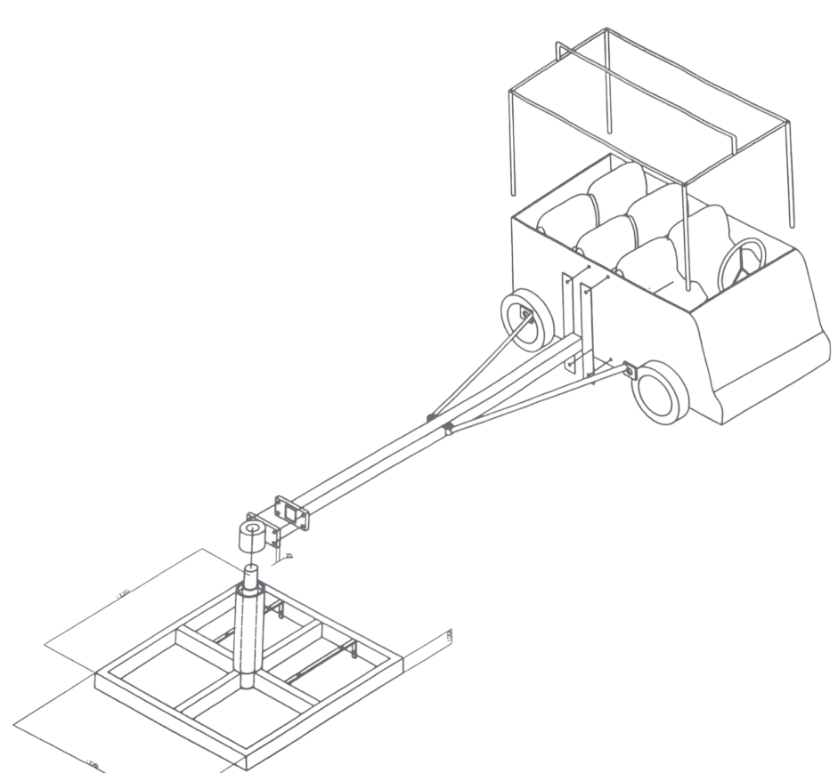
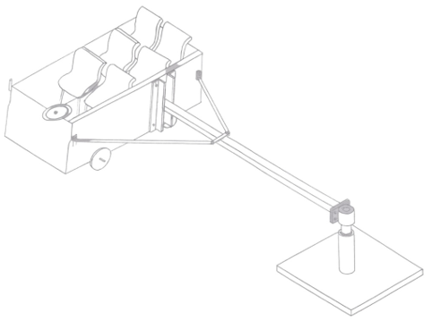
Fig.1: Major Parts of the Amusement Park Train
The amusement park train with remote control is a complete system designed for the purpose of amusing oneself and also to understand the dynamics which is the science that deals with the motion of the system under the influence of motion and to static, which deals with the condition for lack of motion. All these are put into consideration so as to make the system reliable, efficient, and safe for human effort.
The amusement park train with remote control comprises of a seating means for seating at least six (6) passengers riding the park train; a frame for supporting seating means; an arm attached to a carriage; said frame attached to and fully rotatable about said arm; track means allowing said carriage to travel; and a control means for selective allowing and preventing free rotation of the frame. However, the amusement park train with remote control is designed to move people (passenger(s)) through a fixed course within a designed area for the purpose of amusement
Design of the Park Train
The focus of this project is on the design and construction of an amusement park train with remote control
Design Calculations and Assumptions
The main objective of the project is to design and construct an amusement park train wit remote control, that is reliable, simple, efficient and very easy to maintain. So, design calculations were carried out to determine:
Total Load: Assumed total passenger weight = 6 persons × ~67 kg = 402 kg
Required Torque and Power: Using basic drive system equations to select an appropriate motor size and shaft diameter.
Speed: Target speed of 3–5 km/h for safety and comfort.
Turning Radius: Minimum of 3 m radius (6 m diameter) for smooth circular motion.
Motor and shaft selection were verified based on mechanical design standards and load transmission efficiency.
From the design analysis, it is required that the system should be able to carry a load of 600kg when it is powered to a D.C motor with the power rating of 5Hp. conveniently. After the completion of the design and construction, a test was carried out to show that this conforms to the theoretical design.
Component Design and Material Selection
All materials and components were selected based on load-bearing capacity, local availability, ease of fabrication, cost-effectiveness, and suitability for outdoor operation. The table below outlines key materials and components:
Component/Material | Specification
Electric Motor | 5 HP, Three-phase, Variable-speed
Shaft | Mild steel, Diameter = 57.3 mm
Wheels | Rubber-coated, 4 units
Bearings and Couplings | Standard steel, 2 units each
Frame/Chassis | Mild steel square pipe (25×25 mm)
Control System | RF module (transmitter and receiver)
Power Supply | 220V–240V AC, 50 Hz
Relays and Wiring | 12V DC SPDT, insulated wires
Welding Electrodes | E6013
Tools | Welding machine, grinder, drilling machine, spanners
Each component was modeled and sized according to established engineering standards. Design calculations ensured that the system could carry a total load of at least 600 kg.

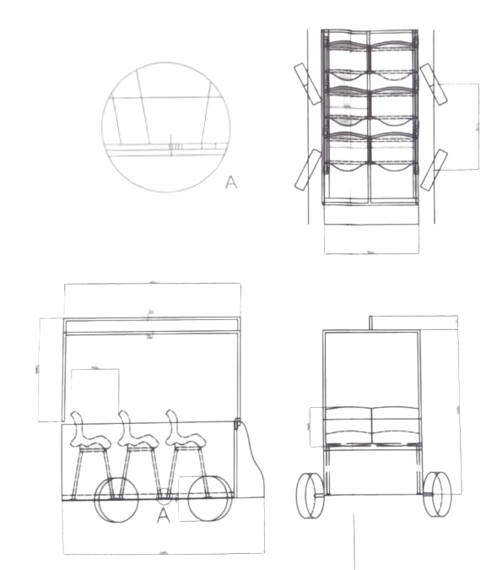
Figure 2: Orthographic views of Amusement Park Train
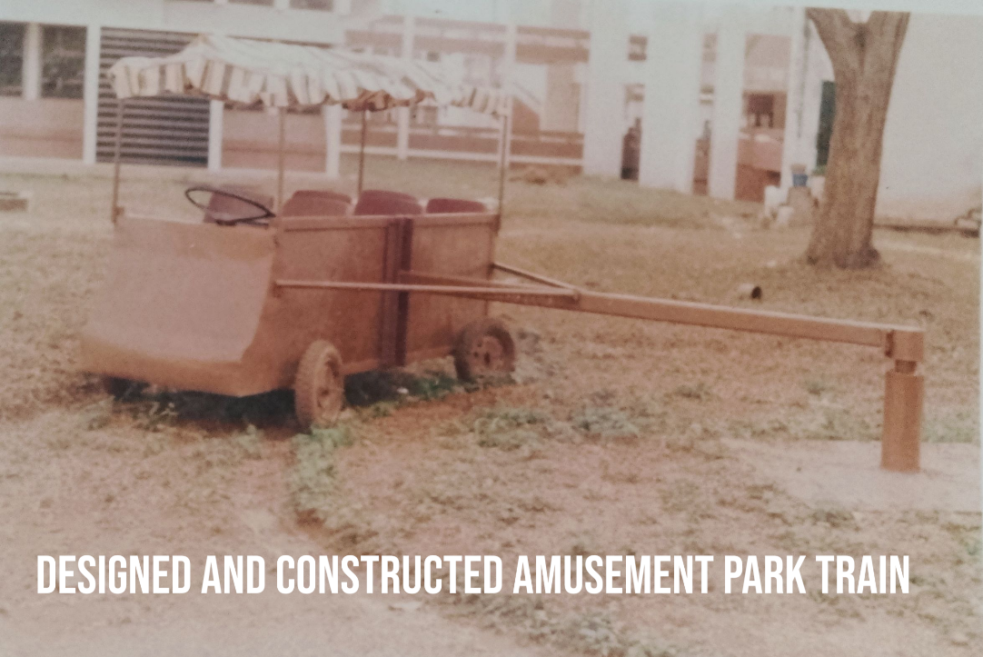
Fig.3: Picture of the assembled remote controlled Amusement park train

RESULTS AND DISCUSSIONS
After the completion of the test the results obtained in 5 revolution for different loads at different time (t) was tabulated in the Tables below:
Table 1: Performance Results Over 5 Revolutions
No of Passengers | Weight  (kg) | Time  (s) | N  (rev/s) | $$ω$$  $$(rad/s)$$ | V  (m/s)
Nil | 90 | 38 | 0.1316 | 0.8269 | 2.4807
1 | 161 | 39 | 0.1282 | 0.8055 | 2.4165
2 | 231 | 40 | 0.1250 | 0.7854 | 2.3562
3 | 289 | 40 | 0.1250 | 0.7854 | 2.3562
4 | 356 | 42 | 0.1191 | 0.7483 | 2.2449
5 | 424 | 43 | 0.1163 | 0.7138 | 2.1414
6 | 494 | 44 | 0.1134 | 0.7125 | 2.1375
7 | 600 | 53 | 0.0943 | 0.5925 | 1.775

Table 2: Static and Dynamic Force Measurements
No. of Passengers | Weight (kg) | Static Force (N) | Dynamic Force (N)
0 | 90 | 39.24 | 19.62
1 | 161 | 78.48 | 29.43
2 | 231 | 98.10 | 49.05
3 | 289 | 117.72 | 78.48
4 | 365 | 156.96 | 88.29
5 | 424 | 176.58 | 137.34
6 | 494 | 215.82 | 156.96

Using results from Table 1 and 2, a frictional force analysis was conducted:
$$Frictional force effect F_{friction} required to overcome =μmg$$
$$F_{friction}=0.04×9.81×600=235.44N$$
If $Theoretical force calculated{ F}_{theoreticcal}=451.8N$
$F_{total}=F_{theoreticcal}+F_{friction}=451.83N+235.44N=687.27N$
The actual power requirement was estimated as:
Actual Power = 2.86HP
$$The Efficiency =\frac{2.86}{3.39}×100=84.4\%$$
However, it can be deduced from both theoretical power estimation power of 3.39 Hp and actual power estimation of 2.86 Hp such that as an angular acceleration (α) increases, so the power will also increase i.e. the higher the angular acceleration (α) the higher the power required. Also, the efficiency of the motor being calculated to be 84.4% shows that the motor is safe for this design.
CONCLUSION
The development and testing of a remote-controlled amusement park train demonstrated the practical application of integrated mechanical and electrical engineering principles. Through systematic design, fabrication, and evaluation, the train was successfully constructed to accommodate up to six passengers, navigating a circular track with a minimum turning radius of 3 meters. The system met the key performance criteria in terms of stability, load-bearing capacity, motion control, and safety.
The use of locally available materials and standard components contributed to cost-effectiveness and ease of maintenance. Performance tests revealed a maximum operating velocity of approximately 2.48 m/s under no load and 1.78 m/s under full load, which aligns well with the safety and comfort requirements for amusement rides. The motor efficiency of 84.4% confirmed the suitability of the selected power system, ensuring reliable operation with minimal energy loss.
The experimental results further validated the design assumptions, particularly the power requirement, torque capacity, and the effect of frictional forces on the overall performance. The integration of a remote- control system provided flexibility in operation and enhanced user interaction, marking a significant step toward automation in small-scale amusement transport systems.
RECOMMENDATIONS
Based on the outcomes of this project, the following recommendations are proposed for future development and optimization:
- Enhanced Control Features: Integration of programmable logic controllers (PLC) or microcontrollers could provide smoother acceleration, emergency stop features, and safety interlocks for advanced control and fault detection.
- Battery-Powered Drive System: Future models could explore battery-powered motors with regenerative braking systems to improve energy efficiency and environmental sustainability, particularly for parks with limited access to AC mains power.
- Structural Optimization: Use of lightweight but strong materials such as aluminum alloys or composite frames may reduce overall weight, improve mobility, and reduce power consumption.
- Passenger Safety Enhancements: Incorporation of safety harnesses, padded interiors, and automated braking systems would improve passenger security, especially for children and elderly users.
- Scalability and Modularity: The design can be expanded to accommodate more coaches and increased passenger capacity through modular design principles, enabling scalability for larger amusement setups.
- Environmental Testing: Further testing under varied environmental conditions such as wet or uneven terrain should be carried out to assess durability and reliability in real-world amusement park environments.
By implementing these recommendations, the system can be refined and adapted for broader applications in the amusement and transportation sectors, providing safe, efficient, and interactive transport experiences.
ACKNOWLEDGMENT
The author gratefully acknowledges the support of the Department of Welding and Fabrication Engineering Technology, whose facilities and resources significantly contributed to the successful completion of this project. Special thanks are extended to the workshop technical staff for their assistance during the fabrication and testing phases. Appreciation is also due to colleagues and mentors who provided valuable suggestions during the design and development stages of the amusement park train.
CONFLICT OF INTEREST
The author declares that there is no conflict of interest regarding the publication of this article. The research was conducted independently and received no funding or external sponsorship that could influence the outcome or interpretation of the results.
AUTHOR’S CONTRIBUTION
The author was solely responsible for the conception, design, fabrication, assembly, and testing of the remote-controlled amusement park train. All phases of the project, including literature review, design calculations, material selection, system integration, data analysis, and documentation, were carried out independently by the author. This article is an original work and represents the author’s individual academic and engineering efforts.
REFERENCES
Afolabi, A. O., Dada, O., & Adeyemi, A. (2020). Material selection for cost-effective fabrication in developing countries. Journal of Engineering Research and Reports, 18(3), 1–8.
Bolton, W. (2015). Mechatronics: Electronic Control Systems in Mechanical and Electrical Engineering (6th ed.). Pearson Education.
Khurmi, R. S., & Gupta, J. K. (2011). A Textbook of Machine Design (14th ed.). Eurasia Publishing House.
Kolmos, A., De Graaff, E., & Du, X. (2009). Research on Problem-Based Learning in Engineering Education. Sense Publishers.
Olawale, D. A., & Ibitoye, S. J. (2012). Maintenance strategies in engineering applications. Engineering Practice Journal, 4(2), 45–51.
Park, J., & Lee, M. (2021). Smart automation in recreational rides: Integration of IoT and energy-efficient drive systems. International Journal of Electrical and Computer Engineering, 11(2), 88–95.
Rehman, S., Ali, M., & Nasir, A. (2018). “Design considerations for small scale electric vehicle propulsion.” Journal of Mechanical Engineering Research and Development, 41(3), 25–32.
Sharma, V., & Singh, H. (2017). Design and analysis of miniature trains for children. International Journal of Mechanical Engineering and Technology, 8(6), 54–61.
Shinde, M., & Gaikwad, S. (2020). Wireless control systems for small-scale transportation. International Journal of Robotics and Automation Studies, 5(4), 109–114.

