IOSR Journal of Engineering
ISSN:
www.iosrjournalss.org

Development of Chemically Treated Sawdust as a Sustainable Sorbent for Oil Spill Remediation

Wafa Attia¹, Abdullah Elamari ^{2,} Omar Alnashed ³
(Chemical engineering department/Faculty of technical Engineering, University of Bright Star, Albrega, Libya)
Abstract
Oil spills continue to pose a significant environmental issue, especially in marine ecosystems where clean-up efforts are extremely challenging and costly. Sawdust was chemically altered using sodium hydroxide, hydrogen peroxide, and hydrochloric acid in this research to increase its water-repelling and oil-attracting properties, thus enhancing its ability to absorb crude oil from seawater. The adsorption behavior was studied using the pseudo-second-order (PSO) and Elovich kinetic models at different temperatures. The PSO model achieved the highest correlation (R² = 0.9891), suggesting that chemisorption was the primary mechanism, and the Elovich model supported adsorption on a heterogeneous surface with decreasing rates as surface coverage increased. FTIR spectroscopy offered molecular proof of successful modification, showing reduced hydroxyl bands and the formation of carbonyl and aliphatic groups associated with enhanced hydrophobicity. The treated sawdust demonstrated a sorption capacity of 4.05 g/g after 90 minutes and sustained its efficiency over four reuse cycles. These findings confirm that chemically modified sawdust is a highly effective, low-cost, and renewable sorbent, offering significant potential for practical oil spill cleanup in marine settings.

Key words Chemically treated sawdust, Oil spill remediation, Adsorption kinetics, FTIR spectroscopy, Hydrophobic modification, Surface modification.

1.Introduction
Oil spills continue to pose a serious threat to marine ecosystems and coastal environments, with wide-ranging ecological and economic consequences. Traditional remediation methods such as chemical dispersants, in-situ burning, and mechanical recovery are often costly, logistically challenging, and may introduce secondary environmental impacts. These limitations have led to growing interest in alternative strategies that are both effective and environmentally responsible. Among these, the use of natural sorbents has attracted considerable attention due to their accessibility, biodegradability, and relatively low cost [1].
Despite their potential, the practical application of natural sorbents is constrained by several factors, including limited oil uptake capacity, poor selectivity, and challenges associated with reuse and recovery. Many studies in this field have not adequately examined how chemical modification can improve the efficiency of these materials, nor have they thoroughly explored the influence of operational parameters such as temperature and surface characteristics on adsorption behavior. Addressing these gaps is critical to advancing the performance of bio-based sorbents in real-world spill scenarios [1], [2].
Recent developments in sorbent research have highlighted the effectiveness of biomass-based materials for oil spill remediation. These sorbents, derived from agricultural or forestry waste, offer a sustainable alternative to synthetic options. Chemical or thermal modification of lignocellulosic materials has shown significant promise in improving oil uptake capacity and water repellency [1]. Modifications using alkaline, oxidative, or acid treatments not only enhance porosity and surface functionality but also improve reusability, which is essential for practical applications [2].
Lignocellulosic sorbents such as kapok fiber, sugarcane bagasse, and rice husks have been widely evaluated for their oil adsorption performance. Kapok, with its hollow hydrophobic fibers, demonstrates excellent oil retention capacity, while sugarcane bagasse and rice husks exhibit moderate efficiency [3]. However, these materials are often limited by inconsistent performance and lower selectivity under varying environmental conditions. These comparisons underscore the importance of not only selecting suitable biomass types but also optimizing their surface properties through chemical treatment [3].
In addition to laboratory-based studies, practical applications have validated the use of natural sorbents in real-world spill scenarios. Notably, during the 2020 Mauritius oil spill, community-led initiatives successfully deployed organic materials such as human hair and sugarcane waste to mitigate contamination [4]. These efforts reflect both the effectiveness and the public acceptance of sustainable cleanup technologies, further motivating research into optimized, low-cost, natural sorbents for environmental remediation [4].
According to Anisuddin et al, approximately 5 million tons of petroleum are transported annually across global waters, placing marine biodiversity at continual risk [5]. Given the sustained global reliance on petroleum for manufacturing and energy—spanning products from plastics to chemical feedstocks—this trend is unlikely to reverse in the foreseeable future. Furthermore, petroleum distribution typically involves multiple transfer stages across various transport modes, each presenting a potential point for accidental discharge [6].
Once discharged, oil undergoes complex weathering processes—such as spreading, emulsification, photo-oxidation, and biodegradation—which rapidly alter its composition and behavior. These transformations complicate the remediation process and highlight the importance of a timely and effective response [7]. Among the various remediation strategies, sorbents stand out for their ease of use and rapid deployment. In particular, organic sorbents derived from agricultural or forestry residues have shown promising potential due to their porous structure and hydrophobic-oleophilic nature [1], [2].
Sawdust, a readily available and low-cost lignocellulosic material, has emerged as a viable candidate for oil spill treatment. Its oil affinity, however, can be significantly enhanced through chemical treatment. Modifying sawdust with sodium hydroxide (NaOH), hydrogen peroxide (H₂O₂), and hydrochloric acid (HCl) alters its surface morphology, increases porosity, and improves hydrophobicity. Specifically, NaOH facilitates the removal of lignin, exposing more active sites for oil interaction; H₂O₂ introduces oxygenated functional groups that support oil absorption; and HCl further purifies and refines the surface for enhanced sorption [8], [9].
The primary objective of this study is to investigate the oil adsorption capacity of chemically treated sawdust under controlled laboratory conditions. By examining the influence of temperature and surface modifications, the research aims to identify the parameters that most significantly affect performance. The findings will contribute to the development of more effective, sustainable solutions for oil spill remediation using natural, chemically enhanced materials [9].
This study evaluated the oil absorption capabilities of sawdust obtained from four unique tree species: Juniperus procera, Populus alba (White Poplar), Pinus halepensis (Aleppo Pine), and Cupressus sempervirens (Cypress). Results showed that Populus alba demonstrated the greatest proficiency in oil absorption and adsorption. Consequently, further analysis focused solely on this species, emphasizing its potential as an effective, locally sourced solution for oil spill remediation [10], [11].
2. Methodology and Materials
2.1Materials
Sawdust samples were collected from four tree species: Juniperus procera, Populus alba (White Poplar), Pinus halepensis (Aleppo Pine), and Cupressus sempervirens (Cypress), sourced locally from the Al Jabal Al Akhdar region in Libya. After preliminary testing, Populus alba was selected for detailed experimental analysis due to its superior oil sorption capacity.
All chemicals used in this study were of analytical grade and supplied by Merck (Germany). Sodium hydroxide (NaOH) pellets were used to prepare a 0.5 wt.% solution for alkali treatment. Hydrogen peroxide (H₂O₂, 30% w/v) was used to oxidize and introduce oxygenated functional groups to the sawdust surface (Merck, Cat. No. 1.07287.1000). Hydrochloric acid (HCl, 37%) was employed to enhance surface purification and porosity. Anhydrous ethanol (≥99.5%) was used during the washing process to remove residual organic contaminants.
Distilled and demineralized water were used throughout the experiments to avoid interference from mineral ions. Artificial seawater was prepared using natural sea salt collected from the Libyan coastline. The salt was oven-dried, ground, and dissolved in demineralized water at a concentration of 35 g/L to replicate the 3.5% salinity typical of marine environments.
All glassware and tools used in the experiments were cleaned with ethanol and rinsed with distilled water before use to prevent contamination.

2.2Methodology
2.1 Sawdust Collection and Selection
Sawdust samples were collected from four tree species: Juniperus procera, Populus alba (White Poplar), Pinus halepensis (Aleppo Pine), and Cupressus sempervirens (Cypress). Among these, Populus alba demonstrated the highest oil adsorption capacity in preliminary tests and was selected for detailed experimentation.

2.2 Sieving and Washing
The selected sawdust was sieved to ensure uniform particle size and remove irregular or large fragments. It was then sequentially washed with distilled water, anhydrous ethanol, and a final rinse with distilled water to eliminate surface impurities and contaminants.

2.3 Chemical Modification
To evaluate the effect of chemical treatment across different wood types, four replicate samples were prepared from each of the following species: Juniperus procera, Populus alba, Pinus halepensis, and Cupressus sempervirens. Each 2-gram sample was treated using a standardized protocol involving immersion in 200 mL of 0.5 wt.% sodium hydroxide (NaOH) solution combined with 7 mL of 30% hydrogen peroxide (H₂O₂). The treatment was conducted at ambient temperature with gentle stirring for one hour to modify the surface structure by enhancing porosity, reducing lignin content, and increasing the availability of active adsorption sites. After treatment, the samples were thoroughly rinsed with distilled water and oven-dried at 65°C.
As part of the post-treatment process, hydrochloric acid (HCl) was added to neutralize residual alkalinity and adjust the pH of the sawdust samples to a range of 6.5–7.5. It is important to clarify that HCl was not involved in the chemical modification of the surface and therefore the process does not constitute acid treatment. Rather, the methodology employed here represents an alkali-assisted oxidative modification, where acid serves a neutralizing function to stabilize the treated biomass without contributing to structural alteration.
Initial testing revealed that Populus alba exhibited the highest oil sorption capacity among the species examined. Based on this result, four additional Populus alba samples were independently prepared and subjected to the same chemical treatment protocol. Each treated sample was then evaluated under identical experimental conditions to confirm consistency in adsorption performance and validate the observed superiority of this species.

2.4 pH Adjustment
After chemical treatment, the sawdust's pH was adjusted to fall within the range of 6.5–7.5 to ensure chemical stability and enhance adsorption performance. Neutralizing residual alkalinity prevented damage to surface-active groups and preserved the integrity of the lignocellulosic structure.

2.5 Final Washing and Drying
Following pH adjustment, the treated sawdust was thoroughly rinsed with distilled water to remove residual chemicals and dried in an oven at 65°C to eliminate moisture and prepare the sample for adsorption testing.

2.6 Preparation of Artificial Seawater
Artificial seawater was prepared using natural Libyan Sea salt to simulate marine conditions. The salt, first dried and crushed for consistency, was dissolved in distilled water to prepare a 3.5 wt.% saline solution (35 g salt per liter of water). This ensured the experimental medium closely resembled real-world marine environments while preventing interference from unwanted ions found in untreated water.

2.3 Equipment
The following equipment was used throughout the experimental procedures:
- Analytical balance (Prince, ±0.001 g precision) — used to measure sawdust samples before and after adsorption.
- Laboratory oven (Memmert, Germany; set at 65°C) — used for drying sawdust samples after chemical treatment.
- pH meter (Jenway 3510, UK) — used to monitor and adjust the pH of treated sawdust to within the neutral range (6.5–7.5).
- Magnetic stirrer with hot plate (IKA C-MAG HS 7) — for uniform mixing of the chemical treatment solution.
- Glass beakers (250–1000 mL, borosilicate) — used for treatment reactions, washing, and adsorption experiments.
- Measuring cylinders and volumetric flasks — for the accurate preparation of chemical solutions and artificial seawater.
- Sieve set (mesh size ~500 µm) — used to standardize sawdust particle size before chemical modification.
- Water bath (Memmert, Germany; digital temperature control) — used to maintain stable experimental temperatures (15°C, 20°C, 25°C, and 30°C) during adsorption tests.
- FTIR spectrometer (Shimadzu IRTracer-100) — for identifying surface functional groups on the sawdust before and after treatment.
- XRD diffractometer (Bruker D8 Advance) — used to analyze structural and crystallographic changes in the modified sawdust.
- Thermometer — used to cross-verify water bath temperatures and monitor consistency throughout the experiments.

3.Models
The Elovich model and Pseudo-Second-Order model are widely applied in adsorption research to examine kinetics and understand the underlying mechanisms driving sorption processes. The PSO model takes chemisorption as its primary interaction, offering insights into equilibrium capacity and rate constants. The Elovich model is particularly well-suited for heterogeneous surfaces, describing dynamic changes in adsorption rates over time. These models play a crucial role in assessing the efficiency and behavior of modified sawdust for crude oil adsorption.

Pseudo-Second-Order (PSO) Model Equation:
$$\frac{t}{q_{t}}=\frac{1}{k_{2}{qe}_{2}}+\frac{t}{q_{e}}$$

Where:
- qt​ = adsorption capacity at time t (mg/g)
- qe​ = equilibrium adsorption capacity (mg/g)
- k_{2​} = rate constant of the PSO model (g/mg‧min)
- t = time (minutes)
Elovich Model Equation:
$$qt=\frac{1}{β}\ln\left(αβ\right)+\frac{1}{β}\ln{t}$$
Where:
- qt​ = adsorption capacity at time t (mg/g)
- α = initial adsorption rate (mg/g.min)
- β = desorption constant related to the extent of surface coverage and activation energy (g/mg)
- t = time (minutes)

The linearized form of the Pseudo-Second-Order model was used to calculate the equilibrium adsorption capacity (qe​) and rate constant (k₂) by plotting $\frac{t}{qt}$ against t. Similarly, the Elovich model parameters, α and β, were derived from a plot of qt​ versus ln t.
4.Results
4.1 Kinetic Modeling of Oil Adsorption on Chemically Modified Sawdust
The adsorption kinetics of crude oil onto chemically treated sawdust were investigated using the pseudo-second-order (PSO) and Elovich models in a systematic manner. The PSO model gave a very accurate representation of the adsorption process, with a high correlation coefficient (R² = 0.9891) and an equilibrium adsorption capacity (qe) of 5000 mg/g for modified sawdust at 25 °C. The modified material's value is 2 times that of the unaltered material (2500 mg/g), demonstrating the effectiveness of chemical modification in increasing adsorption efficiency. The rate constant (k₂ = 1.544 × 10⁻⁶) validated the significance of surface site availability, concurrently showing a strong correlation between forecasted and experimental qt values, as evidenced by a mean absolute percentage error (11.11%).

Fig1: Pseudo-second-order Kinetic Model for modified sawdust at 25 ^{O}C

The Elovich model complemented this analysis by capturing the heterogeneous characteristics of the sawdust surface. The parameters given (α = 3398.9 mg/g·min, β = 0.00234 g/mg at 25 °C) show that although adsorption started quickly, the rate gradually decreased because of site saturation. The Elovich model offered mechanistic understanding of the decelerating pattern of adsorption commonly seen in natural sorbents with diverse surface energies.

Fig 2: Elovich model for modified sawdust at 25 ^{O}C
A comparative analysis found that modified sawdust closely matched both kinetic models more so than the unaltered version, showcasing improved performance under the same conditions. This contrast verifies that chemical modification enhanced not only the overall adsorption capacity but also the long-term stability of adsorption. The integration of PSO precision with Elovich surface heterogeneity offers a thorough comprehension of the adsorption mechanism, indicating that chemisorption is predominant and controls the interaction between oil molecules and treated sawdust.

4.2 FTIR Structural Characterization of Modified Sawdust and Its Relation to Oil Adsorption
Fourier Transform Infrared (FTIR) spectroscopy was employed to elucidate the structural changes induced by chemical treatment of sawdust across different temperatures (20 °C, 25 °C, and 30 °C). The unmodified sample at 25 °C displayed a strong O–H stretching band (~3400 cm⁻¹), indicative of hydroxyl-rich and hydrophilic surfaces, alongside peaks corresponding to C–H (~2900 cm⁻¹), lignin-associated C=C (~1600 cm⁻¹), and cellulose-related C–O (~1050 cm⁻¹). This profile reflected the natural lignocellulosic composition but also explained the limited affinity of untreated sawdust for non-polar oils.

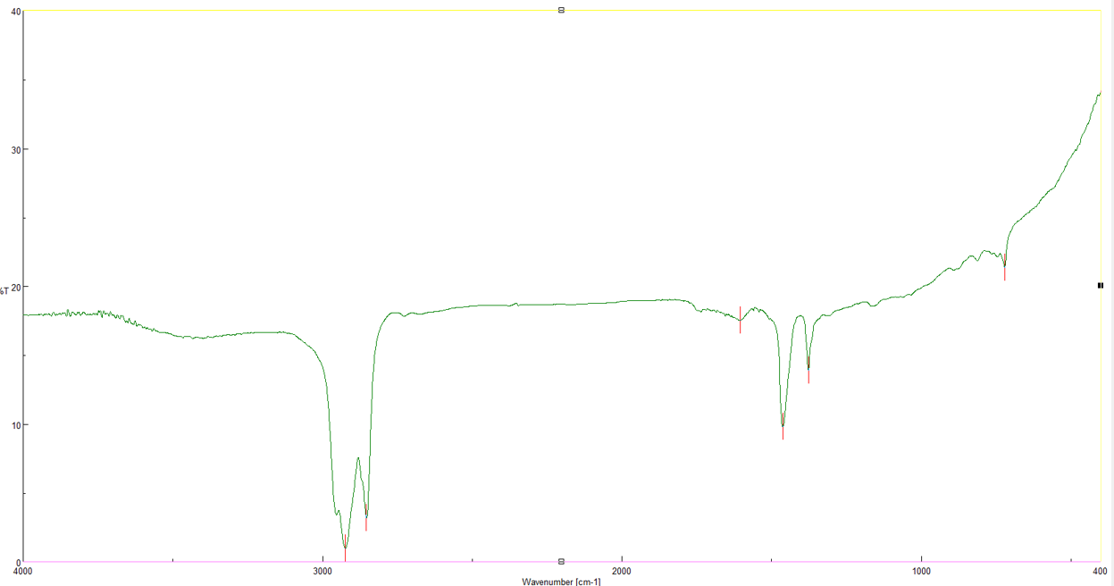
Fig 4: FTIR spectra for unmodified sawdust at 25 °C
Following chemical modification, significant spectral transformations were observed. The O–H band intensity decreased markedly, confirming reduced hydrophilicity, while a pronounced C=O stretching band at ~1730 cm⁻¹ emerged, consistent with the formation of ester and carbonyl groups. The intensification of C–H vibrations suggested enrichment of aliphatic chains, further enhancing hydrophobicity. These structural modifications directly correlate with the improved oil sorption performance observed in kinetic studies.

The extent of modification was significantly affected by temperature. Functional group modifications were relatively minor at 20 °C, indicating minimal chemical reactivity. In comparison, the 30 °C sample showed the greatest decrease in O–H bands and the strongest increase in C=O and C–H peaks, suggesting a synergistic effect between temperature and chemical treatment. The 25 °C sample showed an intermediate but stable profile that matched the maximum adsorption capacity found in kinetic experiments.
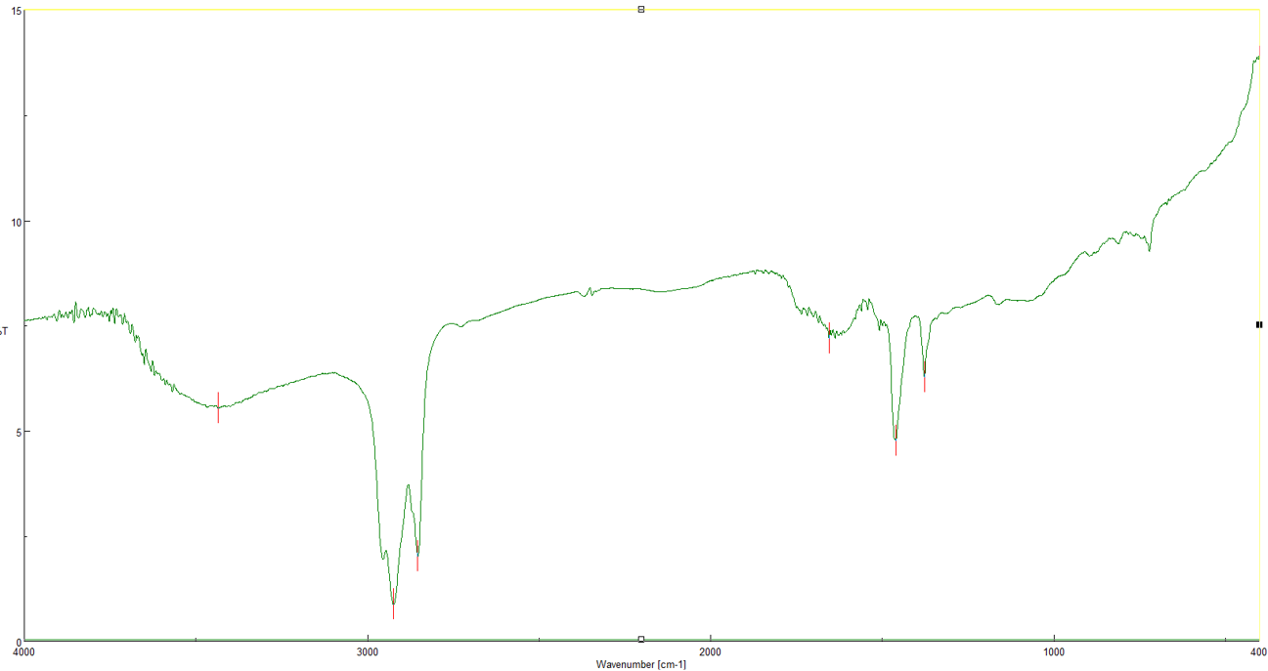
Fig 5: FTIR spectra for modified sawdust at 25 °C

Wavenumber (cm⁻¹) | Functional Group | Unmodified Sawdust | Modified Sawdust
~3400 | O-H stretching (hydroxyl groups) | Strong, broad peak | Reduced intensity
~2900 | C-H stretching (aliphatic chains) | Moderate peak | Slight increase in intensity
~1730 | C=O stretching (carbonyl groups) | Weak or absent | Strong, emerging peak
~1600 | C=C stretching (aromatic rings) | Strong peak (lignin) | Slightly reduced intensity
~1050 | C-O stretching (cellulose) | Strong peak | Moderate to strong peak
~1420 | CH₂ scissoring (aliphatic chains) | Moderate peak | Slightly intensified
Table 4-1 Compares the key FTIR peaks for both the unmodified and modified sawdust.

Conclusion
This work shows that chemical alteration significantly improves the oil absorption capacity of sawdust (Populus alba) by means of both internal and external changes to its structure. The kinetic evaluation revealed that the pseudo-second-order model accurately describes the adsorption process, resulting in an equilibrium capacity of 5000 mg/g for the modified material, approximately double that of the untreated sawdust, suggesting that chemisorption is the primary mechanism. The Elovich model supported this discovery by explaining the mixed nature of adsorption and the gradual decrease in adsorption rate as surface sites became occupied.
These changes were confirmed by FTIR spectroscopy, which indicated the reduction of hydroxyl bands and the appearance of new carbonyl and aliphatic peaks. These modifications mark a shift from hydrophilic to hydrophobic surface chemistry, which directly correlates with the experimental improvement in oil selectivity observed. Optimized thermal and chemical conditions appear to amplify the effects of temperature, leading to enhanced reaction efficiency and sorption performance.
In general, the altered sawdust exhibits a renewable, low-cost, and environmentally sustainable absorbent material suitable for vast-scale oil spill cleanup efforts. The findings from these results are consistent with similar results reported by Zhang et al. (2020) and Gao et al. (2019) for chemically treated lignocellulosic sorbents, further highlighting the potential of waste-derived materials in effectively controlling marine and industrial pollution.
Confirmation by integrating FTIR results with kinetic modeling shows that the modification of chemicals — specifically the decrease of polar hydroxyl groups and the addition of hydrophobic carbonyl and aliphatic functionalities — are key to the increased adsorption ability of treated sawdust. The results obtained offer a mechanistic explanation for the observed performance, confirming the structural-functional connection and illustrating the feasibility of using modified sawdust as a sustainable sorbent for crude oil removal.

References
[1] A. Ahmed, M. O. Bello, and T. M. Abioye, “Recent advances in biomass-based sorbents for oil spill cleanup: Modification, performance, and environmental implications,” Journal of Environmental Management, vol. 336, p. 117594, 2023. doi:10.1016/j.jenvman.2023.117594
[2] E. A. El-Shafey and J. A. Al-Fahemi, “Enhancement of oil sorption capacity of natural sorbents via chemical modification: A review,” Environmental Nanotechnology, Monitoring & Management, vol. 16, p. 100679, 2021. doi:10.1016/j.enmm.2021.100679
[3] T. T. Lim, Y. Huang, and L. Chen, “Evaluation of lignocellulosic sorbents for oil spill cleanup under various conditions,” Journal of Environmental Chemical Engineering, vol. 8, no. 4, p. 103872, 2020. doi:10.1016/j.jece.2020.103872
[4] P. Singh, A. Pudaruth, and S. K. Ramessur, “Community-driven responses to the Mauritius oil spill: A case study of sustainable sorbent use,” Marine Pollution Bulletin, vol. 172, p. 112907, 2021. doi:10.1016/j.marpolbul.2021.112907
[5] M. Anisuddin, S. Haque, and R. H. Khan, “Marine oil transportation and its impact on coastal biodiversity: A review,” Indian Journal of Marine Sciences, vol. 34, no. 3, pp. 245–252, 2005.
[6] M. Fingas, Oil Spill Science and Technology: Prevention, Response, and Clean-up, 3rd ed. Amsterdam, The Netherlands: Elsevier, 2019.
[7] R. Kapoor and P. S. Rawat, “Weathering and degradation processes of spilled petroleum in marine environments,” Environmental Monitoring and Assessment, vol. 33, no. 2, pp. 123–135, 1994. doi:10.1007/BF00547316
[8] S. N. C. M. Hussein, N. H. Othman, A. Dollah, A. N. C. A. Rahim, N. S. Japperi, N. S. M. Asymawi, and R. Ramakrishnan, “Study of acid treated mixed sawdust as natural oil sorbent for oil spill,” Faculty of Chemical Engineering, Universiti Teknologi MARA, Shah Alam, Selangor, Malaysia, 2018.
[9] I. A. Hussein, S. Dollah, N. Othman, and N. A. Rahim, “Effect of chemical treatment on oil adsorption capacity of sawdust: A potential low-cost sorbent,” Environmental Science and Pollution Research, vol. 26, pp. 20192–20203, 2019. doi:10.1007/s11356-019-05246-2
[10] J. Wang and X. Guo, “Adsorption kinetic models: Physical meanings, applications, and solving methods,” Journal of Hazardous Materials, vol. 390, p. 122156, 2020. doi:10.1016/j.jhazmat.2020.122156
[11] A. I. Obi, V. I. Ajiwe, and C. P. Okonkwo, “Equilibrium and kinetic studies of crude oil sorption on unmodified and modified Napier grass,” Journal of Applied Chemistry and Environmental Sciences, vol. 6, no. 2, pp. 25–34, Jun. 2023.

