Review of Deep learning and IOT Based crop diseases detection system
Supriya Kurlekar(JSPM NTC) Tanmay Wankhede ,Mahesh Kokate, Dnyaneshwari Chormale Mitusha Bachhav Ayush Rajmane

ABSTRACT

Plant pest and disease management, especially in the early stages of infestation, is a critical challenge that poses significant threats and has potential to devastate agricultural crops, causing total yield loss and food insecurity. Traditional inspection methods are time-consuming and prone to errors due to limited labor expertise. Therefore, to tackle these challenges, harnessing advanced technologies such as artificial intelligence (AI), Machine Learning/Deep Learning (ML/DL), and Internet of Things (IoT) is essential for managing and mitigating agriculture hazards. This article presents a comprehensive review of the state-of-the-art DL architectures integrated with IoT-based systems applied to plant pest and disease detection (PPDD) by investigating different potential approaches that have been employed using DL and IoT up to the year 2024 to address challenges in agriculture. Convolutional Neural Network (CNN) architectures for image recognition, object detection, and their integration with IoT, embedded into mobile devices and unmanned aerial vehicles (UAV) are explored. Moreover, the research discusses the advantages and limitations of these techniques, emphasizing their architecture design, efficiency and accuracy. The findings demonstrate that there is a tradeoff between robustness and complexity among existing techniques, and authors recommend future trends aimed at creating robust models with fewer parameters that are more accurate and easily implementable on small IoT-based and portable devices suitable for in-field and real time applications. Furthermore, while existing review papers discuss either DL or IoT separately, this research paper uniquely focuses on their combined models, providing a comprehensive overview of the synergistic potential of leveraging IoT-driven technologies alongside advanced DL algorithms to ease the task of researchers in the field of precision agriculture particularly in PPDD.

KEYWORDS:-
Deeplearning,machinelearning,crop pest detection, crop disease detection, convolutional neural networks, Internet of Things.

Introduction
Since the mid-20th century, the global population has experienced rapid growth, increasing from approximately 2.5 billion in 1950 to 7.8 billion in 2020. It is projected to reach 8.5 billion by 2030,
9.7 billion by 2050, and 10.9 billion by 2100 [1]. The rapid growth of the global population implies a continuous increase in global food demand over the coming decades, placing greater demands on

agricultural production [2]. However, crop pests and disease infestations have emerged as major constraints to improving both yield and quality. These threats not only cause direct reductions in crop productivity and quality but also pose a serious challenge to global food security. A study documented the impact of 137 pathogens and pests on five major staple crops across global hotspots, revealing that regions with rapid population growth and food shortages suffer the most severe agricultural losses [3]. The economic burden of crop pests and diseases is substantial, with an estimated 20% to 40% of global crop yields lost annually to pest infestations, translating to approximately $220 billion in economic losses worldwide [4]. With the intensification of climate change and the expansion of global trade, the geographical spread and frequency of pest and disease outbreaks are increasing, presenting an unprecedented challenge to global food security. Pests and diseases are a serious threat to crop diversity. The whitefly, a global polyphagous pest, severely impacts agricultural productivity, especially in solanaceous, cucurbitaceous, and leguminous plants [5] .

The agricultural business is today confronted with many challenges, including climate change, population increase, and resource limitations, which conventional farming practices are sometimes unable to meet. Technological solutions are required instead. AI-driven smart agriculture signifies an innovative approach in agri-tech, wherein artificial intelligence, machine learning, computer vision, and data analytics collaboratively establish a cohesive platform for contemporary farmers by unifying all activities within a singular environment. This article will examine the architectural design, technical elements, and practical applications of smart agriculture, focusing on its AI driven crop disease identification application, intelligent market.al.gorithms, and multilingual support features. The system's performance indicators, user adoption rates, and economic effects on participating farms will be assessed. Automated disease detection systems have transformed agriculture, providing accurate and prompt findings for both small- and large-scale farming. Deep learning and neural networks, especially Convolutional Neural Networks (CNNs), are integral to these technologies. Convolutional Neural Networks (CNNs) can discern between infected and healthy leaves using visual processing, facilitating early disease identification and control. This method improves agricultural output while maintaining crop quality. Precision farming, a cutting edge technique, utilizes sophisticated instruments to enhance crop productivity and refine farm management. It emphasizes aspects such as water, land stress, herbicides, and fertilizers, using image processing to assess agronomic difficulties with precision and efficiency [6].
ML-based applications for agriculture are still young, but are already showing promise. For instance, disease classification from images can be done using popular Convolutional Neural Network (CNN) architectures for different plants with different diseases [7]; relationships between weather data and pest occurrence can be retrieved using Long Short Term Memory(LSTM) networks for forecasting future pest attacks [8]; insect detection on leaves can be performed using object segmentation and deep learning techniques [9].
The IoT has revolutionized not just how we live our lives but also how we operate. The adoption of IoT is growing quickly across many industries, whether it be agricultural, safety, or healthcare [10]. IoT with robotics and artificial intelligence will increase the complexity of commercial farms while reducing manual workers from 90% to 10%. One of the world’s major scientific efforts in agriculture is thought to be happening in India [11]. Agricultural growth has advanced as a result of numerous advancements in modern technology and creativity. Previous research has examined the application of contemporary methods in the agricultural industry, including IoT, sensors, cloud services, mobile computing, and big data analysis [12,13]. According to Ref. [14], a study on an IoT-based process in the context of agriculture, the outcomes were remarkable. The efficiency increased slightly, and what had previously been a human-intensive industry like agriculture has become more scientific [14]

. Placed detectors around the fields, and the Raspberry PI (RPI) were utilized to manage them all. When a sensor and RPI are interfaced, leaf illness can be identified. Farmers are immediately informed of the condition of a field, such as plant diseases or crop-affecting factors like dryness, warmth, and wetness, via a WiFi host using RPI [15].

Literature Review

In recent years, researchers have explored various image processing and deep learning methods to detect crop pests and diseases effectively. Anand H. Kulkarni and Ashwin Patil R. K. in their work on “Applying Image Processing Technique to Detect Plant Diseases” proposed a method where images of plant leaves were captured using digital cameras and subjected to preprocessing techniques such as noise removal, image enhancement, and segmentation. The study aimed to automate early disease detection and reduce dependency on manual observation. However, due to limited dataset size and simple algorithms, the system showed low accuracy and struggled with complex disease patterns or overlapping symptoms[16]
R. Radha and S. Jeyalakshmi, in their research titled “An Effective Algorithm of Edges and Veins Detection in Leaf Images”, introduced an algorithm that detects leaf edges and veins to identify nutrient deficiencies and classify whether a leaf is healthy or diseased. The model utilized classification algorithms, integrating an RNN-based approach for improved detection. While this system provided a structured way to analyze leaf health, it faced issues with low classification accuracy and high computational load, which made it unsuitable for real-time IoT deployment in farms.[17]
M. V. Latte and Sushila Shidnal developed a system for “Multiple Nutrient Deficiency Detection” using the Canny edge detection method. This algorithm successfully identified edges and vein structures in leaves, allowing early detection of nutrient-related diseases. The primary advantage of this method was its ability to detect deficiencies before visible damage appeared. However, the model faced limitations in accurately distinguishing between different plant species and often required manual calibration to adjust to varying environmental lighting conditions.[18]
Pranjali B. Padol and Anjali A. Yadav worked on “SVM Classifier Based Grape Leaf Disease Detection”, where segmentation and image classification techniques were applied to detect and categorize grape leaf diseases. The use of Support Vector Machine (SVM) helped in achieving better classification results compared to basic image processing methods. The system proved useful in improving grape yield by providing early warnings of infections. Nevertheless, it still suffered from low accuracy when dealing with similar disease features and was not robust enough for large-scale or real-time applications.[19]
Ms. Chhaya Narvekar in her paper “Flower Classification Using CNN and Transfer Learning in CNN – Agriculture Perspective” utilized Deep Learning models such as

MobileNet, VGG, and ResNet to classify different flower species. The study demonstrated the power of transfer learning in improving feature extraction and reducing the need for large datasets. The model achieved better generalization and higher accuracy compared to traditional methods. However, the challenge remained in handling high visual similarity between species, which sometimes led to misclassification. The study highlighted how CNN architectures could be extended to crop disease detection for better precision in agricultural monitoring.[20]
Sue Han Lee proposed a “Multi-Organ Plant Classification Based on Convolutional and Recurrent Neural Networks”, which presented a hybrid model combining CNNs and RNNs to process both organ-specific (leaf, stem, fruit) and generic plant data. The model, known as HGO-CNN (Hybrid Generic Organ CNN), used a feature fusion approach to integrate spatial and temporal data, improving classification accuracy significantly. This research showed that combining multiple deep learning architectures could enhance model reliability in complex agricultural datasets. However, the system’s high computational cost and complexity made it less suitable for IoT edge devices like Raspberry Pi without optimization.[21]

Related works
In this section, the previous scientific articles tackled the DL models that widely used for solving the problem of the plant diseases detection. While, other works discussed how to carry the advanced technologies “IoT” and techniques on the traditional central pivot for the plant diseases treatment. For plant diseases detection, a convolutional neural network model was presented for detecting and identifying plant leaf diseases based on visual data to boost accuracy, generality, and the overall efficiency of training. The experimental results showed that the proposed convolutional neural network-based model outperforms other previous models by a classification accuracy of 99.23%[22]. Sun et.al. [23], proposed a convolutional neural network architecture FL-EfficientNet (Focal loss EfficientNet), which was used for multi-category identification of plant disease images. The experiment used the public data set New Plant Diseases Dataset (NPDD) and compared it with three models: ResNet50, DenseNet169, and EfficientNet. The accuracy of FL-EfficientNet in identifying ten diseases of 5 kinds of crops is 99.72%.
In [24], R. Santhana Krishnan and E. Julie proposed an enhanced convolution neural network (CNN) based on a visual geometry group-16 (VGG-16) was used for potato leaf disease classification. The convolution layers of VGG-16 along with the Inception and the SE block were used in this research for classification. This model achieved the highest classification accuracy of 99.3%.
AI, and the IoT has advanced precision agriculture and precise plant health monitoring. The integration of these technologies enables real-time data collection, analysis, prediction, and informed decision-making to improve the accuracy and responsiveness of pest and disease management systems[25].

SYSTEM ARCHITECTURE

  - AI AND ML COMPONENTS

Convolutional Neural Networks (CNN) for Disease Detection
AI-Enabled Smart Agriculture employs a complex image processing pipeline with powerful convolutional neural networks [26]. The design encompasses: a) Input Layer: Processes 224×224×3 RGB images b) Convolutional Layers: Multiple layers with 3×3 filters and ReLU activation c) Pooling Layers: Max pooling with 2×2 filters for feature extraction d) Fully Connected Layers: Dense layers leading to SoftMax classification e) Transfer Learning: Fine-tuned pre-trained models including EfficientNet-B3 and MobileNetV2The CNN architecture enables high-accuracy classification of 38 different crop diseases across 12 plant varieties, with performance metrics significantly exceeding conventional diagnostic methods.
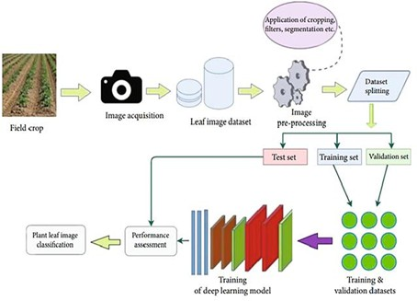

Deep learning (DL) Techniques
The Convolutional Neural Network Technique Convolutional neural networks use deep feed-forward neural networks to examine multidimensional data. The CNN identifies channels that are activated after the classification of a certain feature at certain spatial coordinates [27]. The quantity of epochs used in the application of different convolution filters measuring 2 × 2 and 3 × 3 influences their precision. This is dependent on the size of the filter. Numerous pre trained architectures, such as VGG16, VGG19, ResNet50, ResNet152, InceptionV3, InceptionNet, and DenseNet121, are accessible for implementation using the CNN methodology [28].

Data Pre-Processing
Pre-processing data before feeding it to the model is common in most ML-based applications. Images are typically pre-processed using computer vision techniques to remove noise, to enhance the image contrast, to extract the regions of interest, to extract image features, etc. In general, image

pre-processing steps usually lead to better model outcomes. The most common data pre-processing techniques are covered in the following sub-sections. [29]

Noise Reduction
Different types of filters, such as Gaussian and median filters, are used to reduce noise to obtain smoother images. These filters have an effect of blurring and removing non relevant details of an image, at the expense of potentially losing relevant textures or edges [30].

Images are usually stored in the RGB format, which is an additive color model of red, green, and blue components. Due to the high correlation between these color components, it is usually not suitable to perform color segmentation in the RGB color space. Therefore it is important to bear in mind that there are others color spaces such as HSV or L*a*b*. In HSVthe color components are: hue (pure color), saturation (shade or amount of grey), and value (brightness). In the L*a*b* color space, L* is the luminance (brightness), a* is the value along the red-green axis, and b* is the value along the
blue-yellow axis. In these color spaces, the brightness of a color is decoupled from its chromaticity, allowing the images to be processed with different lighting conditions [30].
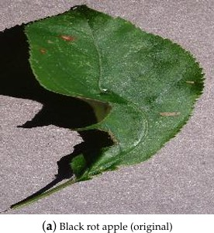
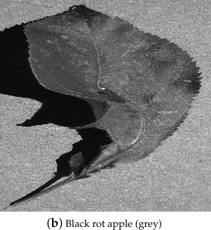

PROCESSING DEVICE:
RASPBERRY Pi 5 The System on Chip (SoC) based device such as Rasp berry Pi 5 serves as the edge computing device onboard the UAV [31]. It processes the data collected from the high-definition camera using DL/CNNmodelstodetect pests and diseases in real-time. The Raspberry Pi 5 is suitable for edge computing due to its compact size and lightweight model, processing power that support complex and powerful DLmodelsas well as energy efficiency capacity, that make it ideal for integration into an IoT ecosystem [32].
The DL models based on CNN architecture such as Efficient Net, MobileNet and Inception series are mostly used due to their high efficiency, balancing accuracy and computational efficiency, makingthemidealfordeploymentonedgedevices like the Raspberry Pi 5 [33]

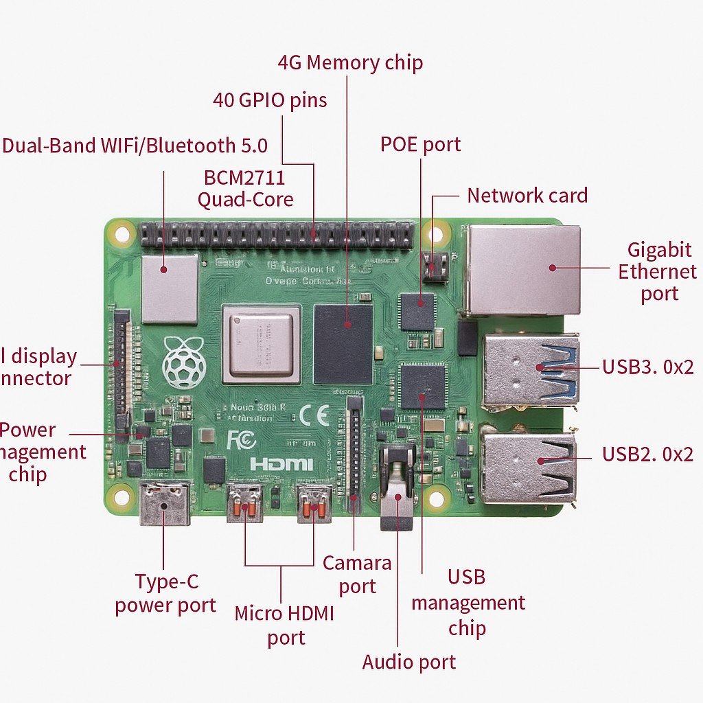

DATA STORAGE
The raw and processed data, including images of infected and healthy plants and their locations, is stored locally on the edge device or transferred to external storage devices. This data can be used for further analysis or historical record-keeping. A128GBmicroSDcardarecommonlyusedforlocalstorage, ensuring that sufficient data can be retained even during long missions[34].

Monitoring of Soil Moisture and Water Levels
Soil monitoring has developed into one of the most challenging agricultural areas, both for manufacturers and farmers. Numerous environmental issues associated with soil monitoring affect agricultural yield. When these sorts of obstacles are correctly identified, farming patterns and methods become readily understandable. The soil’s moisture content, wetness, fertilizer application, and temperature trends are all being monitored. Soil’s moisture environment management system uses soil humidity and moisture sensors. By proposing an appropriate fertilizer approach, the results of a soil monitoring test report assist farmers in increasing crop yield [35]. The sensor can read both analog and digital outputs. The judgment is made based on data collected from sensors and compared to predefined threshold levels. The soil moisture sensor is used to regulate the irrigation system’s automatic operation. When the moisture level goes below the threshold value, the water pump is triggered [36].

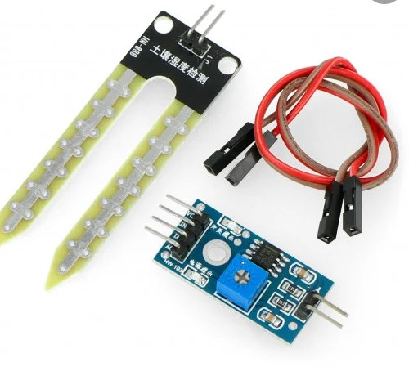
Temperature and humidity sensor:
The temperature and humidity sensor used here is DHT11 which is used to measure the surrounding air, and a capacitive humidity sensor and thermistor in DHT11 spits out a digital signal on the data pin. It also has a resistive elements and a temperature measuring devices. Its technology is highly reliable and more stable. [37]

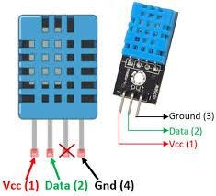

Conclusion
Crop diseases cause large financial losses for the agriculture sector and pose a serious danger to the world's food security. This piece offers a

web-based crop disease detection system that uses sophisticated picture processing and environmental data to give accurate diagnosis and treatment.
An important development in agricultural operations is AI-driven smart agriculture, which shows how AI combined with computer vision and machine learning can revolutionize traditional farming methods. The system may effectively address important modern agricultural issues like disease detection, market efficiency, and information dissemination, according to the system's performance indicators.
The accuracy of disease diagnosis has increased thanks to the use of machine learning methods like convolutional neural networks (CNN) and libraries like TensorFlow. Additionally, cutting-edge models of artificial intelligence,

- The proposed system combines IoT, Deep Learning, and automation to deliver a holistic solution for crop pest and disease management. Unlike traditional systems that only detect problems, this project introduces laser-based pest elimination and automated irrigation, ensuring both crop protection and resource optimization. By integrating soil moisture, temperature, and humidity sensors, the system provides comprehensive monitoring of plant health and environmental conditions.

- This intelligent framework reduces dependency on manual inspection and harmful pesticides, while empowering farmers with real-time alerts and actionable insights. The outcome is a sustainable, eco-friendly, and scalable precision agriculture solution that can significantly reduce crop losses, conserve natural resources, and contribute to global food security.

References
    - Global Population Growth and Sustainable Development|Policy Commons. Available online: https://policycommons.net/artifacts/8983020/global-population-growth-and-sustainable-devel opment/9868536/ (accessed on 19 March 2025).
    - Godfray, H.C.J.; Beddington, J.R.; Crute, I.R.; Haddad, L.; Lawrence, D.; Muir, J.F.; Pretty, J.; Robinson, S.; Thomas, S.M.; Toulmin, C. Food Security: The Challenge of Feeding 9 Billion People. Science 2010, 327, 812–818. [https://doi.org/10.1126/science.1185383 ] [https://www.ncbi.nlm.nih.gov/pubmed/20110467 ]
    - Savary, S.; Willocquet, L.; Pethybridge, S.J.; Esker, P.; McRoberts, N.; Nelson, A. The Global Burden of Pathogens and Pests on Major Food Crops. Nat. Ecol. Evol. 2019, 3, 430–439. [https://doi.org/10.1038/s41559-018-0793-y ] [https://www.ncbi.nlm.nih.gov/pubmed/30718852 ]
    - Researchers Helping Protect Crops From Pests|NIFA. Available online: https://www.nifa.usda.gov/about-nifa/blogs/researchers-helping-protect-crops-pests (accessed on 20 March 2025).
    - Abubakar, M.; Koul, B.; Chandrashekar, K.; Raut, A.; Yadav, D. Whitefly (Bemisia tabaci) Management (WFM) Strategies for Sustainable Agriculture: A Review. Agriculture 2022, 12, 1317. [https://doi.org/10.3390/agriculture12091317 ]
    - AlArfaj, A.A., Altamimi, A., Aljrees, T., Basheer, S., Umer, M., Samad, M.A. et.al.. (2023) Multi-step preprocessing with UNet segmentation and transfer learning model for pepper bell leaf disease detection. IEEE Access, 11, 132254–132267 https://www.researchgate.net/publication/375783797_Multi-Step_Preprocessing_with_UNet_ Segmentation_and_Transfer_Learning_Model_for_Pepper_Bell_Leaf_Disease_Detection
    - Mohanty, S.P.; Hughes, D.P.; Salathé, M. Using deep learning for image-based plant disease detection. Front. Plant Sci. 2016, 7, 1419. [https://www.researchgate.net/publication/301879540_Using_Deep_Learning_for_Image-Bas ed_Plant_Disease_Detection]
    - Xiao, Q.; Li, W.; Kai, Y.; Chen, P.; Zhang, J.; Wang, B. Occurrence prediction of pests and diseases in cotton on the basis of weather factors by long short term memory network. BMC Bioinform. 2019, 20, 688. [https://www.researchgate.net/publication/338142077_Occurrence_prediction_of_pests_and_ diseases_in_cotton_on_the_basis_of_weather_factors_by_long_short_term_memory_network
]
    - Gutierrez, A.; Ansuategi, A.; Susperregi, L.; Tubío, C.; Ranki´c, I.; Lenža, L. A benchmarking of learning strategies for pest detection and identification on tomato plants for autonomous scouting robots using internal databases. J. Sens. 2019, 2019, 5219471. [A Benchmarking of Learning Strategies for Pest Detection and Identification on Tomato Plants for Autonomous Scouting Robots Using Internal Databases - Gutierrez - 2019 - Journal of Sensors - Wiley Online Library]
    - V.P. Kour, S. Arora, Recent developments of the internet of things in agriculture: a survey, IEEE Access 8 (2020) 129924–129957
[https://www.researchgate.net/publication/342937257_Recent_Developments_of_the_Internet
_of_Things_in_Agriculture_A_Survey ]
    - J.A. Wani, S. Sharma, M. Muzamil, S. Ahmed, S. Sharma, S. Singh, Machine learning and deep learning based computational techniques in automatic agricultural diseases detection: methodologies, applications, and challenges, Arch. Comput. Methods Eng. 29 (1) (2022) 641–677

[https://www.researchgate.net/publication/351294231_Machine_Learning_and_Deep_Learnin g_Based_Computational_Techniques_in_Automatic_Agricultural_Diseases_Detection_Meth odologies_Applications_and_Challenges]
    - G. Delnevo, R. Girau, C. Ceccarini, C. Prandi, A deep learning and social iot approach for plant disease prediction toward a sustainable agriculture, IEEE Internet Things J. 9 (10) (2021) 7243–7250
[https://www.researchgate.net/publication/354108323_A_Deep_Learning_and_Social_IoT_ap proach_for_Plants_Disease_Prediction_toward_a_Sustainable_Agriculture ]
    - Y. Wang, H. Wang, Z. Peng, Rice diseases detection and classification using attention based neural network and bayesian optimization, Expert Syst. Appl. 178 (2021), 114770. [https://www.researchgate.net/publication/350181831_Rice_Diseases_Detection_and_Classifi cation_Using_Attention_Based_Neural_Network_and_Bayesian_Optimization ]
    - S.C. Mukhopadhyay, S.K.S. Tyagi, N.K. Suryadevara, V. Piuri, F. Scotti, S. Zeadally, Artificial intelligence-based sensors for next generation IoT applications: a review, IEEE Sensor. J. 21 (22) (2021) 24920–24932.
[https://www.researchgate.net/publication/348888001_Artificial_Intelligence-Based_Sensors_ for_Next_Generation_IoT_Applications_A_Review ]
    - A.A. Ahmed, G.H. Reddy, A mobile-based system for detecting plant leaf diseases using deep learning, AgriEngineering 3 (3) (2021)
478–493.[https://www.researchgate.net/publication/352928171_A_Mobile-Based_System_for
_Detecting_Plant_Leaf_Diseases_Using_Deep_Learning ]
    - Anand H. Kulkarni and Ashwin Patil R. K. Applying image processing technique to detect plant diseases https://www.researchgate.net/publication/308953779_Applying_image_processing_technique
_to_detect_plant_diseases
    - R. Radha and S. Jeyalakshmi “An Effective Algorithm of Edges and Veins Detection. https://ictactjournals.in/paper/IJIVP_Vol_7_Iss_4_Paper_7_1515_1524.pdf
    - M. V. Latte and Sushila Shidnal “Multiple Nutrient Deficiency Detection”.developed a system for “Multiple Nutrient Deficiency Detection” using the Canny edge detection method (ICCSP),2016,IEEE 2016. https://ieeexplore.ieee.org/abstract/document/7754352/references#references
//

    - Pranjali B. Padol and Anjali A. Yadav worked on “SVM Classifier Based Grape Leaf Disease Detection” (CASP) 2016, https://www.researchgate.net/publication/310501241_SVM_classifier_based
_grape_leaf_disease_detection
    - Ms. Chhaya Narvekar in her paper “Flower Classification Using CNN and Transfer Learning in CNN – Agriculture Perspective” https://www.researchgate.net/publication/357547984_A_Study_on_CNN_Based_Tra nsfer_Learning_for_Recognition_of_Flower_Species

Sue Han Lee proposed a “Multi-Organ Plant Classification Based on Convolutional and Recurrent Neural Networks”

https://www.researchgate.net/publication/323349043_HGO-CNN_Hybrid_generic-or gan_convolutional_neural_network_for_multi-organ_plant_classification

Banerjee, S. & Mondal, A. An intelligent approach towards plant leaf disease detection through different convolutional neural Networks. Int. J. Intell. Syst. Appl. Eng. 12(2), 536–546 (2024).
https://www.researchgate.net/publication/380594597_Plant_Leaf_Disease_Detection_ by_Deep_Learning_A_Literature_Review

Sun, X. et.al. Research on plant disease identification based on CNN. Cognitive Robot. 2, 155–163 (2022)
https://www.researchgate.net/publication/362967440_Research_on_plant_disease_ide ntification_based_on_CNN

Krishnan, R. & Julie, E. Computer aided detection of leaf disease in agriculture using convolution neural network-based squeeze and excitation network. Automatika 64(4), 1038–1053 (2023).
https://www.researchgate.net/publication/373078527_Computer_aided_detection_of_l eaf_disease_in_agriculture_using_convolution_neural_network_based_squeeze_and_ excitation_network
    - Nyakuri, J. P., Nkundineza, C., Gatera, O. & Nkurikiyeyezu, K. State-of-the-art deep learning algorithms for internet of things based detection of crop pests and diseases: A comprehensive review. IEEE Access 12(August), 169824–169849 (2024) https://ieeexplore.ieee.org/stamp/stamp.jsp?arnumber=10666658

Venkata K. S. Maddala, Dr. Shantanu Shahi, Yusuf Perwej, H G Govardhana Reddy, “Machine Learning based IoT application to Improve the Quality and precision in Agricultural System”, European Chemical Bulletin (ECB), ISSN: 2063-5346, SCOPUS, Hungary, Volume 12, Special Issue 6, Pages 1711 – 1722, May 2023, DOI: 10.31838/ecb/2023.12.si6.157
https://ijsrcseit.com/index.php/home/article/view/CSEIT25113391/CSEIT25113391
    - Amanullah Ansari1, Shrejal Singh1, Dr. Nikhat Akhtar, “ AI-Driven Crop Disease Detection and Management in Smart Agriculture ” ISSN: 2395-6011, Publication Issue Volume 12, Issue 3 May-June-2025, https://www.researchgate.net/publication/391915798_AI-Driven_Crop_Disease_Dete ction_and_Management_in_Smart_Agriculture

Amanullah Ansari1, Shrejal Singh1, Dr. Nikhat Akhtar, “ AI-Driven Crop Disease Detection and Management in Smart Agriculture ” ISSN: 2395-6011, Publication Issue Volume 12, Issue 3 May-June-2025,
https://www.researchgate.net/publication/391915798_AI-Driven_Crop_Disease_Dete ction_and_Management_in_Smart_Agriculture

Tiago Domingues,Tomás Brandão and João C. Ferreira,” Machine Learning for Detection and Prediction of Crop Diseases and Pests: A Comprehensive Survey”
Published:1 September 2022
https://www.mdpi.com/2077-0472/12/9/1350#Acknowledgments

    - Garcia-Lamont, F.; Cervantes, J.; López, A.; Rodriguez, L. Segmentation of images by color features: A survey. Neurocomputing 2018, 292, 1–27. [CrossRef]
    - Z.Song, X.Qin, Y. Hao, T. Hou,J. Wang,andX.Sun,‘‘Acomprehensive survey on aerial mobile edge computing: Challenges, state-of-the-art, and future directions,’’ Comput. Commun., vol. 191, pp. 233–256, Jul. 2022, doi: 10.1016/j.comcom.2022.05.004.
    - S. Bemposta Rosende, S. Ghisler, J. Fernández-Andrés, and J. Sánchez-Soriano, ‘‘Implementation of an edge-computing vision system on reduced-board computers embedded in UAVs for intelligent traffic management,’’ Drones, vol. 7, no. 11, p. 682, Nov. 2023, doi: 10.3390/drones7110682.
    - P. D. Rosero-Montalvo, P. Tözün, and W. Hernandez, ‘‘Optimized CNN architectures benchmarking in hardware-constrained edge devices in IoT environments,’’ IEEE Internet Things J., vol. 11, no. 11, pp. 20357–20366, Jun. 2024, doi: 10.1109/JIOT.2024.3369607.
    - Nyakuri, J. P., Nkundineza, C., Gatera, O. & Nkurikiyeyezu, K. State-of-the-art deep learning algorithms for internet of things based detection of crop pests and diseases: A comprehensive review. IEEE Access 12(August), 169824–169849 (2024) https://ieeexplore.ieee.org/stamp/stamp.jsp?arnumber=10666658

Saba, T.; Rehman, A.; AlGhamdi, J.S. Weather forecasting based on hybrid neural model. Appl. Water Sci. 2017, 7, 3869–3874. [CrossRef]
    - Sharma, Y.; Tyagi, V.; Datta, P. IoT based smart agriculture monitoring system. Int.
J. Innov. Technol. Explor. Eng. 2020, 9, 325–328. https://www.ijitee.org/wp-content/uploads/papers/v9i9/I7142079920.pdf

Sudarshan, K.; Hegde, R.R.; Sudarshan, K.; Patil, S. Smart agriculture monitoring and protection system using IoT. Perspect. Commun. Embed. Syst. Signal Process. PiCES 2019, 2, 308–310.
https://d-nb.info/1185505792/34

