Role of Artificial Intelligence (AI) in Transport Planning
Jai Parkashª,
ªMaster of Planning (Transport) Guru Ramdas School of Planning, Guru Nanak Dev University, Amritsar-143005
KEYWORDS |  | ABSTRACT
Artificial Intelligence  Fuzzy Logic Model  Bee Colony Optimization |  | Artificial intelligence pertains to the ability of machines or software to exhibit intelligence.AI is a specialized domain of computer science. Human capabilities will be either enhanced or replaced by intelligent machines in the future. Artificial intelligence has revolutionized various fields by providing solutions to complex problems through expert systems. Its extensive use has made a significant impact on various domains such as traffic and transport, weather and climate forecasting, healthcare and medical, GPS and navigation, tourism and hospitality. Transport becoming a major field in upcoming year.

Introduction

AI is a combination of computer science. [1] and robust science [2], which is used in machines and do function like human minds [3]. John McCarthy [4] the first who coined this term in 1956, and define it “the science and engineering of making intelligent machines” [5]

“AI is the part of computer science concerned with designing intelligent computer systems, that is, systems that exhibit the characteristics one associate with intelligence in human behaviour—understanding language, learning, reasoning, solving problems, and so on. “ [6]

Artificial intelligence (AI) is the capacity of a machine to perform analytical functions like perceiving, reasoning, learning and problem-solving like human being. [7]
Source Author ,2025

Artificial intelligence (AI) is the main branch of computer science. AI is used to solve the complex problems in various areas like weather and climate forecasting, healthcare and medical, engineering, GPS and navigation, tourism and hospitality, education, entertainment, security and traffic and transport [8]. Transport is one of the upcoming areas [9] where influence of AI is seen. [10]

AI and Transport

Transportation plays a vital role in both social and economic progress of a country. [11] AI methods such as Artificial Neural Networks (ANNs), Genetic algorithms (GA), Simulated Annealing (SA), Artificial Immune system (AIS), Ant Colony Optimiser (ACO), Bee Colony Optimization (BCO), and Fuzzy Logic Model (FLM) are increasingly being utilized in the transport field. This understanding forms the foundation for successful AI implementation in the transport sector. [12]

The primary goal of implementing these methods in transport management is to alleviate congestion, enhance the reliability of travel time for commuters, and optimize the overall economics and productivity of the system. [13]

Fig1 Different AI method used in transportation
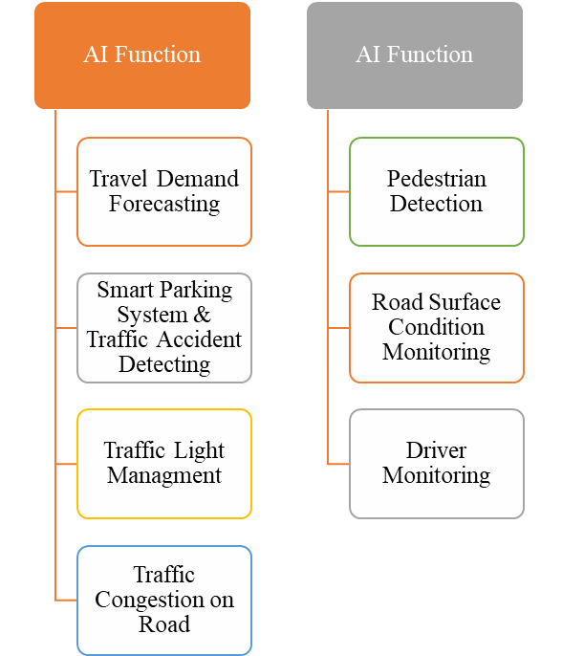
Source Author ,2025

Figure 2 Different function of AI

3. Different Method of AI used in Transportation
There is different method of AI used in traffic and transportation.

3.1 Fuzzy Logic Model

Fuzzy Logic Model is a mathematic approach [14] [15], used in the traffic and transportation for imprecision, ambiguity, and uncertainty. [14]. The Fuzzy Logic is the practical evolution of Binary Logic [16],(0,1) [17].Logic Model is used in trip generation and distribution, model split, Traffic assignment and route choice. [14]. Fuzzy logic model is also used in signal processing, communication and control. [18].

3.2 Bee Colony Optimization

The principles work behind this analogy of bee how bee finds their source and exploit it. [19].Bee Colony optimization is based on Swarn intelligence [20] which is inspired from Swarm behaviour of insets [21]. Due to its complexity and simplicity has been used to solve various optimization problems. [22].Bee Colony Optimization is used in the field of the electromagnetism induction. [23].Application of ABO in traffic and transportation to solve vehicle routing problem [24], to reduce the Average Waiting Time (AWT) of the vehicle at intersection [25], Ride Sharing [26] and Shortest Path Planning Problem [27].

3.3 Ant Colony Optimization
Ant colony optimization is a mathematical approach inspired from the ant to find the food source by using shortest distance [28] from source to destination. Ant colony optimization used the same analogy to mitigate the problem. It is used to minimize delay at intersections. [29]

3.4 Artificial Immune System

Artificial Immune System is based on the biological phenomena of an organism.Trnasportations system is like a human bodies. [30].Same as human bodies Artificial Immune System has the ability to detect that problem and neutralize that problems. [31]

3.5 Genetic Algorithm
Genetic algorithm is inspired from the biological phenomena of Natural selection and evolution. [32]. It is a is technique used to find approximate or true solutions of problems. [33]

3.6 Artificial Neutral Network

This Artificial Neutral Network is based on the neural network of bodies neurons which are interconnected and transmitted the information, process the information and solves the complex problem.Traffic forecasting, Traffic control, Maintenance of transport infrastructure (prediction of pavement condition), river behaviour and autonomous vehicles [34]
- Application of AI in Traffic and Transportation Sector

4.1 Travel demand forecasting

The trip generation zone is the starting point of the travel simulation process, which tracks trips as they pass through a network of linkages and nodes and arrive at the trip attracting zone. Because there are four primary models in use, the simulation process is referred to as a "four step process." These are the following- trip distribution, modal split, traffic assignment, and trip production [35]

4.2 Smart Parking System
Figure 3 Smart Parking Management System
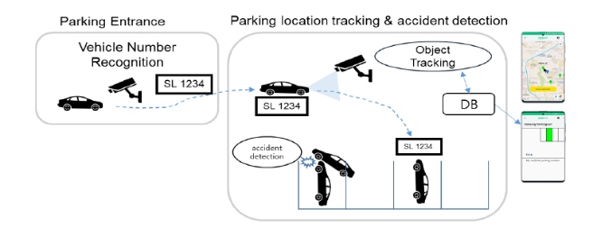
Source: - [36]

During the peak hours congestion on the road inc. It is very difficult for a driver to find out parking space when vehicles enter into the parking, consumes lots of time. To tackle these issues camera-based PGI (Parking Guidance Information) is applied. Smart parking management system utilizing multiple cameras and advanced artificial intelligence techniques. When a vehicle enters the parking lot, an embedded camera instantly captures its number plate, allowing for seamless recognition. By using the YOLO (You Only Look Once, the real-time object detection system known as YOLO was introduced by Joseph Redmon and his colleagues in 2016 based on Convolutional Neural Network (CNN) for its operations.) [37]

This system also keeps track of the specific parking space where the vehicle is parked and updates the parking space information accordingly. And detect the collision accidents that may occur within the parking lot while the vehicle is in motion. The vehicle number recognition system employs optical character recognition (OCR) technology and is implemented on a Raspberry system (Raspberry Pi is a compact and robust mini-computer that is roughly the same size as a credit or debit card, which is highly efficient and powerful.) [38] . By treating the recognized vehicle number at the entrance as an Object ID, the system effectively monitors the vehicle as a moving object within the parking lot, ultimately identifying its exact parking location. To ensure accurate accident detection, the system utilizes YOLO with CNN deep learning processes. [39]

4.3 Traffic Light Management

With increasing the population and urbanization, no. of motor vehicles inc., traffic congestion became a critical issue, which leads to traffic accidents. To address this issue, utilize intelligent traffic signals in place of conventional ones. [40].

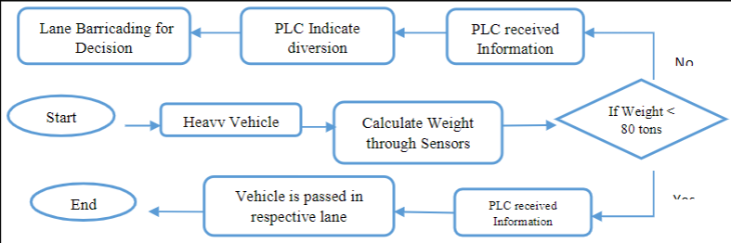
Artificial Intelligence (AI) techniques, such as fuzzy logic, are utilized to create traffic controllers that can mimic human thinking. The primary objective of developing AI traffic controllers is to enable them to adjust to real-time data from detectors and continuously optimize signal timing plans for intersections in a network. This is crucial in reducing traffic congestion, which is currently the primary concern in traffic flow management at intersections [41]
Figure 4 Flow chart for diversion of vehicles based on weight
Source: - (S. S. ZIA, Smart Traffic Light System by Using Artificial Intelligence, 2018)

The purpose of inventing traffic lights was to maintain a seamless flow of traffic and prevent accidents, congestion, and other disturbances in public areas. These lights play a crucial role in the management of traffic and transportation. Previously, humans were responsible for overseeing traffic control systems, and a timer system was introduced to ensure the smooth movement of vehicles. However, with the advancements in computer technology, these control systems have been surpassed. Computer systems utilize binary operations, making them more precise and effective compared to humans. They constantly monitor the traffic situation and regulate the timing of traffic lights across the transportation network.

Currently, numerous countries employ artificial intelligence (AI) to enhance the intelligence and efficiency of traffic lights, ensuring the safety of both passengers and drivers on the road. By utilizing computer vision technology, AI is able to accurately identify the volume of vehicles on the road and the presence of pedestrians near the sidewalk. This valuable data is then utilized to provide drivers with appropriate indications and guidance [42]

4.6 Traffic Congestion on the Road

4.4 Pedestrian Detection

Every year, over 270,000 pedestrians meet their fate on the roads worldwide, constituting a significant 22% of the overall 1.24 million fatalities caused by road traffic accidents. “More than 5000 pedestrians are killed on the world’s roads each week. This is because their needs have been neglected for decades, often in favor of motorized transport,” Dr Etienne Krug, WHO Director of the Department of Violence and Injury Prevention and Disability. [43].

4.5 Road Surface Condition monitoring (RSCM)

Road surface condition monitoring (RSCM) plays a crucial role in ensuring safety, enhancing driving comfort, alleviating traffic congestion and safeguarding vehicles from potential harm caused by irregularities on the road surface. [44]. Two hybrid deep learning models have been proposed for the classification of road surface anomalies. The first model, referred to as Convolutional Neural Network (CNN) combined with Gated Recurrent Units (GRU), utilizes the power of both CNN and GRU to effectively analyze and classify road surface anomalies. The second model, known as CNN-LSTM, combines the strengths of CNN and Long Short-Term Memory (LSTM) to achieve accurate classification results. These models leverage the capabilities of deep learning techniques to enhance the understanding and detection of road surface anomalies, thereby contributing to the improvement of road safety and maintenance.

5.References

[1] | R. S. C. Shahzadi Parveen, “Artificial Intelligence in Transportation Industry,” International Journal of Innovative Science and Research Technology , pp. Vol. 7 1274 ,, August – 2022 .
[2] | A. Turing, “is artificial intelligence (AI),” [Online]. Available: https://www.ibm.com/topics/artificial-intelligence.
[3] | L. S. Iyer, “ AI enabled applications towards intelligent transportation,” sciencedirect, p. 1, 2021.
[4] | S. J. C. E. E. A. E. O. M. A. G. Emmanuel Kwame Nti, “Environmental sustainability technologies in biodiversity, energy, transportation and water management using artificial intelligence: A systematic review”.
[5] | J. T. Pavel Hamet, “Artificial intelligence in medicine,” p. S37, April 2017 .
[6] | A. B. a. E. A. Feigenbaum, Handbook of artificial intelligence, 1981.
[7] | L. S. Iyer, “AI enabled applications towards intelligent transportation,” Sciencedirect, p. 1, 2021.
[8] | M. Verma, “Artificial intelligence and its scope in different areas with special reference to the field of education by Mudit Verma page no. 5, Jan 2018,” p. 5, Jan 2018.
[9] | L. S. Iyer, “AI enabled applications towards intelligent transportation,” Sciencedirect, p. 1, 2021.
[10] | K. M. E. T. N. a. D. K. Alexandros Nikitas, “Artificial Intelligence, Transport and the Smart City: Definitions and Dimensions of a New Mobility Era,” p. 1, Feb.2020.
[11] | ILO, “Transport (including civil aviation, railways and road transport) sector,” [Online]. Available: https://www.ilo.org/global/industries-and-sectors/transport-including-civil-aviation-railways-road-transport/lang--en/index.htm.
[12] | H. D. ,. S. L. a. S. A. B. Rusul Abduljabbar, “Applications of Artificial Intelligence in Transport,” mdpi.com/journal/sustainability, p. 1, 2019.
[13] | L. S. Iyer, “AI enabled applications towards intelligent transportation,” Elsevier, p. 1, 2021.
[14] | G. a. U. Amrita Sarkar, “APPLICATION OF FUZZY LOGIC IN TRANSPORT PLANNING,” International Journal on Soft Computing (IJSC) , p. 1, May 2012 .
[15] | V. R. D.S Hooda, Fuzzy Logic Models and Fuzzy Control. An Introduction, U.K: lpha Science International Ltd.Oxford, U.K, 2017.
[16] | D. V. T. Dhumil Vora, “A Study on Methodology of Fuzzy Logic,” International Journal of Novel Research and Development (IJNRD), p. d726, 10 Oct, 2023.
[17] | O. C. Patricia Melin, “A review on the applications of type-2 fuzzy logic in classification and pattern recognition,” Elsevier Science Direct , Oct 2012 .
[18] | I. Jerry M. Mendel Fellow, “Fuzzy logic systems for engineering: a tutorial,” p. 347, 1995.
[19] | M. N. a. D. T. Aleksandar Jovanovic, “Area-wide urban traffic control: A Bee Colony Optimization approach,” Transportation Research Part C: Emerging Technologies , pp. 1-25, April, 2017.
[20] | V. P. a. G. S. Anand Nayyar, “Artiﬁcial Bee Colony Optimization—Population-Based Meta-HeuristicSwarm Intelligence Technique,” Advance in Intelligent Systems and Computing , pp. 513-525, Jan 2019.
[21] | D. T. a. M. S. Tatjana Davidović, “Bee Colony Optimization - part I: The algorithm overview,” Yugoslav Journal of Operation Research, pp. 33-56, 2015.
[22] | M. Z. a. M. M. E. Yasser M. Ayid, “An artificial bee colony optimization algorithms for solving fuzzy capacitated logistic distribution center problem,” Elsevier, p. 2, Sept 2024.
[23] | M. M. P. F. A. V. E. C. a. N. P. Dennis Wilken, “Artificial Bee Colony Algorithm with Adaptive Parameter Space Dimension: A Promising Tool for Geophysical Electromagnetic Induction Inversion,” MDPI Remote Sensing , 2024.
[24] | S. G. a. S. Binu, “Vehicle Route Optimisation Using Artificial Bees Colony Algorithm and Cuckoo Search Algorithm-A Comparative Study,” International Journal of Applied Engineering Research, pp. 953-959, 2018.
[25] | K. A. A. A. M. S. T. a. B. H. A. Risikat Folashade O. Adebiyi, “Management of Vehicular Traffic System using Artificial Bee Colony Algorithm,” I.J. Image, Graphics and Signal Processing, pp. 18-28, 2017.
[26] | D. A. T. M. D. ORCO, “Mitigating Traffic Congestion: Solving the Ride-Matching Problem by Bee Colony Optimization,” Transportation Planning and Technology, April 2008.
[27] | J. Z. a. Z. Zhang, “An Optimized Artificial Bee Colony Algorithm for the Shortest Path Planning Problem,” International Conference of Transportation Professionals, July 2018.
[28] | M. K. a. M. Kruszyna, “Public Transport Planning Using Modified Ant Colony Optimization,” MDPI, Sustainability , vol. 17, no. 6, 2025.
[29] | X.-H. Y. David Renfrew, “Traffic Signal Optimization Using Ant Colony Algorithm”.
[30] | J. P. a. P. L. Dušan TEODOROVIĆ, “TRANSPORT MODELING: AN ARTIFICIAL IMMUNE SYSTEM APPROACH,” Yugoslav Journal of Operations Research , pp. 3-30 , 2006.
[31] | S. E. a. S. D. Boutheina. TRABELSI, “TRAFFIC CONTROL AT INTERSECTIONS USING ARTIFICIAL IMMUNE SYSTEM APPROACH,” in 9th International Conference of Modeling, Optimization and Simulation - MOSIM’12 , Bordeaux - France, 2012.
[32] | N. M. &. F. D. Henrique Dezani, “Genetic algorithm-based traffic lights timing optimization and routes definition,” in Proceedings of the 19th World Congress, Cape Town, South Africa, 2014.
[33] | S. T. a. H. A. Leena Singh, “Time Optimization for Traffic Signal Control Using Genetic Algorithm,” ternational Journal of Recent Trends in Engineering, vol. Vol 2, no. 2, pp. 4-6, Nov. 2009.
[34] | T. Pamuła, “Neural networks in transportation research-recent applications,” Transport Problem, pp. 27-39, June 2016.
[35] | B. Ahmed, “The Traditional Four Steps Transportation Modeling Using Simplified Transport Network: A Case Study of Dhaka City,Bangladesh,” IJASETR , p. 19, vol.1 February 2012.
[36] | J. M. L. H. Hwan Jung, “Smart Parking Management System Using AI,” pp. Vol.9,4630, 1, January, 2022.
[37] | J. Hwan Jung, “Smart Parking Management System Using AI,” pp. Vol.9,4630, 1 Jan.2022.
[38] | D. L. S. G. S. Hirak Dipak Ghael, “Review Paper on Raspberry Pi and its Applications,” International Journal of Advances in Engineering and Management (IJAEM), pp. Vol.2,225, 06-01-2021.
[39] | J. Hwan Jung, “Smart Parking Management System Using AI,” pp. Vol.9,4630, 1 Jan 2022.
[40] | M. N. I. M. M. T. T. J. A. M. a. T. M. S. S. ZIA, “Smart Traffic Light System by Using Artificial Intelligence,” SINDH UNIVERSITYRESEARCHJOURNAL (SCIENCESERIES), pp. Vol.50 (004) 639-646 , 2018.
[41] | H. M. S. Azura Che Soh/Lai Guan Rhung, “MATLAB Simulation of Fuzzy Traffic Controller for Multilane Isolated Intersection,” IJCSE) International Journal on Computer Science and Engineering, pp. Vol. 02, 924-933, 2010.
[42] | D. &. Wissen, “Advanced Traffic Control System using AI,” 27 September 2022. [Online]. Available: https://datenwissen.com/blog/ai-traffic-system/.
[43] | WHO, “More than 270000 pedestrians killed on roads each year,” 3 May 2013. [Online]. Available: https://www.who.int.
[44] | Y. K. Abdelkader Hadj-Attou, “Hybrid deep learning models for road surface condition monitoring,” ELSEVIER, p. 1, 2023.
[45] | M. N. I. M. M. T. T. J. A. M. a. T. M. S. S. ZIA, “Smart Traffic Light System by Using Artificial Intelligence,” SINDH UNIVERSITYRESEARCHJOURNAL (SCIENCESERIES), pp. Vol.50 (004) 639-646, 2018.

